estimating_flux
2024-04-23

Purpose
The goal of this document is to demonstrate the workflow for estimating global fluxes of contaminants. The are five primary data requirements.
- The global amount of annual insect emergence (mgDM/y)
- The proportion of emergence that is carrying a given contaminant
- The effect of the contaminant on insect emergence
- The concentration of the contaminant in the surviving adult aquatic insects
- The global amount of contaminant flux from adult aquatic insects
A sixth data need that is not addressed here is the spatial location of this flux (i.e., where does the flux happen on earth?). This will come from the spatial mapping approaches (see last section here).

Approach
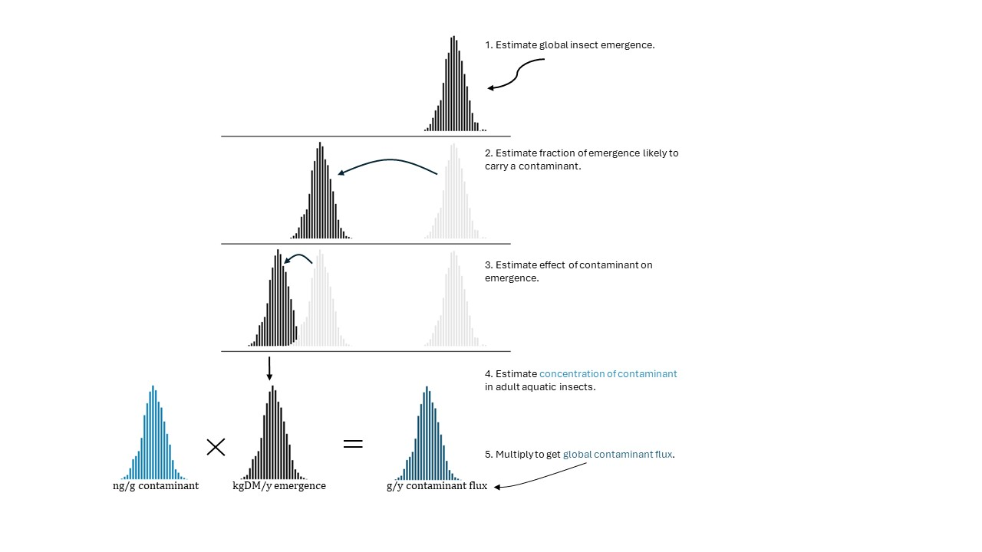
Figure 1. Schematic approach of the steps needed to estimate global contamiant (or nutrient) flux by adult aquatic insect emergence.
Our overall approach (Figure 1) is to use literature estimates and Bayesian modeling to quantify the uncertainty in each of the data needs above, and then combine that uncertainty into estimates of the global flux of contaminants transported by emerging aquatic insects from rivers each year. This approach focuses on contaminants, but nutrient flux can be added using the same methods.
We address 1-5 above (Figure 1) as follows, using mercury as a case study:

1. The global amount of annual insect emergence (mgDM/y)
We obtained ~92 records of total community macroinvertebrate annual production. A smaller number included information on only insect community production, which is the measure we are interested in. To obtain estimates of insect production from the community production data, we first estimated the proportion of community production that wer insects using an intercept only Beta model with the raw proportions as the response variable (i.e., insect production/community production using only data that reported both). We then multiplied the posterior distribution of this proportion by estimates of total community production for data that did not have insect production, yielding modeled estimates of aquatic insect secondary production (mean and sd) for each collection.
Next, we estimated the fraction of this annual insect production that emerged each year using data published in Gratton et al. (2008). We fit a random effects model to the Gratton data with the fraction of larval production that emerges each year as the response variable, and varying intercepts for taxon and study.
We then used a Monte Carlo approach to multiple the estimates of annual insect secondary production by the fraction emerging each year ($∼$ 0.19), yielding n = 173 mean +/- sd estimates of insect emergence (mgDM/m2/y). Based on the location of those estimates, we assigned values for mean annual air temperature, elevation, and other predictor variables from the BIOCLIM data set.
To estimate emergence as a function of temperature, we fit a Bayesian generalized linear mixed model with emergence as the response variable (posterior mean weighted by it’s sd), temperature as the predictor, and study (author/year) as a varying intercept. The likelihood was Gamma, since the data were positive and continuous. This model revealed a weak positive relationship between emergence and mean annual air temperature.
We then used the emergence vs temperature model to estimate total emergence in the $∼47,000$ river basins reported by Allen and Pavelsky (2018). We assigned a mean annual air temperature to each basin and then used the posterior predictive distribution of the Gamma regression to predict annual emergence in units of mgDM/m2/y. Then, we mutiplied that prediction by the area of river water in each of the 47,000 basins (Allen and Pavelsky 2018) to yield a total basin flux of mgDM/y. Summing that across basins yields a global estimate of insect emergence from rivers each year:
## # A tibble: 5 × 2
## statistic `MT/dm/y`
## <chr> <dbl>
## 1 median_MTdmy 472631.
## 2 mean_MTdmy 540148.
## 3 sd_MTdmy 298869.
## 4 low95_MTdmy 182136.
## 5 high95_MTdmy 1277135.
The results indicate that rivers export a mean of $∼540,000$ metric tons (MT) of emerging insect dry mass each year with a 95% credible interval of 182,000 to 1,270,000 MTdm/y.

2. The proportion of emergence that is carrying a given contaminant
Of the $∼540,000$ MTdm/y emergence, some fraction is carrying contaminants. For example, if 2% of surface river area is contaminated with Hg, then we can assume that 2% of emergence, or 0.02 $×$ 540,000 = 10,800 MTdm/y will contain Hg. However, we are not aware of direct estimates of contaminant coverage globally. Instead, we used indirect measures as described below for mercury.
Example for Mercury To estimate the proportion of river area (and hence insect emergence) impacted by Hg, we used Peterson et al. Environ. Sci. Technol. 2007, 41, 1, 58–65. Using random surveys of fish from western US rivers, they reported that “11% of the assessed stream length” contained fish with more than 0.1 $μ$gHg/g. Anything below this level is considered safe for consumption by fish-eating mammals. Thus, we made the simplifying assumption that 11% of stream lengths (and hence area) would also result in Hg bioaccumulation in insects. However, Peterson et al. (2007) measured only streams $≤$ 60m wide. Therefore, we needed to also assess the proportion of global stream widths are 60m wide so that we can model Hg in a similar set of streams (NOTE: Perhaps we can assume that Hg is also accumulating in larger rivers, but here we assume that anything greater than 60m has zero Hg. This might make more sense for metals as well, given that Macklin et al. report that nearly all metal contaminants from mines is contained with small river basins <500km2).
To assess the proportion of stream widths globally that are >60m wide, we used the Pareto distrbution equation from Allen and Pavelsky (2018). They estimated that stream widths globally are distributed as a power law with a Pareto shape parameter of 0.83. We simulated 10,000 stream widths using the rpareto() function from the VGAM package, and calculated the proportion of stream widths ≤60m. The result indicates that 99% of stream widths are likely less than 60m wide.
Hence, we assumed that the global flux of insects carrying Hg was/ $540,000 x 0.99 x 0.11=58,806$MTdm/y. In other words, mean total global emergence is 540,000 MTdm/y, 99% of which occurs in streams ≤60m, with 11% of those streams containing elevated Hg.
Caveats: We’re assuming that 11% of streams globally contain Hg, but this is based on a study in the western US, which is likely to have relatively high levels of Hg. Thus, using 11% would result in a high estimate. Below, we also include scenarios with lower % Hg for comparison.

3. The effect of the contaminant on insect emergence
For Hg, we did not assume any effect on insect emergence. For contaminants that do have an effect on insect emergence, we would add an additional multiplier to equation above (with uncertainty included as well). For example, if a contaminant is expected to reduce emergence by 0.5, then the value above would $58,806 x 0.5=29,503$MTdm/y

4. The concentration of the contaminant in the surviving adult aquatic insects
To estimate the concentration of contaminants in adult aquatic insects, we used literature extractions for contaminants that reported either adult aquatic insect tissue concentrations, water concentrations, and/or sediment concentrations.
Example for mercury Using the 52(ish) measures of Hg in adult aquatic insects, we ran a generalized linear model with adult Hg concentration as the response variable, sediment Hg concentration as the predictor variable, and study as a varying intercept. It suggested that the mean Hg concentration in adult aquatic insects is ~0.2 Hg ng/gDM. This value (and its uncertainty) is used in step 5 to estimate global Hg flux.

5. The global amount of contaminant flux from adult aquatic insects
Given the posterior predictions of the amount of potentially contaminated insect emergence (~58,806 MTdm/y) along with the posterior predictions of Hg concentration in those insects (~0.2 Hg ng/gDM), we estimate that the mean annual flux of Hg in emerging aquatic insects is:
## proportion_with_mercury global_flux_mercury_kg_y .lower .upper .width
## 1 0.01 1.3 0.4 4.2 0.95
## 2 0.05 6.5 2.2 21.2 0.95
## 3 0.11 14.4 4.8 46.6 0.95
## 4 0.17 22.2 7.4 72 0.95
## 5 0.23 30.1 9.9 97.4 0.95
The table above gives five scenarios for the proportion of global emergence impacted by Hg, from 1% to 23%. This provides a range of scenarios centered around Peterson et al.’s estimate of 11%. The results suggest that emerging aquatic insects transport between 1 and 30 kg of Hg per year, with credible intervals ranging from 0.4 to 97 kgHg/y. For perspective, Pacific salmon of North America transport ~ 7kg Hg/yr from marine to freshwater (Brandt et al. in review). Hence, these estimates appear reasonable to at least an order of magnitude.

Combining this workflow with spatially explicit estimates.
The approach here is top-down in the sense that we are largely ignoring spatially explicit predictions. Ideally, in addition to temperature, elevation, flow, etc., we could also have spatially explicit estimates of contaminant concentrations in the water or sediment for each river/stream on earth. In such a case, we could use a bottom-up approach model predictions from step 4 are used to estimate contaminant concentrations across rivers. Those estimates would multiplied by emergence predictions at the same rivers. And the result would be spatially explicit estimates of contaminant flux. Global flux would then be calculated by summing up the individual river fluxes. Such an approach would obviate the need for step 2 (estimating the proportion of water impacted by contaminants). But it seems unlikely to be feasible on global scale, given the paucity of contaminants data in many river basins.
However, we will use the spatially explicit bottom-up approach for targeted rivers where we do have spatially explicit estimates of contaminants, namely in the US and Europe (Jakob’s predictions). Those models can be used to demonstrate the feasibility of mapping contaminant flux at the river level. Their results will help to refine global estimates as well (i.e., basins for which we have river-level predictions will be used to predict flux for those basins, rather than the indirect approach described above here).

