BEXIS 2.11.0

Data Dissemination Module

User Guide

Authors

Nafiseh Navabpour, Roman Gerlach, David Blaa

Contact

Website: <http://bexis2.uni-jena.de>

Email: bexis-support@uni-jena.de

Phone: +49-(0)3641-948968

Acknowledgement

The development of the BEXIS 2 software would not be possible without the German Research Foundation (DFG) funding the BEXIS++ project. BEXIS++ is a collaboration of the Friedrich-Schiller-University Jena (Dept. of Computer Science, Dept. for Geography), the Max-Planck-Institute for Biogeochemistry Jena, the Technical University Munich (Dept. Ecology and Ecosystem Management), the Gesellschaft für wissenschaftliche Datenverarbeitung mbH Göttingen (GWDG), and the Georg-August-University Göttingen.

**Content**

1 Overview 3

2 Publish a Dataset Version 3

2.1 Configurate 3

2.2 Publish 4

2.3 Zip 4

# Overview

The Data Dissemination Module, available via **Setup** (Cog button) and **Export Metadata**, provides a tool to export metadata to a standard compliant XML file. For every metadata structure in the system there is one tab in the tab strip.

The data grid in one tab shows all datasets belonging to the selected metadata structure.

Select a checkbox to mark the datasets you would like to export.

Please click the Export button and wait until the metadata XML file has been created successfully and a download link is available in-line.

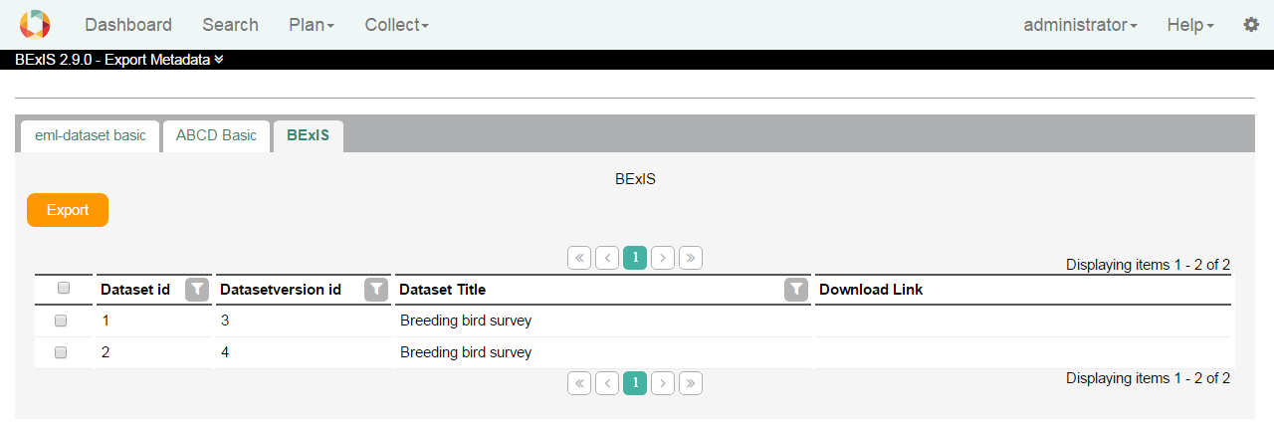

# Mapping tool

In the mapping tool in BEXIS it is possible to set each metadata structure to predefined keys and party types (for more information about party types see the manual about parties).

* Keys are attributes such as title or description.
* Party types are defined objects such as persons, institutes, organization or workshops.

Advantages after mapping a metadata structure:

1. When publishing a dataset, BEXIS must retrieve information from the metadata and convert it to the requested formats. The more keys and party types are defined, the better the information can be prepared for publication.
2. In the BEXIS there are party types like people, project, etc.

In the metadata form, according to the mapping, appropriate results are suggested. If a user encapsulates a person in the metadata form, all matching persons are made available for selection. This simplifies the input of metadata.

WHERE TO GO?

## Overview

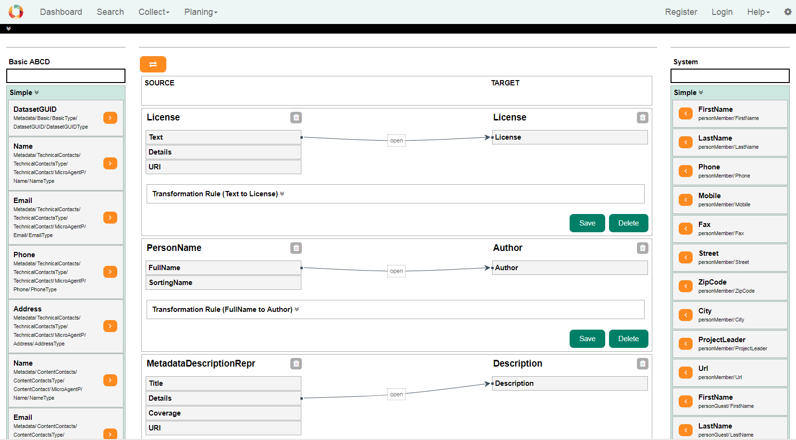

The page is divided into 3 sections. The source is displayed on the left. The target is displayed on the right side. In the middle all created mappings are displayed.

### Source and Target

Each side as a simple and complex block as also a free text search. Simple elements are example first name, last name or full name from a person. A Complex type can be a person.

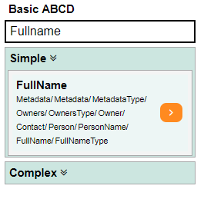 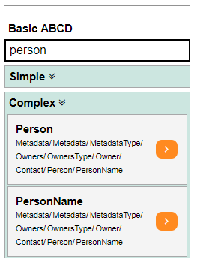

### Mapping

Mappings are connections between the source and the target. There are different connection possibilities between the simple attributes. Generally only the connection between two simple attributes is considered.

With the aid of a transformation rule, it is possible to cover a wide range of different cases. A transformation rule consists of a RegEx and a mask. With an example you can check the values and the expected result.

LINK REGEX

#### EXAMPLE one to one

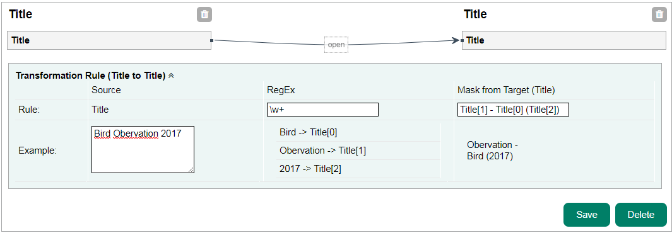

#### EXAMPLE one to many

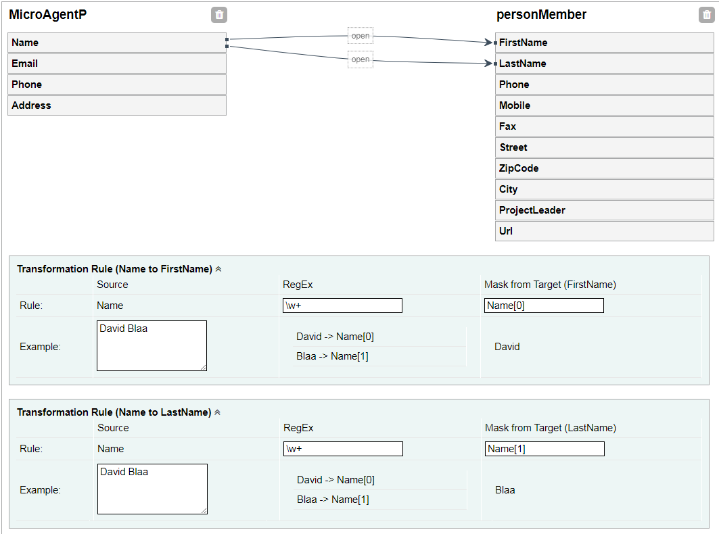

#### EXAMPLE many to one

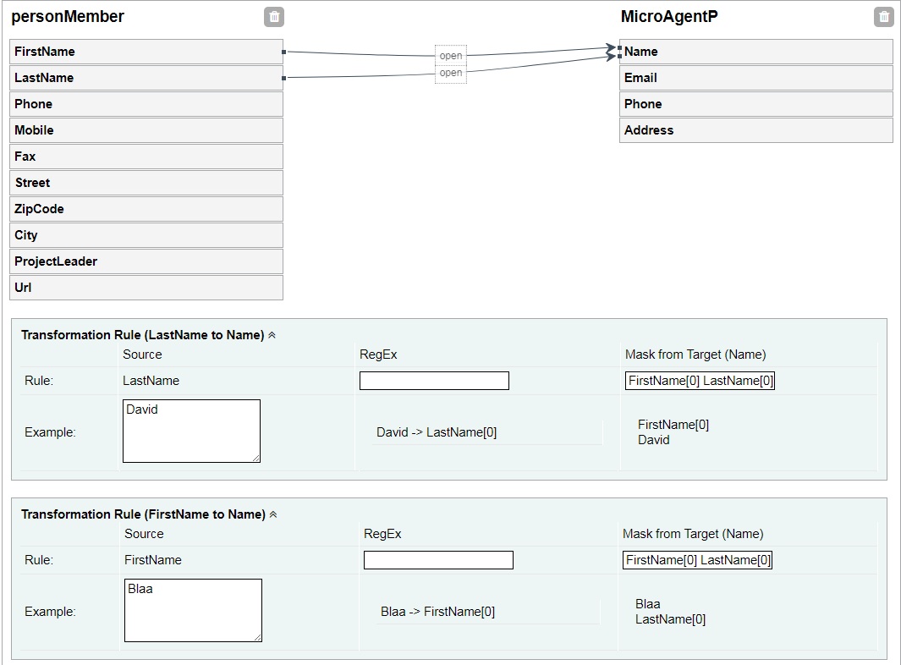

#### Create a mapping

1. Search an select for a simple or complex element from the source.
2. Add Element to the mapping in the middle by clicking the orange arrow next to the element.
3. Search an select for a simple or complex element from the target.
4. Search an select for a simple or complex element from the target.
5. Create the mapping by clicking the create button
6. In the mapping container there are all available simple elements for this mapping. Draw a line by clicking on one simple element from the source side and drag it to a simple element on the target side.
7. If needed, add RegEx and mask to the transformation rule. After entering values in the blocks
8. Press save

# Publishing a Dataset Version

## Administration

### Configure

In the workspace a submisionConfig.xml is placed under “…\Workspace\Modules\DIM”.  
The data centers can be registered in this file. Here you can define requirements such as, for example, to export the primary data to csv.

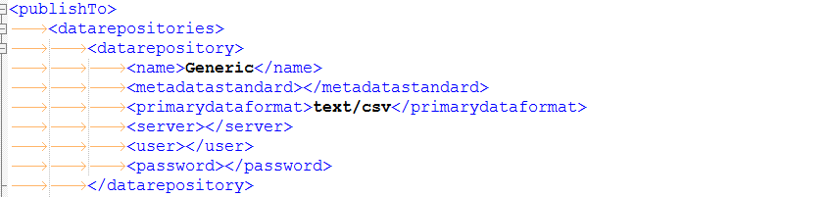

### Publish

The user can publish a dataset version if you go to the dataset and find the publish tab.  
The dropdown is showing all available data center. Select on and the system try to convert the data and the metadata as defined in the submissionConfig.xml. If something fails a message will displayed.  
There are two types of fails.

1. The system is not able to convert the data. The administrator should check the config and the convert option.
2. Metadata is not valid. This is a warning. You can go on but the metadata.xml in the zip ist not valid against the exported xsd schema

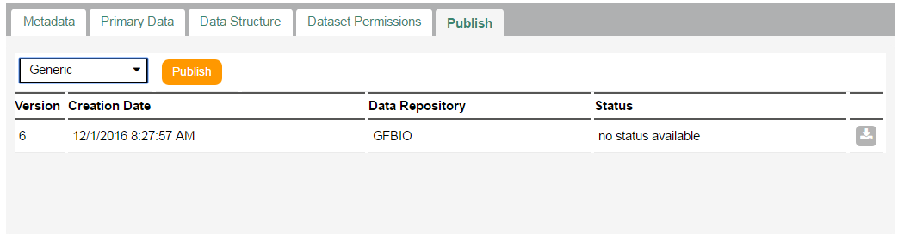

### Zip

The following files can be found in the zip file.

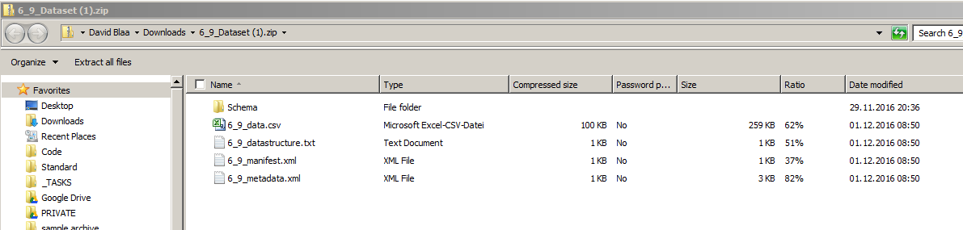

1. Schema - XSD Schema for the metadata
2. Data.*** - Primary Data
3. Data structure - Structure of the primary data
4. Manifest File - General information’s about the Dataset
5. Metadata - Metadata information’s about the dataset

## User