BEXIS 2.11.4

System Administration Module

User Guide

Authors

Nafiseh Navabpour, Roman Gerlach

Contact

Website: <http://bexis2.uni-jena.de>

Email: bexis-support@uni-jena.de

Phone: +49-(0)3641-948968

Acknowledgement

The development of the BEXIS 2 software would not be possible without the German Research Foundation (DFG) funding the BEXIS++ project. BEXIS++ is a collaboration of the Friedrich-Schiller-University Jena (Dept. of Computer Science, Dept. for Geography), the Max-Planck-Institute for Biogeochemistry Jena, the Technical University Munich (Dept. Ecology and Ecosystem Management), the Gesellschaft für wissenschaftliche Datenverarbeitung mbH Göttingen (GWDG), and the Georg-August-University Göttingen.

Content

1. Overview 3

# 1. Overview

Visualization or in other words the visual representation of data in an easily comprehensible form is the feature of the visualization module for BEXIS2. User of BEXIS2 is able to get a quick overview of the system behaviour with looking at diagrams. Visualization is accessible through setup in the main menu.

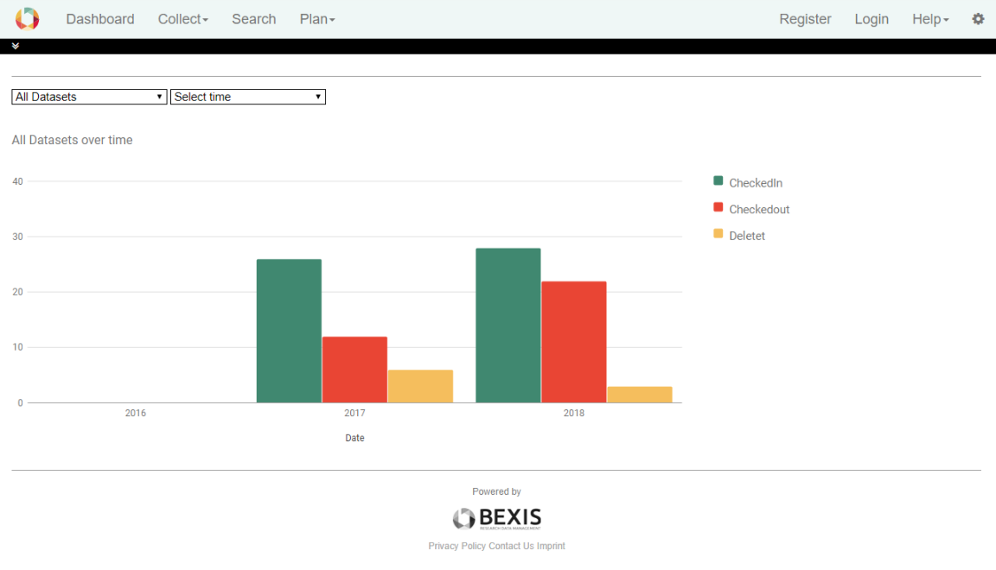

# 2. Select Ranges

Visualization provides diagrams depend on the selected ranges in different dropdown lists. There is two different lists to control the diagram. One is to select the kind of data and one is to select the time range.

## 2.1. Select Data

The actual version of the BEXIS2 makes you able to see the statistic of created, checkedIn, checkedOut or deleted datasets over a time range.

If you select “All Dataset”, which is selected by default, you can see different diagrams in a single chart.

## 2.2. Select Time

In the drop-down list "Select time”, you can find the past years. By default, the chart displays the data distribution over the entire time from the first activities.

Select a specific year and see the statistic for only that year, separated in twelve months.

The statistics shows for more than a year, even if you did not start BEXIS2 in one year.