BEXIS 2.12.2

Installation Manual

Authors

David Schöne, Andreas Ostrowski, Nafiseh Navabpour, Roman Gerlach

Contact

Website: <http://bexis2.uni-jena.de>

Email: bexis-support@uni-jena.de

Phone: +49-(0)3641-948968

Acknowledgement

The development of the BEXIS 2 software would not be possible without the German Research Foundation (DFG) funding the BEXIS++ project. BEXIS++ is a collaboration of the Friedrich-Schiller-University Jena (Dept. of Computer Science, Dept. for Geography), the Max-Planck-Institute for Biogeochemistry Jena, the Technical University Munich (Dept. Ecology and Ecosystem Management), the Gesellschaft für wissenschaftliche Datenverarbeitung mbH Göttingen (GWDG), and the Georg-August-University Göttingen.

Content

1 BEXIS 2 Package 2

2 Additional Software / Prerequisites 3

2.1 .NET Framework 4.5.2 3

2.2 Database System PostgreSQL 3

3 Setup Internet Information Service (IIS) 4

3.1 Activate IIS7 4

3.2 Register .Net Framework 4.0 in IIS 5

4 Deploy BEXIS2 web application 6

4.1 Configure server components 6

4.1.1 Create Website 6

4.1.2 Configure IIS 6

4.1.3 Create empty database 6

4.1.4 Configure postgres 7

4.2 Install BEXIS 2 package 9

4.2.1 Deploy Website (new installation) 9

4.2.2 Deploy Website (patch existing installation) 9

4.2.3 SMTP server configuration 9

4.2.4 SSL Setup 9

4.2.5 Start Website 11

5 Errors 11

5.1 ERROR [08004][IBM] SQL30061 11

5.2 ERROR [08001][IBM] SQL30081n 12

5.3 ERROR HTTP-ERROR 403.14 12

5.4 ERROR HTTP- ERROR 404.2 12

5.5 ERROR SQL1159 12

6 Setting up multiple tenants in a single BEXIS 2 instance 12

6.1 Tenants.Catalog.xml 12

6.2 Manage Tenants Folder 13

# BEXIS 2 Package

* First download the application package from: <http://bexis2.uni-jena.de/releases/2-12/>
* Unzip BEXIS212_full.zip.

Please note that changing the name and place of that folder is not possible after installing.

Usage of contained files and folders is described in section 4.

# Additional Software / Prerequisites

The following software is needed to run the BEXIS 2 web application. If they are installed on your computer already please jump to section 3. If not, please download BEXIS2113_Prerequisites.zip from: <http://bexis2.uni-jena.de/releases/2-11-3/> and unzip the file.

## .NET Framework 4.5.2

* Open folder Prerequisites\.NET 4.5.2 and start “NDP452-KB2901907-x86-x64-AllOS-ENU.exe” as admin
* Or download it here: [Download .net Framework 4.5.2](http://www.microsoft.com/en-US/download/confirmation.aspx?id=42642)
* follow the steps in the installation window

## Database System PostgreSQL

BEXIS 2 needs database management system to be available on your server. BEXIS2 developer team tested the PostgreSQL and we recommend it. If it not available already please follow the installation instructions below.

From the following link [http://www.enterprisedb.com/downloads/postgres-postgresql-downloads](http://www.enterprisedb.com/downloads/postgres-postgresql-downloads%20%20)  select either the 32-bit or 64-bit version of PostgreSQL depending on your hardware and your installed operating system and install it. The Postgres version 9 is recommended.

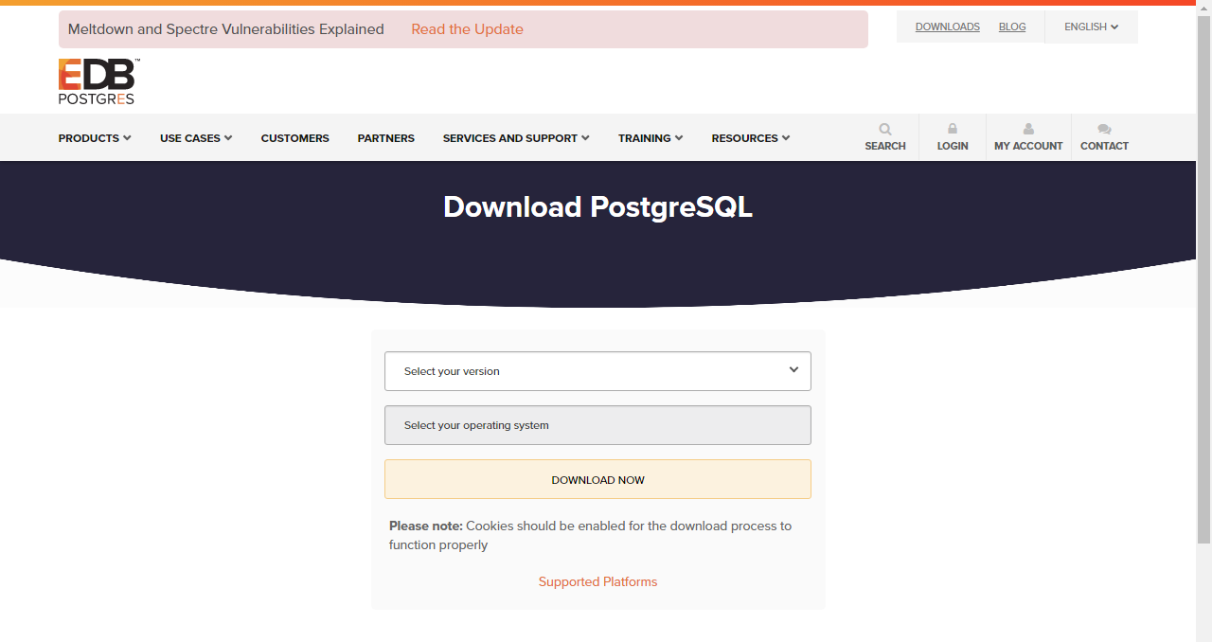

The installation of PostgreSQL is easy. It is enough to run the Installer and follow the steps. During installation, when asked, please

* As user enter "postgres"
* As password enter “1”
* As port number enter “5432”.

Launch Stack Builder that is asked in the last step is not recommended.

When the installation is finished, run PgAdmin and add a connection to the server that you want to work on it.

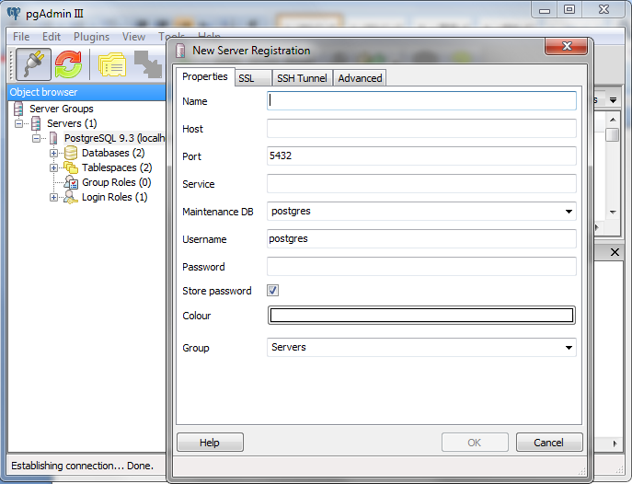

# Setup Internet Information Service (IIS)

IIS is needed to host a website on the server. If your IIS is already activated and .NET framework is registered move on to section 4. If you don’t know if your IIS is activated or if .NET is registered, please follow the steps below.

## Activate IIS7

* Open Control Panel > Programs and Features,
* On the left side click the “Turn Windows features on/off” link.

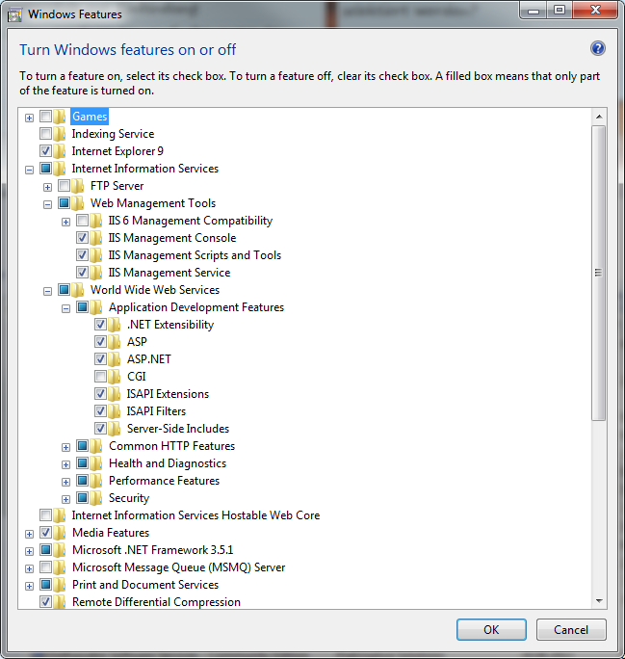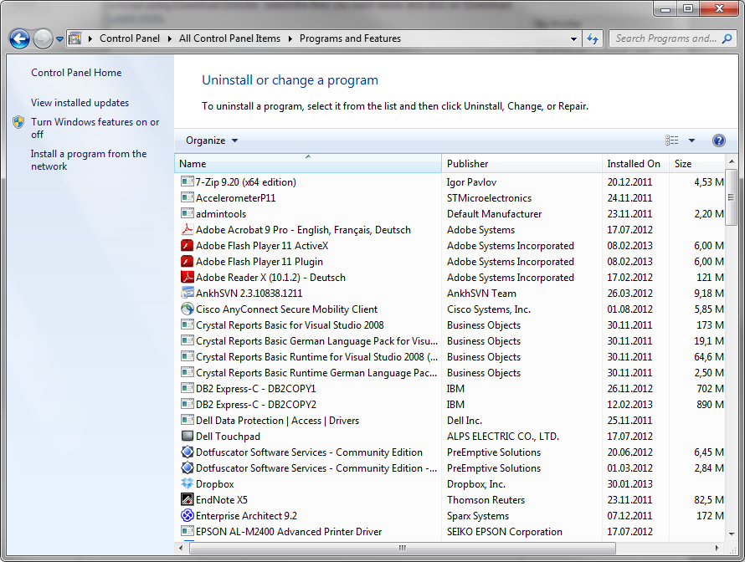

* First select “Internet Information Service”(IIS) and open this node
* Open “Web Management Tools ” and select/tick:
  + IIS Management Console
  + IIS Management Scripts and Tools
  + IIS Management Service
* Below IIS (Internet Information services) open “World Wide Web Services” > “Application Development Features” and select/tick all versions of:
  + .Net Extensibility
  + Asp
  + Asp .NET
* Below IIS open “World Wide Web Services” / “Common HTTP Features” and select/tick:
  + Static Content
* Click “OK” Button

## **Register .Net Framework 4.0 in IIS**

First find “Windows” folder in your computer. It is probably in “c:\” and marked as “%windir%” in following steps.

Register .Net Framework 4.0:

* Find one of the following paths in your computer direct in folders or through cmd as administrator
  + %windir%\Microsoft.NET\Framework64\v4.0.30319\

or

* + %windir%\Microsoft.NET\Framework\v4.0.30319\
* Run aspnet_regiis.exe­ir by double clicking or type as command.

# Deploy BEXIS2 web application

## Configure server components

Perhaps some of the following configuration settings are already in place. But please check them out.

### Create Website

* Open IIS (Control Panel / Administrative Tools)
* Stop Default Website (Click it and choose “stop” on the right side)
* Create a new Website (right click on sites and choose Add Web Site)
* Enter your preferred Site name
* Select Application pool ASP .NET v4.0 (not Classic)
* Select physical path of your website. It is inside the unzipped BEXIS 2 Package.
* Confirm your selections by pressing the ok button
* Stop your website (Click it and choose “stop” on the right side)

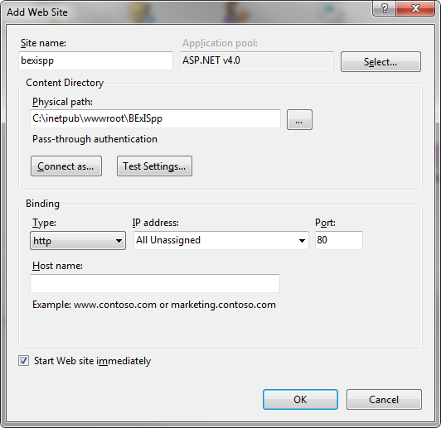

### Configure IIS

* Configure application pool:
  + Open IIS (Control Panel/Administrative Tools)
  + Select **Application Pools** and right click in “**ASP .NET v4.0**” and select “**Set Application Pool Defaults…**”
  + Change “**General-Enable 32-Bit Applications**” to “True”
  + Change “**Process Model – Identity**” to “NetworkService”

### Create empty database

If you want to work with an empty database, you need to create it.

Open pgAdmin. Double click on the “PostgreSQL…”. A popup window will open where you need to enter the password for user ‘postgres’. Please enter the password you defined when you installed PostgreSQL.

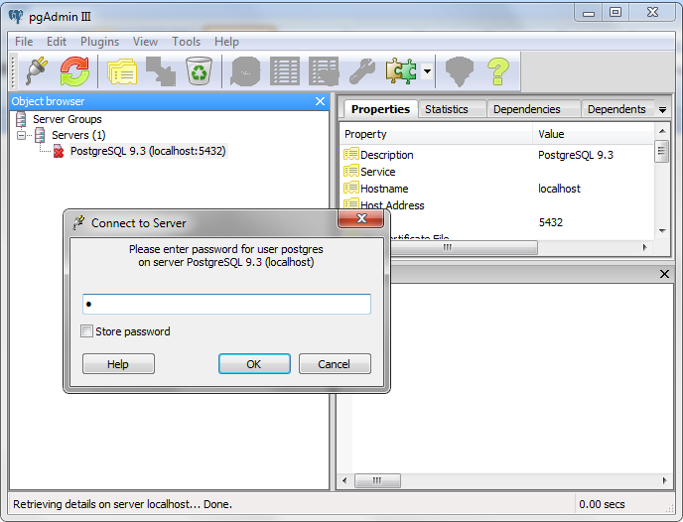

Then in the Object browser section, Right click on “Databases” node and create a new database. Enter “BEXIS” as a database name.

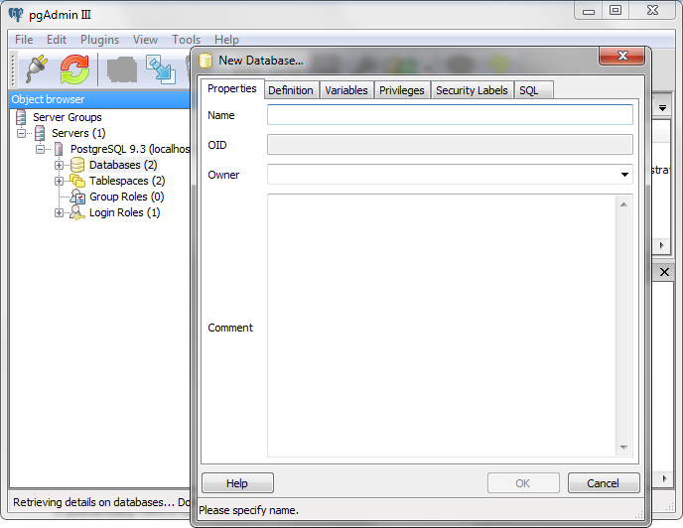

### Configure postgres

BEXIS22 works with a DateTime format “mdy”. So Postgres need to setup with the same format.

* Open postgres config file

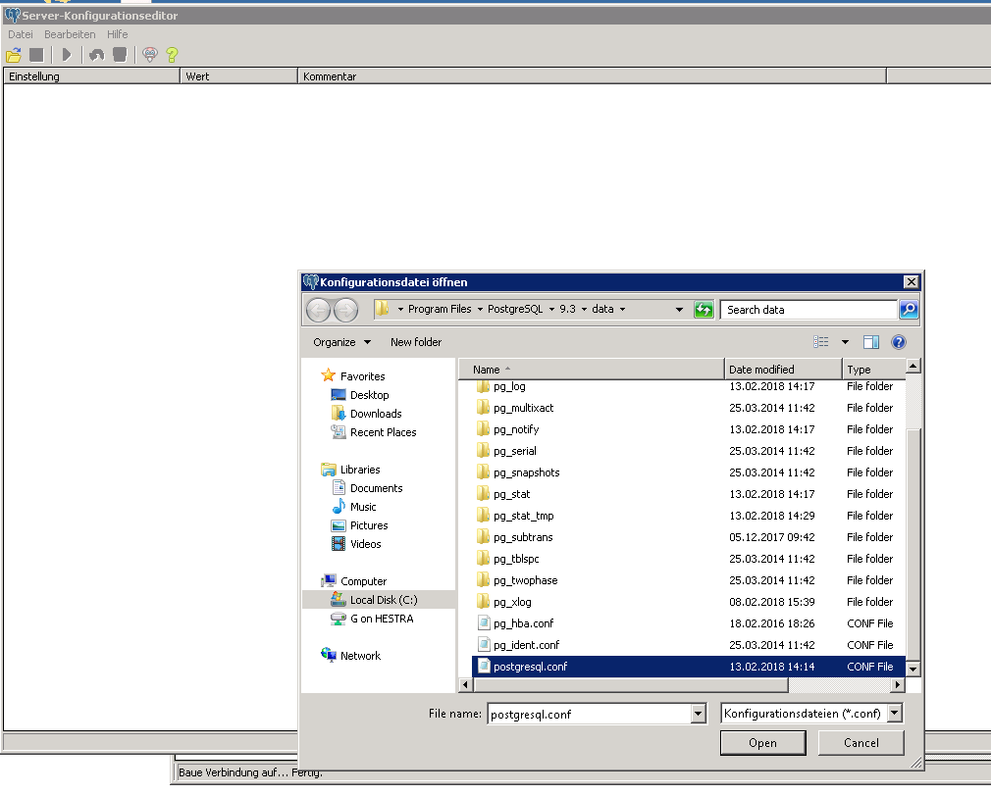

* Search for datestyle

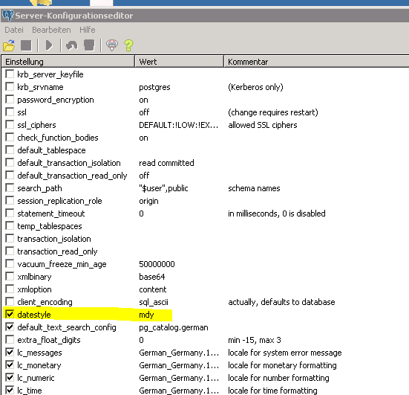

* Change it to “mdy”

## Install BEXIS 2 package

To install BEXIS 2 successfully, you need first unzip the BEXIS 2 package. Depends on it is a new or patch installation, follow steps bellow.

### Deploy Website (new installation)

* Create a new folder and call it “Data” (in the BEXIS 2 unzipped package is recommended)
* The IIS_IUSRS user needs full control permissions to the following folders:
  + Workspace folder
  + Data folder
* Open configuration file (web.config) from the folder of your website inside unzipped BEXIS 2 package with a text editor. You mentioned it when you was selecting physical path of your website:
  + enter (or adapt) database name in section connection strings
  + set “CreateDatabase” to “true“ in section appSettings

**ATTENTION!! Define “true” value for “CreateDatabase” clears the database.**

* + update “DataPath” in section appSettings
  + update “SystemEmail” in section appSettings (some system activities will reported to this Email address)

### Deploy Website (patch existing installation)

* Copy inside the “Website” folder from the BEXIS 2 unzipped package to the folder of Your_Websitename and overwrite existing files.
* If there are changes in the web.config, you will find in patch directory a web_update.config. From this file, the changes have to be taken.
* If there are changes in the Workspace, you will find a “Workspace” folder in the directory. The contents of the folder must be copied into the current Workspace folder.

### SMTP server configuration

SMTP server configuration is needed from the BEXIS2.11. You need to configure an SMTP server for the “SystemEmail”, which you defined in the web.config.

To find and set up SMTP parameters, open Credentials.config from Workspace > General > Configurations.

### SSL Setup

Nowadays, the demand of security in the internet is increasing tremendously. An important step to achieve that requirement is using SSL (***S****ecure* ***S****ockets* ***L****ayer*). With SSL it is possible to establish an encrypted connection between server (e.g. web server that is hosting the website) and client (typically a browser). That connection allows sensitive information (e.g. login credentials) to be transmitted securely through the web. Otherwise, that data would be sent as plain text between browsers and web servers – leaving you vulnerable to eavesdropping. If an attacker is able to intercept all data being sent between a browser and a web server they can see and use that information.

You are free to enable or even enforce SSL for your website inside IIS (***I****nternet* ***I****nformation* ***S****ervice*). Just use the following steps:

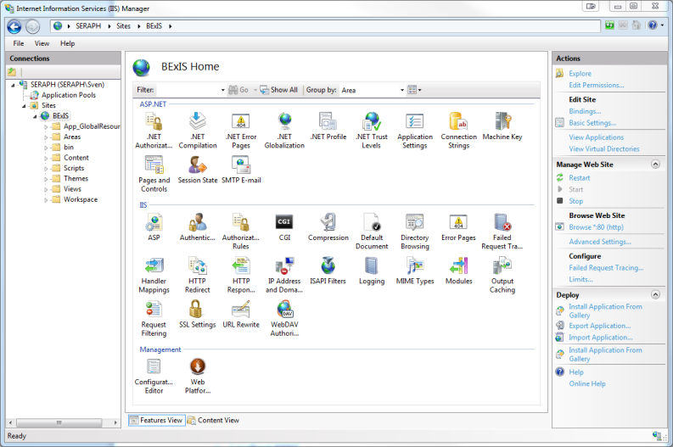

* Open IIS
* Select proper website (left panel)
* Select “Bindings…” (right panel)

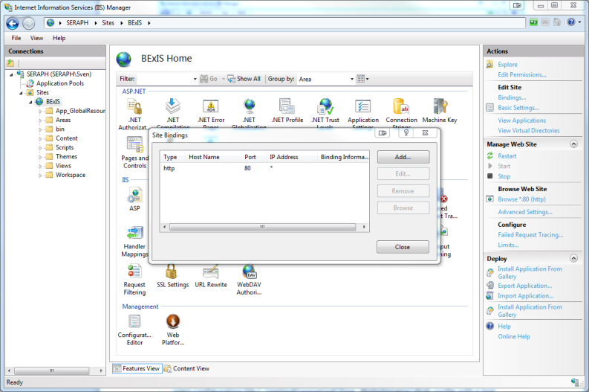

* Select „Add…“

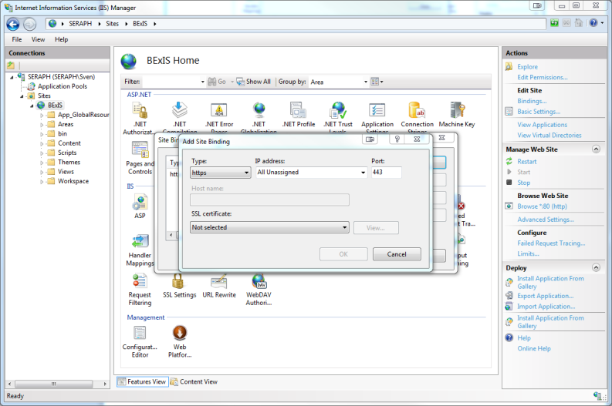

* Select „https“ as Type
* Check Port! (by default this is „443“, but maybe you have to change it)
* Select SSL certificate
* Confirm settings by clicking “OK”

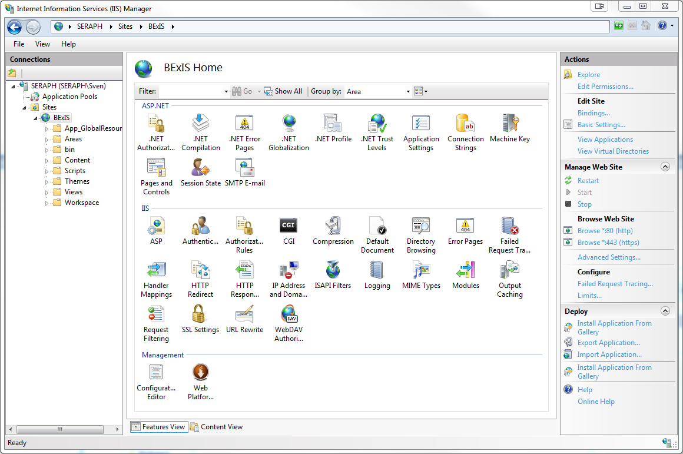

* Check SSL settings in “Browse Web Site” by clicking on “Browse *:443 (https)” (right panel)
* Web Browser should bring up the website in https (if everything is set up in the right way)

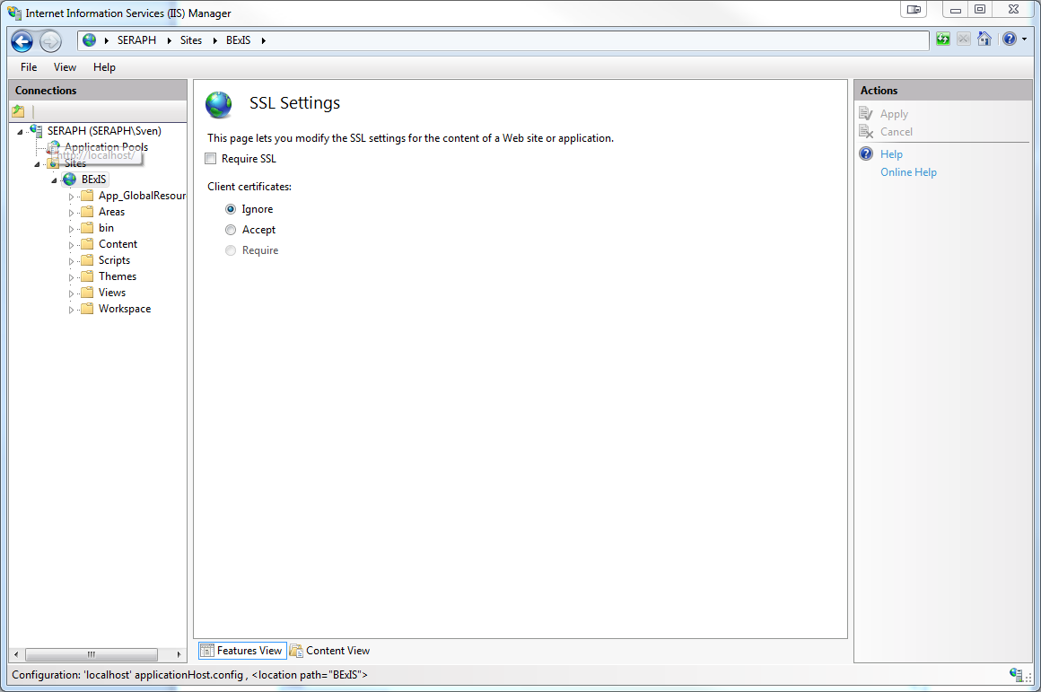

* It is possible to run the website in https ONLY!
* Select proper website (left panel)
* Select “SSL settings”
* Tick “Require SSL”
* Click “Apply” (right panel)

### Start Website

* Open the IIS and select your Website
* Start your website (Click it and choose “Start” on the right side)
* Open Browser and enter: localhost
* Open configuration file C:\inetpub\wwwroot\Your_Websitename\Web.config with a text editorset “CreateDatabase” to “false“ in section appSettings

Note:From the version BEXIS2.11 the application doesn’t need a default “Administrator” user. “Manage Features” is accessible via Gear button on the right side in menu bar. First user is able to set permissions. If you need an administrator user or a group administrators, you can create a new user or group and get it all permissions.

# Errors

## 5.1 ERROR [08004][IBM] SQL30061

* Check if database exist. If not create this database
* If you run more than one instances of db2, you need to add another port number to the server name in the connection string
  + Localhost:50001

## 5.2 ERROR [08001][IBM] SQL30081n

* Please check if the Database Instance is running.
* If not, start the instance

## 5.3 ERROR HTTP-ERROR 403.14

* .Net is not registered for IIS 7
* Open the BEXIS 2.11.3 folder and start **aspnet_regiis.exe** as admin

## 5.4 ERROR HTTP- ERROR 404.2

* change app pool in IIS7 to integrated (asp.net 4)

# Setting up multiple tenants in a single BEXIS 2 instance

In BEXIS 2 system administrators are able to set up individual tenants with project specific characteristics on a single instance of BEXIS 2 (one application on IIS, different appearances on different domains). For example, a system administrator may want to have three different appearances for tree different projects, each with its own name, logo, privacy policy, contact information and imprint.

Two locations in the application folder need to be edited to specify a tenant:

* the *Tenants.Catalog.xml*
* *tenants* Folder in the Workspace.

## Tenants.Catalog.xml

In the Tenants.Catalog.xml file each tenant must have an entry to be recognized in the system.Tenant.Catalog.xml has the following pattern:

<?xml version="1.0" encoding="utf-8" ?>

<Tenants>

<Tenant id="bexis" default="true" status="active"/>

<Tenant id="idiv" default="false" status="active"/>

</Tenants>

Each tenant should have the following elements:

* **Id:** this is the internal name of the tenant used in the system. A folder with the same name should be available in Workspace > Tenants.
* **Default:** one tenant must be specified as the default (default=”true”). In case other tenants are not fully specified or fail, information from the default tenant are used as a fallback.
* **Status:** specify status=“active” to make this tenant available in the system.

## Manage Tenants Folder

Each tenant should have a specific folder in Workspace > Tenants. The name of this folder should match the id-attribute in the Tenant.Catalog.xml (e.g. bexis).

A Tenant folder includes:

* A folder called “contents” includes html views (e.g. imprint)
* A folder called “images” includes images like Logos
* A folder called “themes” includes themes
* The manifest.xml

The manifest.xml includes all specification that a tenant needs. Following is the manifest of bexis tenant.

<?xml version="1.0" encoding="utf-8" ?>

<Tenant id="bexis" useFallback="false">

<ShortName>BEXIS2.10</ShortName>

<Title>Research Data Management System</Title>

<Description>BExIS is a general purpose research data management system...

</Description>

**<Logo>Bildmarke_BEXIS_cmyk.svg</Logo>**

**<FavIcon>favicon.ico</FavIcon>**

<Theme>Default</Theme>

<Layout>_Layout</Layout>

<LandingPage>/</LandingPage> <!-- a relative path to an action inside the app-->

<PolicyFileName>policy.htm</PolicyFileName>

<ContactUsFileName>contact.htm</ContactUsFileName>

<ImprintFileName>imprint.htm</ImprintFileName>

<ContactEmail>conatct@bx.de</ContactEmail>

<SupportEmail>support@bx.de</SupportEmail>

<MatchingRules> <!--of form: scheme://host:port all optional, all regex-->

<MatchingRule>(http:\/\/)?localhost:63535</MatchingRule>

<MatchingRule>(https?:\/\/)?bx2test.inf-bb.uni-jena.de:2016</MatchingRule>

</MatchingRules>

<**AllowedFileExtensions**>.csv,.xml,.xsl,.xsls</AllowedFileExtensions>

<!—start with point, comma separated, no spaces -->

<MaximumUploadSize>1024</MaximumUploadSize> <!--In MB-->

<Resources>

**<Resource key="biglogo" id="Logo_BEXIS_cmyk.svg" contentType="Image">**

**</Resource>**

</Resources>

</Tenant>

The definition of the most of elements are understandable by their names. However, there is more descriptions:

Logos could be appears in three different places. The may have different sizes and should be placed in the images folder.

**Logo:** This is the logo, which appears in the menu bar.

**FavIcon:** This is the little logo icon in the browser tab.

**Biglogo:** This is the big logo on the first page, before loge in.

A list of file formats, which are used only for unstructured datasets are defined by **AllowedFileExtensions** element. A file format should follow the same pattern like “.csv”. Comma is needed between file formats.