BEXIS 2.12.2

User Guide

Authors

Serine Aghazaryan, Nafiseh Navabpour, Roman Gerlach

Contact

Website: <http://bexis2.uni-jena.de>

Email: bexis-support@uni-jena.de

Phone: +49-(0)3641-948968

Acknowledgement

The development of the BEXIS 2 software would not be possible without the German Research Foundation (DFG) funding the BEXIS++ project. BEXIS++ is a collaboration of the Friedrich-Schiller-University Jena (Dept. of Computer Science, Dept. for Geography), the Max-Planck-Institute for Biogeochemistry Jena, the Technical University Munich (Dept. Ecology and Ecosystem Management), the Gesellschaft für wissenschaftliche Datenverarbeitung mbH Göttingen (GWDG), and the Georg-August-University Göttingen.

**Contents**

1 Overview 3

2 BEXIS2 installation 3

3 Registration 3

4 Future Permissions 4

5 Upload Data 4

5.1 Push Big File 5

5.2 Import Data 5

5.3 Upload File Data 5

5.4 Upload Tabular Data 5

6 Entity Permissions 5

7 Dashboard 6

8 Search 6

8.1 Search UI 6

8.2 Search Manager 7

# Overview

BEXIS2 USER GUIDE provides a brief description for users of BEXIS2 from installation to uploading data. All steps described in various user manuals available on the BEXIS2 website under the latest version.

# BEXIS2 installation

BEXIS2 installation is the first step to use the application. You can download the current release version package from the BEXIS2 website (<http://bexis2.uni-jena.de/>). The **installation manual** walks you through the installation requirements and making application ready to use.

BEXIS2 Demo version always runs with the latest BEXIS2 version for testing.

# Registration

After successfully installing and running BEXIS2, use **BEXIS2_SystemAdmin_UserGuide** to complete your Registration.

Under Register in the main menu, you find the registration page.

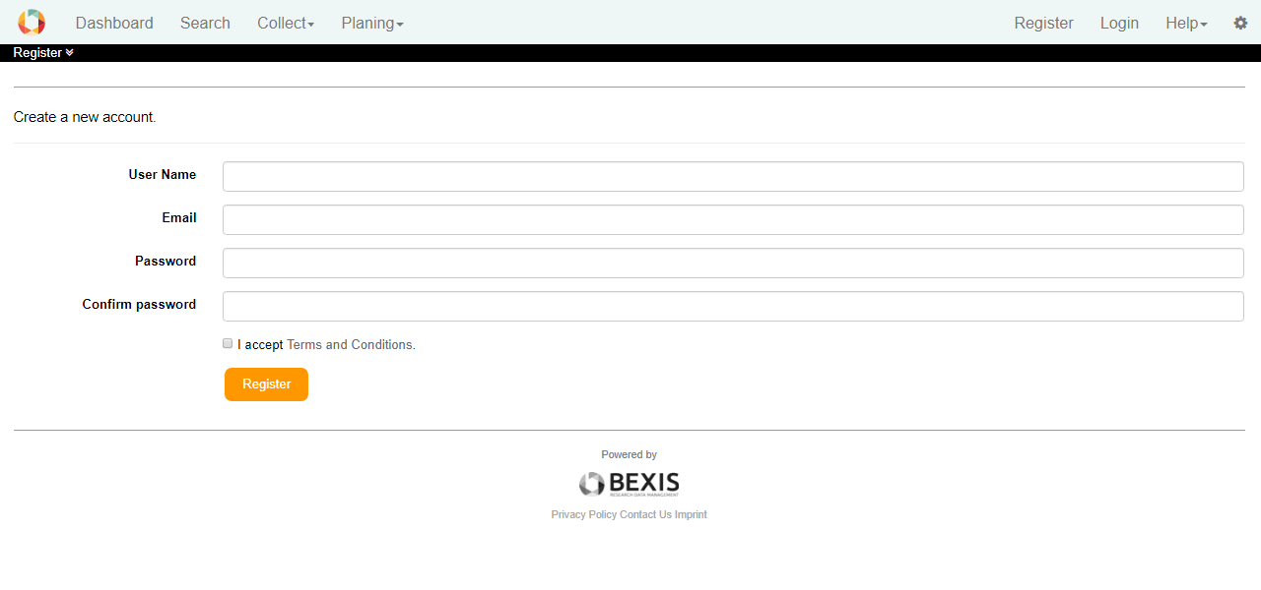

You need to enter your information in all required fields and accept **Terms and Conditions** to complete your registration. Then you are able to login to the BEXIS2 application through Login page.

Note: If you did not install the BEXIS2 by yourself and you registered only to use this application, please contact the administrator to give you rights. If not, follow the next section to set up the Feature Permissions.

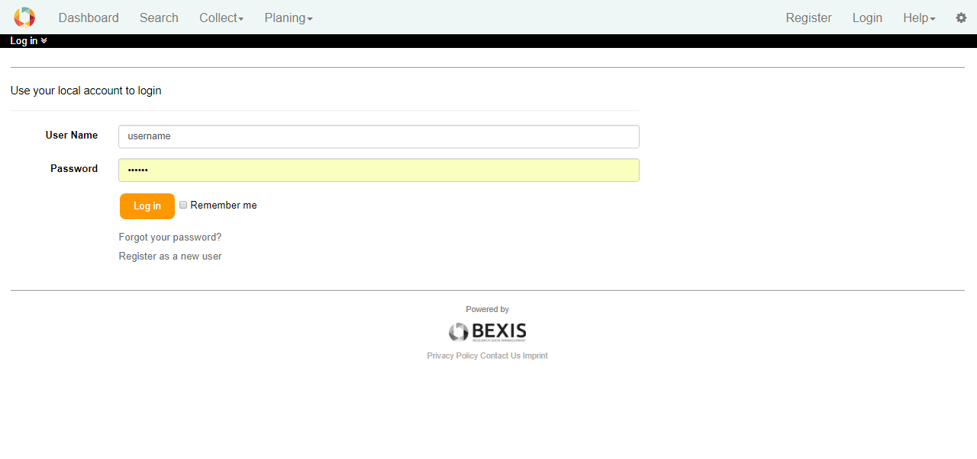

# Future Permissions

This is the first step administrative After Login. You need to set the Feature Permissions to use functions on BEXIS2. Your access to the pages for which you have no authorization to perform the function denies. You can find Feature Permissions manager under **Setup > Feature Permissions**. You may grant or deny permissions for individual users or groups using the radio buttons.

**Pay attention on Features Permissions option!** Once your access to the Feature Permissions option will denied you have no more access to the Feature Permission manager. It means you will not able to set permissions for yourself or other users or groups.

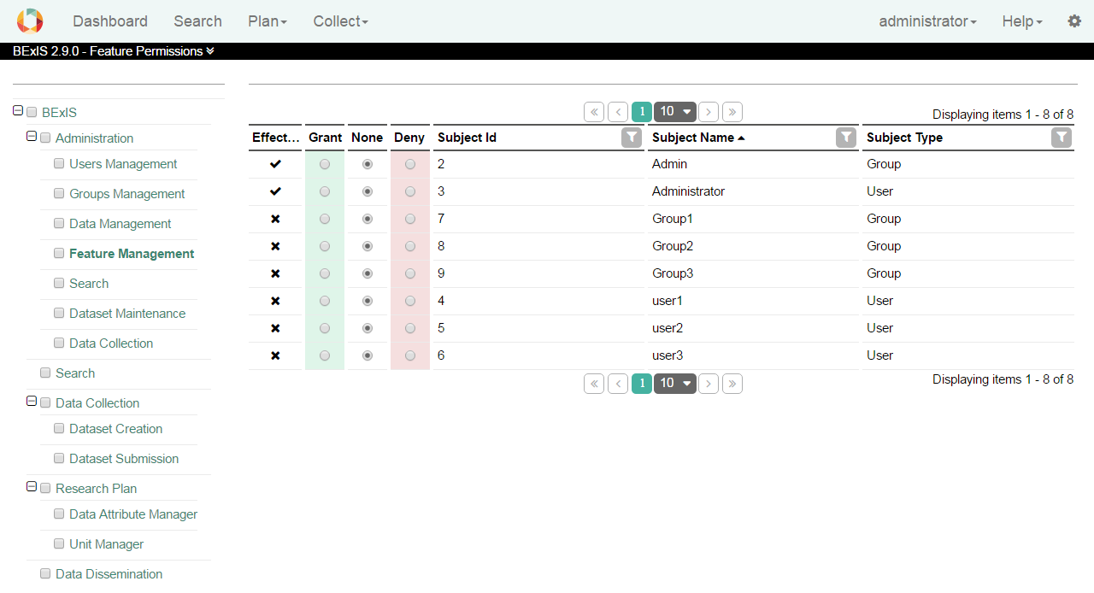

# Upload Data

Upload data into the BEXIS2 is possible in different ways:

* Push Big File
* Import Data
* Upload File Data
* Upload Tabular Data

## Push Big File

You can send your files to the BEXIS2 Server to use them later, when you want to upload a File Data or Tabular Data. Push Big File is find under Collect menu item. BEXIS2 supports a defined file formats with a maximum file size. You can find more details in the compatible version of DataCollection_UserGuide.

## Import Data

This is a way to upload data in BEXIS2 without spend time to define a data structure. Import Data is find under Collect menu item. More details you can find in the DataCollection_UserGuide.

## Upload File Data

Upload File Data is find in BEXIS2 under Collect > Upload Data through the meu bar. BEXIS2 accepts only supported file formats with a maximum file size. You can find details in the DataCollection_UserGuide.

To upload a File Data in BEXIS2 you need to go through following steps.

1. Create a Data Structure with the File Data Format (see **DataPlanning_UserGuide**).
2. Create a Dataset related to that Data Structure (see **DataCollection_UserGuide**).
3. Upload Data

## Upload Tabular Data

Upload a dataset in BEXIS2 is more efficient and you need much time consume to preparation. Upload Tabular Data is find through Collect > Upload Data and details you can find in the DataCollection_UserGuide.

To upload a Tabular Data in BEXIS2 you need to go through following steps.

1. Analyze your dataset and find if all variables that you need are exist. Create a new Variable Template if you need (see DataPlanning_UserGuide).
2. Create a Data Structure with tabular data format (see DataPlanning_UserGuide).
3. Create a Dataset and connect it to the data structure, which you earlier created (see DataCollection_UserGuide).
4. Upload Data to the dataset, which you earlier created (see DataCollection_UserGuide).

# Entity Permissions

After upload your dataset you may need to manage the rights of Read, Download, Write, delete and Grant for other users or groups. Through **Setup > Entity Permissions** you can do such management. Define permission status regarding the selected Dataset. (See **SystemAdmin_UserGuide**).

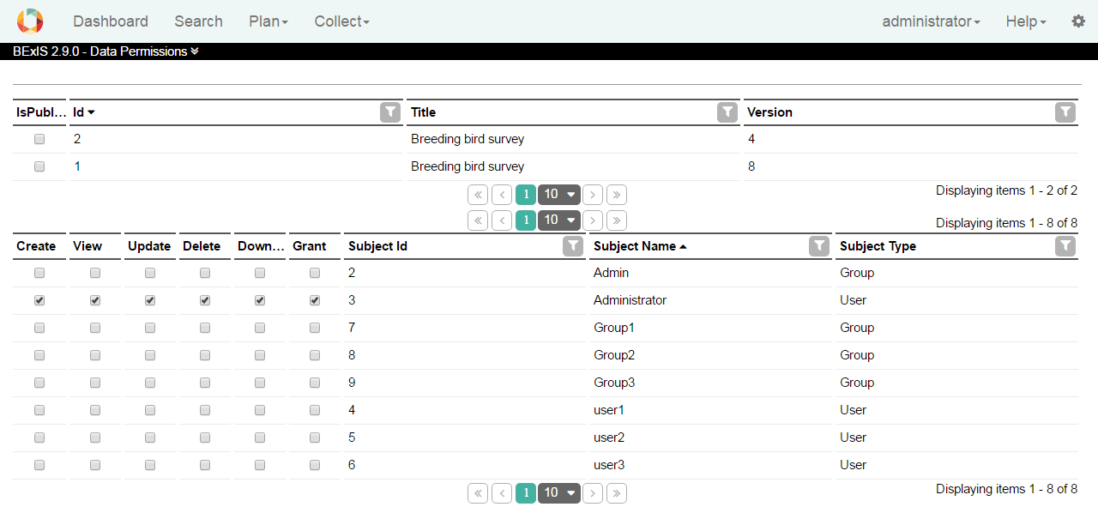

# Dashboard

While you have at least one of the Read, Download, Write, Delete or Grant permission for a dataset, it appears in your Dashboard.

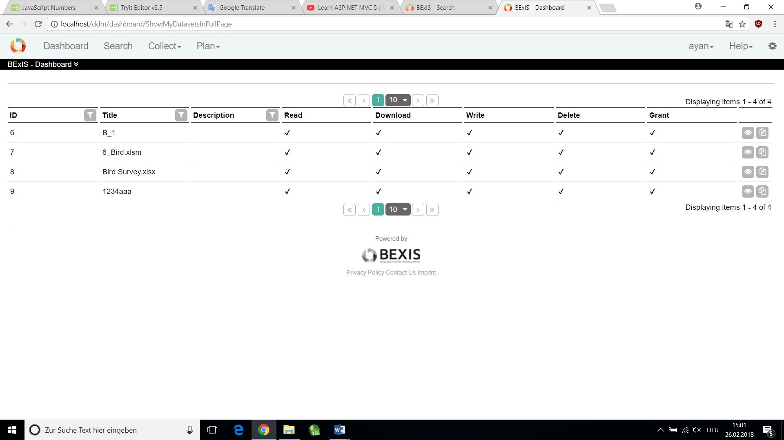

# Search

# 8.1 Search UI

Search UI contains some parts to make search easier (See **BEXIS2111_SearchUI_UserGuide**).

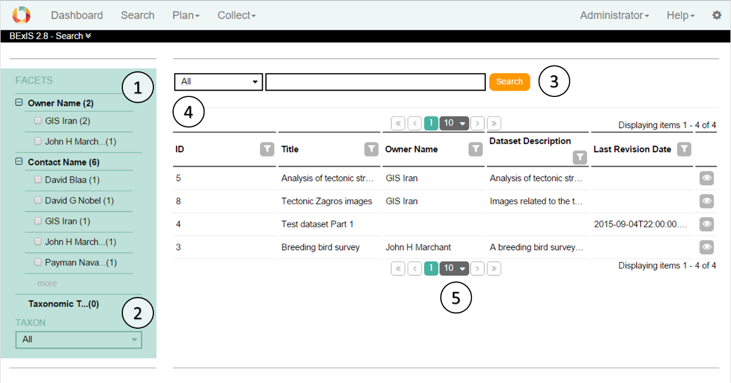

# 8.2 Search Manager

you can make search UI more operative. This part is available from **Setup > Manage search**.

You can add a new search component (Create Search Attribute button), also use  for edit and  for delete a search component.

