BExIS 2.5.0

Data Dissemination Manual

Content

Overview 3

# Overview

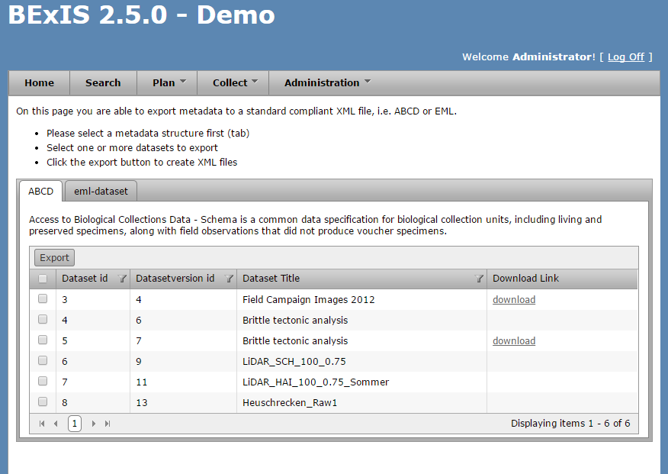

* Export the metadata of a dataset to a standard like ABCD or eml.
* For every metadata structure in the system there is one tab in the tab strip.
* The data grid in one tab is showing all datasets belongs to the selected metadata structure.
* With selecting the checkbox you mark the datasets you want to export.
* Select the export button to export.
* After successful conversion for each data set is a link here for download.