BEXIS 2.5.0

Data Planning Module

*User Guide*

***Authors***

Martin Hohmuth, Roman Gerlach

***Contact***

Website: <http://fusion.cs.uni-jena.de/bexis>

Email: bexis-support@uni-jena.de

Phone: +49-(0)3641-948968

***Acknowledgement***

The development of the BExIS 2.4.0 software would not be possible without the German Science Foundation (DFG) funding the BExIS++ project. BExIS++ is a collaboration of the Friedrich-Schiller-University Jena, Germany (Dept. of Computer Science, Dept. for Geography, Dept. of Ecology) and the Max-Planck-Institute for Biogeochemistry Jena, Germany.

**Overview**

In BExIS your data is stored and managed as part of a dataset. A dataset may be anything from a single record up to a collection of millions of records and multiple variables. Each dataset may have an individual structure given by the number of variables and their properties. It is up to the user or the data manager of a project to define such Data Structures. This is what the Data Planning Module is for.

The module is called “Data Planning” since it is good practice to specify the Data Structure before collecting your data in the field or the laboratory. Your data can only be uploaded to the system (using the Data Collection Module) if there is a corresponding Data Structure already existing.

A Data Structure contains one or more Data Attributes. Each Data Attribute is defined by its Data Type, a Unit, and a unique name. So defining Data Types and Units would be the first step, if they are not available yet. In a typical project scenario, the responsible data(base) manager would have created the most common Data Types and Units.

The system encourages reuse of Data Attributes, as well as Data Types and Units. For example, there should be only one Data Attribute for temperature values with a Data type of ‘float’ and measured in degree Celsius (i.e. unit). All datasets containing such temperature measurements should use this data attribute in there data structure. The advantage of such reuse is not only to avoid redundancy (e.g. different names for same thing), but is foremost to enable integration of identical variables across different datasets for large synthesis tasks later on.

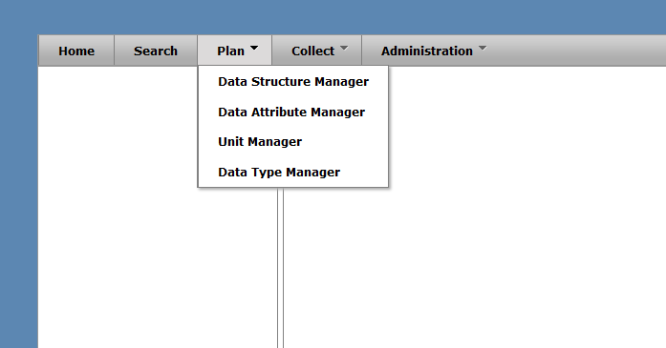

**Data Type Manager**

With the Data Type Manager you are able to create, modify and delete Data Types. They are required to specify Data Attributes.

**Create a Data Type**

* Open **Plan Data Type Manager**
* Click on the **Add Data Type** button

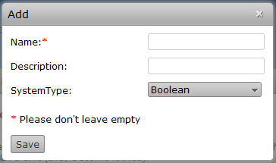

* Fill the **Name** and the **Description** field
* Choose **System Type** (is Data Type used form the System to Store values of the Data Attributes using this Data Type)
* Click **Save button**
* The Data Type is stored if all information are correct and it is not a duplicate

**Edit/Delete a Data Type**

* Open **Plan Data Type Manager**
* To delete a Data Type click the delete button or the edit button for editing
* For editing a Unit follow steps 3 – 6 from **Create a Data Type** part

**Unit Manager**

With the Unit Manager you are able to create, modify and delete Units. Units may be required to define Data Attributes.

**Create a Unit**

* Open **Plan Unit Manager**
* Click on the **Add Unit** button

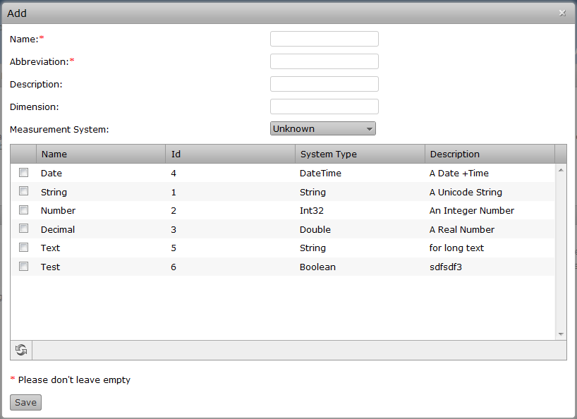

* Fill the **Name, Abbreviation, Description, Dimension** fields
* Choose **Measurement System** and **Associated Data Types** (optional)
* Click **Save button**
* The Unit is stored if all information are correct and it is not a duplicate

**Edit/Delete a Unit**

* Open **Plan Unit Manager**
* To delete a Unit click the delete button or the edit button for editing
* For editing a Unit follow steps 3 – 6 from **Create a Unit** part

**Data Attribute Manager**

With the Data Attribute Manager you are able to create, modify and delete Data Attributes. Data Attributes are required to create Data Structures.

**Create a Data Attribute**

* Open **Plan Data Attribute**
* Click on the **Add Data Attribute** button

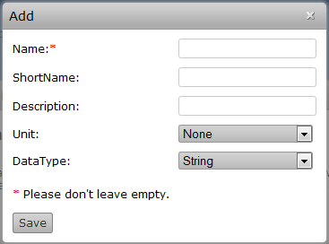

* Fill the **Name, Short Name** and the **Description** field
* Choose a **Unit** and a **Data Type**
* Click **Save button**
* Data Type is stored if all information are correct and it is not an duplicate

**Edit/Delete a Data Type**

* Open **Plan Data Attribute**
* To delete a Data Attribute click the delete button or the edit button for editing
* For editing a Unit follow steps 3 – 6 from **Create a Data Attribute** part

**Data Structure Manager**

The Data Structure Manager is a tool to create, modify and delete Data Structures. Data Structures contain Variables, which are specific instances of Data Attributes. For example, only one Data Attribute ‘Count’ is needed to build a Data Structure of multiple similar variables where only the name (e.g. species name) is different. Each Variable uses the same Data Attribute (e.g. instances of Count). It is possible to create Data Structures for structured data (Excel tables, CSV-Files, ... ) and for unstructured data (images, videos, ...)

**Create a Data Structure**

* Open **Plan Data Structure Manager**
* Choose **Create Structured** or **Create Unstructured**

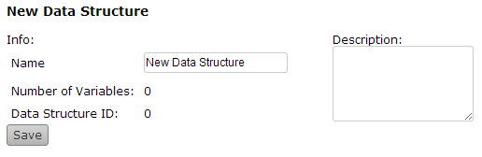

* Type the Name of your Data Structure in the **Name** field and a Description in the **Description** field
* Click the **Save** button

**Add a Variable to a Data Structure**

* Open **Plan Data Structure Manager**
* Select a Data Structure from the **tree** on the Left side

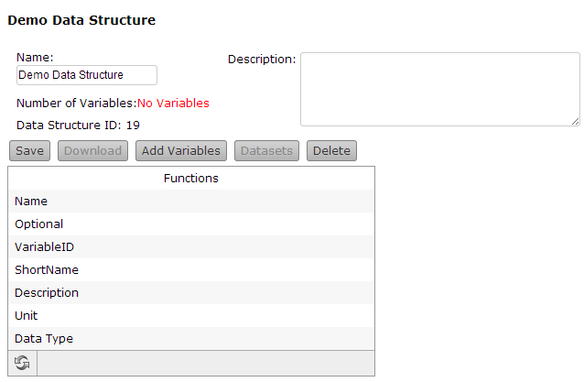

* Click the **Add Variable** button

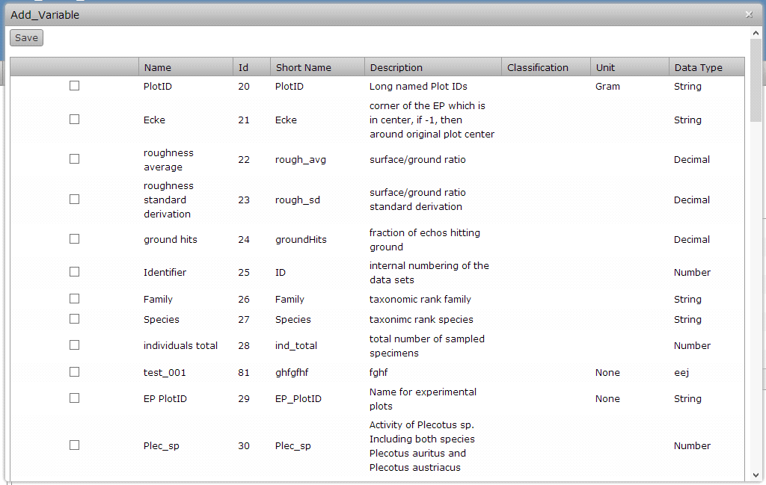

* Mark all **Attributes** you want to add an click the **Save** Button (to add one Attribute multiple times just repeat step 3 and 4)

**Edit/Remove a Variable**

* Open **Plan Data Structure Manager**
* Select a Data Structure from the **tree** on the Left side
* To delete a Variable click the delete button or the edit button for editing (the Variable is deletable/editable if the Data Structure is not used by an Dataset)

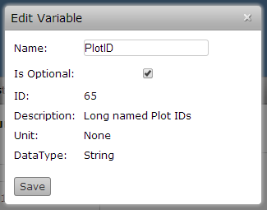

* If you use one Attribute multiple times you should change the name of the Variable and click Save

**Delete a Data Structure**

* Open **Plan Data Structure Manager**
* Select a Data Structure from the **tree** on the Left side
* Click the **Delete** button (the Data Structure is deletable if the Data Structure is not used by an Dataset)