BExIS 2.5.0

Search UI Manual

Content

Overview 3

Data Details 4

# Overview

## 

1. **Categories**   
   The main nodes like “Project Name” are based on nodes in the metadata. The elements are values in the metadata from a main node and can be used to restrict the current selection. The numbers next to the elements and main nodes show the number of existing data sets in the database. This list changes according to the current selection. After selection the results and the facets updated. With the “more” button it is possible to select more than on element at the same time.
2. **Properties**In this section there are predefined UI Components like dropdown, radio button or slider to filter the data. There is only one possible choice for every component. After selection the results and the facets are updated accordingly.
3. **Free text search with Autocomplete**

The free text search works as in any common search engine (e.g. Google, Yahoo). It includes Autocomplete where words or phrases are being predicted once three letters or figures are entered. It supports also different languages (currently English and German).

1. **Selected Filter**

Every filter applied from section 1-3 is displayed here. Filters can be deselected just by clicking on it. In point 1 by the categories you are able to select more than one option to a category. If there are more than 2 you will see only the category. Click on the category and a window will open to define your selection for this category.

1. **Results**

The matching results are displayed in a table or in the list view. To change the view click the change result view button. Basic functions like sorting, filtering, paging are available in the table header. Additionally you are able to group columns by dragging a column to the top of the table.  
The details button opens the detailed view of the selected data set.

# Data Details

1. **Meta Data**

On this tab you have access to the meta data of the selected datasets.

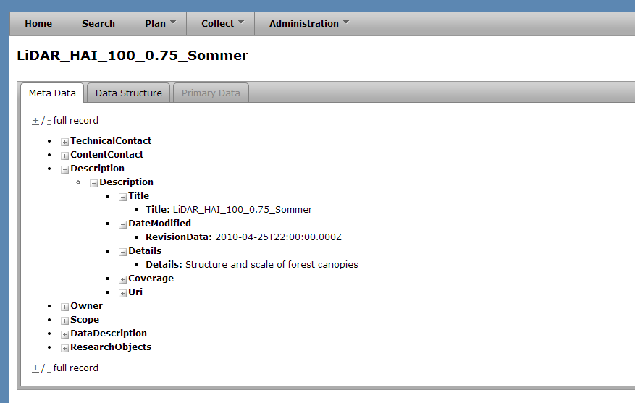

1. **Data Structure**

On this tab you have access to the data structure of the selected datasets.

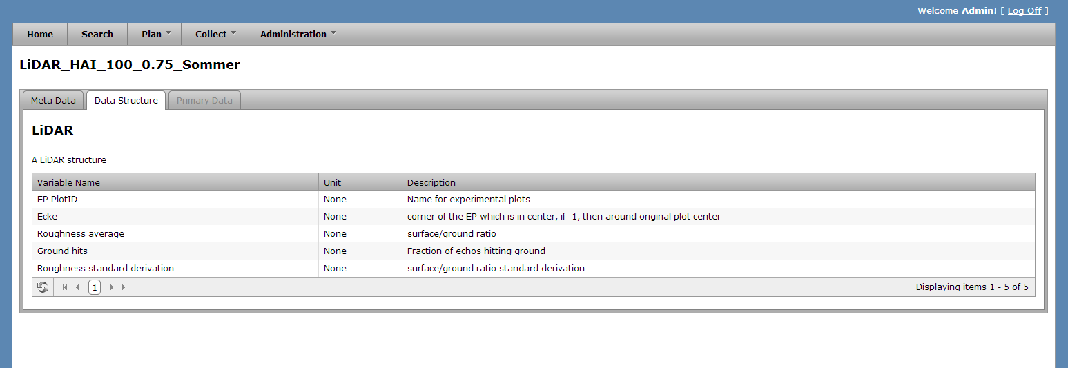

1. **Primary Data**

On this tab you have access to the primary data of the selected datasets.  
The data can be filtered and adjusted as desired. You can also hide or add columns.   
Download the data in Excel or csv, filtered or all.

