BEXIS 2.5.0

Security System

User Guide

Authors

Sven Thiel, Roman Gerlach

Contact

Website: <http://fusion.cs.uni-jena.de/bexis>

Email: bexis-support@uni-jena.de

Phone: +49-(0)3641-948968

Acknowledgement

The development of the BExIS 2.5.0 software would not be possible without the German Science Foundation (DFG) funding the BExIS++ project. BExIS++ is a collaboration of the Friedrich-Schiller-University Jena, Germany (Dept. of Computer Science, Dept. for Geography, Dept. of Ecology) and the Max-Planck-Institute for Biogeochemistry Jena, Germany.

Table of Contents

Introduction 3

Account 4

Registration 4

LogOn 4

Users 6

Creation 6

Deletion 7

Details 7

Groups 11

Creation 11

Deletion 11

Details 12

Permissions 16

Features 16

Feature Permissions 17

Data 19

Dataset Permissions 20

Introduction  
  
**Caution! Do not delete the preset user and group!**

*Users*. There is just a single user inside the database. The user name is “Administrator” with the password “gWg2xG”. By default, this user has full access to the whole application (because of the relationship to group “Admin”, see next paragraph).

*Groups*. Similar to *Users*, there is just one group inside the database – and the group name is “Admin”. In addition to that, the user “Administrator” belongs to that group. By default, this group grants full access to the application by several pre-defined permissions.

*Authenticators*. In addition to the internal authentication provider, the application supports AD and LDAP as authentication services. Unfortunately, there is no user interface available in version 2.5.0.

*Features.* The set of features is fixed and corresponds to the different hierarchical items of the menu bar.

*Permissions*. Within the system, it is possible to add, remove or modify existing permissions on features and datasets.

# Account

By default, only a few components of BExIS are accessible for anonymous users. Any further access to the application is available for authorized users, only. Therefore you need to register and create an account. After a successful registration you are able to logon to BExIS using your account credentials for authentication.

## Registration

First press **[ Register ]** in the upper right corner. Figure 1 shows the registration form. You have to complete the form before you press Register, otherwise the registration will fail. Furthermore, the system supports you with different validation messages if any information is not valid.

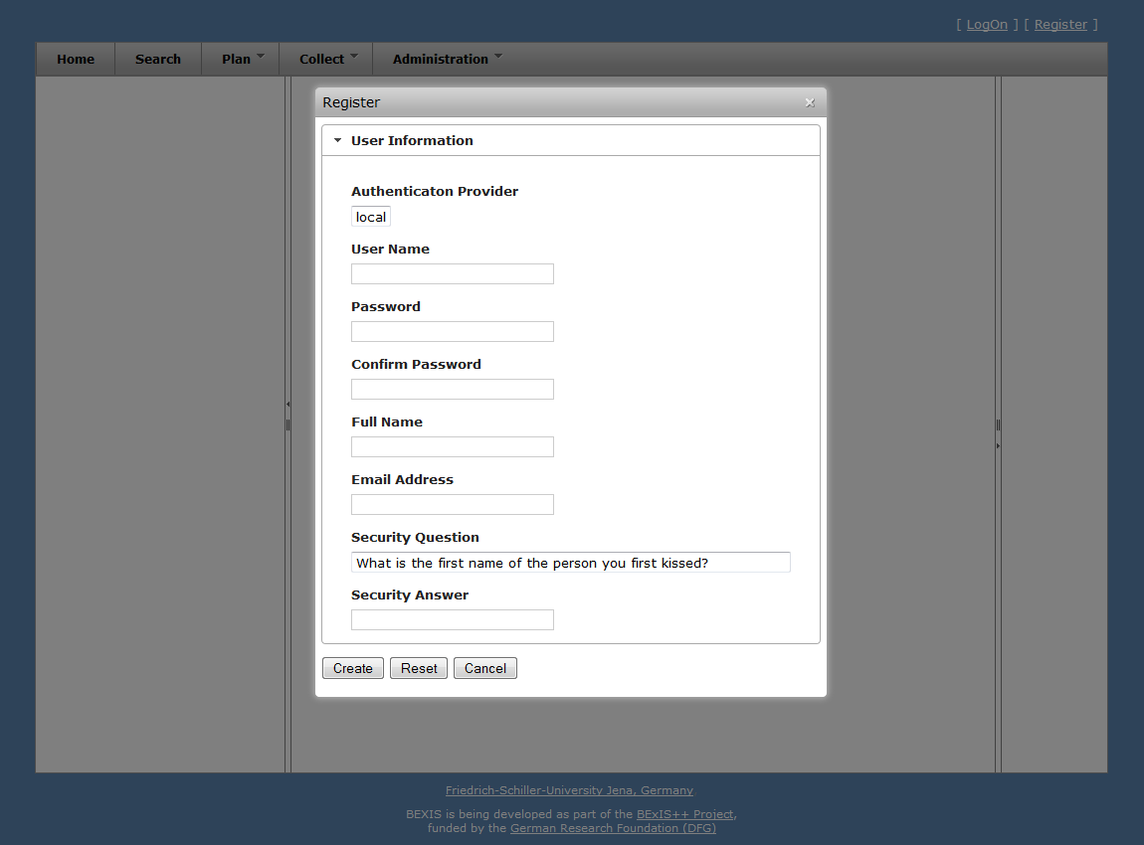

Figure 1

## LogOn

First press **[ LogOn ]** in the upper right corner. The system redirects you to the logon form (see fig 1) and you have to enter your account credentials (user name and password). If the logon is successful, you will see a short welcome message instead of **[ LogOn ]**. Otherwise, the system will notify you about the status and reason why the logon was not successful.

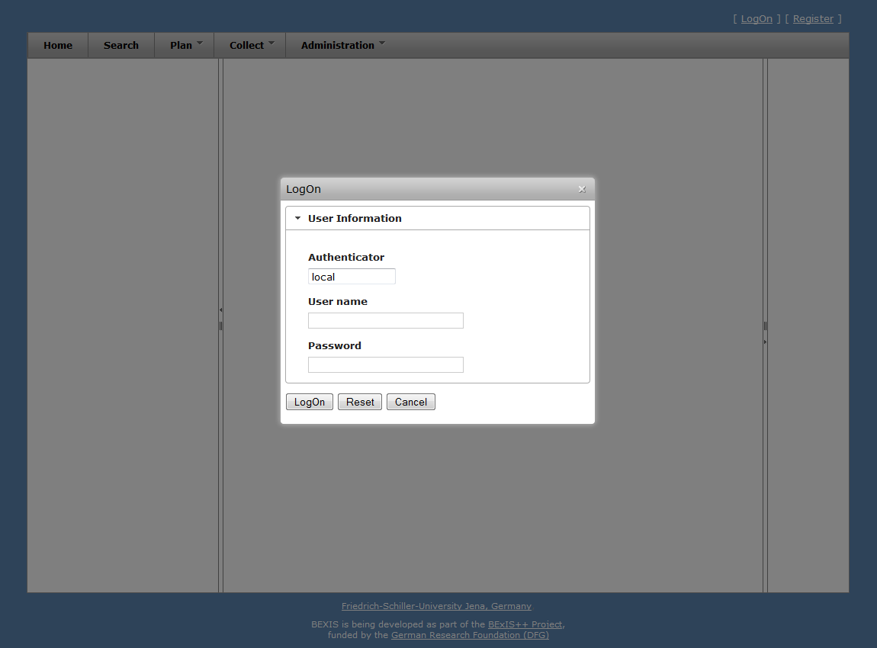

Figure 2

# Users

**Caution! This part of the system is secured. You may not have access to it.**

BExIS provides different features for managing users. These are typically available to system administrators only. Each of them is described in more detail in one of the following subsections.

## Creation

In addition to the self-registration procedure, user accounts may also be created by an administrator. This feature is available from **Administration > Authorization > Users**. Please press the **+New User** button. A modal window will pop up that contains the user creation form (see fig 3). Similar to the self-registration, the system supports you with validation on all information entered.

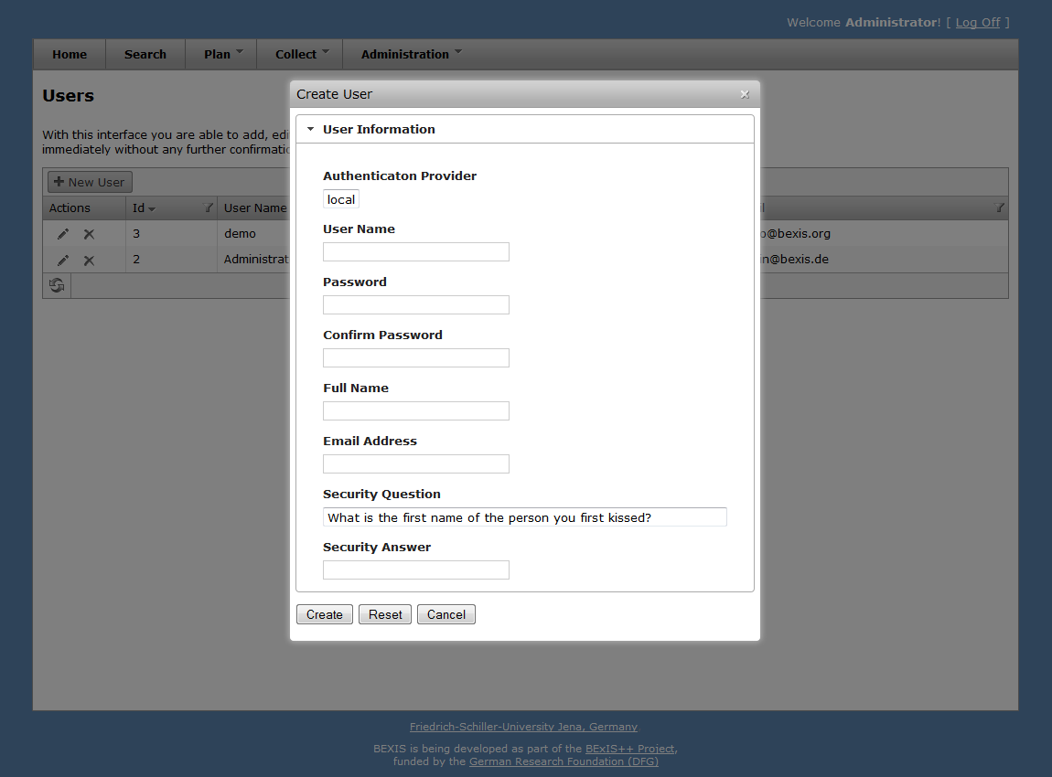

Figure 3

## Deletion

Please go to **Administration > Authorization > Users** and press the delete button of the corresponding user. Figure 4 shows the modal window that will pop up after pushing the button. The deletion will be confirmed by clicking the **OK** button.

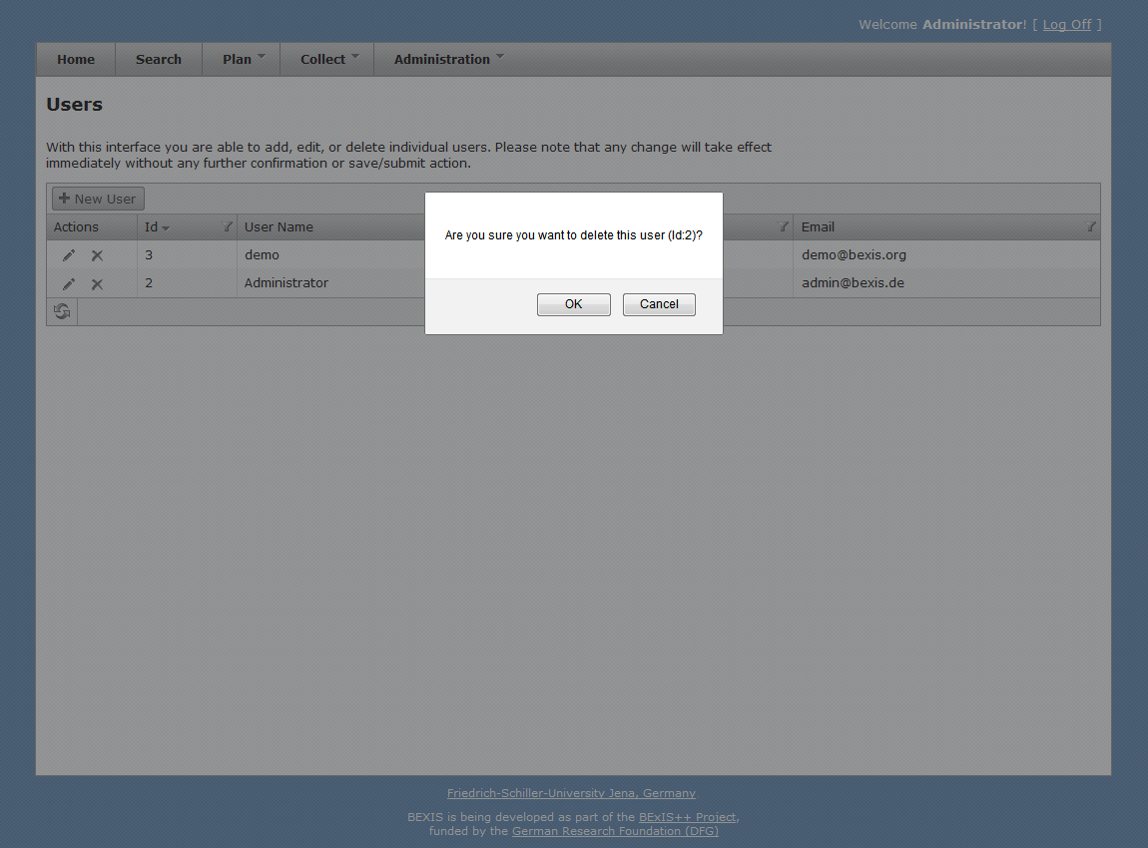

Figure 4

## Details

Within BEXIS you are able to display and modify user information (see fig 5 and fig 6). For security and usability reasons, the system allows modification only for certain parts of the user information. Please go to **Administration > Authorization > Users** and press the details button of the respective user. By default, the modal window only shows the user information. To enable the edit mode, please press the **Edit** button. You are now able to alter the user information. Changes are committed to the system once you pressed the **Save** button.

For any given user memberships to certain groups need to be specified. Please go to **Administration > Authorization > Users** and press the details button of the respective user. Within the modal window please select the tab **Membership** (see fig 7). There are two different states:

user is in group 🡪 checkbox selected

user is NOT in group 🡪 checkbox NOT selected

You can change the status easily by (un)select the corresponding checkbox.

Furthermore, the system supports you for all mentioned features with different validation messages if any status or information is not valid.

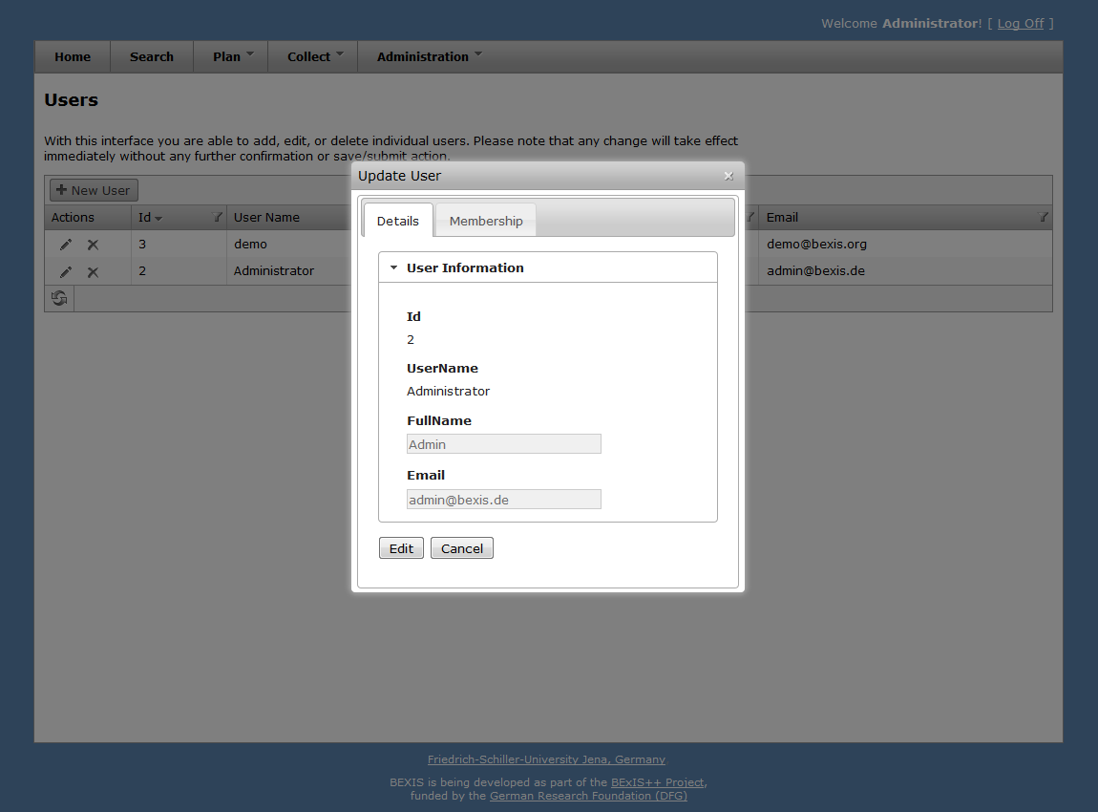

Figure 5

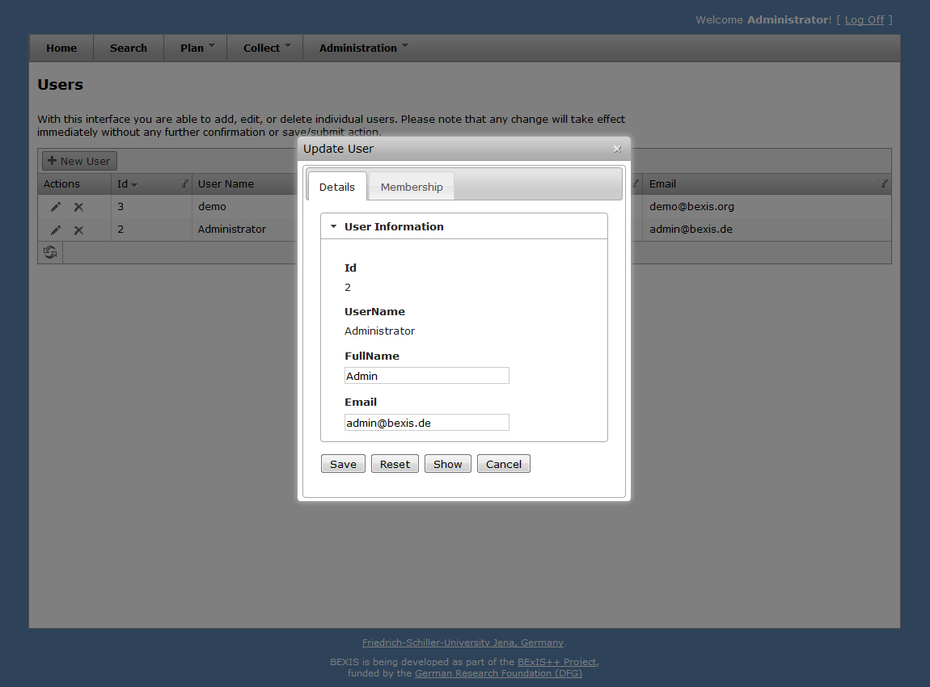

Figure 6

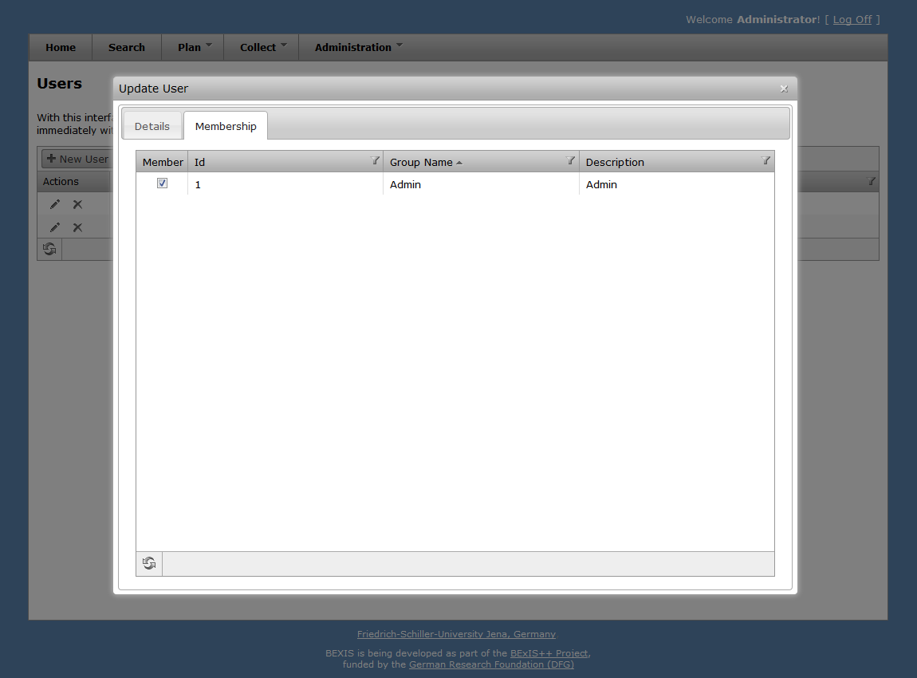

Figure 7

# Groups

**Caution! This part of the system is secured. You may not have access to it.**

BExIS provides different features for the managing groups. They are typically available to system administrators only. Each of them is described in more detail in the following subsections.

## Creation

To use this feature, This feature is available from **Administration > Authorization > Groups**. Please press the **+New Group** button. A modal window will pop up that contains the group creation form (see fig 8). The system supports you with validation on all information entered.

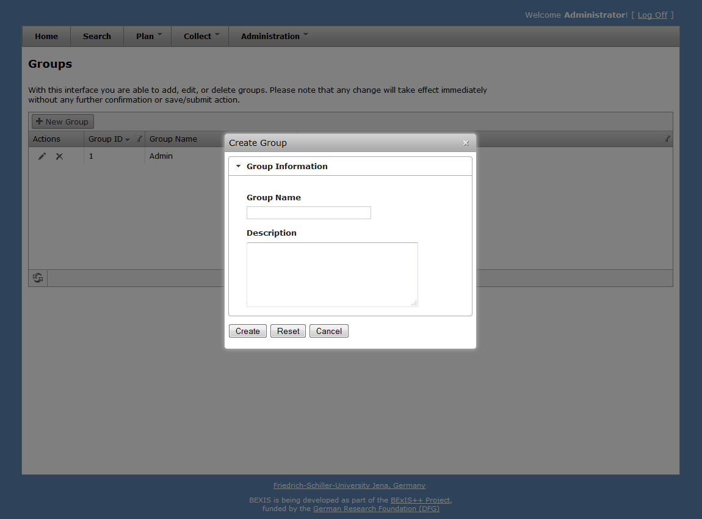

Figure 8

## Deletion

Please go to **Administration > Authorization > Groups** and press the delete button of the corresponding group. Figure 9 shows the modal window that will pop up after pushing the button. The deletion will be confirmed by clicking the **OK** button.

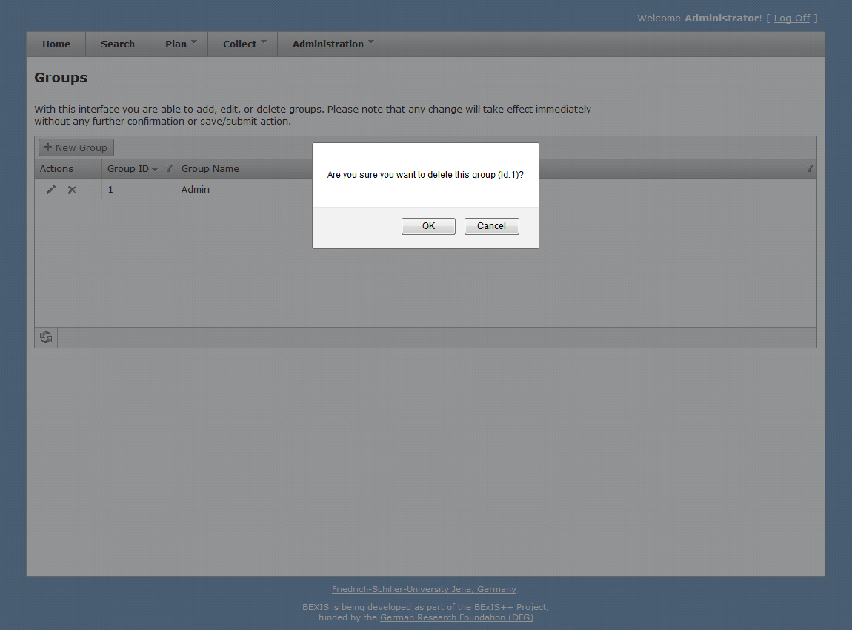

Figure 9

## Details

Within BExIS, you are able to display and modify group information (see fig 10 and fig 11). Please go to **Administration > Authorization > Groups** and press the details button of the respective group. By default, the modal window only shows the group information. To enable the edit mode, please press the **Edit** button. You are now able to alter the group information. Changes are committed to the system once you pressed the **Save** button.

For any given group memberships of users need to be specified. Please go to **Administration > Authorization > Groups** and press the details button of the respective group. Within the modal window please select the tab **Membership** (see fig 12). There are two different states:

user is in group 🡪 checkbox selected

user is NOT in group 🡪 checkbox NOT selected

You can change the status easily by (un)select the corresponding checkbox.

Furthermore, the system supports you for all mentioned features with different validation messages if any status or information is not valid.

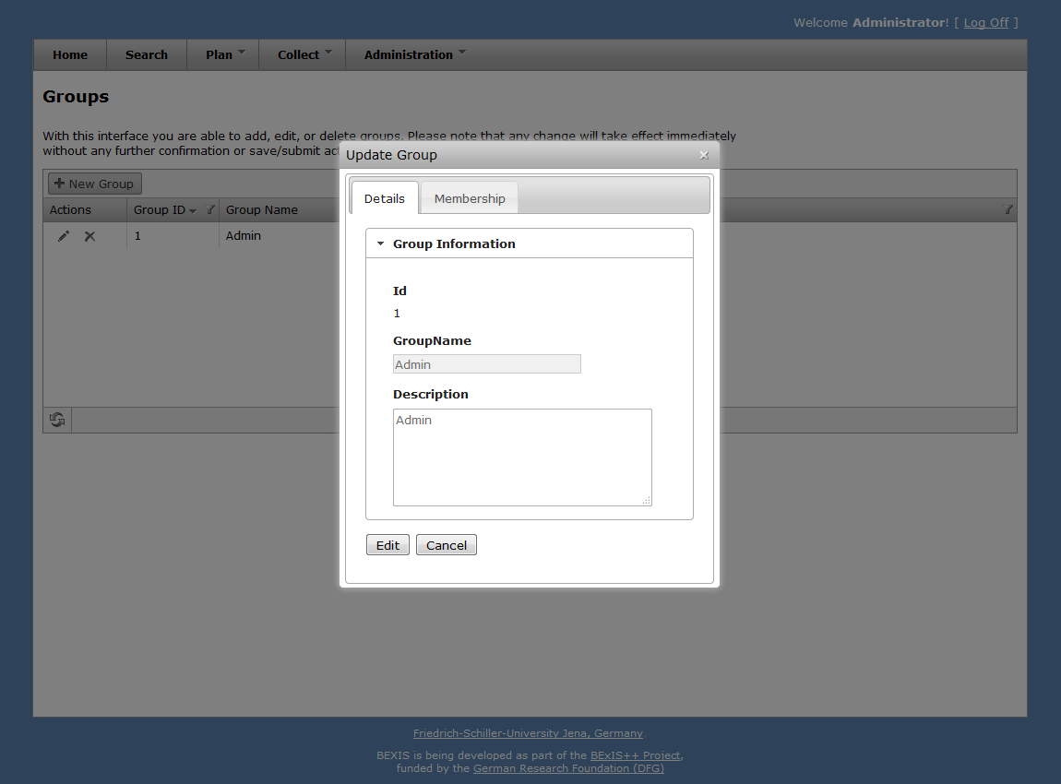

Figure 10

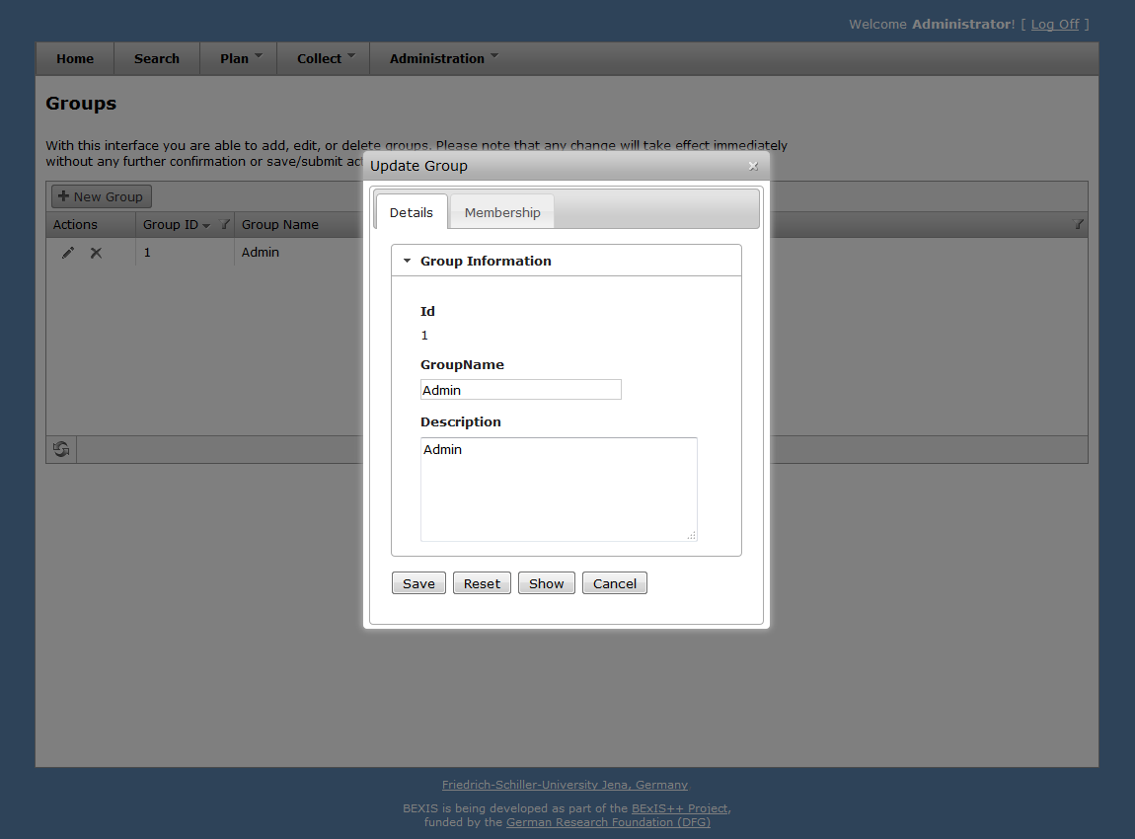

Figure 11

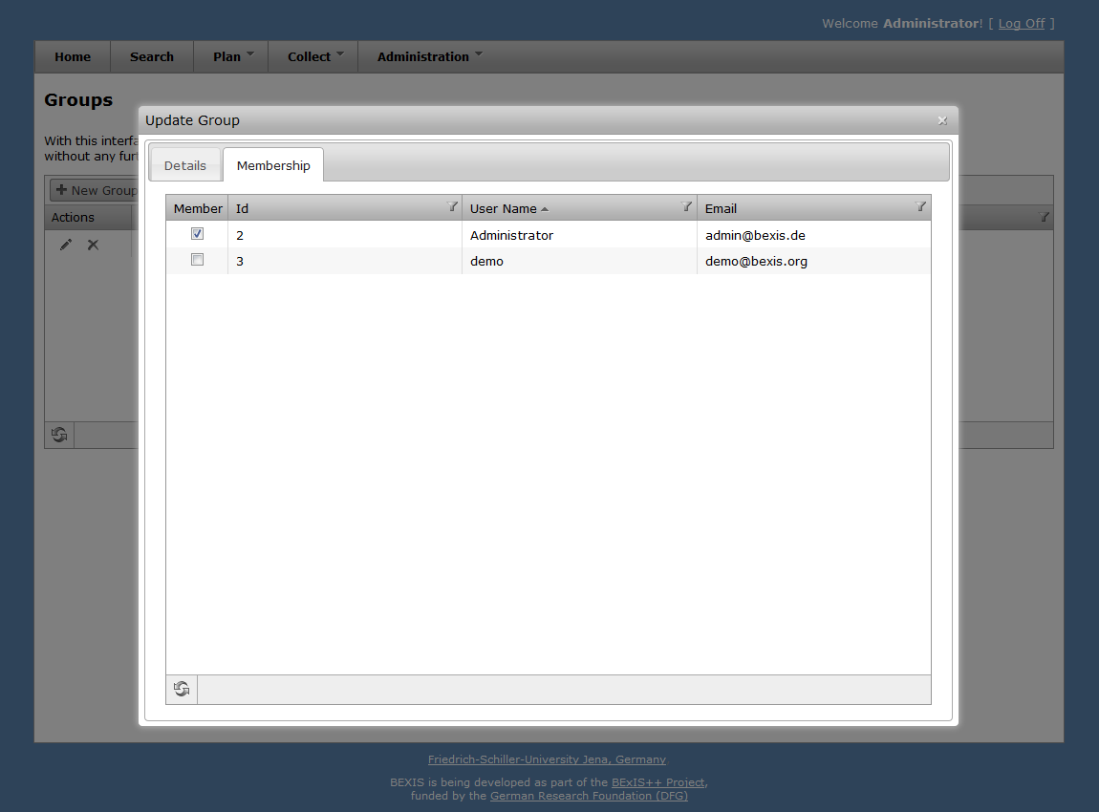

Figure 12

# Permissions

**Caution! This part of the system is secured. You may not have access to it.**

A permission is a rule that contains certain security regulations. In general, it is possible to set a rule on both, users and groups.

The security system of BExIS distinguishes between two types of permissions. On the one hand, there are feature permissions, which allow or prohibit the access to well-defined and delimited areas of the application. This type of permissions is working on functional objects (e.g. actions that should be performed) – so called *Features*. On the other hand, data permissions provide the ability to protect real data (e.g. datasets, research plans and so on). However, data permissions are not implemented yet.

## Features

Currently, features are fixed. It is not possible to add, edit or remove features. Furthermore you are not able to change well-defined and delimited area of a feature, e.g. cannot add “Search” into the feature “Administration”. The feature tree is predefined, but later on, the administrator will be able to modify features also. Nevertheless, BExIS provides a tree that shows all features and their hierarchical relationship (parent /children). Therefore, please go to **Administration > Authorization > Features Manager**. This will bring up a page with the mentioned tree on the left side (see fig 13).

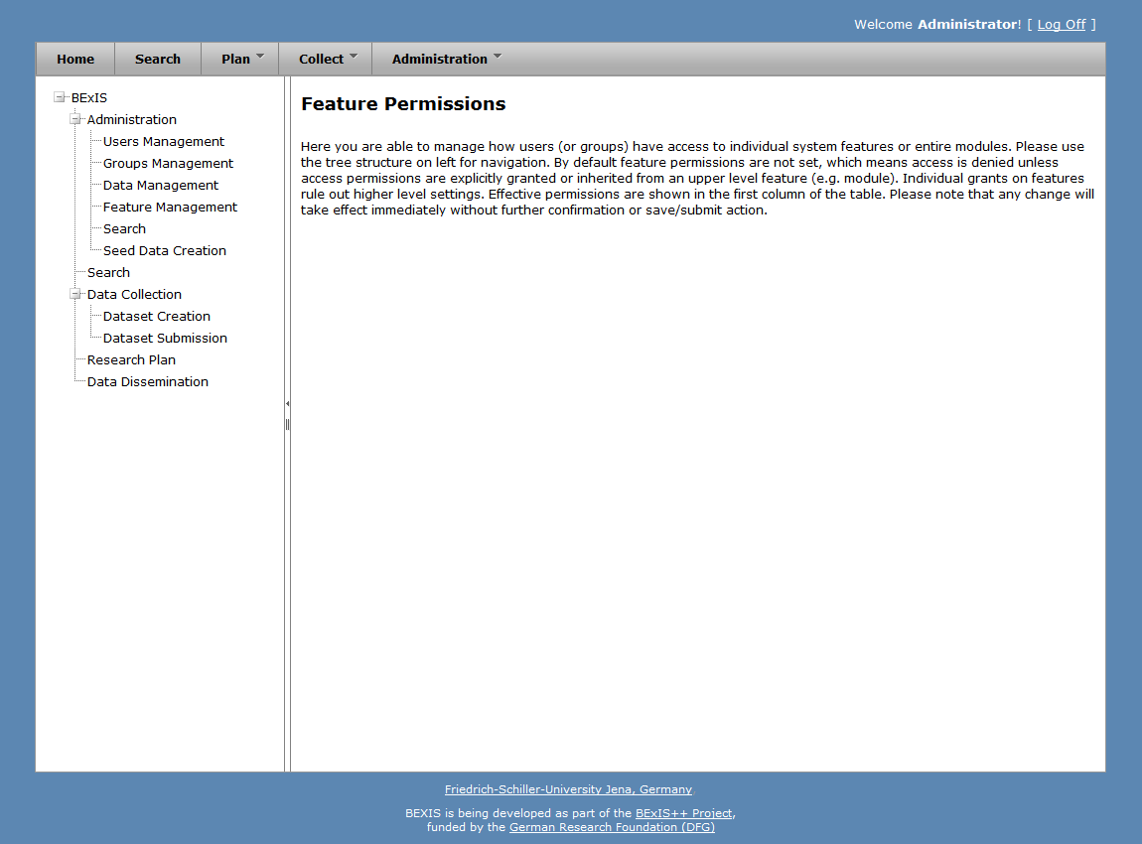

Figure 13

## Feature Permissions

BExIS provides a user-friendly interface to manage feature permissions (**Administration > Authorization > Features**)**.** As depicted in fig. 13 features are organized in a tree. By selecting a feature on the left side (one node of the tree), the system will show a table on the right side, which contains all subjects (users and groups) and their feature permission type (see fig 14). In total, there are three different types of feature permissions:

* Grant: allow access
* None: revoke permission
* Deny: prohibit access

Each type is marked with a distinct color (see fig 14). On this page, you are also able to alter all permissions for the selected feature.

For each user access request to the application, the security system must allow or deny the access. This decision is called *effective right* and it is calculated with the help of a security policy. In general, BExIS provides a set of different security policies from which one can be selected. Each of them contains specific rules, e.g. how to decide if there is no feature permission for a given user. Currently, the system works with a default and fixed security policy. This one uses the following rules for a user ***u*** and a requested feature ***f***, whereby ***r*** = {r1, …, rn} is the set of groups which ***u*** belongs to.

1. If there is a feature permission for user ***u*** and feature ***f***, then return the corresponding permission type (allow or deny). Else, go to step 2.
2. Get the list of all feature permissions for the set of groups ***r*** and feature ***f***. If there is no feature permission go to step 3. Else, if the amount of grants and denies is equal, then return the default draw permission type (deny). Else, return the permission type, which occurs more frequently (allow or deny).
3. If ***f*** has a parent feature, then go to step 1 with ***f*** = *parent(****f****)*. Else, return the default permission type (deny).

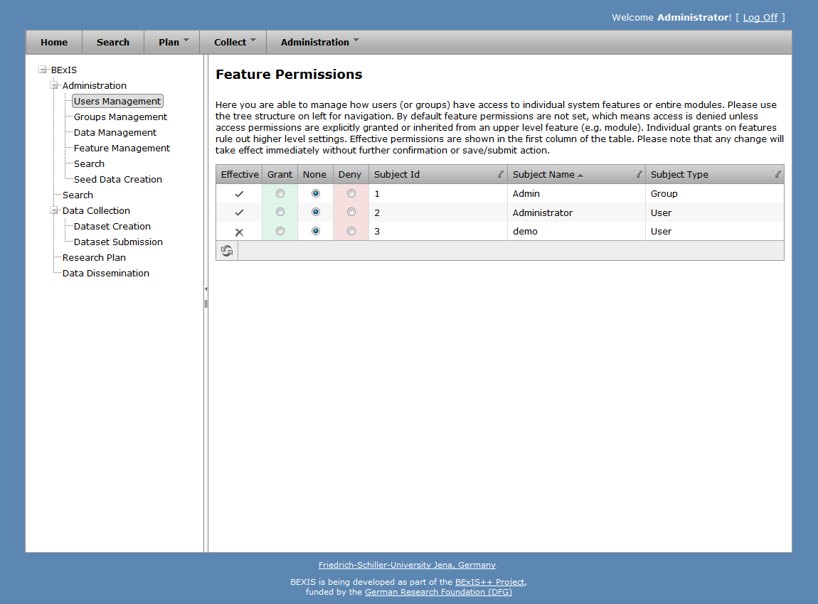

Figure 14

## Data

The security system of BExIS is working on both, functional (features) and non-functional (data) items. Basically each entity in BExIS can be considered as "data". But currently, it is only possible to manage the access of datasets. Please go to **Administration > Authorization > Datasets** if you like to manage the access. This will bring up a page with the mentioned tree on the left side (see fig 15).

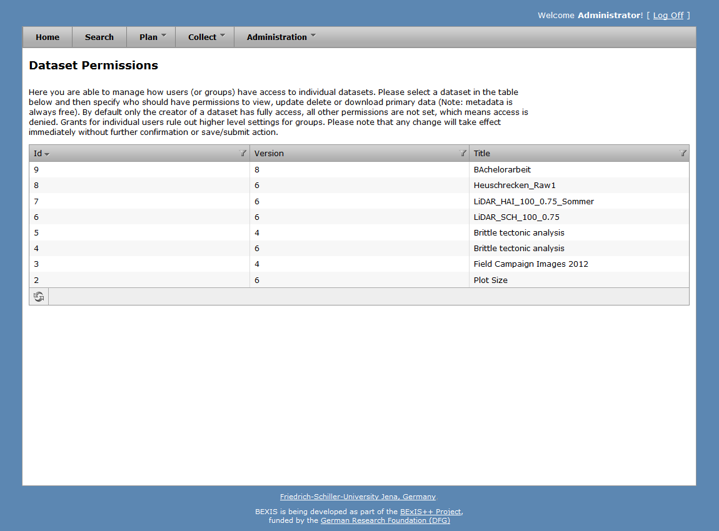

Figure 15

## Dataset Permissions

First of all, please go to **Administration > Authorization > Datasets.** This will bring up a page with a table that contains all datasets of the system (see fig 15). By selecting a dataset, the system will show a second table underneath the first one, which contains all subjects (users and groups) and their different data permission statuses regarding the selected dataset (see fig 16). On this page, you are also able to alter all different kinds of data permissions for a selected dataset.

In general, the system is working on three different data permission types. Each of them is responsible to regulate the access for specific data. In the case of datasets, this means:

* View: allow/deny access to primary data
* Update: allow/deny manipulation (upload and update) of primary data
* Delete: allow/deny deletion of the whole dataset
* Download: allow/deny the download of the whole dataset (metadata + primary data)

Currently, only ***view***, ***update*** and ***download*** are implemented. Similar to feature permissions, the security system must allow or deny the access. This decision is called *effective right* and it is calculated with the help of the security policy. In general, BExIS provides a set of different security policies from which one can be selected. Each of them contains specific rules, e.g. how to decide if there is no data permission for a given user. Unfortunately, the current system works with a default and fixed security policy. This one uses the following rules for a user ***u***, a requested dataset ***d*** and a permission type ***t***, whereby ***r*** = {r1, …, rn} is the set of groups which ***u*** belongs to.

1. If there is a data permission for user ***u*** or group ***v*** (whereby ***v $∈$*** ***r***), dataset ***d*** and permission type ***t***, then return allow. Else return deny.

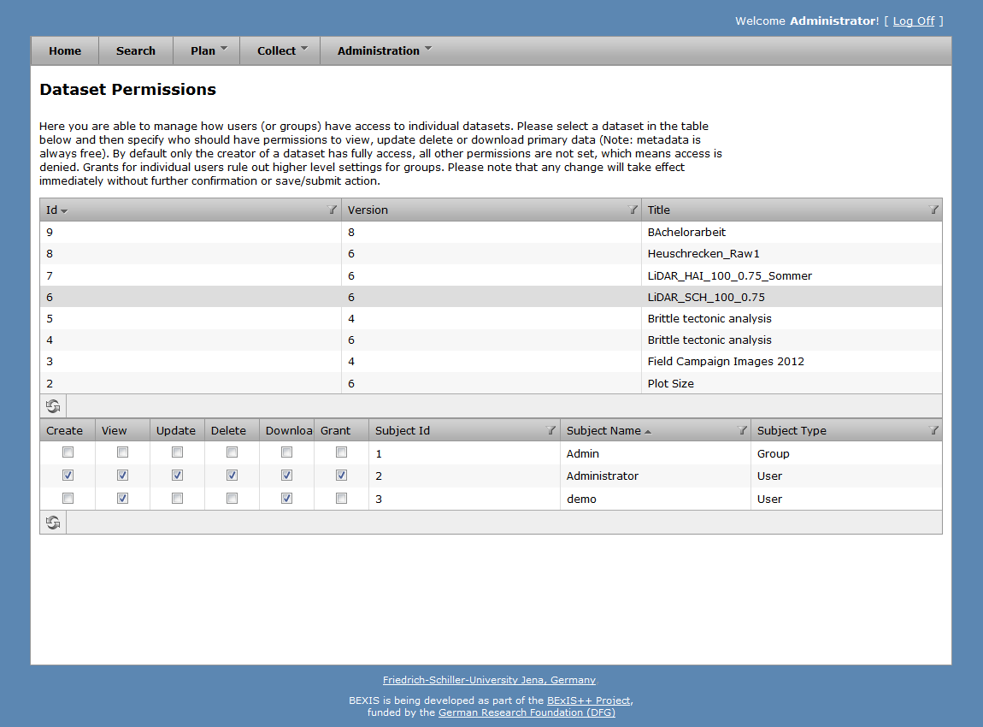

Figure 16