BEXIS 2.8.0

Data Planning Module

User Guide

***Authors***

Nafiseh Navabpour, Martin Hohmuth, Roman Gerlach

***Contact***

Website: http://fusion.cs.uni-jena.de/bexis

Email: bexis-support@uni-jena.de

Phone: +49-(0)3641-948968

***Acknowledgement***

The development of the BEXIS 2 software would not be possible without the German Science Foundation (DFG) funding the BExIS++ project. BExIS++ is a collaboration of the Friedrich-Schiller-University Jena, Germany (Dept. of Computer Science, Dept. for Geography, Dept. of Ecology) and the Max-Planck-Institute for Biogeochemistry Jena, Germany.

Contents

1. Overview 3

2. Data Type Manager 4

3. Unit Manager 5

4. Data Attribute Manager 6

5. Data Structure Manager 8

5.1. Create a Data Structure 8

5.2. Add Variables 8

5.3. Create a copy data structure 9

# 1. Overview

In BEXIS your data is stored and managed as part of a dataset. A dataset may be anything from a single record up to a collection of millions of records and multiple variables. Each dataset may have an individual structure given by the number of variables and their properties. It is up to the user or the data manager of a project to define such Data Structures. This is what the Data Planning Module is for.

The module is called “Data Planning” since it is good practice to specify the Data Structure before collecting your data in the field or the laboratory. Your data can only be uploaded to the system (using the Data Collection Module) if there is a corresponding Data Structure already existing.

A Data Structure contains one or more Data Attributes. Each Data Attribute is defined by its Data Type, a Unit, and a unique name. So defining Data Types and Units would be the first step, if they are not available yet.

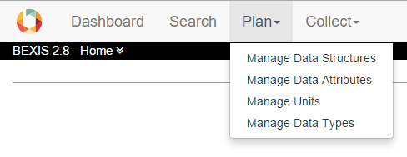

The system encourages reuse of Data Attributes, as well as Data Types and Units. For example, there should be only one Data Attribute for temperature values with a Data type of ‘float’ and measured in degree Celsius (i.e. unit). All datasets containing such temperature measurements should use this data attribute in their data structure. The advantage of such reuse is not only to avoid redundancy (e.g. different names for same thing), but is foremost to enable integration of identical variables across different datasets for large synthesis tasks later on.

# 2. Data Type Manager

With the Data Type Manager you are able to create, modify and delete Data Types. They are required to specify Data Attributes.

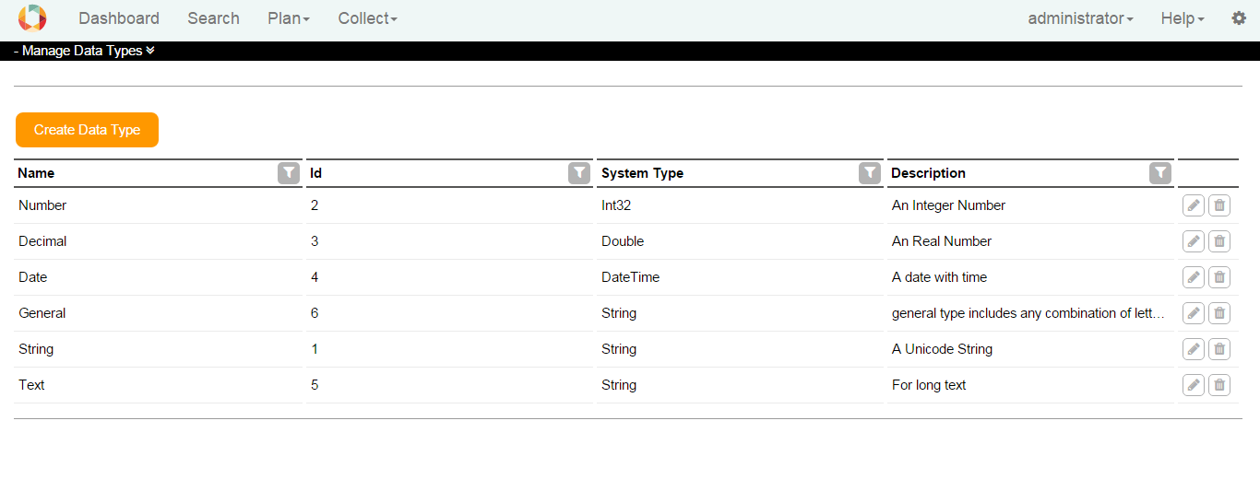

To create a Data Type, click on the Create Data Type button. Fill the fields, select a system type and click on the Save button. The Data Type is stored if all information are correct and it is not a duplicate.

Use for edit and for delete a data type.



In a typical project scenario, the responsible data(base) manager would have created the most common Data Types and Units.

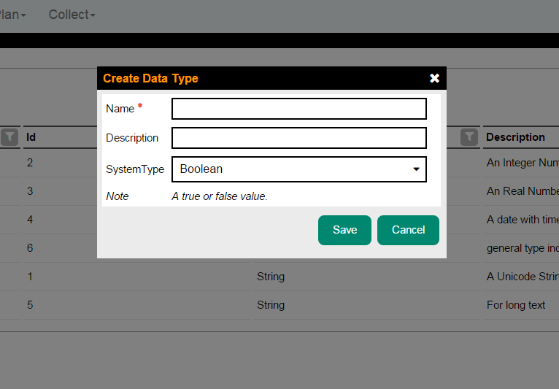

# 3. Unit Manager

With the Unit Manager you are able to create, modify and delete Units. Units may be required to define Data Attributes.

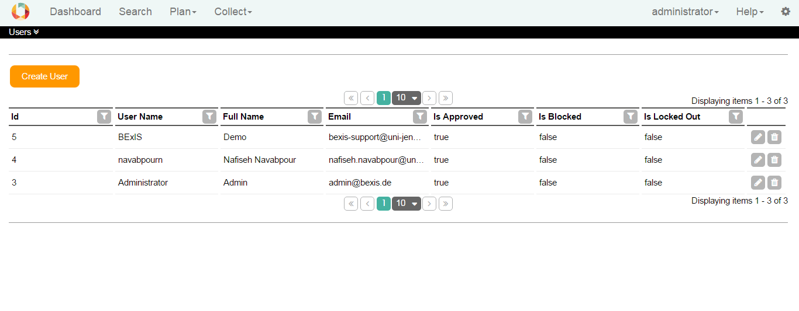

To create a Unit, click on the Create Unit button. Fill the fields, select a Measurement System and create or select a Dimension. To create a Dimension enter a Name in the Dimension Name field and edit the Dimension Specification in this pattern "L(0,0)M(0,0)T(0,0)I(0,0)Θ(0,0)N(0,0)J(0,0)", for more information click [here](https://translate.google.de/translate?sl=de&tl=en&js=y&prev=_t&hl=de&ie=UTF-8&u=https%3A%2F%2Fde.wikipedia.org%2Fwiki%2FDimension_%28Gr%25C3%25B6%25C3%259Fensystem%29&edit-text=). For example, a Unit of meter per second (m/s) would represented as "L(1,0)M(0,0)T(0,1)I(0,0)Θ(0,0)N(0,0)J(0,0)".

For a Unit, you could define one or more data types associated with it. By clicking on the Save button, the Unit is stored if all information is correct and it is not a duplicate.

Use for edit and for delete a Unit.

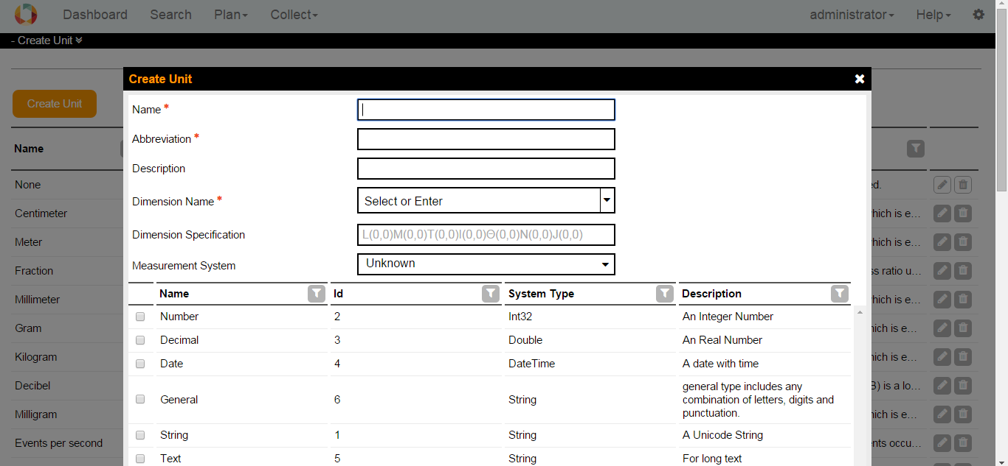

# 4. Data Attribute Manager

With the Data Attribute Manager you are able to create, modify and delete Data Attributes. Data Attributes as variables are required to create Data Structures.

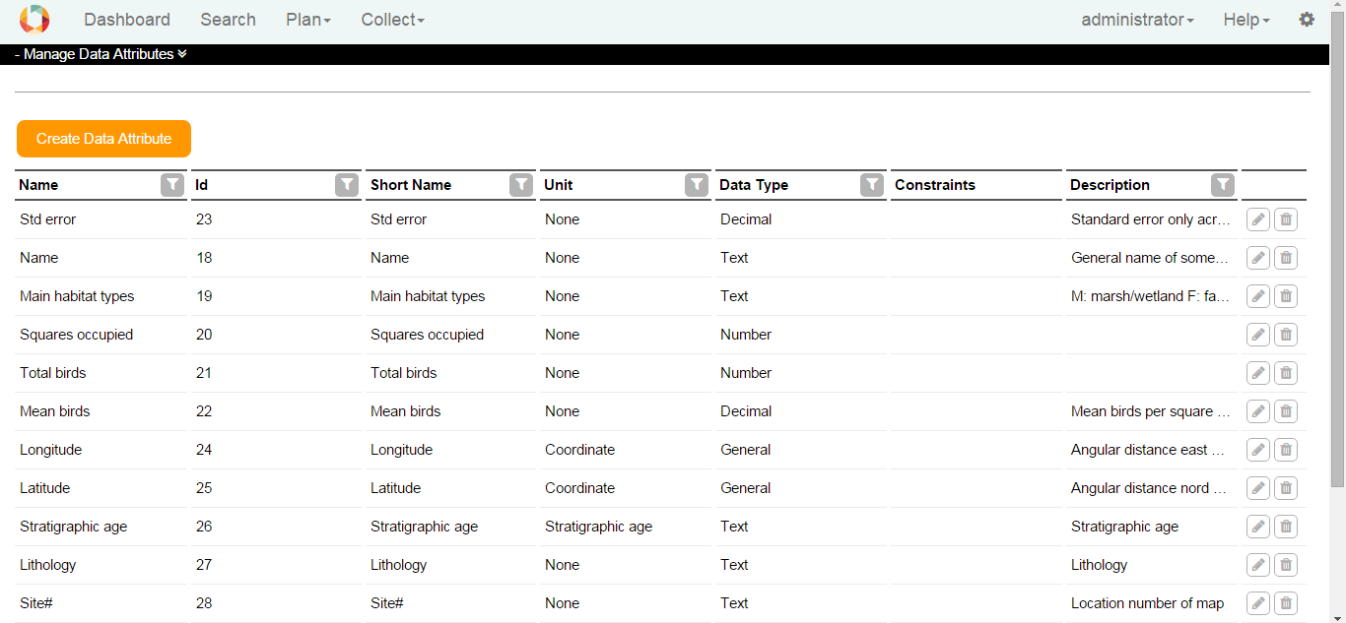

To create a Data Attribute, click on the Create Data Attribute button. Fill the fields. Select an associated Unit and Data Type and click on the Save button. The Data Attribute is stored if all information are correct and it is not a duplicate.

Use for edit and for delete a Data Attribute.

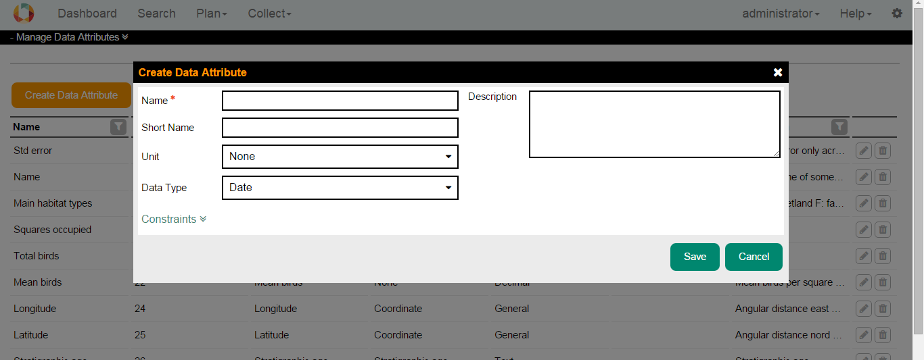

It is possible to put constraints on Data Attributes, to add constraints click on the link Constrains. You can add a Range, a Pattern and a Domain Constraint to each Data Attribute.

* **Range:** If the input data is of numeric type, this constraint checks whether the input value falls in the specified range. If the input data is of type string, the range check behaves like a length check, which means the length of the input string should fall in the range. The range has a lower bound and an upper bound, plus two indicators to show whether the boundary values are included in the range. Negate function checks if the value is out of the range!
* **Pattern:** takes the value as input and matches it against a pattern to see whether the pattern is found in the input. If so, it returns true; otherwise false. Pattern constraints apply to text values only, for more information on the format click [here](https://en.wikipedia.org/wiki/Regular_expression).
* **Domain:** takes the value as input and matches it against each and every domain item in the list. If the value matches one, it stops matching and returns true, which means the value satisfies the constraint. If no match is found it returns false. No duplicate domain item is allowed, although it does not affect the matching procedure described. Domain items can be characters, strings, Booleans or numbers. Their data type is enforced by the associated data attribute. Using the domain constraint as a tool to model acronyms and similar topics provided that some extra information such as description of each item is available, is supported.
* **Negation:** The inversion of the chosen constraint will apply. In fact the result of the constraint is XORed with the negation field. For example, a negated Range Constraint of Min = 1 and Max = 100 will allow all values outside of this range.

# 5. Data Structure Manager

The Data Structure Manager is a tool to create, modify and delete Data Structures. Data Structures contain Variables, which are specific instances of Data Attributes. For example, only one Data Attribute ‘Count’ is needed to build a Data Structure of multiple similar variables where only the name (e.g. species name) is different. Each Variable uses the same Data Attribute (e.g. instances of Count).

It is possible to create Data Structures for structured data (Excel tables, CSV-Files ...) and for unstructured data (images, videos ...).

## 5.1. Create a Data Structure

To create a data structure, in the plan Data Structure Manager, click on the Create Structured or Create Unstructured button. Fill fields and click on the Save button. A name for a data structure is required.

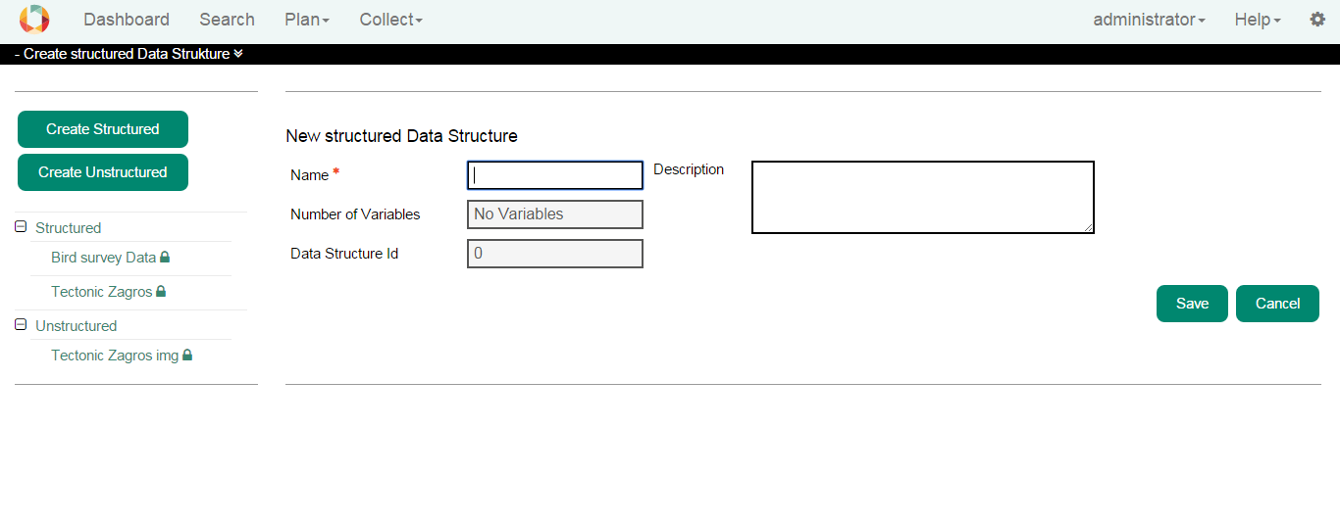

By clicking on the name of a Data Structure in the list, if it is not already in use by a dataset, you can edit it. In case of Structured, you can edit name, description or variables.

In Edit mode, you can

* see datasets that are using that data structure
* download an Excel template (in case of structured)
* delete a data structure
* create a copy by clicking on the Save as button

## 5.2. Add Variables

In case of structured, a data structure usually contains variables. Variables are defined before as data attributes. If a data structure is in use, you are not able to add or remove variables.

In the Add Variable window, by clicking on the up and down arrows near the variable name, you can select how many variables of that particular data attribute should be added your data structure.



After adding variables, you can rearrange the order of the variables by using the left and right arrows. Please note, that the order cannot be changed anymore once a dataset is using this data structure. You may also delete variable from the list by using the X button.



You can define requirement for each variable. In the Optional row, if the checkbox is ticked, means that during upload data to a dataset, this variable could be empty.

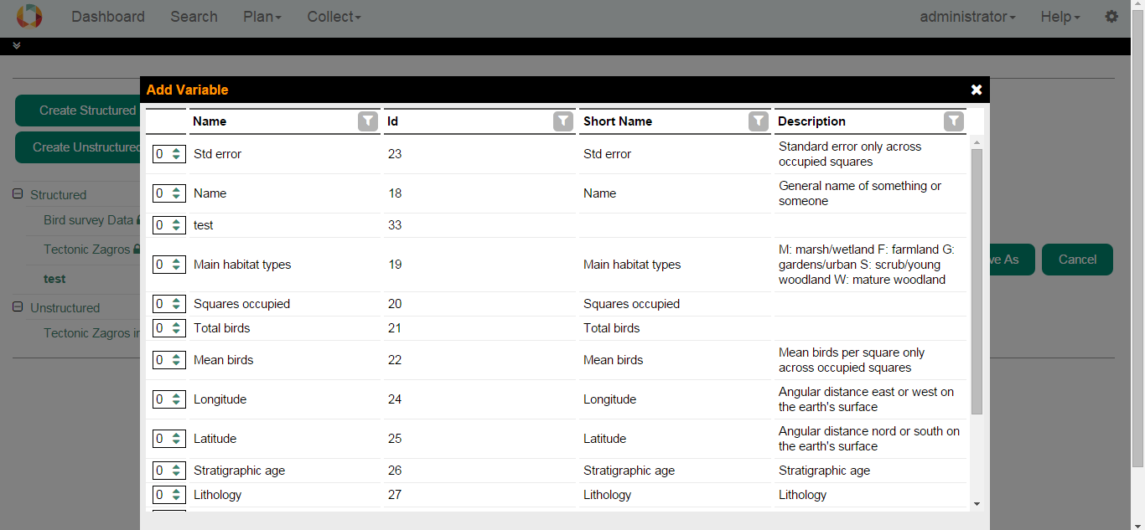

## 5.3. Create a copy data structure

Either from a structured or unstructured data structure, you can create a copy of it by clicking on the Save as button. In that window, the Name is filled with the original one and you need to fill it with a new one.

