A national, multi-decadal, water quality and Landsat dataset

Matthew Ross and lots of others!

October 22, 2018

Table of Contents

# Introduction

The production of and easy access to water quality data is a vital first step towards understanding natural and anthropogenic drivers of aquatic ecosystem degradation and for using this knowledge to protect and manage inland waters (Srebotnjak et al., 2012). Collecting such valuable data has historically been expensive and time-consuming, and it has often proved difficult to maintain useable and open datasets. In many developed nations, however, over the last 10-20 years many of these data access problems have been actively addressed, leading to the publication and maintenance of large open-access data repositories of water quality measurements (Ballantine & Davies-Colley, 2014; Lack, 2000; Read et al., 2017; Soranno et al., 2017). Although they contain millions of individual measurements, these datasets remain limited to the relatively time-intensive process of field sampling, which limits the number of water-bodies that can be observed and the spatial variation in water quality captured within a single waterbody. Furthermore, access to such robust historic water quality sampling data remains limited to a few economically developed countries. With satellite remote sensing detection of water quality, we can augment these *in-situ* sampling efforts and provide water quality information in places with little or no data.

Since the beginning of the Landsat missions, limnologists, oceanographers, and hydrologists have been interested in developing universal algorithms for extracting water quality information from remotely sensed images (Clarke et al., 1970; Holyer, 1978; Klemas et al., 1973; Maul & Gordon, 1975; Ritchie et al., 1976). Since these early efforts, there has been almost fifty years of work with the basic goal of using spectral information to predict water quality parameters like total suspended solids (TSS), Chlorophyll a (Chl_a), colored dissolved organic matter (CDOM), and Secchi disk depth (SDD). However, progress towards universal algorithms and unified approaches has been slow (Blondeau-Patissier et al., 2014; Bukata, 2013; Gholizadeh et al., 2016), with most papers published focusing on developing predictive methods as opposed to using predictions to interrogate processes that control water quality dynamics (Topp et al., 2018). Furthermore, most of the datasets used in these prior studies are inherently local in scale, often sampling a single waterbody on a single day corresponding to a satellite overpass (Topp et al., 2018). These limited datasets have contributed to the slow evolution in methods and approaches along with the inherent optical complexity of inland waters, where spectral signatures reflect a mixture of inorganic sediment, organic sediment, algae, dissolved organic matter, and other constituents. Compared to oceanic remote sensing of water quality which benefits from robust, open datasets paired with satellite overpass reflectance (Blondeau-Patissier et al., 2014; Bukata, 2013), progress on inland water algorithms is impeded by this lack of an open, merged satellite reflectance and *in-situ* water quality dataset. Such a dataset would facilitate more unified approaches to water quality remote sensing, ideally simplifying algorithm development to the point where remote estimates of water quality are integrated into our approaches for understanding inland water quality dynamics and their controls.

Here, we create and share a merged dataset, AquaSat, of water quality measurements and same-day satellite reflectance (which we call “overpasses”). This is the largest such overpass dataset ever assembled for inland waters. We use the Landsat TM/ETM+/OLI archive from 1984-2018 using the using the Google Earth Engine platform (Gorelick et al., 2017) in combination with data from the Water Quality Portal (Read et al., 2017) and phase one of the *LAke multi-scaled GeOSpatial and temporal database*, with data only in the Northeastern United States (LAGOS-NE)(Soranno et al., 2017). The WQP data covers the conterminous USA and Alaska. Joining these datasets provides us with an unprecedented resource to model, predict, and understand the long-term and large-scale dynamics of variation in four key water clarity constituents: TSS, SDD, Chl_a, and dissolved organic carbon (DOC). We also outline and share our approach, code, and intermediate data for bringing these three free datasets together; generating a high-graded analysis-ready dataset for remote sensors of water quality. We hope that publishing the code will encourage developing similar matchup datasets for public water quality datasets like in New Zealand (Ballantine & Davies-Colley, 2014) or Europe(Lack, 2000).

# Methods

## Parameter description

For this project we chose to focus on the four most common water quality parameters used in remote sensing of water quality: TSS, SDD, Chl_a, and DOC [Topp et al., 2018]. All four of these parameters provide useful and complimentary information on the water quality status of a waterbody and are also optically active, making them observable from space. TSS is a measure of the mass of solids, both organic and inorganic, in a water column. Waters with higher TSS generally scatter more sunlight at all visible and near-infrared wavelengths (Ritchie et al., 1976). Knowing TSS concentrations can provide insight into light conditions (Julian et al., 2008), erosion conditions [Syvitski2011], and the hydrologic status of waterbodies, where high TSS generally means high flow velocities [Williams (1989);Pavelsky2009]. DOC is the broad description for the total amount of organic Carbon that is dissolved in water, and can provide insight into light conditions (Vähätalo et al., 2005), heterotrophic energy availability (Robbins et al., 2017), and terrestrial organic matter processing (Williamson et al., 2008). While DOC does not inherently alter the optical properties of water, it is generally strongly correlated with CDOM, which is optically active, generally a brown or yellow color (Bricaud et al., 1981; Griffin et al., 2011). Though this correlation between CDOM and DOC can breakdown in places with low DOC concentratnio (Griffin et al., 2018). For this project, we included both DOC and CDOM data. Chlorophyll a is a photosynthetically active pigment contained in all phytoplankton, which helps give algal blooms their green color. Chlorophyll a concentrations can be used to detect algae blooms (Kutser, 2004), estimate primary productivity (Antoine et al., 1996), and understand algae dynamics (Richardson, 1996). Finally, we gathered data on Secchi disk depth, a long-standing method for estimating water clarity (Secchi, 1864). The Secchi disk is a 30 cm diameter disk divided into four quadrants painted alternately white and black. To measure water clarity, the disk is lowered into a waterbody; the depth at which the disk is no longer visible is the Secchi disk depth. Deeper depths mean clearer water. Secchi disk depth is a simple measurement that integrates the optical properties of all water constituents and can provide information on the trophic status of waterbodies (Carlson, 1977) or the algae status of a waterbody (Lorenzen, 1980). These four parameters capture key ecological and physical factors that control water quality, and capabilities to remotely sense each of them have been demonstrated in many studies (Topp et al., 2018), making them ideal for our dataset construction efforts.

## Data source description

Combining *in-situ* data with Landsat reflectance information first requires a large repository of water quality samples, which increases the likelihood that a given sample happened to be taken on the same day as a Landsat overpass. For this paper, we focused on the two largest databases of water quality in the United States. The first, the Water Quality Portal has tens of millions of water observations in all types of inland surface waters. The WQP data is gathered by a range of national and state agencies (USGS, EPA, state water quality programs). While there is no entity that harmonizes and cleans the data across systems and data providers (Read et al., 2017), subsets of the data have been used in many previous publications (Booth et al., 2011; Sprague & Lorenz, 2009; Sprague et al., 2017). The second dataset, LAGOS-NE, currently only covers lakes in the northeastern United States (Soranno et al., 2017). While LAGOS-NE has less data than the WQP, with more than a million total observations, a group of dedicated researchers has spent years ensuring data quality, making it a more analysis-ready dataset (Soranno et al., 2017). These similar but contrasting datasets, one with more quantity (WQP) and the other with more quality assurances (LAGOS-NE), ensures that our dataset covers the largest possible number of waterbodies, while retaining a high quality subset of the data.

### Water Quality Portal

The WQP is the largest dataset of water observations ever assembled with more than 290 million observations at 2.7 million sites dating back more than a century, mostly in the USA (Read et al., 2017). The WQP continuously gathers water quality information from more than 450 organizations including academic, government, NGO, tribal, and state datasets (Read et al., 2017). These datastreams are gathered and distributed in a standardized format, making analysis across different collection methods more readily available. As with many large datasets, however, the diversity of data sources and variation in meta-data quality results in some significant challenges to directly using the WQP as an analysis-ready dataset (Sprague et al., 2017). Instead, end-users must carefully harmonize data across sampling methods, analytic approaches, and units. The nature of harmonizing such large, distributed data generates a necessary trade-off between a deep, time-consuming exploration of data interoperability and a shallower less time-consuming but potentially more error-prone data quality check.

### LAGOS-NE

The LAGOS project (which generated the dataset LAGOS-NE) was, in part, meant as a direct way to address some of the problems inherent to the WQP, with the explicit goal of building a publically available high-quality dataset for continental-scale lake analyses (Soranno et al., 2017, 2015). In addition to pairing *in-situ* lake data with physical lake characteristics and local geologic setting, LAGOS researchers standardized key water quality measurements across the 87 water quality datasets that they gathered (Soranno et al., 2017, 2015). Because LAGOS researchers harmonized data from many different sources, they chose to identify all data for a single lake with the lake centroid. If two different organizations were measuring Secchi disk depth at the north and south end of a lake, the LAGOS dataset would combine all of these measurements into a single time series, geographically located at the lake centroid, for same day observations the deepest observation would have been kept (Soranno et al., 2015). This approach is different from that used by the Water Quality Portal, which often includes multiple sites per water body and simiultaneous observations. In its current form, the LAGOS-NE dataset covers only lakes in the northeast and midwest, two lake-rich regions of the USA. LAGOS-NE provides an end-member dataset of the highest quality for matching *in-situ* data to Landsat overpasses.

### Landsat

For this project, we join these two *in-situ* datasets with the Landsat data archive for Landsat missions 5 (Thematic Mapper), 7 (Enhanced Thematic Mapper +), and 8 (Operational Land Imager). . The Landsat missions started in July 1972, as the Earth Resources Observation Satellite with an explicit mission to provide solutions for some of earth’s pressing issues associated with industry and environmental change (Loveland & Dwyer, 2012). For this project we are only using the three most recent Landsat mission datasets: Landsat 5 with coverage from 1984-2012 and over 192745 available images; Landsat 7 which is still collecting data after launching in July of 1999 with 191366 images; and finally Landsat 8 which launched in November, 2013 still adding to its collection of 61790 images. The total usable images will be much less than the total images because of cloud cover, which varies greatly by region. Furthermore, on May 31, 2003, the Landsat 7 scan line corrector failed, causing the Landsat 7 images after this date to have striped data gaps (Storey et al., 2005). We included all Landsat 7 data before and after this date, but did not fill gaps associated with the scan line error. The orbit repeat period of all three satellites is sixteen days, though at high latitudes overlapping images result in shorter revisit times (Loveland & Dwyer, 2012; Wulder et al., 2016). In most of the USA, a given spot will be imaged at least once every sixteen days, and during periods of mission overlap, images are available on average at least every eight days.

Landsat 5 and 7 have onboard imagers that collects seven bands of imagery centered on three visible wavelengths (blue, green, and red) and four infrared (near infrared, shortwave infrared 1, shortwave infrared 2, and thermal band). Landsat 8 has the same bands with slightly different wavelengths and improved spectral accuracy (Barsi et al., 2014) plus a few extra bands that we did not include in this work. Landsat 7 and 8 have panchromatic bands at 15m resolution, while Landsat 5 does not. For our matchup data, the bands we used, their wavelengths, and resolution are in SI table 1.

## Data integration

The goal of uniting the WQP, LAGOS-NE and Landsat datasets requires a combination of computational approaches and an architecture that allows for a single workflow to download data from all three portals. An ideal overarching approach allows us to break the various data downloads, quality assurance checks, and joining data into separate pieces that can be updated only as needed. In developing this approach, we emphasize not only the possibilities that come with open data, but also the importance of reproducible science and code. Here we chose to use a “MAKE” like environment (Feldman, 1979) that only executes sections of code that have been altered or when data sources are out of date. Though this project uses three different tools (R, Python, and Google Earth Engine), each tool is called directly from R and RMarkdown files. This reliance on R makes remake <https://github.com/richfitz/remake> an excellent choice to keep track of changes to the complex commands required to compile AquaSat. Remake provides an R-specific, MAKE-like environment that can check if code has been updated and then update all downstream data. We anticipate that these efforts will make recreating or altering our specific approach easier for future researchers who may want to use our code in different ways. The detailed process of data integration is captured in Figure .

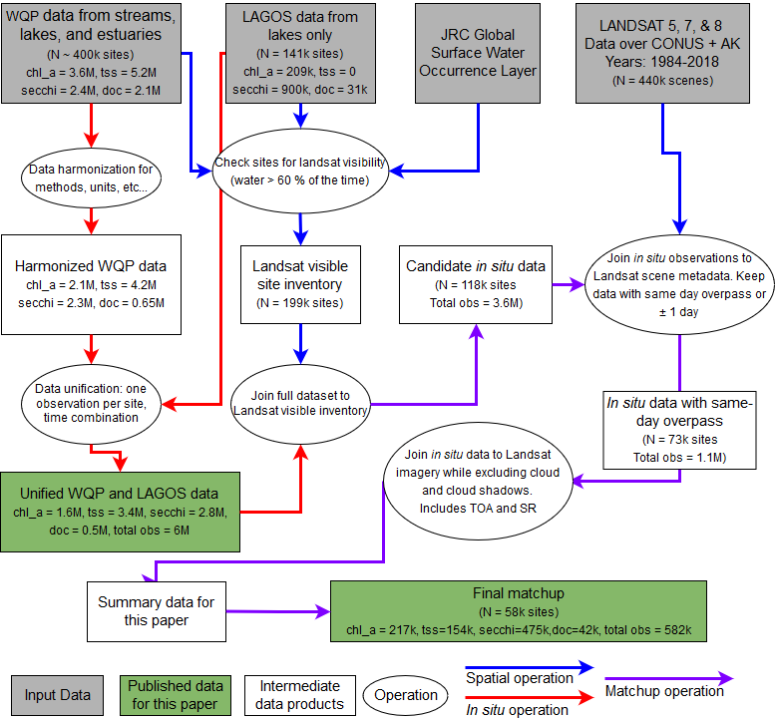

Overview of data sources, steps taken to join data, and total observation counts

### *In situ* data download and quality control.

To begin the development of the AquaSat database, we developed an automated method to retrieve our four water quality parameters from the WQP and LAGOS sites. For the WQP we used the [dataRetrieval](https://github.com/USGS-R/dataRetrieval) R package. DataRetrieval, maintained and supported by the USGS, which allows for systematically downloading data from the WQP. The WQP contains hundreds of parameter types (under the field “characteristicName” in the WQP), and we carefully selected those that best represented our target parameters based on our own expertise and previously published research using the same data sources (Butman et al., 2016; Stets & Striegl, 2012)(SI Table 2). For all parameters, we downloaded data for all US states except Hawaii. The WQP classifies water body types in many possible categories and we downloaded data for the four following water body types: Lake, Reservoir, Impoundment; Stream; Estuary; Facility, where facility can indicate wastewater treatment facilities, including lakes and ponds. Finally, we restricted our queries to data sampled in water as a sample media, excluding sediment and benthic samples.

Working with the LAGOS-NE data (version 1.087.1) required many less decisions to combine parameters since LAGOS researchers have already harmonized and combined parameters into simple categories that reflect our general parameter codes(Soranno et al., 2017, 2015). LAGOS-NE includes measurements of: DOC, Chl_a, and SDD, but no data on TSS. As with the WQP the dataset can be simply loaded using an R package (‘LAGOS-NE’)(Soranno et al., 2017).

Turning data from the WQP into an analysis-ready dataset similar to LAGOS-NE requires a chain of decisions that is extensively documented in the supplemental [website](link). We have attempted to make these decisions both clear and justifiable, with the end goal of producing a high-quality dataset. Figure presents these data quality assurance procedures and shows how they reduce the number of observatiosn at each step. The following are the most important decisions:

1. All observations were verified to have analytical methods that matched their parameter name; when this was not the case, samples were dropped. For example, if an observation was supposed to report TSS, but the analytical method was listed as “Nitrogen in Water,” then that sample would be dropped. For TSS in particular, we assumed that the characteristicName Suspended Sediment Concentration reflected essentially the same data despite some methodoligical differences in the data as shown [here](https://water.usgs.gov/osw/pubs/WRIR00-4191.pdf).
2. We harmonized the data across units such that TSS and DOC data are in mg/L, Chl_a data is in $μ$ g/L, and Secchi disk depth is in meters. We removed all observations with nonsensical units (e.g. SDD in mg/L).
3. We ensured that both LAGOS-NE and WQP data to have only one observation per site at a particular date and/or time. We converted true duplicates where the date, time, and observation value were the same for multiple observations to a single value. When the site and date were the same, but the parameter values were different, we averaged multiple observations to a single observation if the coefficient of variation was less than 0.1, and removed observations with too many simultaneous observations (5 per date time combination) or too much variation with no metadata explaining the repeat observations. We assume that these simultaneous observations are either reporting errors, represent field sampling campaigns with genuinely simultaneous observations, or reflect simultaneous sampling at different depths.

While other decisions could have been included to make all observations fully consistent, we avoided choices that removed the majority of the WQP data. For example, while some samples included sampling depth information, which is useful when matching water quality data to reflectance information, most samples did not. As a result, we elected to simply keep all the data, assuming that the majority of the data was collected near the surface (see supplement for justification of this assumption). Some additional decisions that resulted in retaining data included: not filtering data based on sampling method, not including temperature data as a filter for DOC and Chl_a samples, and including data that had unlabeled sample fraction metadata. While these decisions may preclude some types of analysis, our free and open code allows future researchers to choose different data quality criteria and recreate a stricter dataset to match other criteria.

### Joining *in-situ* data to Landsat

Both the WQP and LAGOS-NE datasets include sample latitude and longitude. Joining the in-situ data to Landsat requires using this location data to select sites, gather spatially averaged reflectance, and match water quality observations to temporally proximal overpasses. Because LAGOS-NE uses lake centroids for location, while the WQP uses observation points, when data is both in the WQP portal and in LAGOS-NE, then we will potentially have different reflectance information for the same water quality observation. In the WQP data, where sampling sites are often along the shores of lakes and banks of rivers, the exact sampling location may be more likely to include mixed pixels that contain some spectral information of the pure water body and the adjacent land. Keeping sites pinned to the reported sampling location does allow for more spatial variation in waterbody water quality, which could reflect genuine spatial variation in water quality in larger waterbodies (Griffin et al., 2011). In the LAGOS-NE dataset, using lake centroid spectral information essentially eliminates the risk of pixel contamination for most large lakes, but makes the implicit assumption that water quality does not vary too much across the water body. We kept both of these data sources, so that data users can choose which data source best suits their needs.

The first step in linking these datasets is finding out which water bodies are likely to be Landsat visible, where the 30m resolution pixels of Landsat detect a uniform (entirely water) pixel. Because of the 30 m resolution of Landsat, we generally detect waterbodies > 60 m on all sides to ensure that the spectral information captures only purely water pixels. In essence, this means that our “Stream” data is limited to rivers wider than 60 m, though we use the terms stream and river interchangeably. Similarly, estuaries and lakes are mostly limited to sites where the waterbody is wider than 60 m.

We elected to only keep sites that are usually classified as water in the Landsat archive, using the water occurrence layer developed by Pekel et al. (2016). Sites were preserved if they were within 200 meters of at least one pixel with a water occurrence of at least 60%, a permissive threshold that ensured the largest possible number of candidate sites. All such sites were kept in the dataset and were spatially joined to an inventory of Landsat WRS-2 paths and rows, where each site was affiliated with a specific Landsat tile.

We generated a dataset including the dates and times that each tile was observed by any of the three Landsat missions. We joined this dataset to the *in-situ* database by date. In cases with multiple *in-situ* observations of the same water body on the same day, we kept only the observation closest in time to the Landsat overpass. In order to maximize the size of the dataset, we retained all *in-situ* data that fell within $±$ day of a Landsat overpass. This one-day shouldering is relatively conservative compared to some previous work in lakes (Olmanson et al., 2011; Torbick et al., 2013) and rivers (Griffin et al., 2011), but may result in mismatches between reflectance and water quality parameter values for estuaries and rivers with rapidly changing discharge, where water quality values can very on sub-hourly intervals (Rode et al., 2016). The timing difference between overpasses and *in-situ* collection is preserved in the final dataset and users can specify minimum overpass timing if they choose to be more strict.

With this trimmed down dataset of Landsat-visible sites matched to Landsat overpass times, we used Google Earth Engine to pair *in-situ* observations with median Landsat reflectance values in a 200 m buffer around each site. To ensure the highest quality reflectance data, we took several quality assurance steps. First, within the buffered zone we throw out any pixel that is not classified as water at least 80% of the time in the Landsat archive (Pekel et al., 2016), which reduces the likelihood of using mixed pixels. Second, Landsat data includes quality assessment bands for detection of water, clouds, aerosols, and other similar conditions. We used these bands to remove all pixels classified as cloud and cloud shadows, but we elected to keep all data classified as land, ice, or water, since very high sediment concentrations can lead to classification as land or ice (Xiao citation?). Third, because many of the samples in the WQP are taken from or near bridges that are smaller than 30m in width, we also created a 30 m buffer around the TIGER road [dataset](https://www.census.gov/geo/maps-data/data/tiger.html) from the US Census office. This step ensures that pixels within 30 m of any transport artery (road, traintracks, etc…) were removed, and won’t create mixed water/road pixels. After these quality assurance steps were taken, we calculated a spatial median of reflectance in each band from all remaining pixels in the buffer zone. These spatial medians include a median of the quality assessment band, which can be used to indicate if the median assessment value was water or some other class like land or ice. These steps produce a “wide” (Wickham, 2014) dataset matching *in-situ* observation and Landsat reflectance values for all site and date combinations.

One of the most critical components of inland water remote sensing is the atmospheric correction, where radiance at the satellite sensor is corrected to radiance from the land surface (Brando & Dekker, 2003; CASELLES & LÓPEZ GARCÍA, 1989). Atmospheric correction, when properly applied, can reduce the impact of aerosol interference, sun glint, and other processes that might alter the radiance leaving waterbodies, giving a much cleaner signal of the optical qualities of water (Gordon, 1997). There are many options for atmospheric correction algorithms, but Google Earth Engine only includes the USGS Surface Reflectance archive which uses a version of the 6S radiative transfer model called *Landsat Ecosystem Disturbance Adaptive Processing System* (LEDAPS) for Landsat 5 and 7 (Ju et al., 2012). For Landsat 8 the algorithm is called *Landsat 8 Surface Reflectance Code* (LaSRC) that uses the ultra blue band to correct for aerosols (Doxani et al., 2018). Because users may want to apply other atmospheric correction schemes, we include both the USGS surface reflectance and the uncorrected top-of-atmosphere reflectance.

# Results

## [1] "SiteID" "date_unity" "date_only" "chl_a" "doc"   
## [6] "p_sand" "secchi" "tis" "tss" "source"

After the quality assurance steps there are almost 600,000 matchups with near simultaneous Landsat overpasses and *in-situ* data collection. As figure shows, matching in situ data to Landsat overpasses generally reduced the total available data for a given parameter by 6-25 times, with the biggest dropoff in TSS observations and the smallest in SDD. This pattern stems from the fact that most TSS observations are made in streams that are too small to be visible to Landsat, while SDD observations are mostly in lakes, which are visible. Given this dropoff, we elected to drop CDOM from the work because there were only 2761 CDOM results in the entire WQP. The remaining data are well distributed across the parts of the USA with many lakes and rivers, including the Upper Midwest, Northeast, and Florida, with notable data concentrations near the Chesapeake Bay and along the U.S. East Coast in major estuarine environments (Fig ). The western United States has notably less data available, which likely reflects: lower concentrations of lakes and rivers in these states, the lack of LAGOS-NE data for these states, and, potentially, a bias in the completeness of the WQP towards certain states.

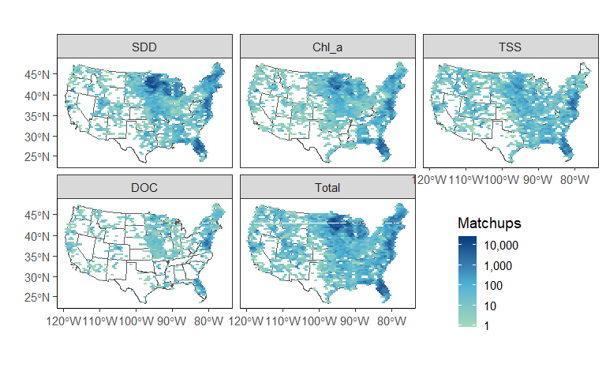

Distribution of observations across the conterminous USA. The data is split by observation type, where total represents an overpass for any of the four primary parameters

As suggested by the spatial distribution of data shown in figure lakes dominate the dataset. They contribute 71% of the data to the entire dataset, mostly in the form of SDD observations. Half of all the data come from sites with one or two matchups, with less than 10% of sites having at least 25 observations. Given this limitation, regional, reflectance-based water quality models may be the most efficient way to use the database, where information from multiple sites can be leveraged to increase the matchup count. Still, there are hundreds of sites for each parameter that have at least 50 matchups, which presents exciting opportunities for site-specific remote water quality predictions as well.

The timing of observations in our matchup dataset generally reflect the availability of data in the WQP and LAGOS-NE and the launch or retirement of Landsat missions (SI Figure 2), and lines up well with the original WQP data (Read et al., 2017). Figure (SI Fig. 2) also shows that DOC is the rarest observation in both AquaSat and the *in-situ* data. TSS data mostly comes from small, streams not visible by Landsat which explains the large dropoff in TSS observations from *in-situ* datasets to the Aquasat matchups. Chl_a, and SDD are well-preserved in AquaSat, because most of these observations were in Landsat-visible lakes. There is increasing data available in the *in-situ* datasets from 1984-2012. The more recent decline in data availability may reflect a lag between agencies collecting data and submitting final datasets to the *in-situ* databases.

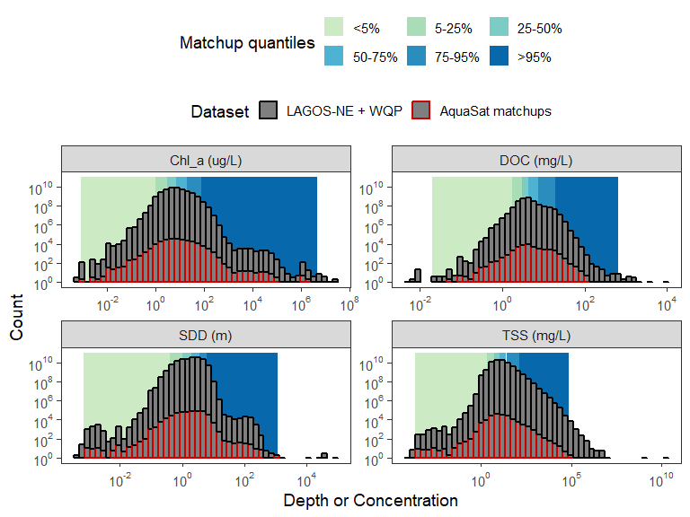

Shows the data distributions for only the in-situ data in gray with the matchup data distributions in red. Data quantiles are shown in the background as a color ramp from sage to blue.

The data we captured in the matchup dataset generally reflects the distribution of in-situ data quite well (fig ). This is especially true for Chl_a and SDD, where the overpass distribution shapes are nearly identical to the *in-situ* distributions, just with fewer observations. The matchup data misses the largest values for both DOC and TSS, which occur almost entirely in small streams, not visible to Landsat. Across parameters, the matchup data spans several orders of magnitude and captures environmentally meaningful variation in water quality. For each parameter, the data is approximately log-normally distributed, with the majority of the data occupying a relatively narrow range, within ~1-2 orders of magnitude of the median (fig ).

Based on decades of previous research (Topp et al., 2018), we know that the concentration of our four primary parameters should control, to some degree, the reflectance from a waterbody that reaches the Landsat sensor. While exploring these relationships at individual sites or regions is beyond the scope of this paper, we interrogate the dataset to examine how variation in each water quality constituent maps to variation in reflectance in each spectral band. To explore these relationships, we divide the data into the six quantiles shown in figure 5 for each water quality parameter (figure ) Increasing concentrations of Chl_a, DOC, and TSS or increasing SDD control spectral variation across our three waterbody types (Estuary, Stream, and Lake) and averaged for the entire USA. Despite using such a heterogeneous dataset, figure {} shows clear systematic variation in spectral response for each parameter as concentration or SDD increases.

# Discussion

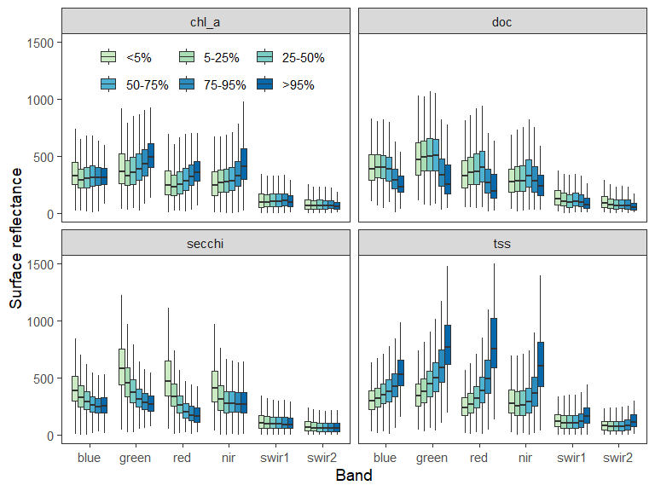

Shows spectral response for each data quantile for each Landsat band. For Chl_a, DOC, and TSS, concentration increases moving from left to right for higher quantiles. For SDD quantiles indicate increasing clarity or increasing depth.

We built AquaSat to move towards a more continental and global approach to remote sensing of water quality, but the dataset comes with caveats and limitations. First and foremost, the Water Quality Portal and LAGOS-NE have inherent spatial biases in terms of which water bodies were sampled, which agencies fully report their data, and the completeness of records. Second, our efforts to harmonize and unify the data in the Water Quality Portal were primarily with the explicit goal of including as much data as could be reasonably included. Such inclusivity ensured a dataset that emphasized quantity over quality guarantees, despite our best efforts to also ensure data quality. The LAGOS-NE dataset, which was much more extensively assured for quality, provides a nice foil to our approach (Soranno et al., 2017, 2015). Our inclusive approach did not stop at the harmonizing step, we also elected to keep all data that had positive values. This means we did not do any quality analysis based on “sensible” data values, unlike the LAGOS approach (Soranno et al., 2015). For example, there are some secchi disk depth samples that report a secchi disk depth of > 100s of meters. Such values are highly unlikely, but we elected to keep them so that end-users can set their own “sensibility” thresholds based on expert knowledge for their systems. The quality controls we took for the WQP data stand in sharp contrast to our approach with the Landsat archive.

To our knowledge, the AquaSat dataset is the largest matchup dataset ever assembled for inland waters. It captures a broad range of variation in the four main remotely sensible water quality parameters across thousands of waterbodies, and we anticipate it will unlock many avenues for remote water quality work. By publishing this data, we hope to contribute to the current transition in the field from developing methods to a field where those methods are used to interrogate patterns in water quality, drivers of change, and spatial variability of key water quality parameters (Topp et al., 2018). For example, with an open dataset predictive algorithm and methods comparisons can be conducted on a shared resource, discouraging repetitive development of the same appraoch on different data (Bukata, 2013). We also built the dataset to provide an easy way for researchers who typically don’t use remote sensing as one of their tools to begin to use it as integral aspect of water quality research. Because the matchup data covers the United States, this work could range from building local water quality algorithms for detecting algae blooms in a single lake, to building predictions of TSS in all the major rivers of the USA.

This approach of using public *in-situ* data paired with public satellite data, can be vastly expanded to any place that has measurements of water quality. By publishing our code, we encourage using the overall approach and/or code archicture to expand this kind of matchup work to other countries with similar datasets, moving towards truly global remote sensing of inland water quality. Additionally, there is ample previous work showing that remote sensing of water quality can be expanded to include constituents that not optically active but are correlated with TSS or DOC, like mercury (Fichot et al., 2016; Telmer et al., 2006) or phosphorus (Kutser et al., 1995). Finally, this work can be adjusted to include other satellites with publically available color imagery (like Sentinel 2) or even private satellites with higher temporal and spatial resolution (like DigitalGlobe or PLANET).

# References

Antoine, D., André, J.-M., & Morel, A. (1996). Oceanic primary production: 2. Estimation at global scale from satellite (Coastal Zone Color Scanner) chlorophyll. *Global Biogeochemical Cycles*, *10*(1), 57–69. <https://doi.org/10.1029/95GB02832>

Ballantine, D. J., & Davies-Colley, R. J. (2014). Water quality trends in New Zealand rivers: 1989–2009. *Environmental Monitoring and Assessment*, *186*(3), 1939–1950. <https://doi.org/10.1007/s10661-013-3508-5>

Blondeau-Patissier, D., Gower, J. F., Dekker, A. G., Phinn, S. R., & Brando, V. E. (2014). A review of ocean color remote sensing methods and statistical techniques for the detection, mapping and analysis of phytoplankton blooms in coastal and open oceans. *Progress in Oceanography*, *123*, 23–144. <https://doi.org/10.1016/j.pocean.2013.12.008>

Booth, N. L., Everman, E. J., Kuo, I.-L., Sprague, L., & Murphy, L. (2011). A Web-Based Decision Support System for Assessing Regional Water-Quality Conditions and Management Actions1. *JAWRA Journal of the American Water Resources Association*, *47*(5), 1136–1150. <https://doi.org/10.1111/j.1752-1688.2011.00573.x>

Brando, V., & Dekker, A. (2003). Satellite hyperspectral remote sensing for estimating estuarine and coastal water quality. *IEEE Transactions on Geoscience and Remote Sensing*, *41*(6), 1378–1387. <https://doi.org/10.1109/TGRS.2003.812907>

Bricaud, A., Morel, A., & Prieur, L. (1981). Absorption by dissolved organic matter of the sea (yellow substance) in the UV and visible domains. *Limnology and Oceanography*, *26*(1), 43–53. <https://doi.org/10.4319/lo.1981.26.1.0043>

Bukata, R. P. (2013). Retrospection and introspection on remote sensing of inland water quality: "Like Déjà Vu All Over Again". Elsevier B.V. <https://doi.org/10.1016/j.jglr.2013.04.001>

Butman, D., Stackpoole, S., Stets, E., McDonald, C. P., Clow, D. W., & Striegl, R. G. (2016). Aquatic carbon cycling in the conterminous United States and implications for terrestrial carbon accounting. *Proceedings of the National Academy of Sciences*, *113*(1), 58–63. <https://doi.org/10.1073/pnas.1512651112>

Carlson, R. E. (1977). A trophic state index for lakes1. *Limnology and Oceanography*, *22*(2), 361–369. <https://doi.org/10.4319/lo.1977.22.2.0361>

CASELLES, V., & LÓPEZ GARCÍA, M. J. (1989). An alternative simple approach to estimate atmospheric correction in multitemporal studies. *International Journal of Remote Sensing*, *10*(6), 1127–1134. <https://doi.org/10.1080/01431168908903951>

Clarke, G. L., Ewing, G. C., & Lorenzen, C. J. (1970). Spectra of Backscattered Light from the Sea Obtained from Aircraft as a Measure of Chlorophyll Concentration. *Science*, *167*(3921), 1119–1121. <https://doi.org/10.1126/science.167.3921.1119>

Doxani, G., Vermote, E., Roger, J.-C., Gascon, F., Adriaensen, S., Frantz, D., et al. (2018). Atmospheric Correction Inter-Comparison Exercise. *Remote Sensing*, *10*(3), 352. <https://doi.org/10.3390/rs10020352>

Feldman, S. I. (1979). Make — a program for maintaining computer programs. *Software: Practice and Experience*, *9*(4), 255–265. <https://doi.org/10.1002/spe.4380090402>

Fichot, C. G., Downing, B. D., Bergamaschi, B. A., Windham-Myers, L., Marvin-Dipasquale, M., Thompson, D. R., & Gierach, M. M. (2016). High-Resolution Remote Sensing of Water Quality in the San Francisco Bay-Delta Estuary. *Environmental Science and Technology*, *50*(2), 573–583. <https://doi.org/10.1021/acs.est.5b03518>

Gholizadeh, M., Melesse, A., & Reddi, L. (2016). A Comprehensive Review on Water Quality Parameters Estimation Using Remote Sensing Techniques. *Sensors*, *16*(8), 1298. <https://doi.org/10.3390/s16081298>

Gordon, H. R. (1997). Atmospheric correction of ocean color imagery in the Earth Observing System era. *Journal of Geophysical Research: Atmospheres*, *102*(D14), 17081–17106. <https://doi.org/10.1029/96JD02443>

Gorelick, N., Hancher, M., Dixon, M., Ilyushchenko, S., Thau, D., & Moore, R. (2017). Google Earth Engine: Planetary-scale geospatial analysis for everyone. *Remote Sensing of Environment*, *202*, 18–27. <https://doi.org/10.1016/j.rse.2017.06.031>

Griffin, C. G., Frey, K. E., Rogan, J., & Holmes, R. M. (2011). Spatial and interannual variability of dissolved organic matter in the Kolyma River, East Siberia, observed using satellite imagery. *Journal of Geophysical Research: Biogeosciences*, *116*(3), 1–12. <https://doi.org/10.1029/2010JG001634>

Griffin, C. G., Finlay, J. C., Brezonik, P. L., Olmanson, L., & Hozalski, R. M. (2018). Limitations on using CDOM as a proxy for DOC in temperate lakes. *Water Research*, *144*, 719–727. <https://doi.org/10.1016/J.WATRES.2018.08.007>

Holyer, R. J. (1978). Toward universal multispectral suspended sediment algorithms. *Remote Sensing of Environment*, *7*(4), 323–338. <https://doi.org/10.1016/0034-4257(78)90023-8>

Ju, J., Roy, D. P., Vermote, E., Masek, J., & Kovalskyy, V. (2012). Continental-scale validation of MODIS-based and LEDAPS Landsat ETM+ atmospheric correction methods. *Remote Sensing of Environment*, *122*, 175–184. <https://doi.org/10.1016/J.RSE.2011.12.025>

Julian, J. P., Doyle, M. W., Powers, S. M., Stanley, E. H., & Riggsbee, J. A. (2008). Optical water quality in rivers. *Water Resources Research*, *44*(10), 1–19. <https://doi.org/10.1029/2007WR006457>

Klemas, V., Borchardt, J. F., & Treasure, W. M. (1973). Suspended sediment observations from ERTS-1. *Remote Sensing of Environment*, *2*, 205–221. <https://doi.org/10.1016/0034-4257(71)90094-0>

Kutser, T. (2004). Quantitative detection of chlorophyll in cyanobacterial blooms by satellite remote sensing. *Limnology and Oceanography*, *49*(6), 2179–2189. <https://doi.org/10.4319/lo.2004.49.6.2179>

Kutser, T., Arst, H., Miller, T., Käärmann, L., & Milius, A. (1995). Telespectrometrical estimation of water transparency, chlorophyll-a and total phosphorus concentration of Lake Peipsi. *International Journal of Remote Sensing*, *16*(16), 1–2. <https://doi.org/10.1080/01431169508954609>

Lack, T. (2000). Eurowaternet- A Freshwater Monitoring and Reporting Network for All European Countries. In *Transboundary water resources in the balkans* (pp. 185–191). Dordrecht: Springer Netherlands. <https://doi.org/10.1007/978-94-011-4367-7_19>

Lorenzen, M. W. (1980). Use of chlorophyll-Secchi disk relationships. *Limnology and Oceanography*, *25*(2), 371–372. <https://doi.org/10.4319/lo.1980.25.2.0371>

Loveland, T. R., & Dwyer, J. L. (2012). Landsat: Building a strong future. *Remote Sensing of Environment*, *122*(October 2000), 22–29. <https://doi.org/10.1016/j.rse.2011.09.022>

Maul, G. A., & Gordon, H. R. (1975). On the Use of the Earth Resources Technology Satellite ( LANDSAT-1 ) in Optical Oceanography. *Remote Sensing of Environment*, *4*(C), 95–128. <https://doi.org/10.1016/0034-4257(75)90008-5>

Olmanson, L. G., Brezonik, P. L., & Bauer, M. E. (2011). Evaluation of medium to low resolution satellite imagery for regional lake water quality assessments. *Water Resources Research*, *47*(9), 1–14. <https://doi.org/10.1029/2011WR011005>

Pekel, J.-F., Cottam, A., Gorelick, N., & Belward, A. S. (2016). High-resolution mapping of global surface water and its long-term changes. *Nature*, *540*(7633), 418–422. <https://doi.org/10.1038/nature20584>

Read, E. K., Carr, L., De Cicco, L., Dugan, H. A., Hanson, P. C., Hart, J. A., et al. (2017). Water quality data for national-scale aquatic research: The Water Quality Portal. *Water Resources Research*, *53*(2), 1735–1745. <https://doi.org/10.1002/2016WR019993>

Richardson, L. L. (1996). Remote Sensing of Algal Bloom Dynamics. *BioScience*, *46*(7), 492–501. <https://doi.org/10.2307/1312927>

Ritchie, J., Schiebe, F., & McHENRY, J. (1976). Remote sensing of suspended sediments in surface waters. *American Society of*, *42*(12), 1539–1545. Retrieved from <https://trid.trb.org/view.aspx?id=66674>

Robbins, C. J., King, R. S., Yeager, A. D., Walker, C. M., Back, J. A., Doyle, R. D., & Whigham, D. F. (2017). Low-level addition of dissolved organic carbon increases basal ecosystem function in a boreal headwater stream. *Ecosphere*, *8*(4), e01739. <https://doi.org/10.1002/ecs2.1739>

Rode, M., Wade, A. J., Cohen, M. J., Hensley, R. T., Bowes, M. J., Kirchner, J. W., et al. (2016). Sensors in the Stream: The High-Frequency Wave of the Present. *Environmental Science & Technology*, *50*(19), 10297–10307. <https://doi.org/10.1021/acs.est.6b02155>

Secchi, P. (1864). Relazione delle esperienze fatte a bordo della pontificia pirocorvetta l’Immacolata concezione per determinare la trasparenza del mare; Memoria del P. A. Secchi. *Il Nuovo Cimento*, *20*(1), 205–238. <https://doi.org/10.1007/BF02726911>

Soranno, P. A., Bissell, E. G., Cheruvelil, K. S., Christel, S. T., Collins, S. M., Fergus, C. E., et al. (2015). Building a multi-scaled geospatial temporal ecology database from disparate data sources: fostering open science and data reuse. *GigaScience*, *4*(1), 28. <https://doi.org/10.1186/s13742-015-0067-4>

Soranno, P. A., Bacon, L. C., Beauchene, M., Bednar, K. E., Bissell, E. G., Boudreau, C. K., et al. (2017). LAGOS-NE: A multi-scaled geospatial and temporal database of lake ecological context and water quality for thousands of US lakes. *GigaScience*, *6*(12), 1–22. <https://doi.org/10.1093/gigascience/gix101>

Sprague, L. A., & Lorenz, D. L. (2009). Regional nutrient trends in streams and rivers of the United States, 1993-2003. *Environmental Science and Technology*, *43*(10), 3430–3435. <https://doi.org/10.1021/es803664x>

Sprague, L. A., Oelsner, G. P., & Argue, D. M. (2017). Challenges with secondary use of multi-source water-quality data in the United States. *Water Research*, *110*, 252–261. <https://doi.org/10.1016/j.watres.2016.12.024>

Srebotnjak, T., Carr, G., Sherbinin, A. de, & Rickwood, C. (2012). A global Water Quality Index and hot-deck imputation of missing data. *Ecological Indicators*, *17*, 108–119. <https://doi.org/10.1016/J.ECOLIND.2011.04.023>

Stets, E., & Striegl, R. (2012). Carbon export by rivers draining the conterminous United States. *Inland Waters*, *2*(4), 177–184. <https://doi.org/10.5268/IW-2.4.510>

Storey, J., Scaramuzza, P., Schmidt, G., & Barsi, J. (2005). Landsat 7 scan line corrector-off gap filled product development. *PECORA 16 Conference Proceedings, Sioux Falls, South Dakota*, 23–27. Retrieved from <http://www.asprs.org/a/publications/proceedings/pecora16/Storey{_}J.pdf>

Telmer, K., Costa, M., Simões Angélica, R., Araujo, E. S., & Maurice, Y. (2006). The source and fate of sediment and mercury in the Tapajós River, Pará, Brazilian Amazon: Ground- and space-based evidence. *Journal of Environmental Management*, *81*(2), 101–113. <https://doi.org/10.1016/j.jenvman.2005.09.027>

Torbick, N., Hession, S., Hagen, S., Wiangwang, N., Becker, B., & Qi, J. (2013). Mapping inland lake water quality across the Lower Peninsula of Michigan using Landsat TM imagery. <https://doi.org/10.1080/01431161.2013.822602>

Vähätalo, A. V., Wetzel, R. G., & Paerl, H. W. (2005). Light absorption by phytoplankton and chromophoric dissolved organic matter in the drainage basin and estuary of the Neuse River, North Carolina (U.S.A.). *Freshwater Biology*, *50*(3), 477–493. <https://doi.org/10.1111/j.1365-2427.2004.01335.x>

Wickham, H. (2014). Tidy Data. *Journal of Statistical Software*, *59*(10). <https://doi.org/10.18637/jss.v059.i10>

Williams, G. P. (1989). Sediment concentration versus water discharge during single hydrologic events in rivers. *Journal of Hydrology*, *111*(1-4), 89–106. <https://doi.org/10.1016/0022-1694(89)90254-0>

Williamson, C. E., Dodds, W., Kratz, T. K., & Palmer, M. A. (2008). Lakes and streams as sentinels of environmental change in terrestrial and atmospheric processes. *Frontiers in Ecology and the Environment*, *6*(5), 247–254. <https://doi.org/10.1890/070140>

Wulder, M. A., White, J. C., Loveland, T. R., Woodcock, C. E., Belward, A. S., Cohen, W. B., et al. (2016). The global Landsat archive: Status, consolidation, and direction. *Remote Sensing of Environment*, *185*, 271–283. <https://doi.org/10.1016/j.rse.2015.11.032>