

**Little story**

**Team members: Kuantkhan Alibek – 3d modeler and programmer**

**Kurasbek Dana – art-designer**

**Team representative: Elmira Nurbekkyzy**

**1. Project Summary**

**Significance of project**. The project is a computer game the main goal of which is to preserve the traditions and historical folklore of the Kazakh nation. The main problem of modern children is a lack of awareness of their identity and national personality that might well be adverse for the future of Kazakhstan. In our days, children don’t really know the characters such as “Mystan kempir”, “Kobylandy”, “Diu”, “Alpamys”, “Shoyinkulak”, “Aldar Kose”, “Zheztyrnak” and etc**.**

**Solution**. It is very important to maintain good proliferated knowledge about the Kazakh tales and stories within the Kazakh society in order to lay the foundation and provide us with the happy life further, so due to our game children will get to know about their own culture. Some characters listed ahead is active characters in our game( Mystan kempir, Diu, Shoyinkulak , Zheztyrnak).

**The Process Itself.** In the game, player will be introduced to different characters from Kazakh folklore by the comics-styled narrative. The entire plot is connected with the “Aidakhar” that destroyed the village of the main hero (Taymas). We tried to remake the villages, “Kiiz uy” of that time so as to get the player interested in that time’s values. The game consists of 5 levels should be passed to reach the main antagonist – “Aidakhar”. Each of the levels have their own atmosphere and color range for easier association. All characters were recreated by our team from the paper image concepts to 3d textured models. The game is entirely in minimalistic low poly style, made for emphasizing childish nature of the game and make it easy to perceive additional knowledge from since the dawn of time

**Used tools and programs:** Blender3D – for 3d models, Unity3d – as the main engine, Krita and Sai and Photoshop – for commix, Visual code- for programming, Magica voxel – for easy 3d models, Boxa Ceoil- for music , DragonBones3d-animation tool.

**2. Details of insides**

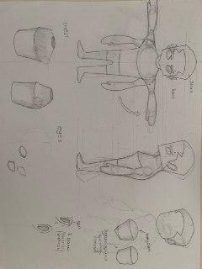Picture 1.1 The main hero of the game and his concept

Picture 1.2 The main hero of the game and his concept

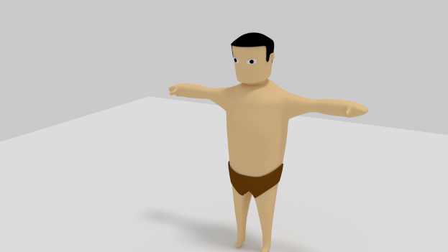

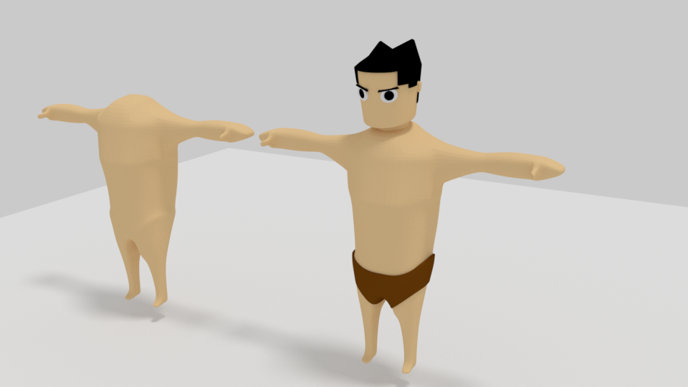

Picture 1.3 The main hero of the game and his concept

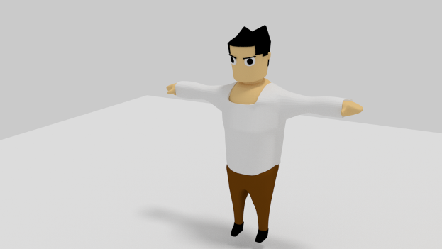

Picture 1.4 The main hero of the game and his concept

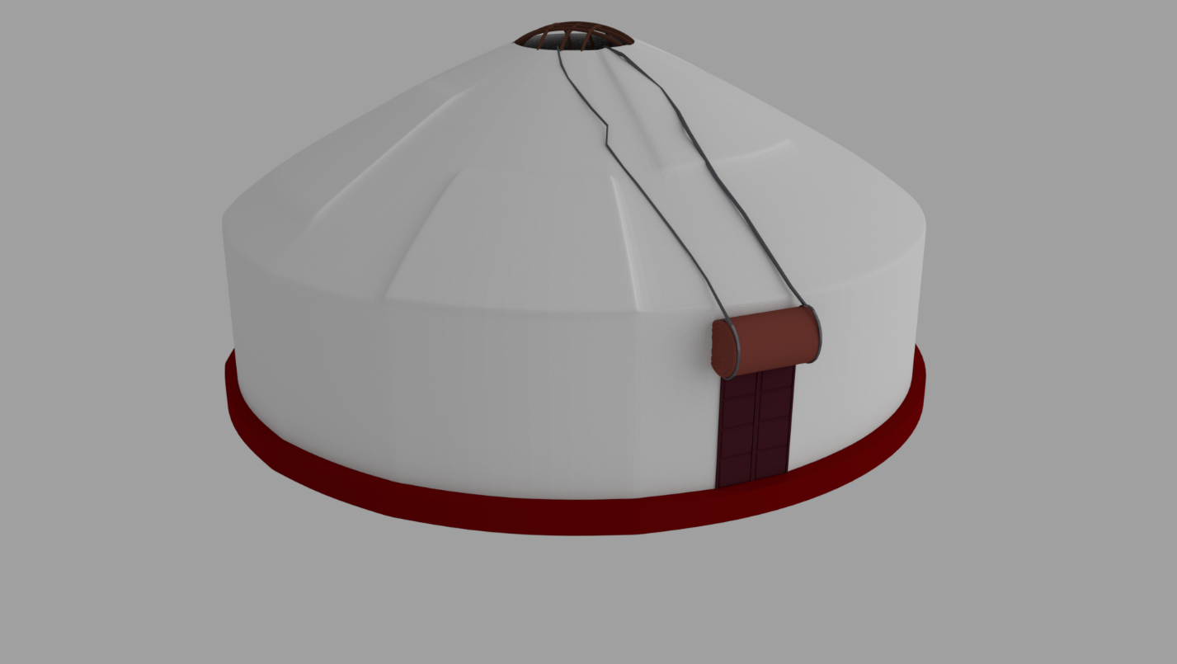

Picture 2.1 (Киiз уй)The main concept (in the game you will meet different versions of it)

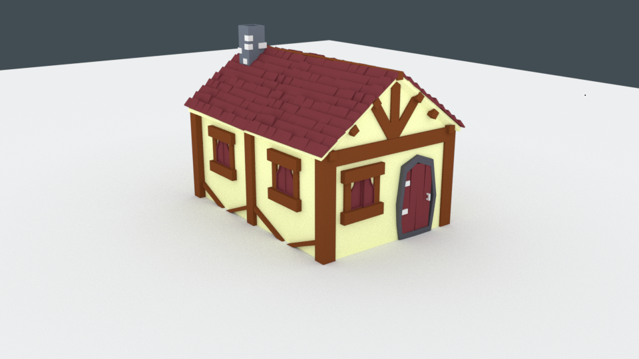Picture 2.2 One of the houses from the game

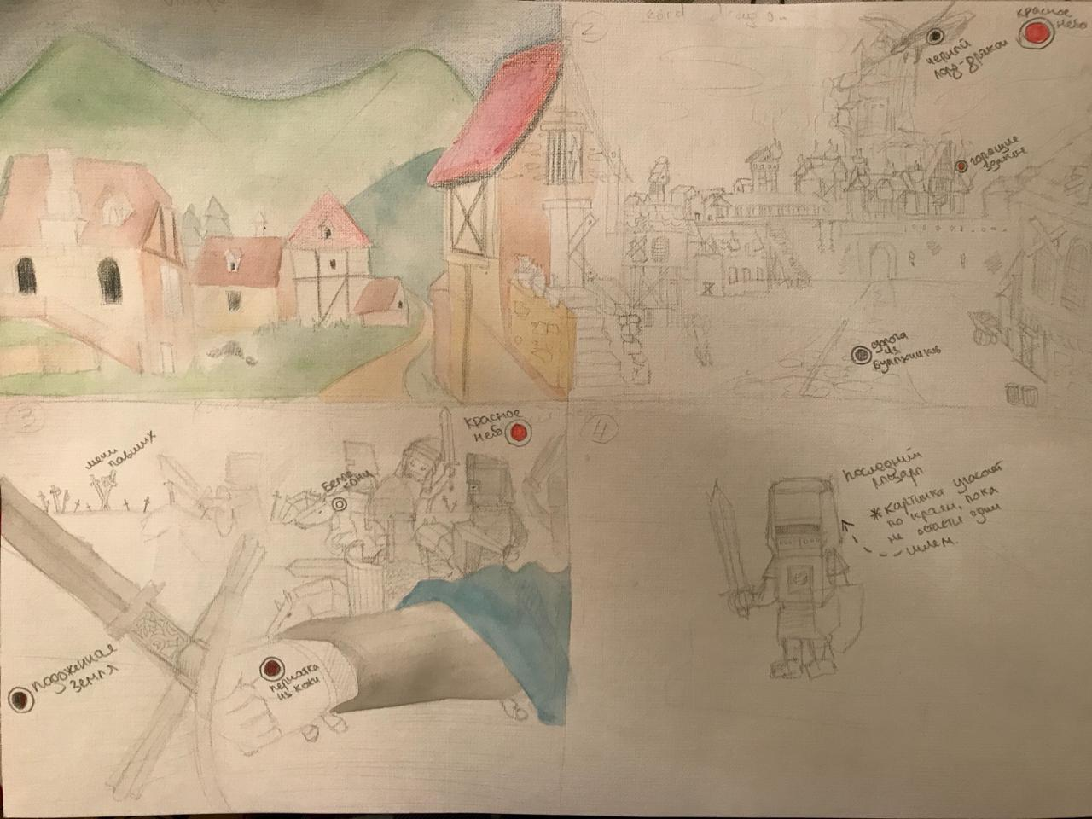

Picture 3.1 One of the houses from the game

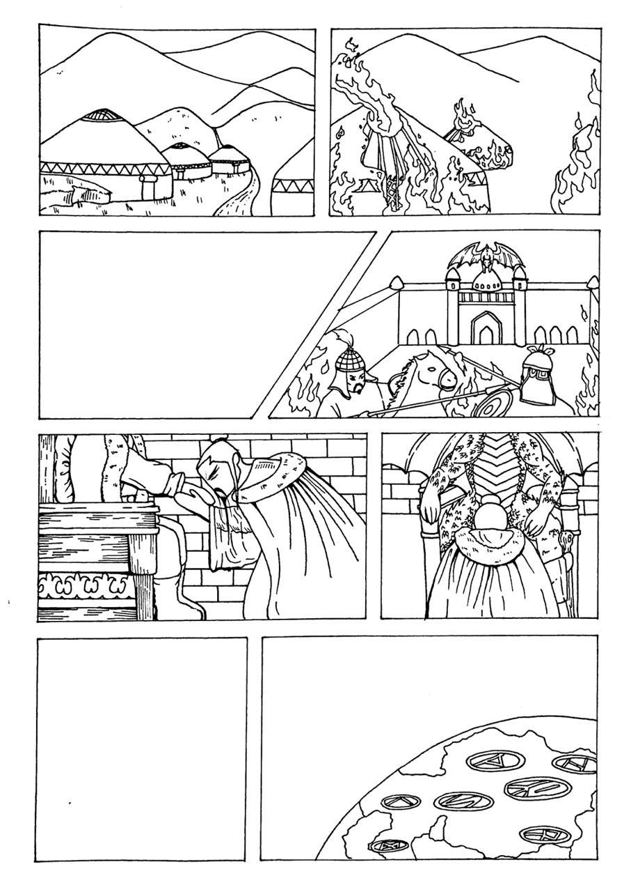

Picture 3.2 One of the houses from the game