**Practical-2**

**Aim**: **Consider the sample of 50 students. Gather the university exam score**

**of the students across all semesters of Engineering for one college.**

**Write a program to find out mean and standard deviation for this**

**college. Now consider the sample of students of different colleges of**

**Gujarat for university exam score. Write a program to find out mean**

**and standard deviation. Write the observations.**

**Program:**

# To import libraries

import pandas as pd

# To import File and print first 5 records of RNGPIT college

college1=pd.read_csv("/content/prac_2_dataset - Sheet1.csv")

print(college1.head())

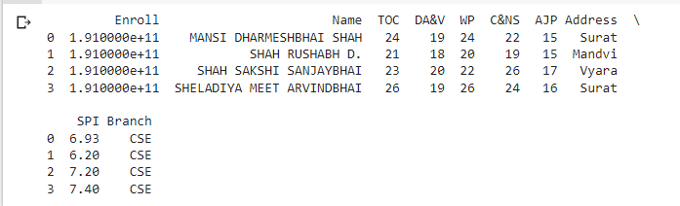

**#** Calculating Average and Standard Deviation of RNGPIT college

average_marks=college1.loc[:,"Average"]

print("The mean of RNGPIT college is:"+str(average_marks.mean()))

print("The Standard Deviation of RNGPIT college is:"+str(average_marks.std()))



# To import File and print first 5 records of college2

college2=pd.read_csv("/content/college2.csv")

print(college2.head())

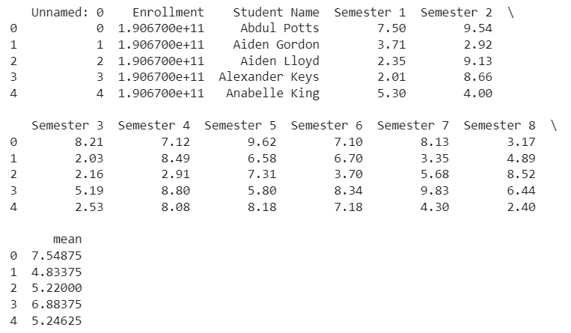

**#** Calculating Average and Standard Deviation of college2

average_marks=college2.loc[:,"mean"]

print("The mean of college2 is:"+str(average_marks.mean()))

print("The Standard Deviation of college2 is:"+str(average_marks.std()))

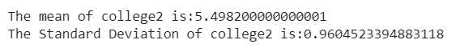

**#** To import File and print first 5 records of college3

college3=pd.read_excel("/content/college-3.xlsx")

print(college3.head())

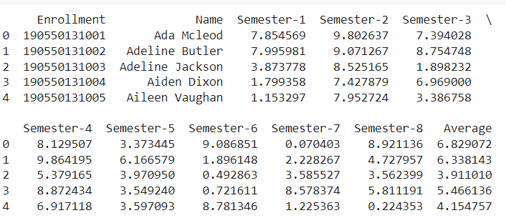

**#** Calculating Average and Standard Deviation of college3

average_marks=college3.loc[:,"Average"]

print("The mean of college3 is:"+str(average_marks.mean()))

print("The Standard Deviation of college3 is:"+str(average_marks.std()))



**#** To import File and print last 5 records of college4

college4=pd.read_excel("/content/College4.xlsx")

print(college4.tail())

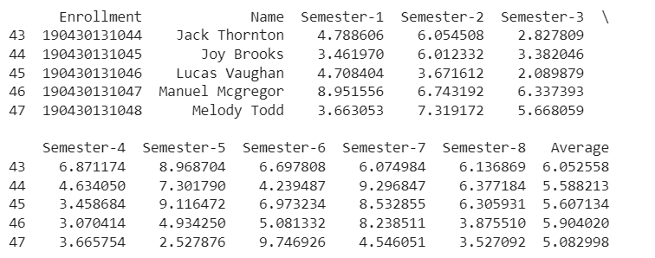

**#** Calculating Average and Standard Deviation of college4

average_marks=college4.loc[:,"Average"]

print("The mean of college4 is:"+str(average_marks.mean()))

print("The Standard Deviation of college4 is:"+str(average_marks.std()))



**#** To import File and print first 5 records of college5

college5=pd.read_csv("/content/college1.csv")

print(college5.head())

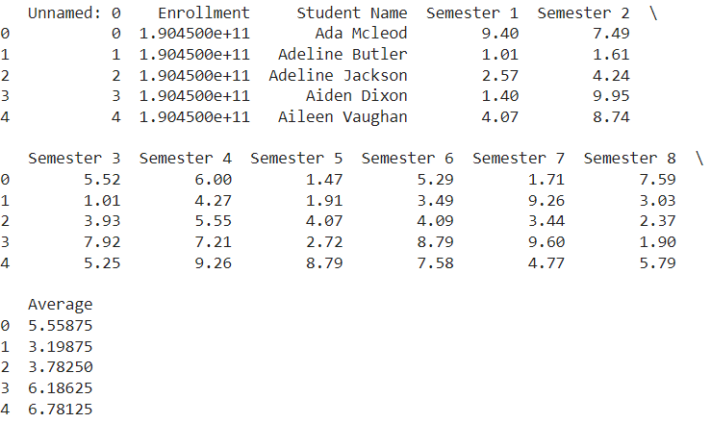

**#** Calculating Average and Standard Deviation of college5

average_marks=college5.loc[:,"Average"]

print("The mean of college5 is:"+str(average_marks.mean()))

print("The Standard Deviation of college5 is:"+str(average_marks.std()))

