**Practical-3**

**Aim**: **Collect the month wise COVID cases data for cities – Ahmedabad,**

**Vadodara, Rajkot, Surat. Plot this time series Data. Analyze the trend**

**as per time.**

**Program:**

# To import libraries

import pandas as pd

import matplotlib.pyplot as plt

# To import File and print month wise COVID records of Surat city

surat=pd.read_csv("/content/Surat_covid.csv")

print(surat)

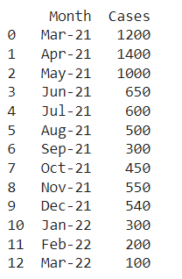

**#** Line plot of COVID cases in Surat city

plt.plot(surat['Month'],surat['Cases'],c='b')

plt.xlabel('Month')

plt.ylabel('Number of Cases')

plt.xticks(rotation=30)

plt.show()

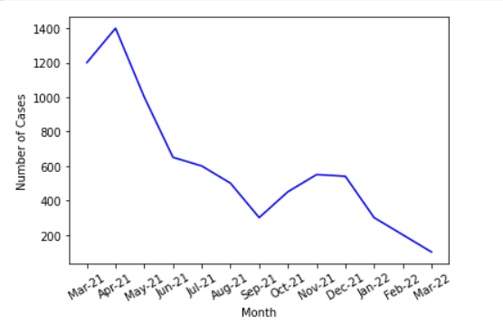

# To import File and print month wise COVID records of Ahmedabad city

ahmedabad=pd.read_csv("/content/Ahmedabad_covid.csv")

print(ahmedabad)

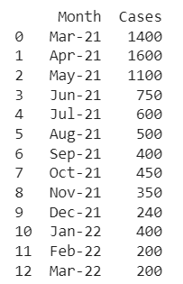

**#** Line plot of COVID cases in Ahmedabad city

plt.plot(ahmedabad['Month'],ahmedabad['Cases'],c='m')

plt.xlabel('Month')

plt.ylabel('Number of Cases')

plt.xticks(rotation=30)

plt.show()

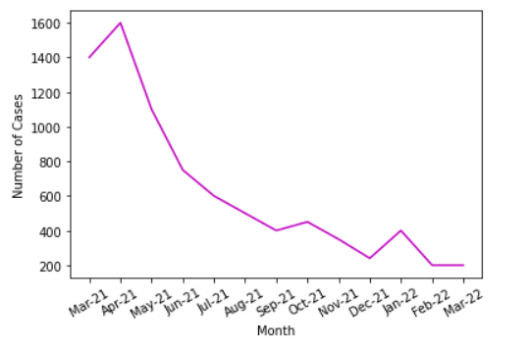

# To import File and print month wise COVID records of Vadodara city

vadodara=pd.read_csv("/content/Vadodara_covid.csv")

print(vadodara)

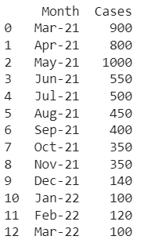

**#** Line plot of COVID cases in Vadodara city

plt.plot(vadodara['Month'],vadodara['Cases'],c='y')

plt.xlabel('Month')

plt.ylabel('Number of Cases')

plt.xticks(rotation=30)

plt.show()

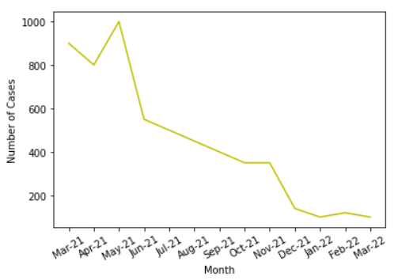

# To import File and print month wise COVID records of Rajkot city

rajkot=pd.read_csv("/content/Rajkot_covid.xlsx.csv")

print(rajkot)

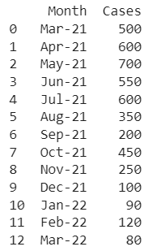

**#** Line plot of COVID cases in Rajkot city

plt.plot(rajkot['Month'],rajkot['Cases'],c='g')

plt.xlabel('Month')

plt.ylabel('Number of Cases')

plt.xticks(rotation=30)

plt.show()

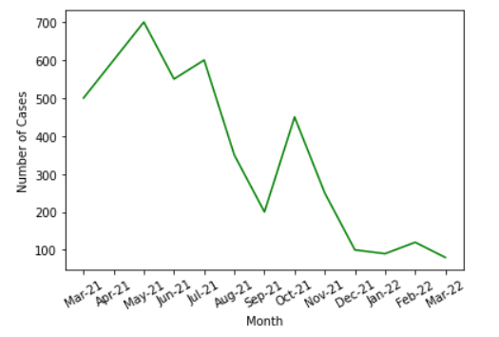

# To plot multiple line graph for analysis of all above cities

plt.plot(ahmedabad['Month'],ahmedabad['Cases'],c='m')

plt.plot(surat['Month'],surat['Cases'],c='b')

plt.plot(vadodara['Month'],vadodara['Cases'],c='y')

plt.plot(rajkot['Month'],rajkot['Cases'],c='g')

plt.xlabel('Month')

plt.ylabel('Number of Cases')

plt.xticks(rotation=30)

plt.legend(['Ahmedabad','Surat','Vadodara','Rajkot'])

plt.show()

