**Practical-5**

**Aim**: **Consider the following data set.**

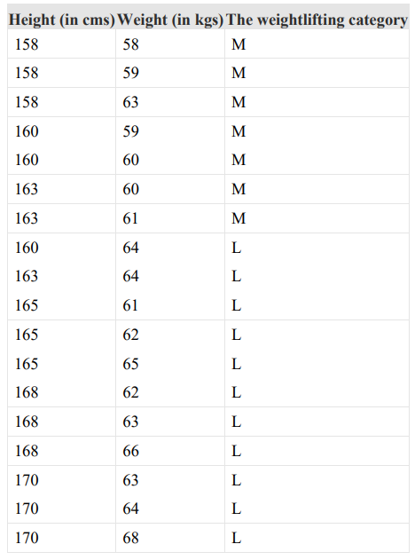

**Write a program for KNN algorithm to find out weight lifting**

**category for height 161cm and weight 61kg.**

**Program:**

# To import libraries

import pandas as pd

# To import dataset and print first 10 records

df=pd.read_csv("/content/Pr.csv")

df.head(10)

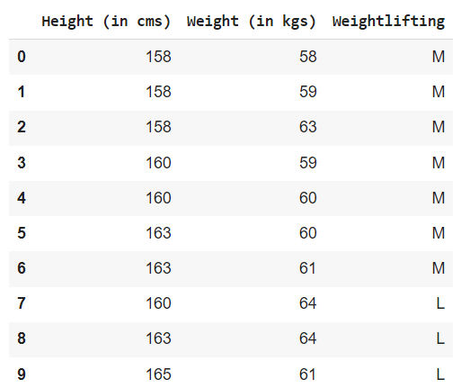

**#** Converting labels into list

labels_lst=list(df['Weightlifting'])

print(labels_lst)



# Converting features(height and weight) into list of tuples and printing first 9 elements of list

features=list(zip(df['Height (in cms)'],df['Weight (in kgs)']))

print(features[:9])



**#** Importing and training the KNN Classifier model

from sklearn.model_selection import train_test_split

x_train, x_test, y_train, y_test=train_test_split(features, labels_lst,test_size=0.2,random_state=3)

from sklearn.neighbors import KNeighborsClassifier

knn=KNeighborsClassifier(n_neighbors=3, weights="distance", metric="euclidean")

knn.fit(x_train,y_train)



# Accuracy of the model

from sklearn.metrics import accuracy_score

y_pred=knn.predict(x_test)

print("Accuracy of test set=",accuracy_score(y_test, y_pred)*100)



**#** predicting the class of random values of features

print(knn.predict([[161,61]]))

