**Practical-6**

**Aim**: **Take the data of the students prepared in exercise 1. Visualize the data**

**to show region wise results, branch wise results, subject wise results.**

**Decide the visualization technique to show appropriate data.(bar chart,**

**pie chart, maps, scatter plot).**

**Program:**

# To import libraries

import numpy as np

import pandas as pd

import matplotlib.pyplot as plt

**# Region Wise Results comparison**

# To read dataset and grouping address and taking mean of it

df = pd.read_csv('Student_Dataset_1.csv')

mean2 = list(df.groupby(['Address'])['SPI'].mean())

mean2

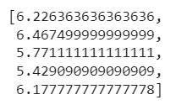

**#** Counts of cities and how many students are there in every city

df['Address'].value_counts()

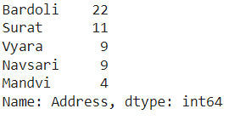

# Plotting bar graph of Cities and SPI

cities = ['Bardoli','Vyara','Mandavi','Surat','Navsari']

plt.bar(cities, mean2, color='r')

plt.title("Region Wise Results")

plt.xlabel("Address")

plt.ylabel("Average SPI")

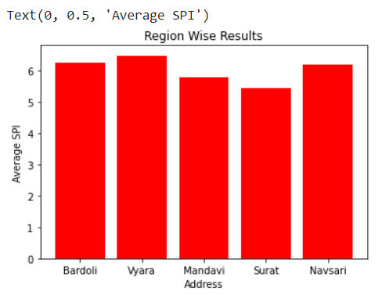

**# Subject Wise Results comparison**

**#** Calculating mean of every subjects

meantoc = df['TOC'].mean()

meanDAV = df['DA&V'].mean()

meanWP = df['WP'].mean()

meanCNS = df['C&NS'].mean()

meanAJ = df['AJP'].mean()

# Storing every subject mean value in mean list

mean = []

mean.append(meantoc)

mean.append(meanDAV)

mean.append(meanWP)

mean.append(meanCNS)

mean.append(meanAJ)

print(mean)

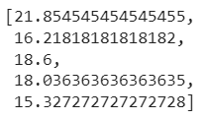

# Plotting bar graph of Subject and average score of that subject

Subjects = ['TOC','DA&V','WP','C&NS','AJP']

plt.bar(Subjects, mean, color='blue')

plt.title("Subject Wise Results")

plt.xlabel("Subjects")

plt.ylabel("Average Score")

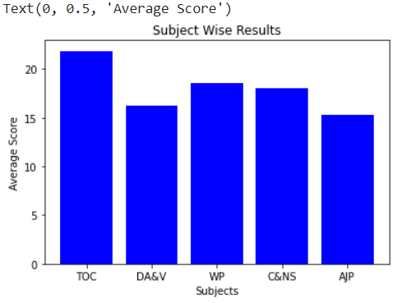

**# Branch Wise Results comparison**

# Grouping branch and taking mean of it

mean3 = list(df.groupby(['Branch'])['SPI'].mean())

print(mean3)



# Counts of branch and how many students are there in every branch

df['Branch'].value_counts()

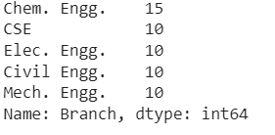

# Plotting bar graph of branch and Average SPI

branches = ['Chem. Engg.','CSE','Elec. Engg.','Civil Engg.','Mech. Engg.']

plt.bar(branches, mean3, color='pink')

plt.title("Branch Wise Results")

plt.xlabel("Branch")

plt.ylabel("Average SPI")

