Sandusky Bay Light 2020

Ryan Wagner

03/20/2023

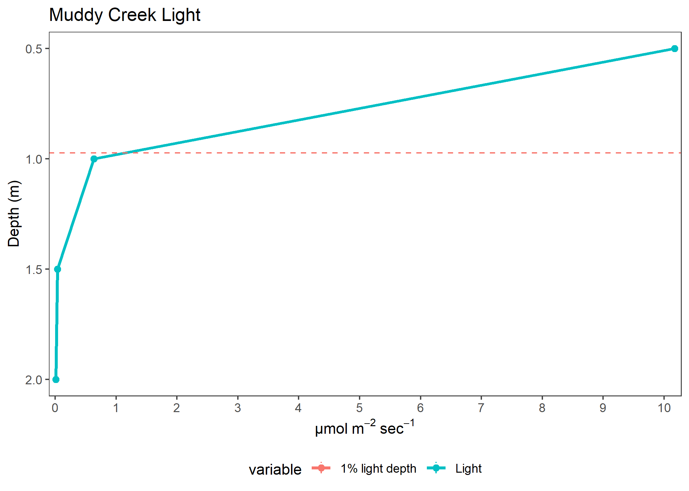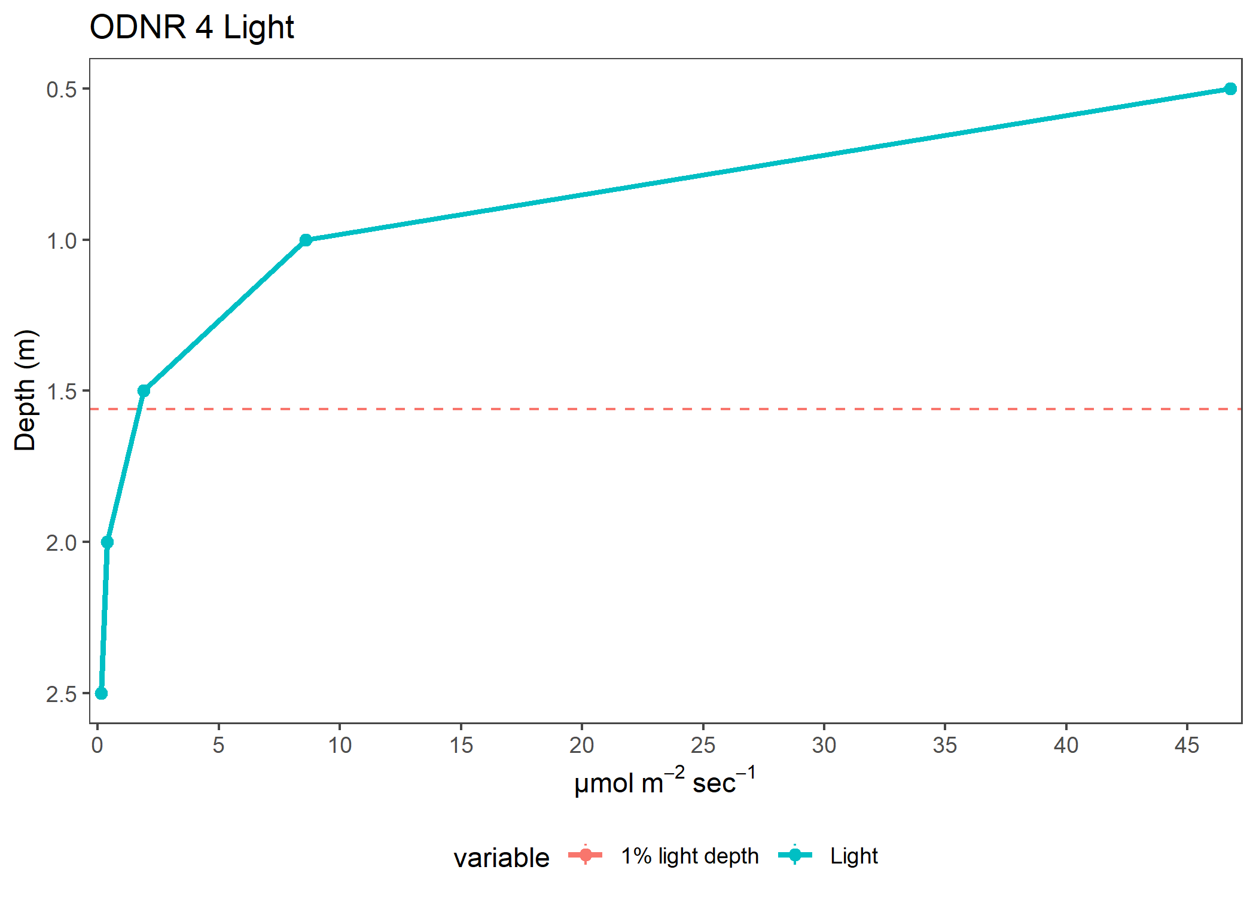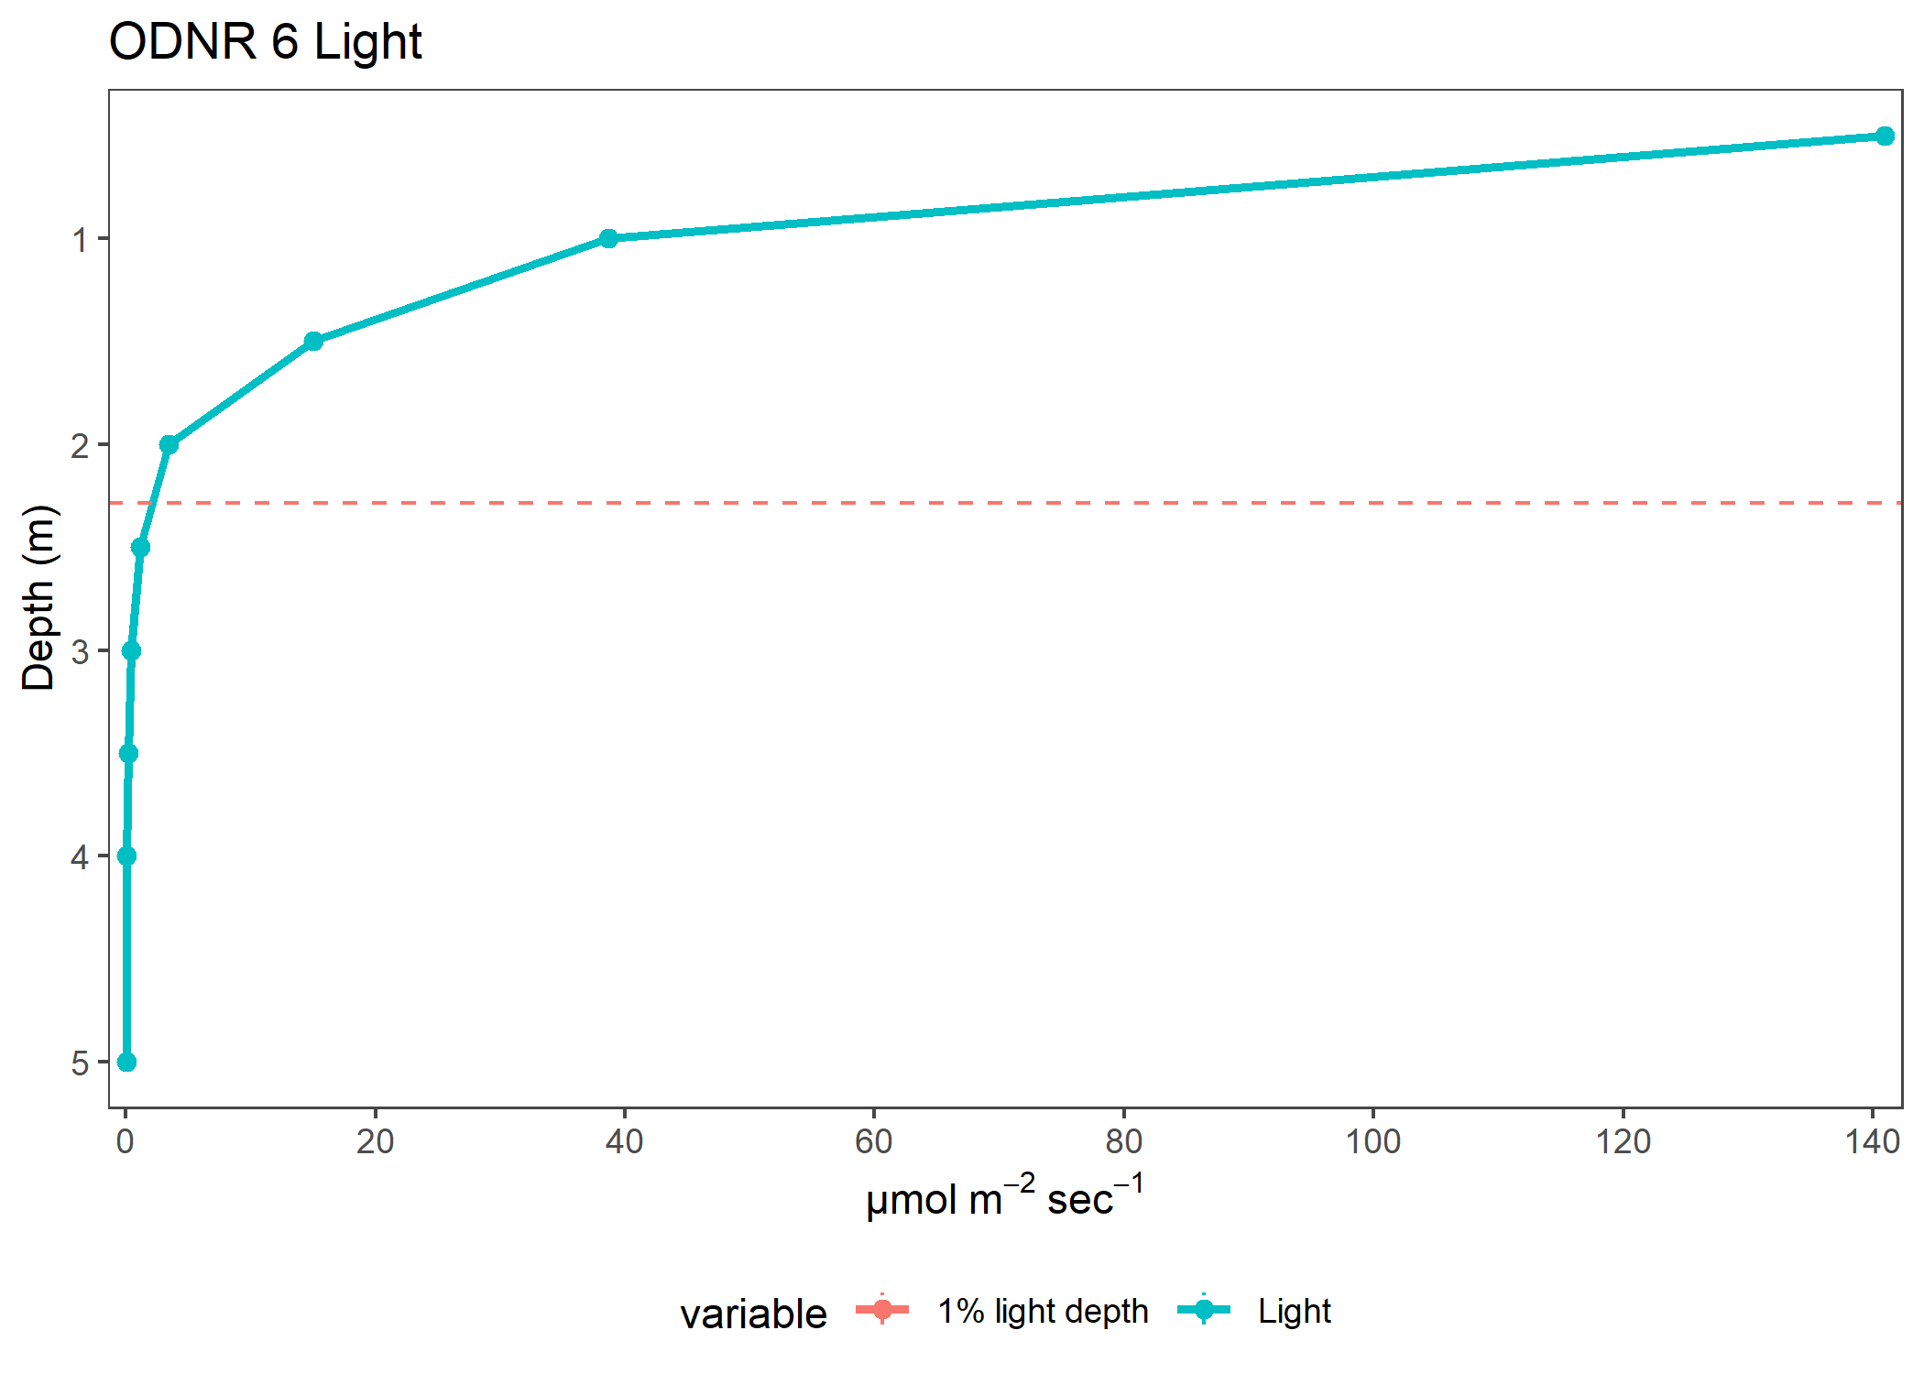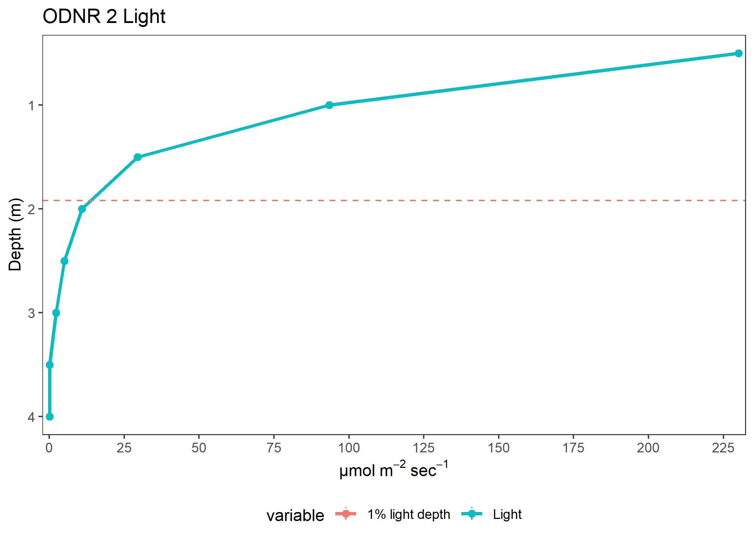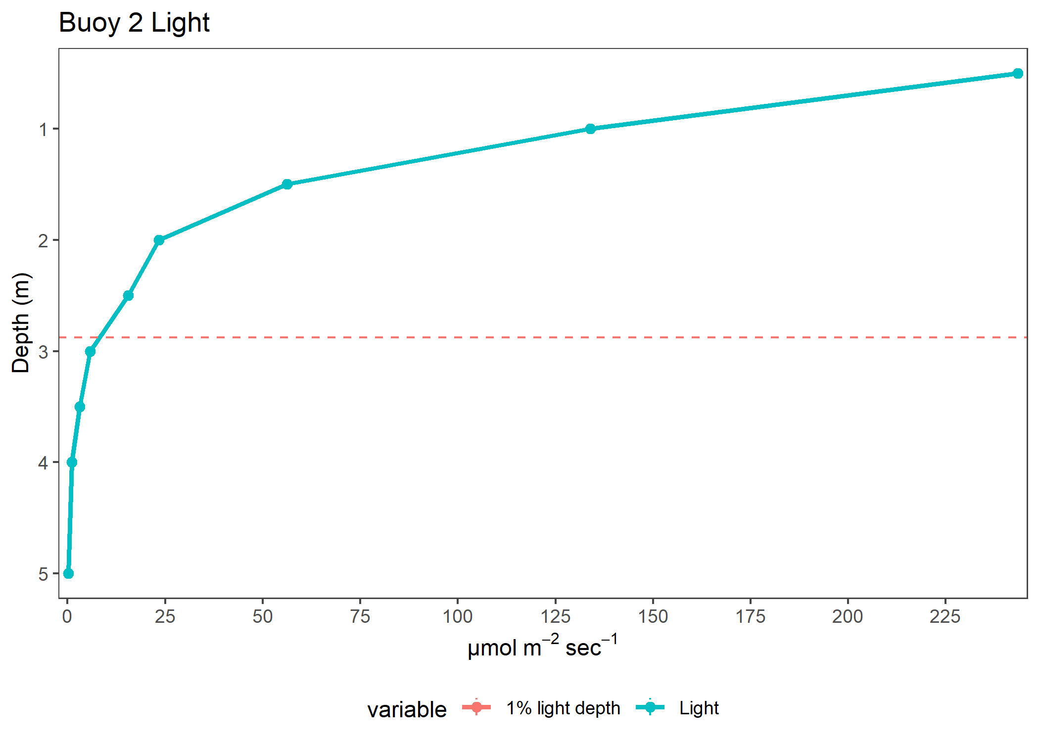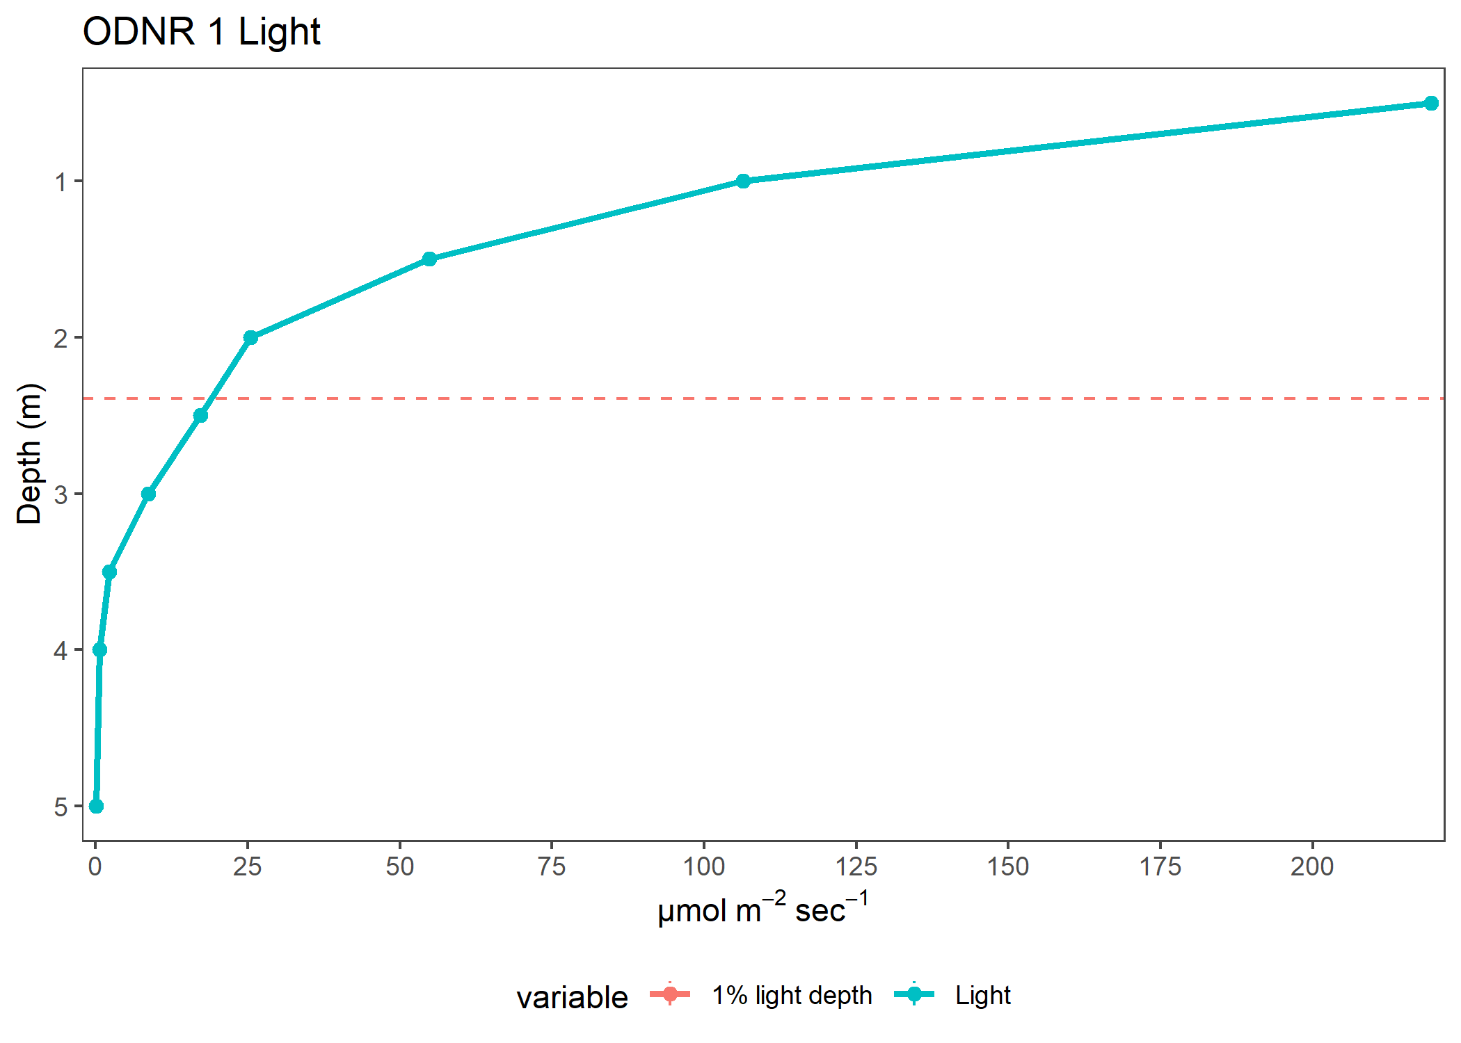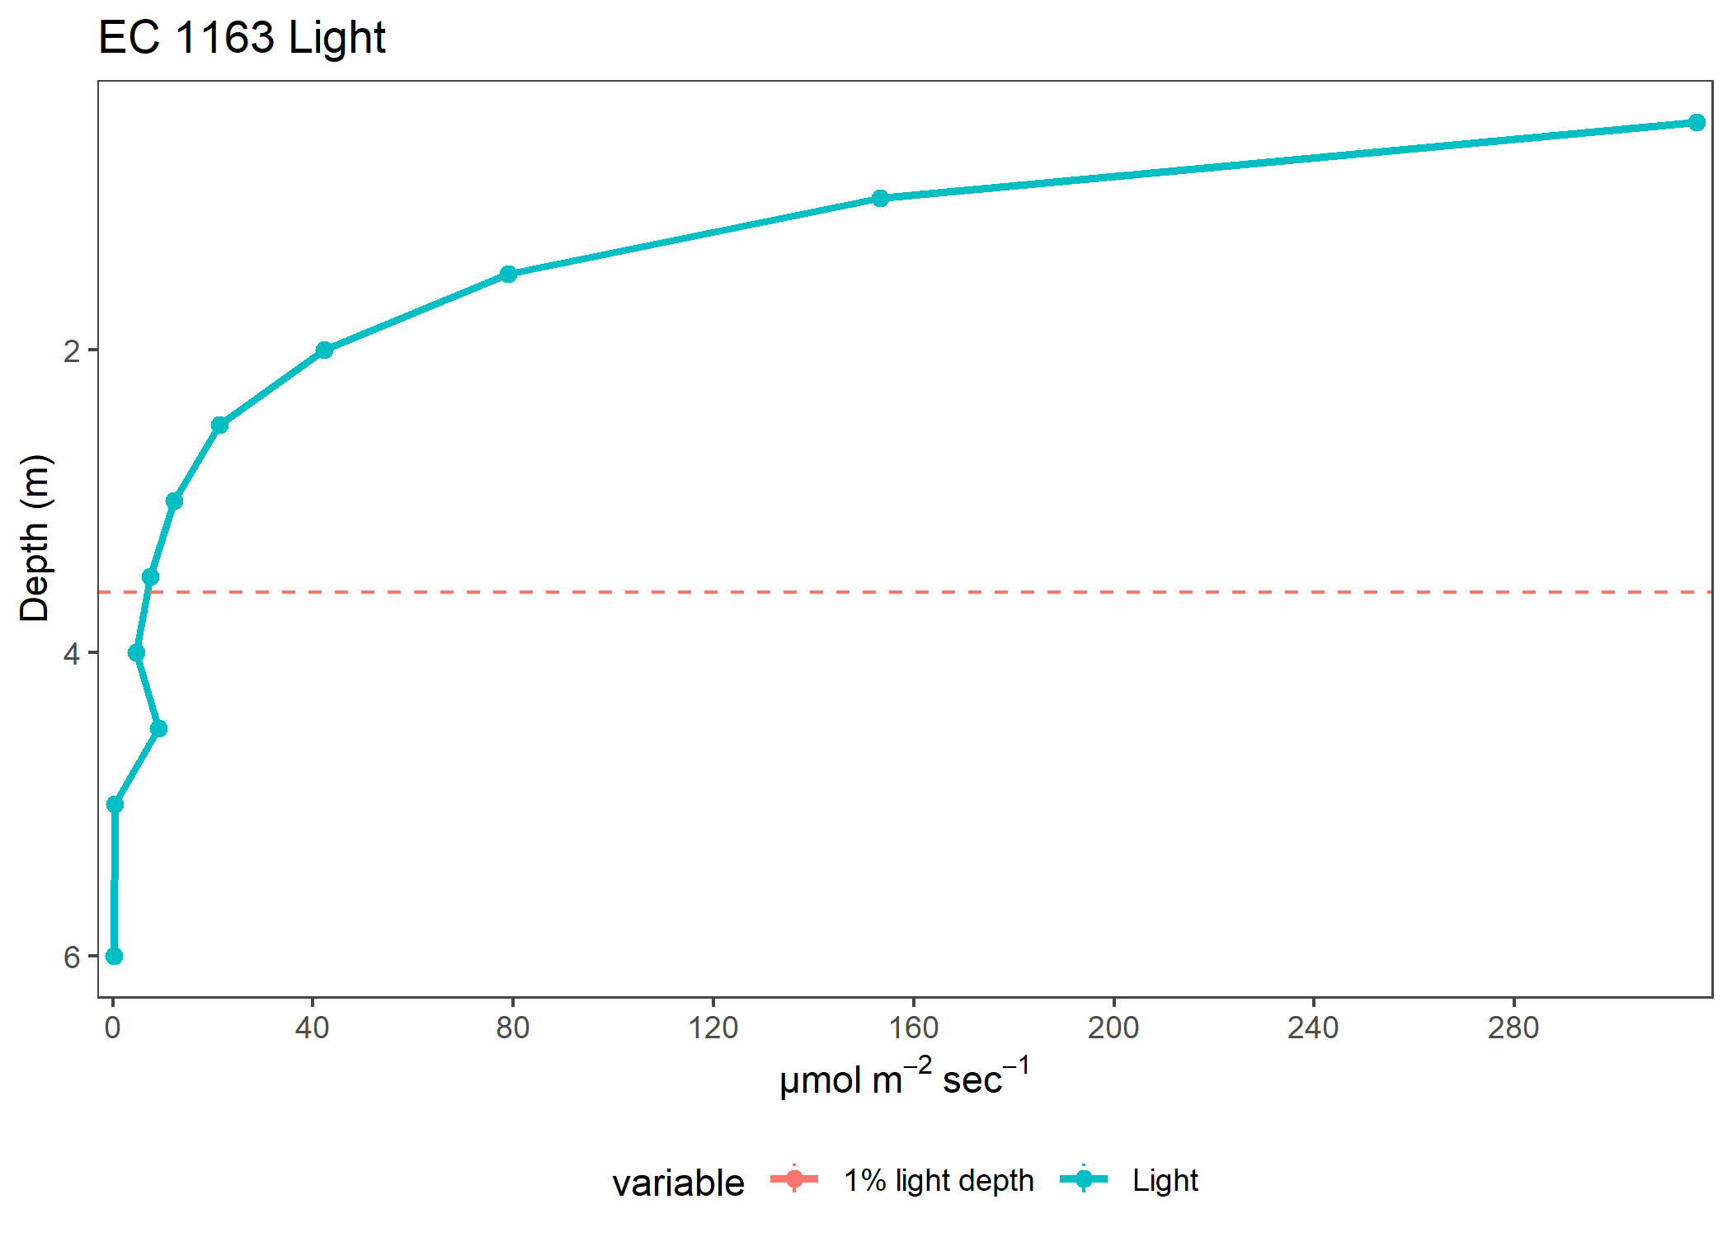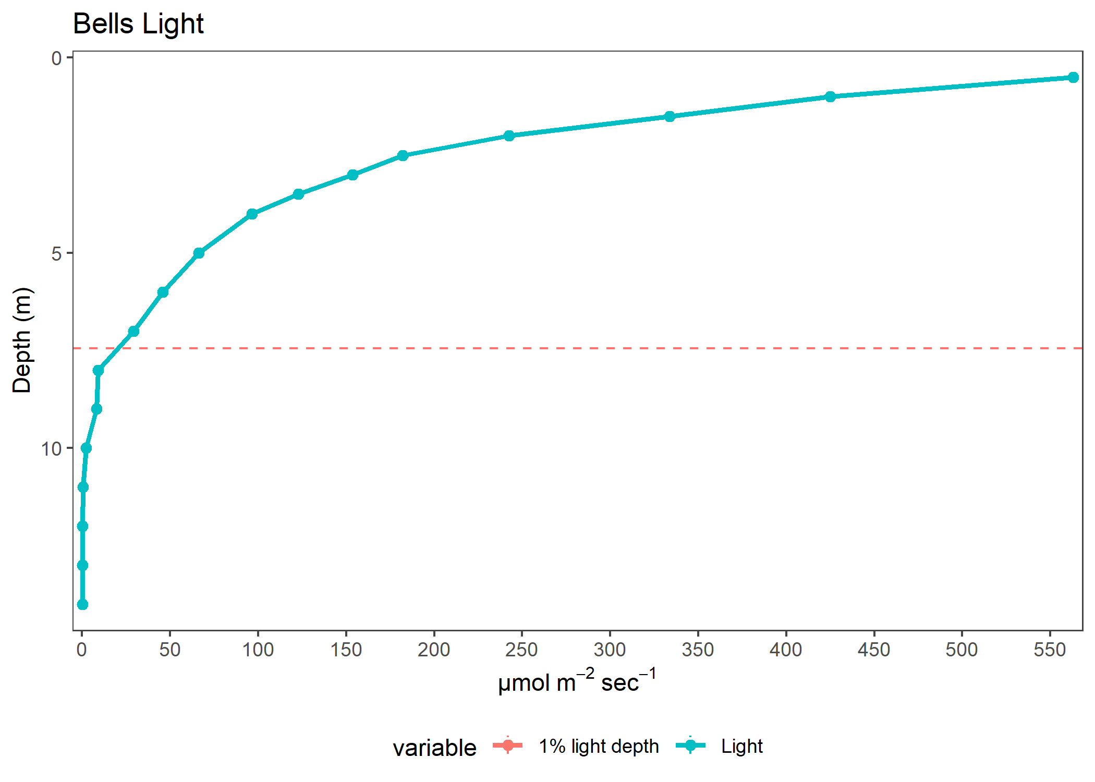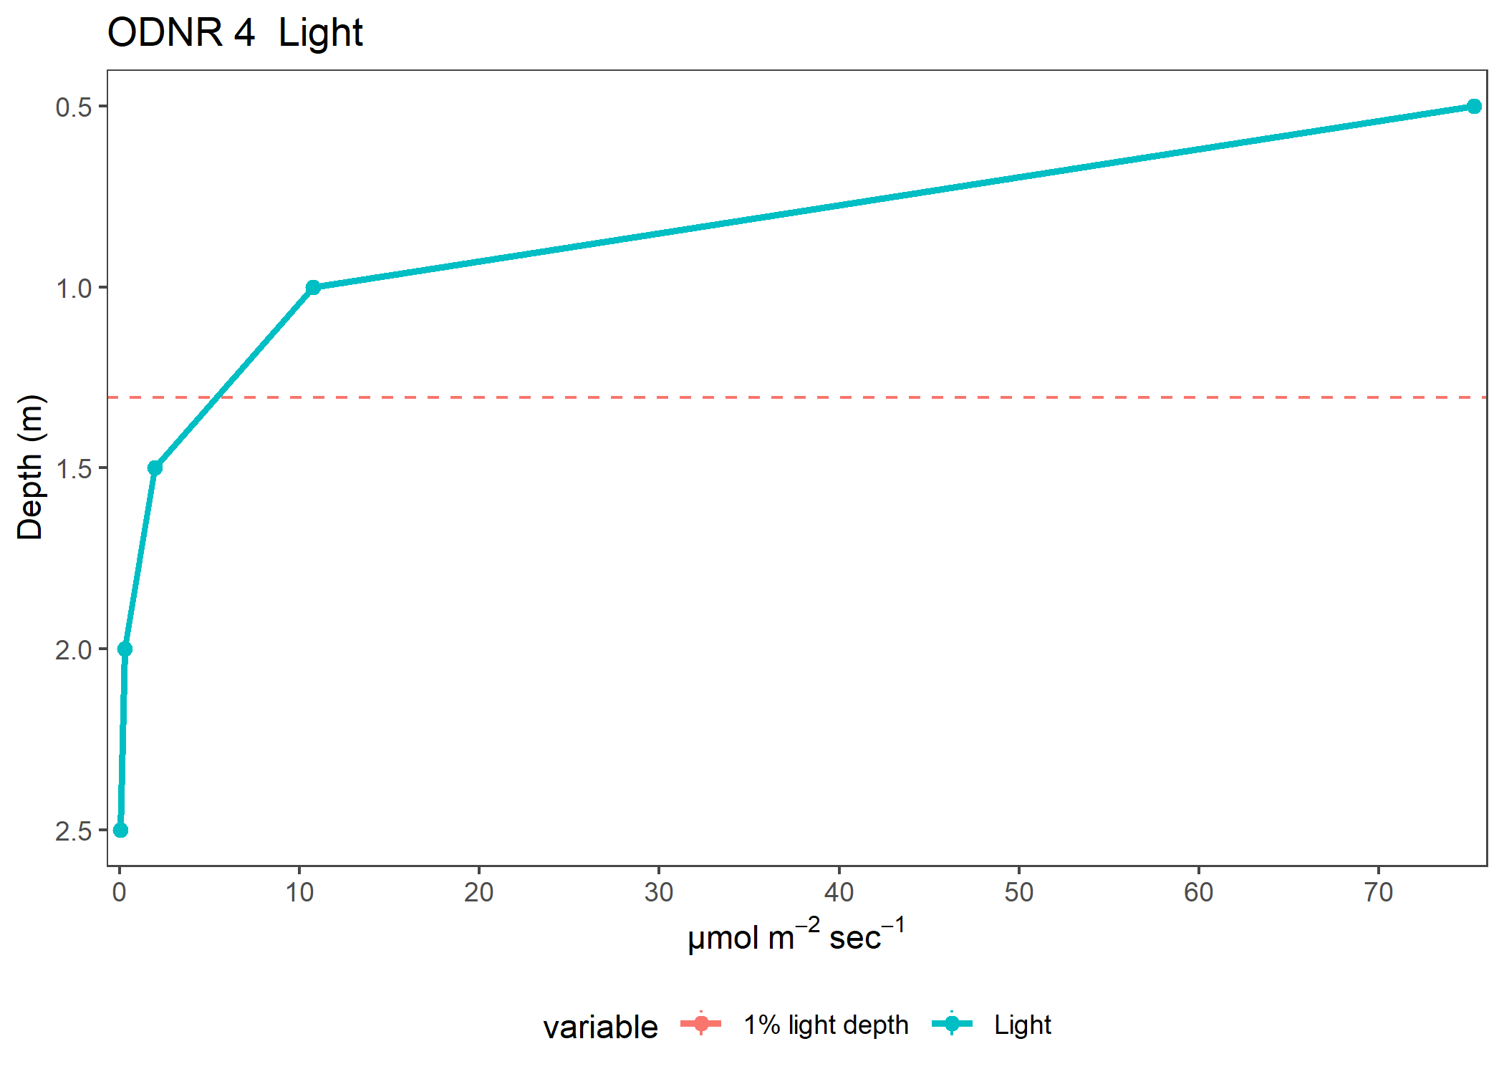

| variable | Depth | Site | Year | K_avg | value | plot |
| --- | --- | --- | --- | --- | --- | --- |
| Light | 0.5 | Muddy Creek | 2020 | 6.6309116 | 10.1730000 | Light |
| Light | 1.0 | Muddy Creek | 2020 | 6.6309116 | 0.6361111 | Light |
| Light | 1.5 | Muddy Creek | 2020 | 6.6309116 | 0.0357143 | Light |
| Light | 2.0 | Muddy Creek | 2020 | 6.6309116 | 0.0100000 | Light |
| Light | 0.5 | ODNR 4 | 2020 | 4.0633572 | 46.7750000 | Light |
| Light | 1.0 | ODNR 4 | 2020 | 4.0633572 | 8.5980000 | Light |
| Light | 1.5 | ODNR 4 | 2020 | 4.0633572 | 1.9080000 | Light |
| Light | 2.0 | ODNR 4 | 2020 | 4.0633572 | 0.3912500 | Light |
| Light | 2.5 | ODNR 4 | 2020 | 4.0633572 | 0.1375000 | Light |
| Light | 0.5 | ODNR 6 | 2020 | 2.9922240 | 140.9865000 | Light |
| Light | 1.0 | ODNR 6 | 2020 | 2.9922240 | 38.6810000 | Light |
| Light | 1.5 | ODNR 6 | 2020 | 2.9922240 | 15.0585000 | Light |
| Light | 2.0 | ODNR 6 | 2020 | 2.9922240 | 3.4460000 | Light |
| Light | 2.5 | ODNR 6 | 2020 | 2.9922240 | 1.1690000 | Light |
| Light | 3.0 | ODNR 6 | 2020 | 2.9922240 | 0.4207143 | Light |
| Light | 3.5 | ODNR 6 | 2020 | 2.9922240 | 0.1681667 | Light |
| Light | 4.0 | ODNR 6 | 2020 | 2.9922240 | 0.0400000 | Light |
| Light | 5.0 | ODNR 6 | 2020 | 2.9922240 | 0.0300000 | Light |
| Light | 0.5 | ODNR 2 | 2020 | 2.4396999 | 230.1155000 | Light |
| Light | 1.0 | ODNR 2 | 2020 | 2.4396999 | 93.4215000 | Light |
| Light | 1.5 | ODNR 2 | 2020 | 2.4396999 | 29.4045000 | Light |
| Light | 2.0 | ODNR 2 | 2020 | 2.4396999 | 10.8460000 | Light |
| Light | 2.5 | ODNR 2 | 2020 | 2.4396999 | 4.9805000 | Light |
| Light | 3.0 | ODNR 2 | 2020 | 2.4396999 | 2.2200000 | Light |
| Light | 3.5 | ODNR 2 | 2020 | 2.4396999 | 0.1150000 | Light |
| Light | 4.0 | ODNR 2 | 2020 | 2.4396999 | 0.0525000 | Light |
| Light | 0.5 | Buoy 2 | 2020 | 1.7820705 | 243.5015000 | Light |
| Light | 1.0 | Buoy 2 | 2020 | 1.7820705 | 133.9305000 | Light |
| Light | 1.5 | Buoy 2 | 2020 | 1.7820705 | 56.2485000 | Light |
| Light | 2.0 | Buoy 2 | 2020 | 1.7820705 | 23.3550000 | Light |
| Light | 2.5 | Buoy 2 | 2020 | 1.7820705 | 15.5030000 | Light |
| Light | 3.0 | Buoy 2 | 2020 | 1.7820705 | 5.7935000 | Light |
| Light | 3.5 | Buoy 2 | 2020 | 1.7820705 | 3.0942857 | Light |
| Light | 4.0 | Buoy 2 | 2020 | 1.7820705 | 1.1500000 | Light |
| Light | 5.0 | Buoy 2 | 2020 | 1.7820705 | 0.1550000 | Light |
| Light | 0.5 | ODNR 1 | 2020 | 1.8260268 | 219.5045000 | Light |
| Light | 1.0 | ODNR 1 | 2020 | 1.8260268 | 106.3805000 | Light |
| Light | 1.5 | ODNR 1 | 2020 | 1.8260268 | 54.8100000 | Light |
| Light | 2.0 | ODNR 1 | 2020 | 1.8260268 | 25.4010000 | Light |
| Light | 2.5 | ODNR 1 | 2020 | 1.8260268 | 17.2680000 | Light |
| Light | 3.0 | ODNR 1 | 2020 | 1.8260268 | 8.5915000 | Light |
| Light | 3.5 | ODNR 1 | 2020 | 1.8260268 | 2.2500000 | Light |
| Light | 4.0 | ODNR 1 | 2020 | 1.8260268 | 0.5900000 | Light |
| Light | 5.0 | ODNR 1 | 2020 | 1.8260268 | 0.0200000 | Light |
| Light | 0.5 | EC 1163 | 2020 | 1.7037714 | 316.4510000 | Light |
| Light | 1.0 | EC 1163 | 2020 | 1.7037714 | 153.2255000 | Light |
| Light | 1.5 | EC 1163 | 2020 | 1.7037714 | 78.9210000 | Light |
| Light | 2.0 | EC 1163 | 2020 | 1.7037714 | 42.3105000 | Light |
| Light | 2.5 | EC 1163 | 2020 | 1.7037714 | 21.4050000 | Light |
| Light | 3.0 | EC 1163 | 2020 | 1.7037714 | 12.2105556 | Light |
| Light | 3.5 | EC 1163 | 2020 | 1.7037714 | 7.4206250 | Light |
| Light | 4.0 | EC 1163 | 2020 | 1.7037714 | 4.7700000 | Light |
| Light | 4.5 | EC 1163 | 2020 | 1.7037714 | 9.1000000 | Light |
| Light | 5.0 | EC 1163 | 2020 | 1.7037714 | 0.4200000 | Light |
| Light | 6.0 | EC 1163 | 2020 | 1.7037714 | 0.1733333 | Light |
| Light | 0.5 | Bells | 2020 | 0.6487865 | 562.9021429 | Light |
| Light | 1.0 | Bells | 2020 | 0.6487865 | 424.8971429 | Light |
| Light | 1.5 | Bells | 2020 | 0.6487865 | 333.6535714 | Light |
| Light | 2.0 | Bells | 2020 | 0.6487865 | 242.5642857 | Light |
| Light | 2.5 | Bells | 2020 | 0.6487865 | 181.9907143 | Light |
| Light | 3.0 | Bells | 2020 | 0.6487865 | 153.7414286 | Light |
| Light | 3.5 | Bells | 2020 | 0.6487865 | 122.8150000 | Light |
| Light | 4.0 | Bells | 2020 | 0.6487865 | 96.5542857 | Light |
| Light | 5.0 | Bells | 2020 | 0.6487865 | 66.0978571 | Light |
| Light | 6.0 | Bells | 2020 | 0.6487865 | 45.7314286 | Light |
| Light | 7.0 | Bells | 2020 | 0.6487865 | 29.1521429 | Light |
| Light | 8.0 | Bells | 2020 | 0.6487865 | 9.1458333 | Light |
| Light | 9.0 | Bells | 2020 | 0.6487865 | 8.2340000 | Light |
| Light | 10.0 | Bells | 2020 | 0.6487865 | 2.3650000 | Light |
| Light | 11.0 | Bells | 2020 | 0.6487865 | 0.3887500 | Light |
| Light | 12.0 | Bells | 2020 | 0.6487865 | 0.2800000 | Light |
| Light | 13.0 | Bells | 2020 | 0.6487865 | 0.2650000 | Light |
| Light | 14.0 | Bells | 2020 | 0.6487865 | 0.2600000 | Light |
| Light | 0.5 | ODNR 4 | 2020 | 4.2557666 | 75.2650000 | Light |
| Light | 1.0 | ODNR 4 | 2020 | 4.2557666 | 10.7520000 | Light |
| Light | 1.5 | ODNR 4 | 2020 | 4.2557666 | 1.9470000 | Light |
| Light | 2.0 | ODNR 4 | 2020 | 4.2557666 | 0.3030000 | Light |
| Light | 2.5 | ODNR 4 | 2020 | 4.2557666 | 0.0666667 | Light |