Sandusky Bay Light 2021

Ryan Wagner

03/19/2023

read in data.

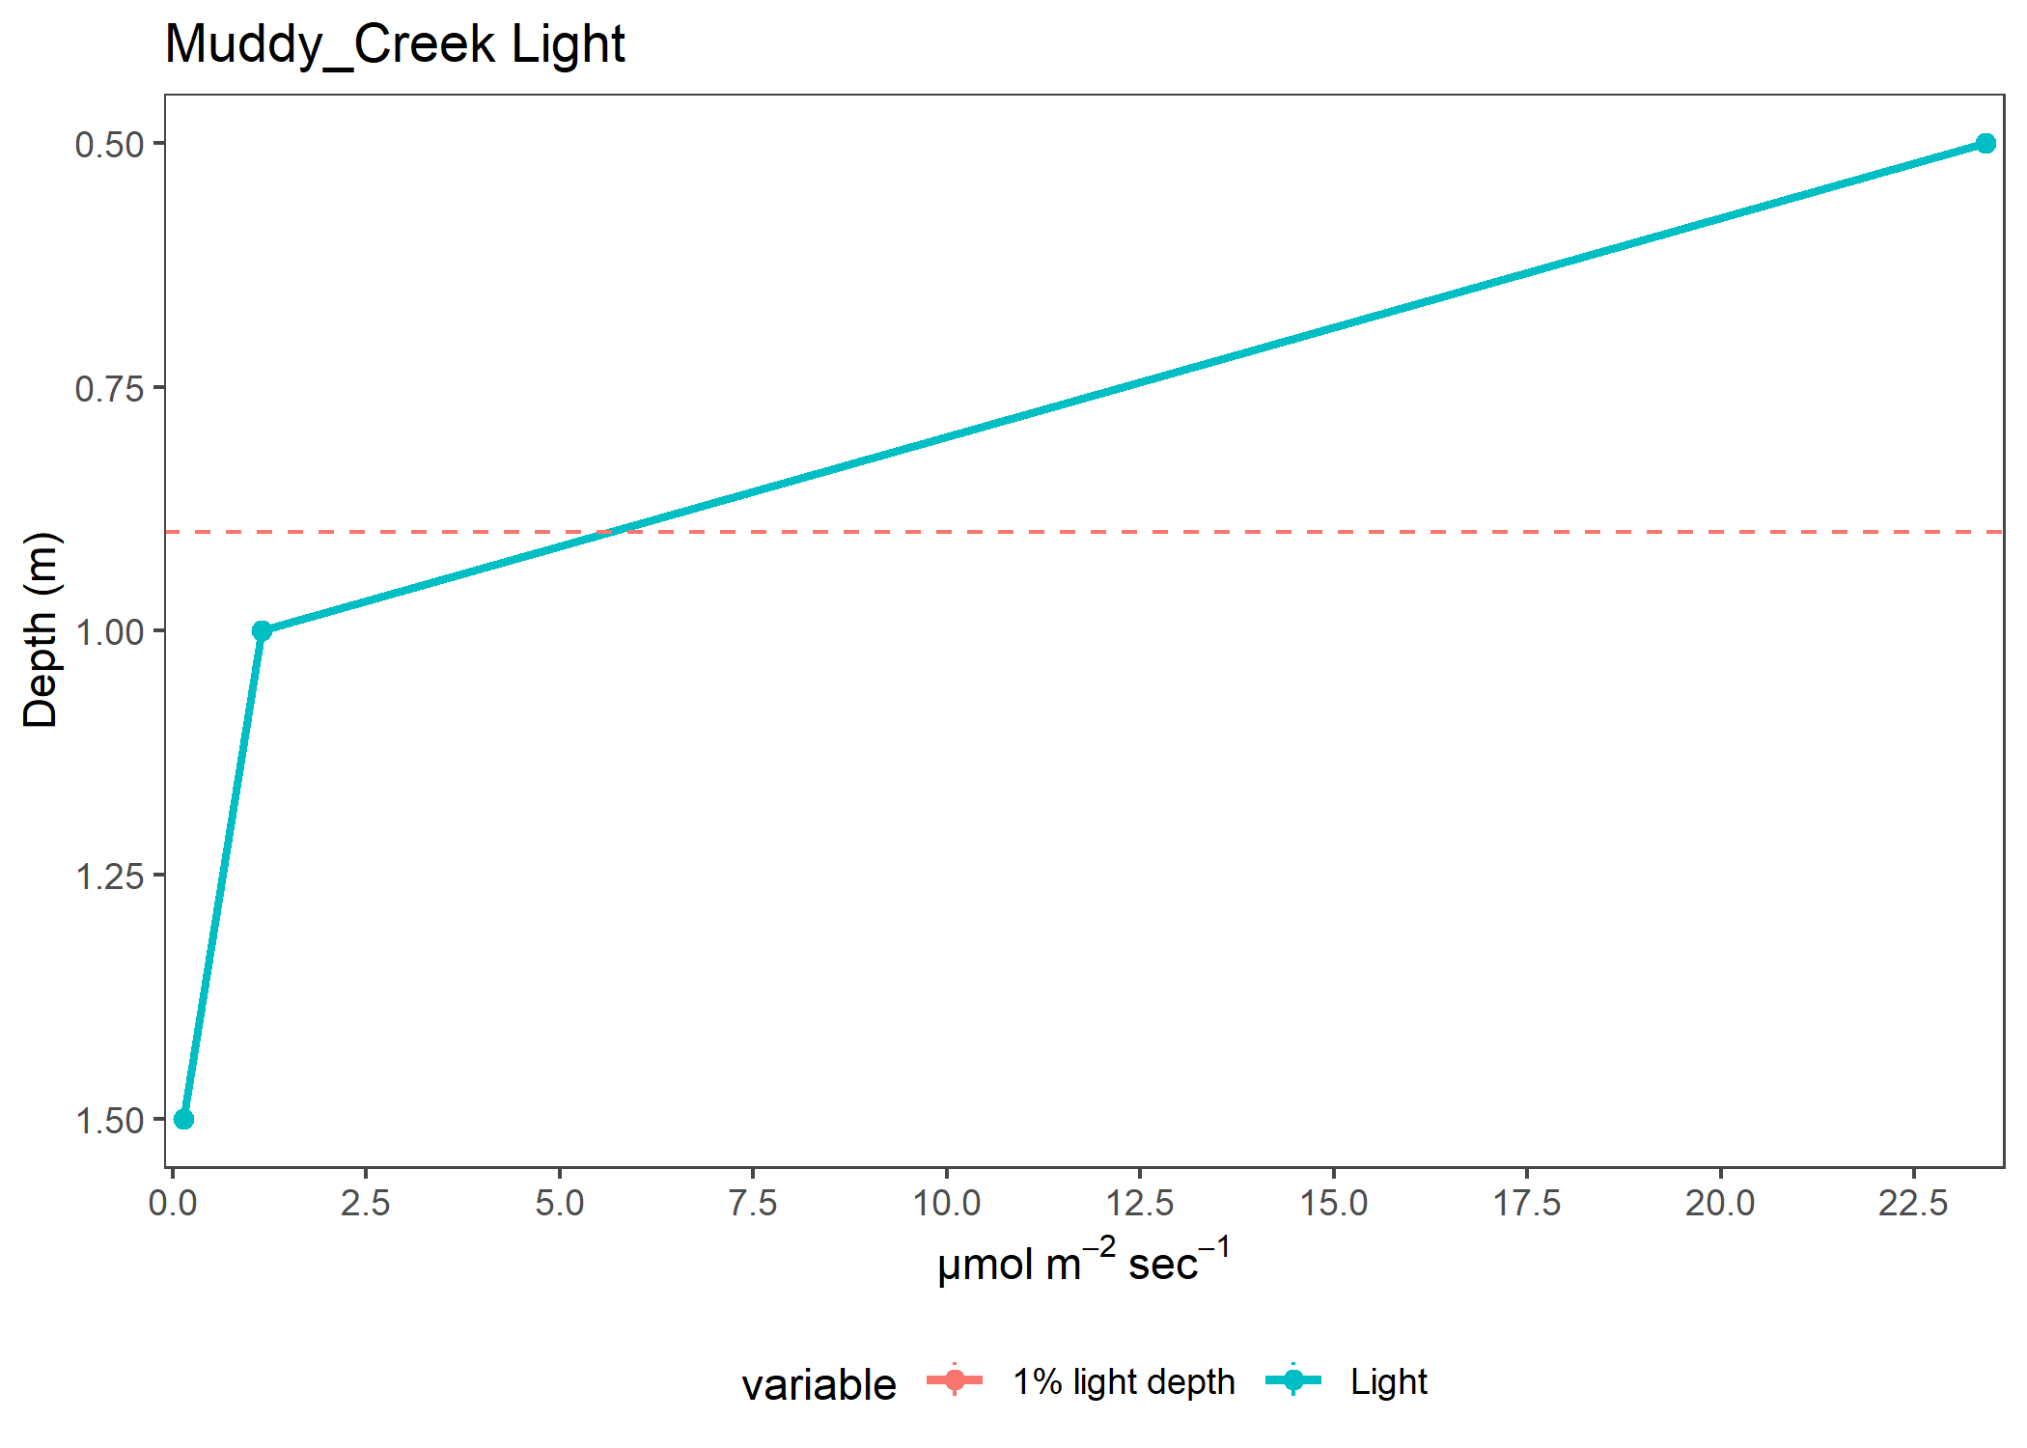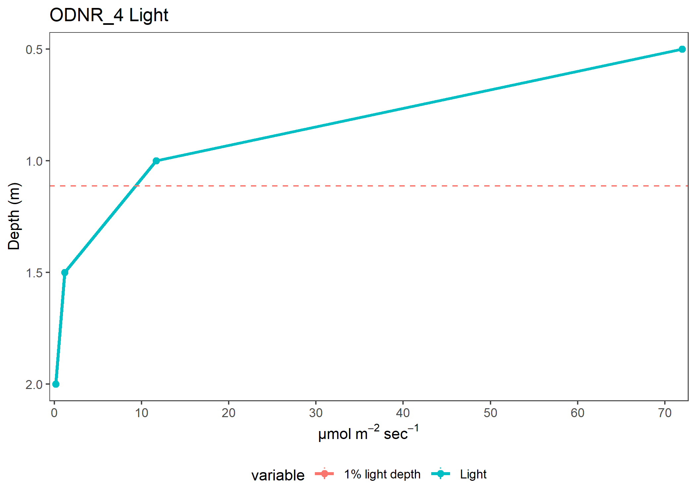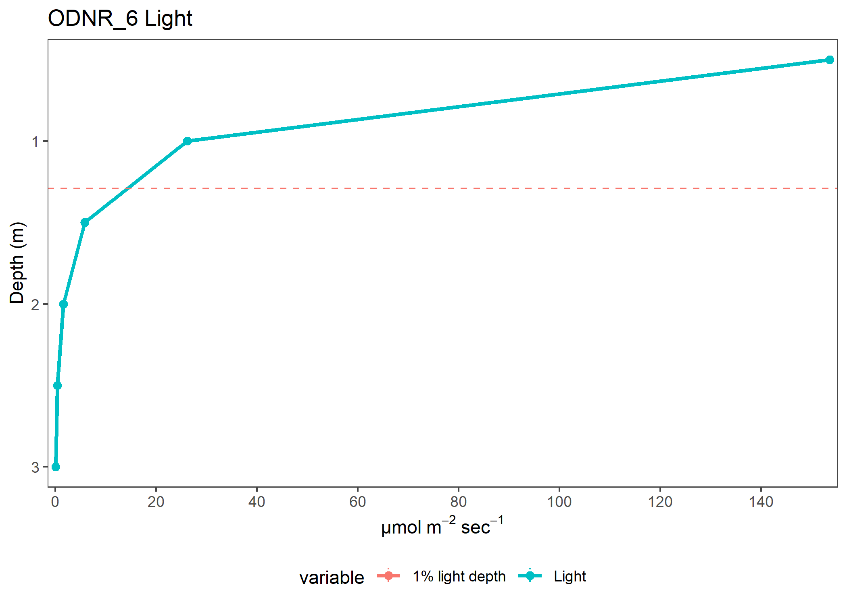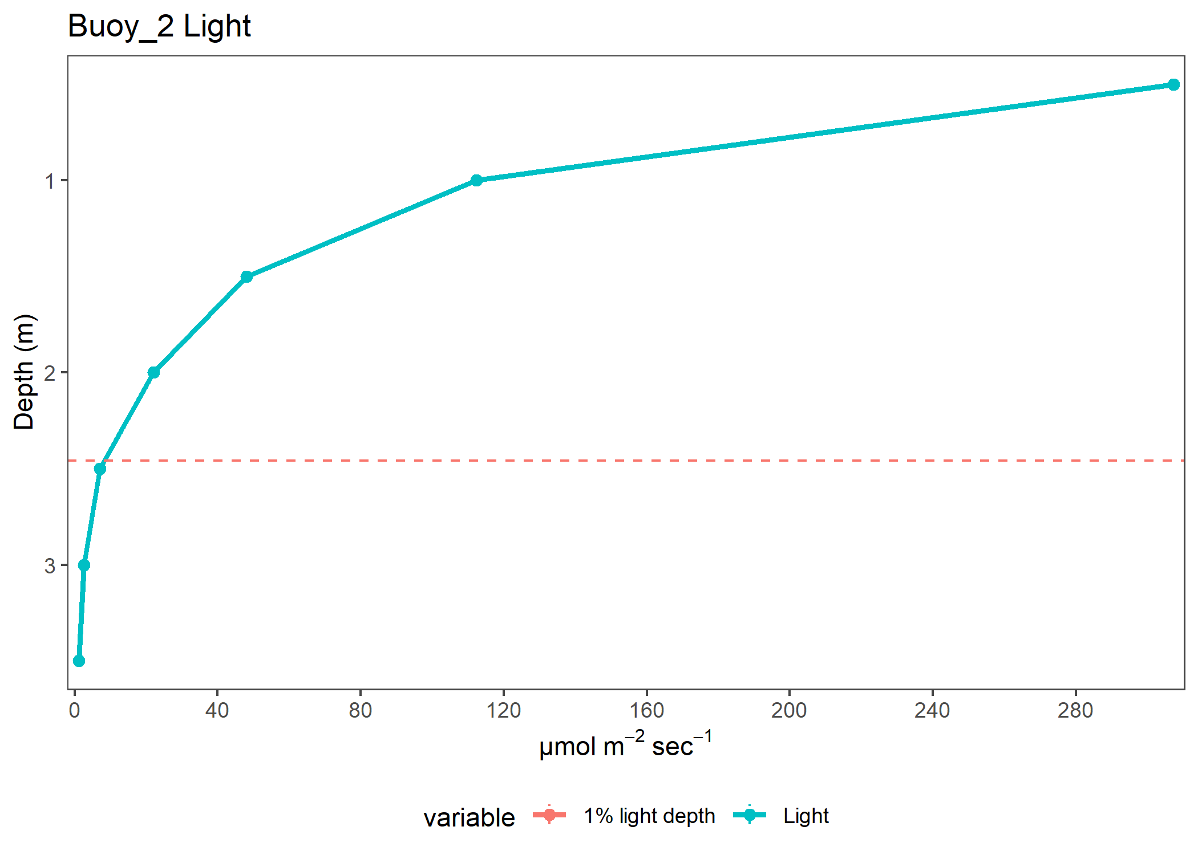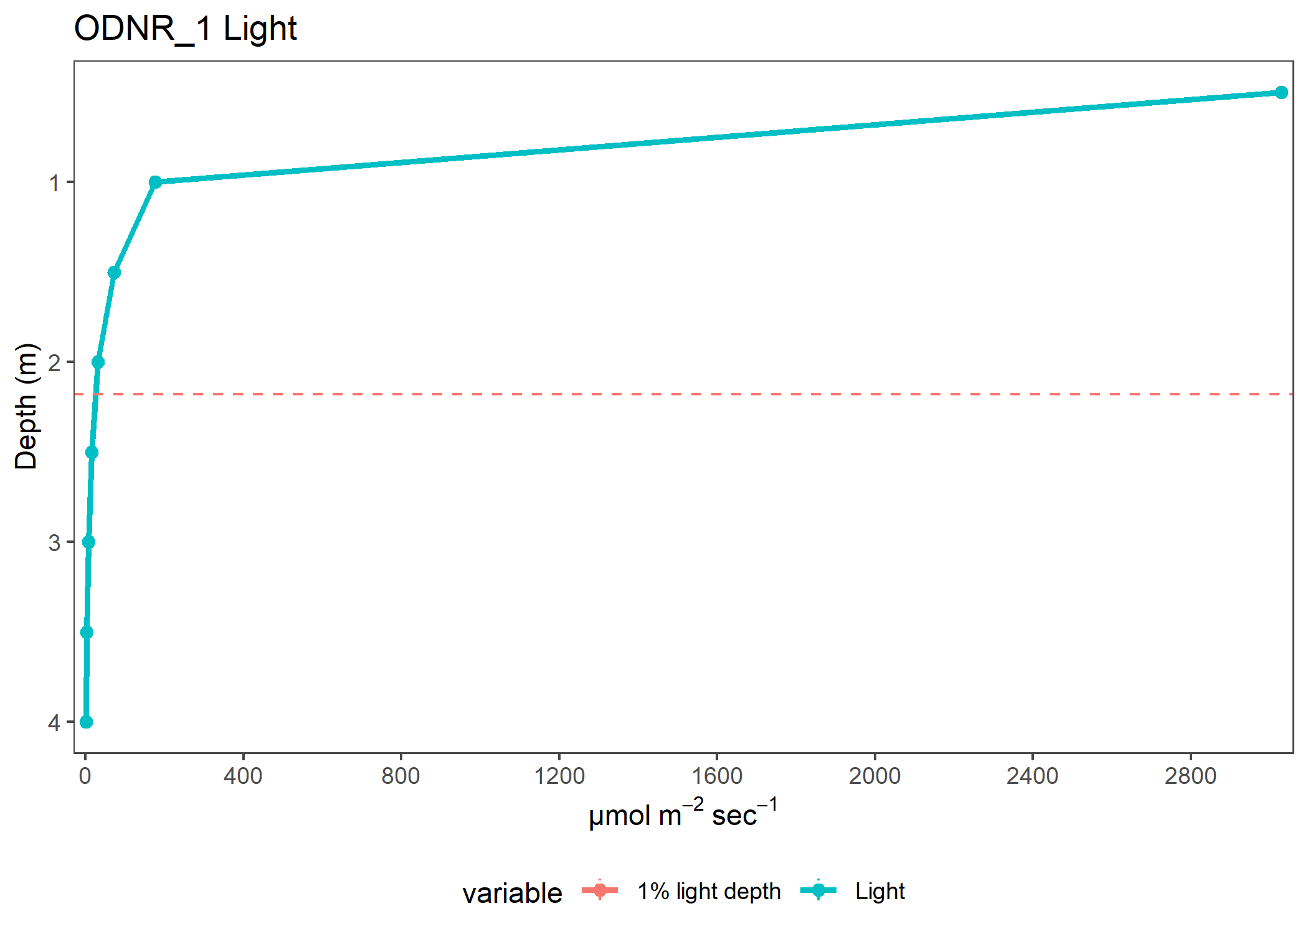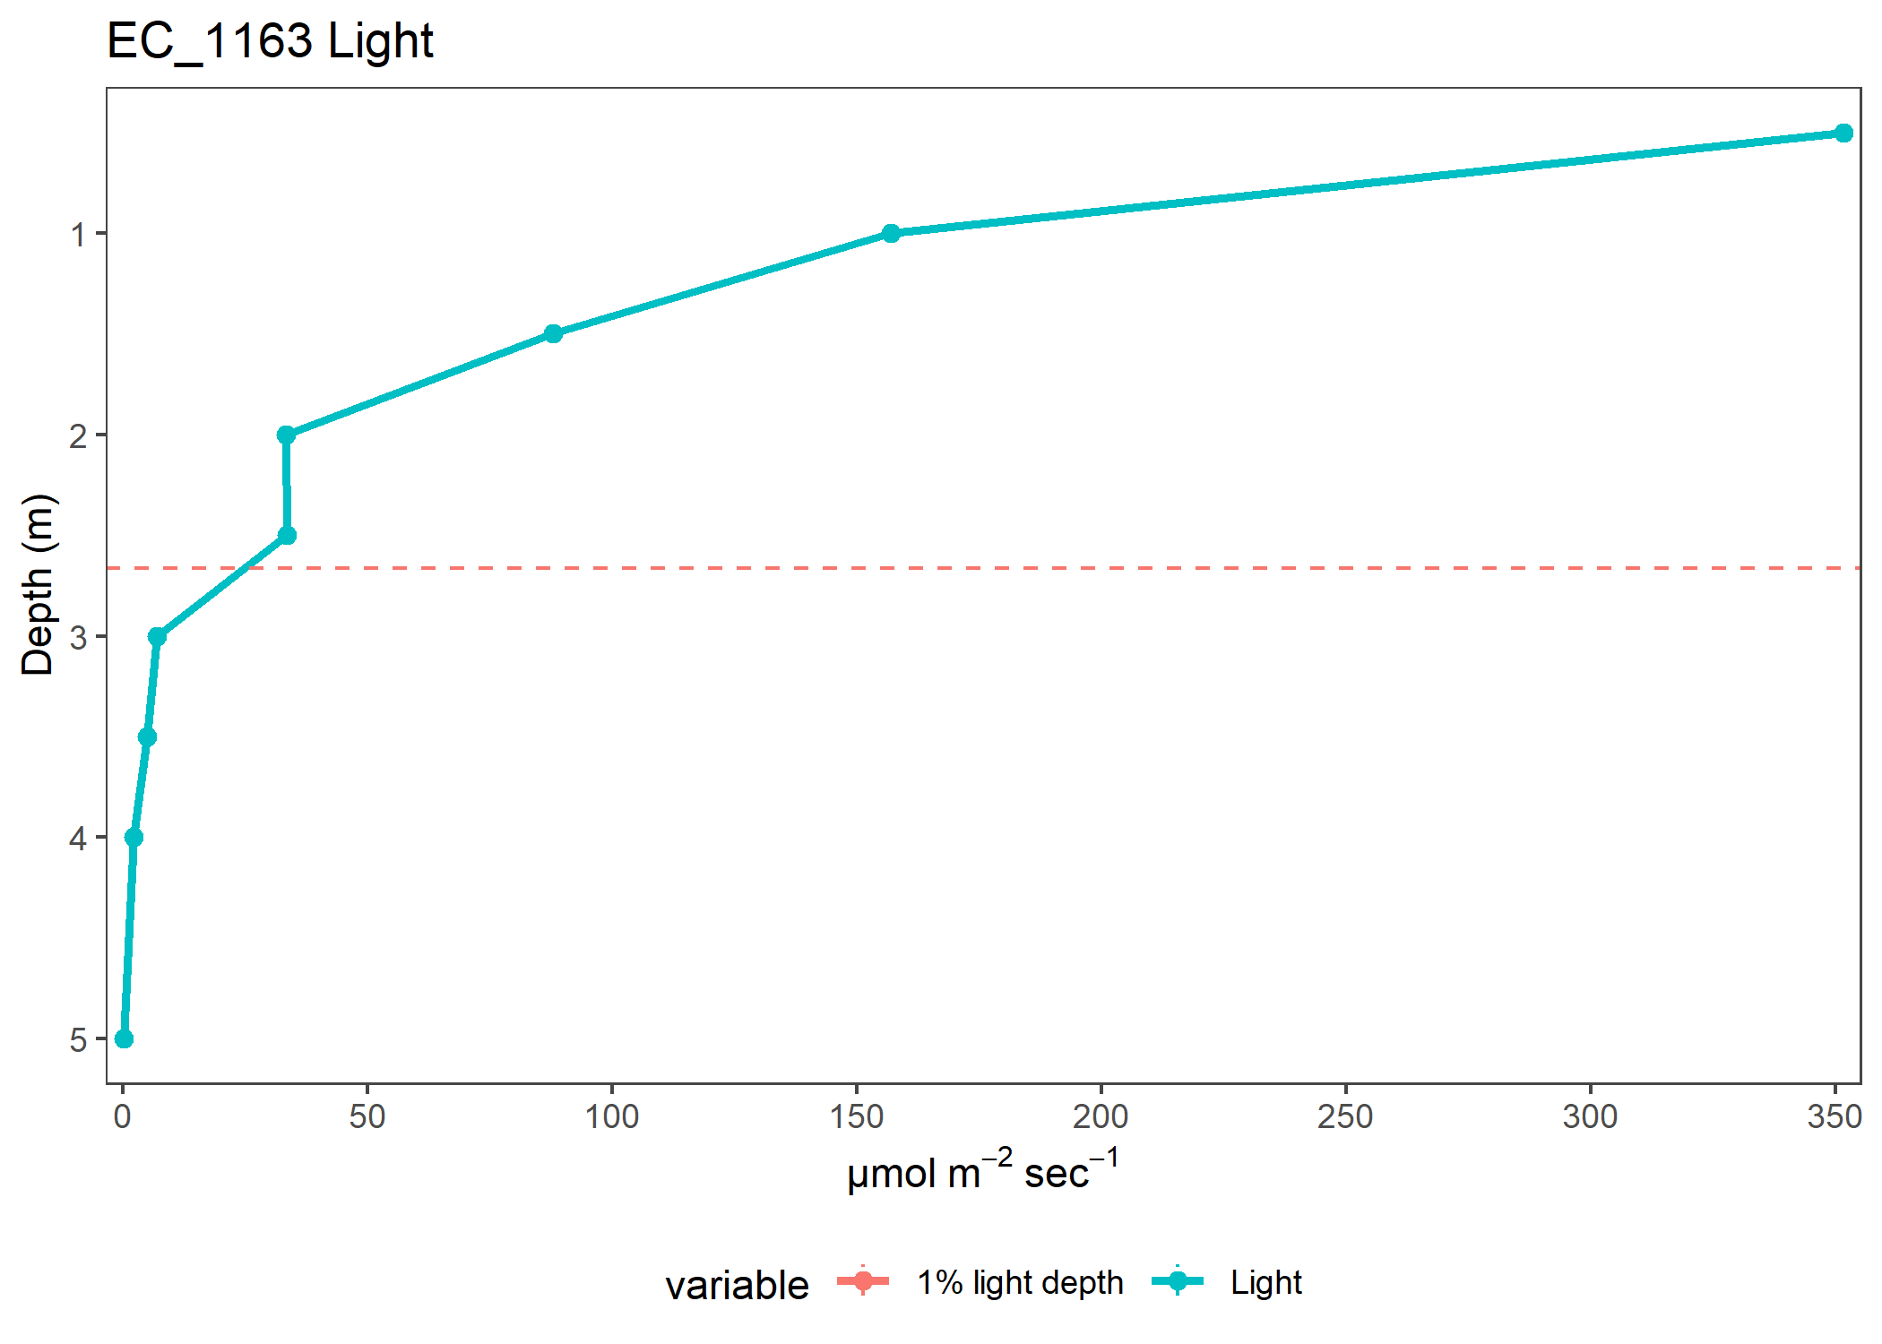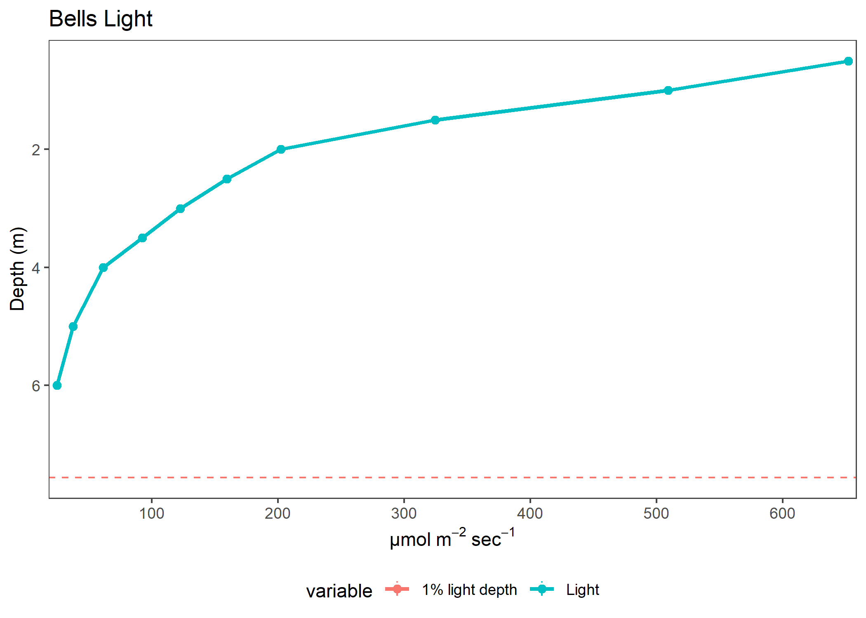

| variable | Depth | Site | Year | K_avg | value | plot |
| --- | --- | --- | --- | --- | --- | --- |
| Light | 0.5 | Muddy_Creek | 2021 | 7.2010925 | 23.4187143 | Light |
| Light | 1.0 | Muddy_Creek | 2021 | 7.2010925 | 1.1533333 | Light |
| Light | 1.5 | Muddy_Creek | 2021 | 7.2010925 | 0.1392857 | Light |
| Light | 0.5 | ODNR_4 | 2021 | 4.8425808 | 71.9736667 | Light |
| Light | 1.0 | ODNR_4 | 2021 | 4.8425808 | 11.6580000 | Light |
| Light | 1.5 | ODNR_4 | 2021 | 4.8425808 | 1.1703929 | Light |
| Light | 2.0 | ODNR_4 | 2021 | 4.8425808 | 0.1562500 | Light |
| Light | 0.5 | ODNR_6 | 2021 | 3.8882364 | 153.6556667 | Light |
| Light | 1.0 | ODNR_6 | 2021 | 3.8882364 | 26.1083333 | Light |
| Light | 1.5 | ODNR_6 | 2021 | 3.8882364 | 5.8053667 | Light |
| Light | 2.0 | ODNR_6 | 2021 | 3.8882364 | 1.5614286 | Light |
| Light | 2.5 | ODNR_6 | 2021 | 3.8882364 | 0.3522727 | Light |
| Light | 3.0 | ODNR_6 | 2021 | 3.8882364 | 0.0100000 | Light |
| Light | 0.5 | Buoy_2 | 2021 | 2.2283373 | 307.3326923 | Light |
| Light | 1.0 | Buoy_2 | 2021 | 2.2283373 | 112.3638462 | Light |
| Light | 1.5 | Buoy_2 | 2021 | 2.2283373 | 48.0754167 | Light |
| Light | 2.0 | Buoy_2 | 2021 | 2.2283373 | 22.1400000 | Light |
| Light | 2.5 | Buoy_2 | 2021 | 2.2283373 | 7.0408333 | Light |
| Light | 3.0 | Buoy_2 | 2021 | 2.2283373 | 2.6962500 | Light |
| Light | 3.5 | Buoy_2 | 2021 | 2.2283373 | 1.1250000 | Light |
| Light | 0.5 | ODNR_1 | 2021 | 1.8349168 | 3029.5457692 | Light |
| Light | 1.0 | ODNR_1 | 2021 | 1.8349168 | 176.0669231 | Light |
| Light | 1.5 | ODNR_1 | 2021 | 1.8349168 | 72.3384615 | Light |
| Light | 2.0 | ODNR_1 | 2021 | 1.8349168 | 31.9573077 | Light |
| Light | 2.5 | ODNR_1 | 2021 | 1.8349168 | 16.2457692 | Light |
| Light | 3.0 | ODNR_1 | 2021 | 1.8349168 | 7.3388462 | Light |
| Light | 3.5 | ODNR_1 | 2021 | 1.8349168 | 2.5614286 | Light |
| Light | 4.0 | ODNR_1 | 2021 | 1.8349168 | 0.5700000 | Light |
| Light | 0.5 | EC_1163 | 2021 | 1.8085520 | 351.7585714 | Light |
| Light | 1.0 | EC_1163 | 2021 | 1.8085520 | 157.0078571 | Light |
| Light | 1.5 | EC_1163 | 2021 | 1.8085520 | 87.9484615 | Light |
| Light | 2.0 | EC_1163 | 2021 | 1.8085520 | 33.3707143 | Light |
| Light | 2.5 | EC_1163 | 2021 | 1.8085520 | 33.4389286 | Light |
| Light | 3.0 | EC_1163 | 2021 | 1.8085520 | 6.9007143 | Light |
| Light | 3.5 | EC_1163 | 2021 | 1.8085520 | 4.8818182 | Light |
| Light | 4.0 | EC_1163 | 2021 | 1.8085520 | 2.2250000 | Light |
| Light | 5.0 | EC_1163 | 2021 | 1.8085520 | 0.0700000 | Light |
| Light | 0.5 | Bells | 2021 | 0.9001854 | 651.9250000 | Light |
| Light | 1.0 | Bells | 2021 | 0.9001854 | 509.1483333 | Light |
| Light | 1.5 | Bells | 2021 | 0.9001854 | 324.5422222 | Light |
| Light | 2.0 | Bells | 2021 | 0.9001854 | 202.2188889 | Light |
| Light | 2.5 | Bells | 2021 | 0.9001854 | 159.6244444 | Light |
| Light | 3.0 | Bells | 2021 | 0.9001854 | 122.7466667 | Light |
| Light | 3.5 | Bells | 2021 | 0.9001854 | 92.4655556 | Light |
| Light | 4.0 | Bells | 2021 | 0.9001854 | 61.5988889 | Light |
| Light | 5.0 | Bells | 2021 | 0.9001854 | 37.7637500 | Light |
| Light | 6.0 | Bells | 2021 | 0.9001854 | 24.8506250 | Light |