Sandusky Bay Light 2022

Ryan Wagner

03/19/2023

read in data.

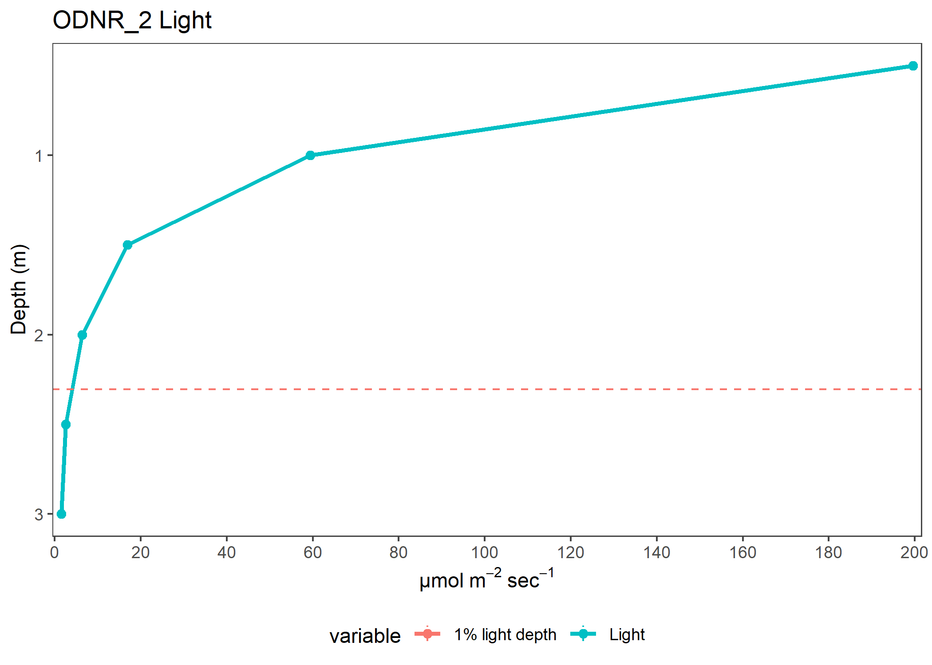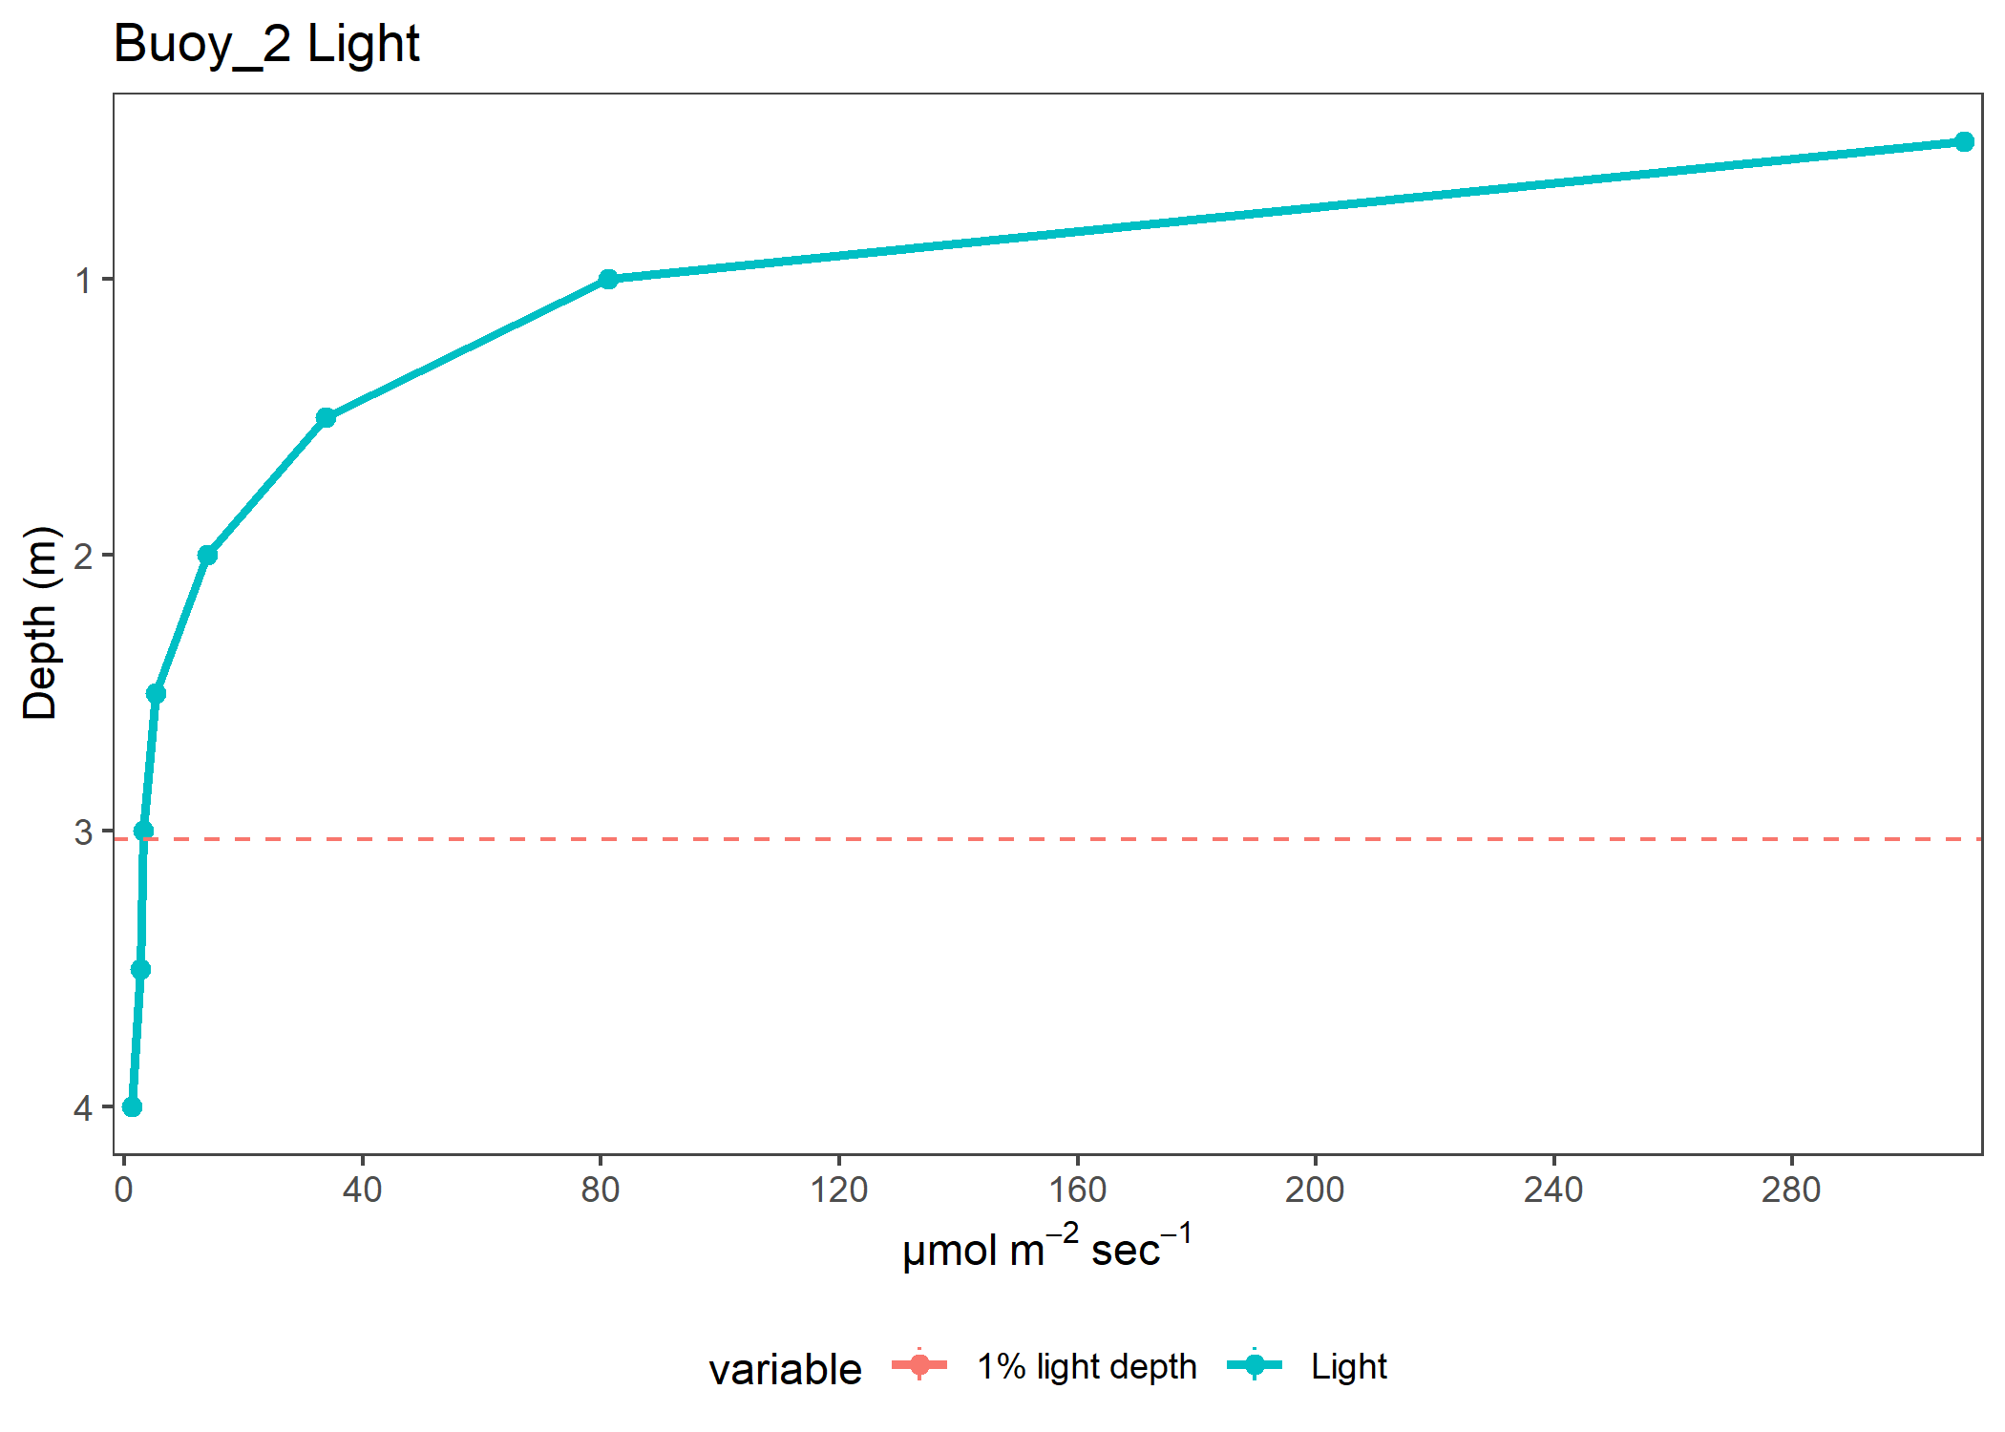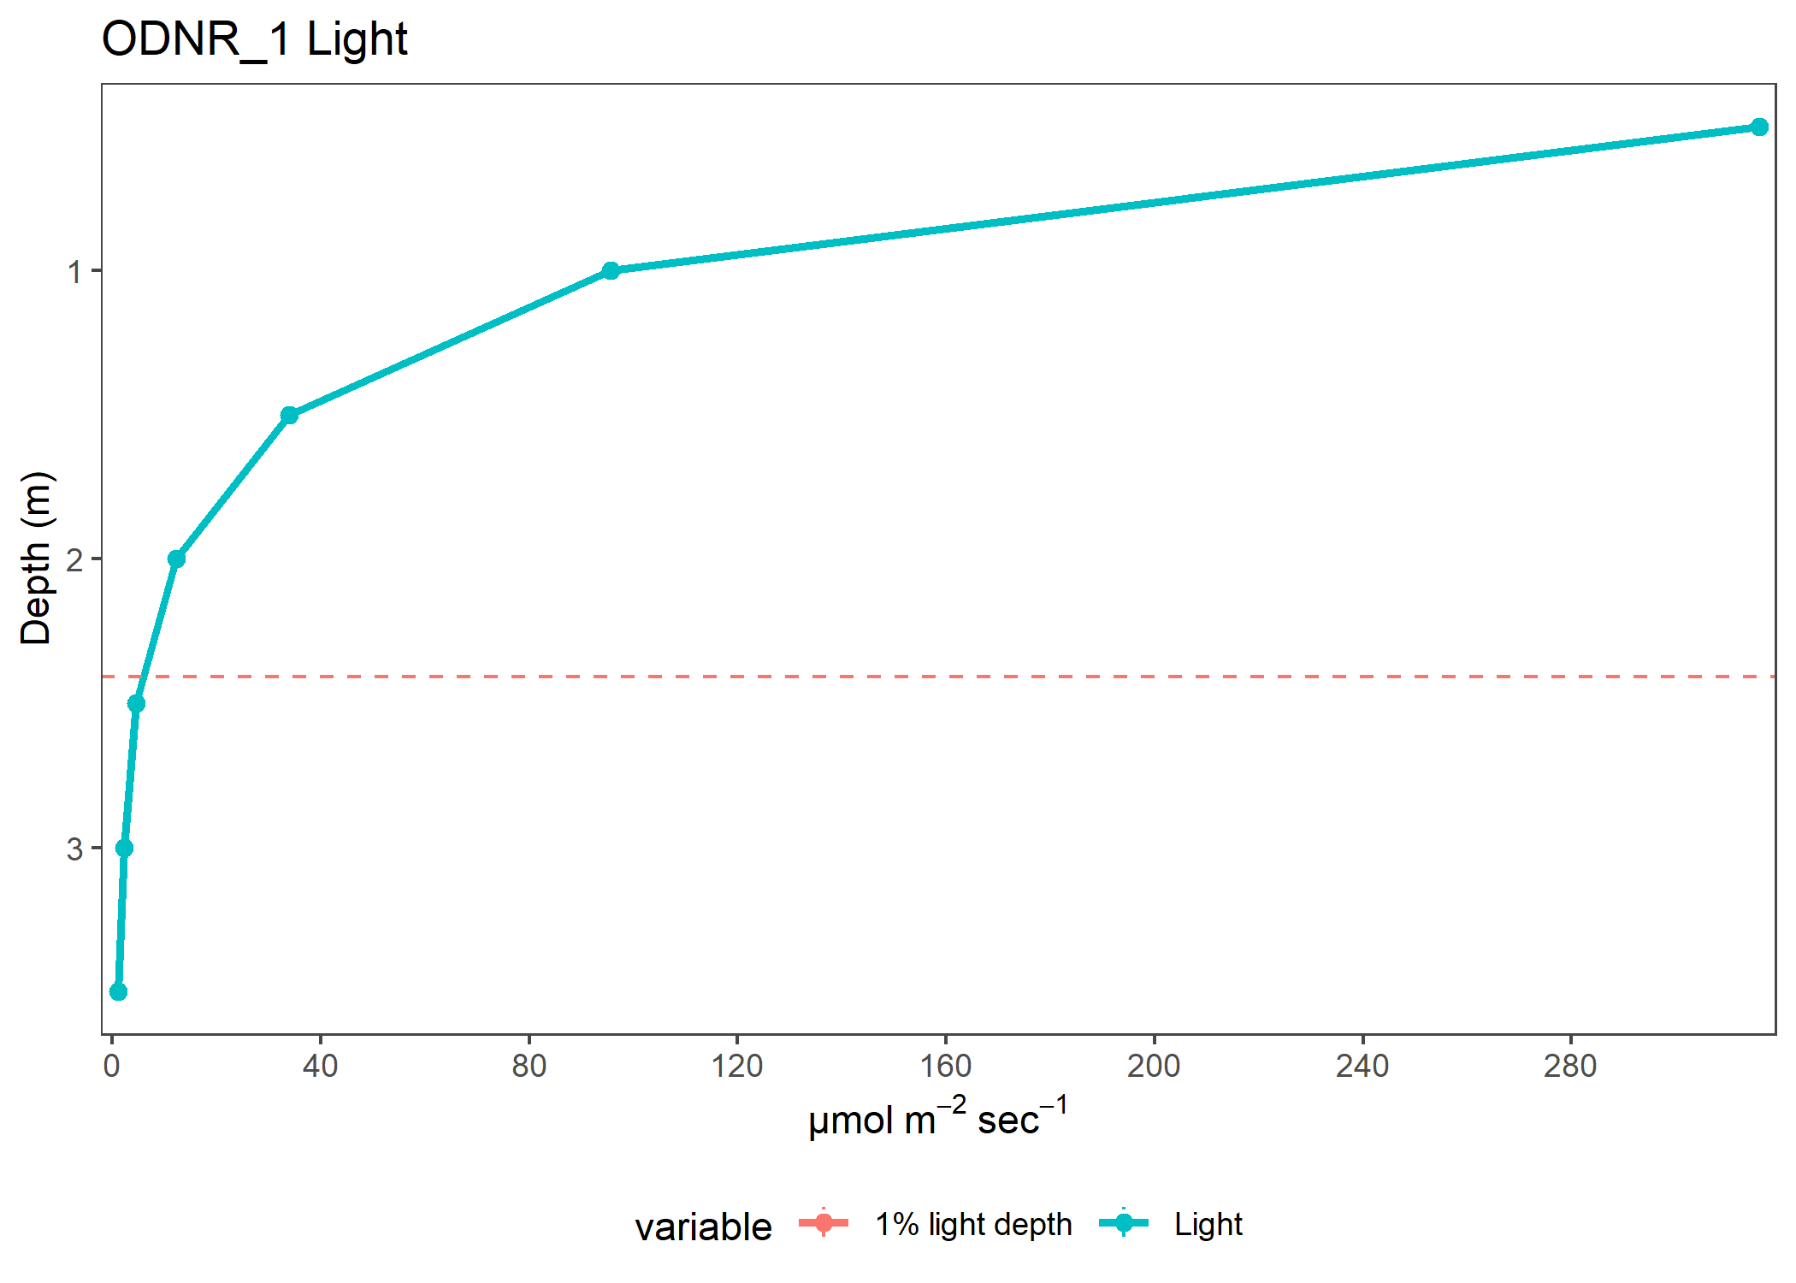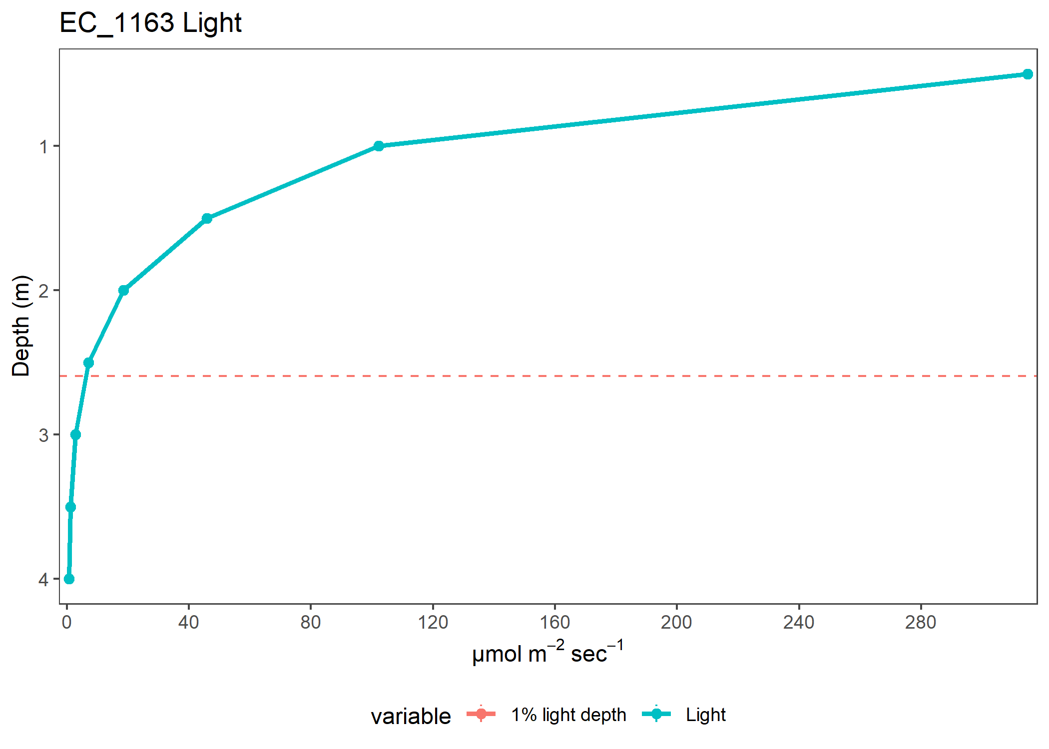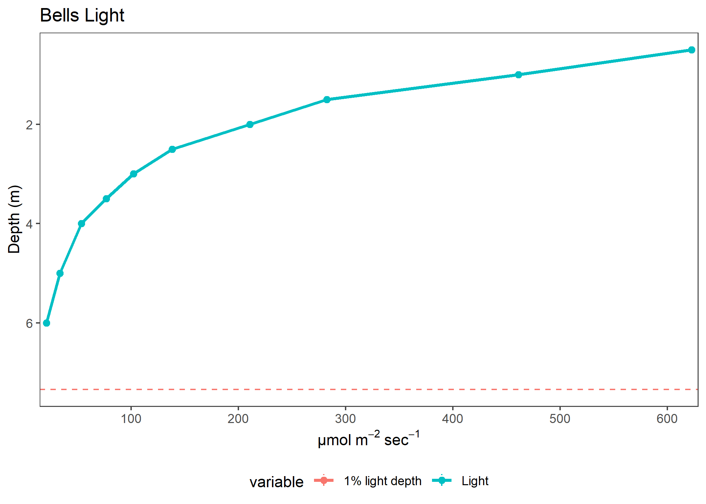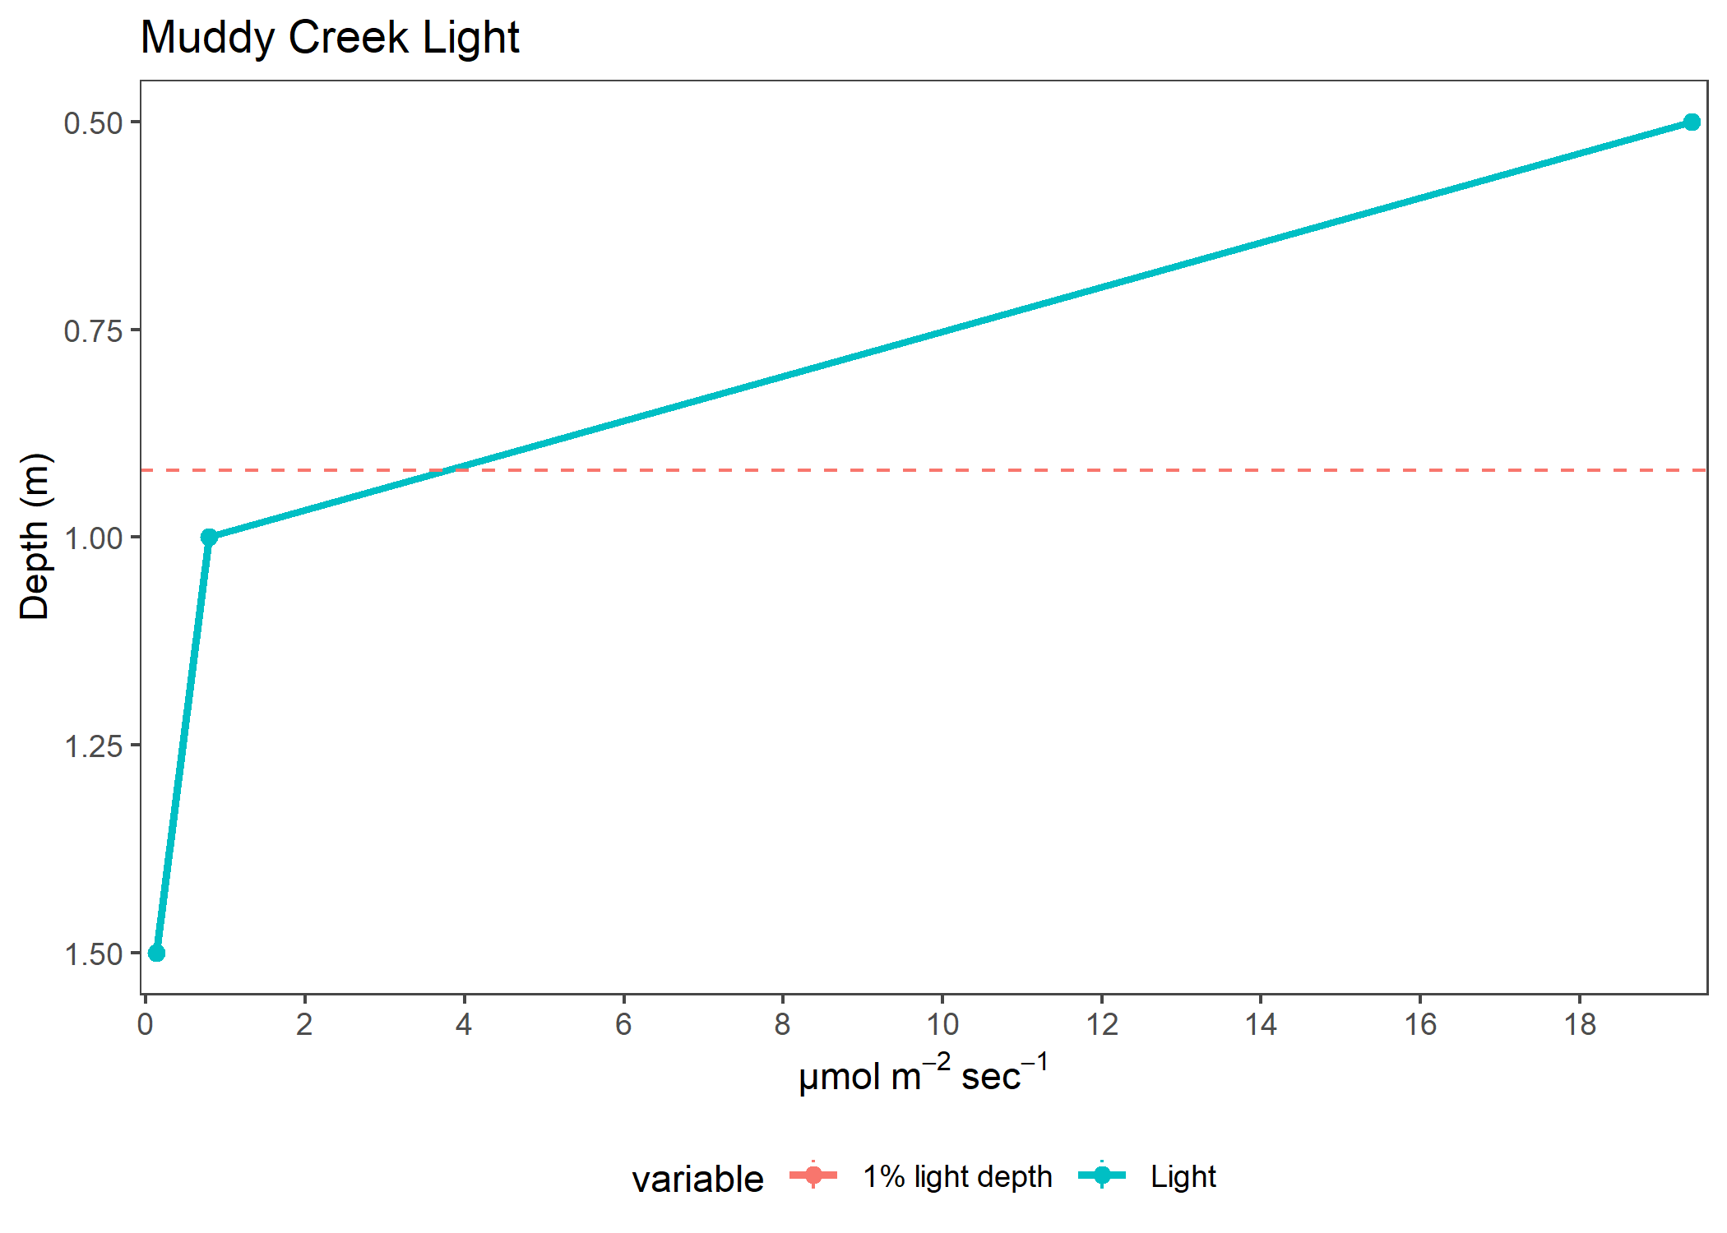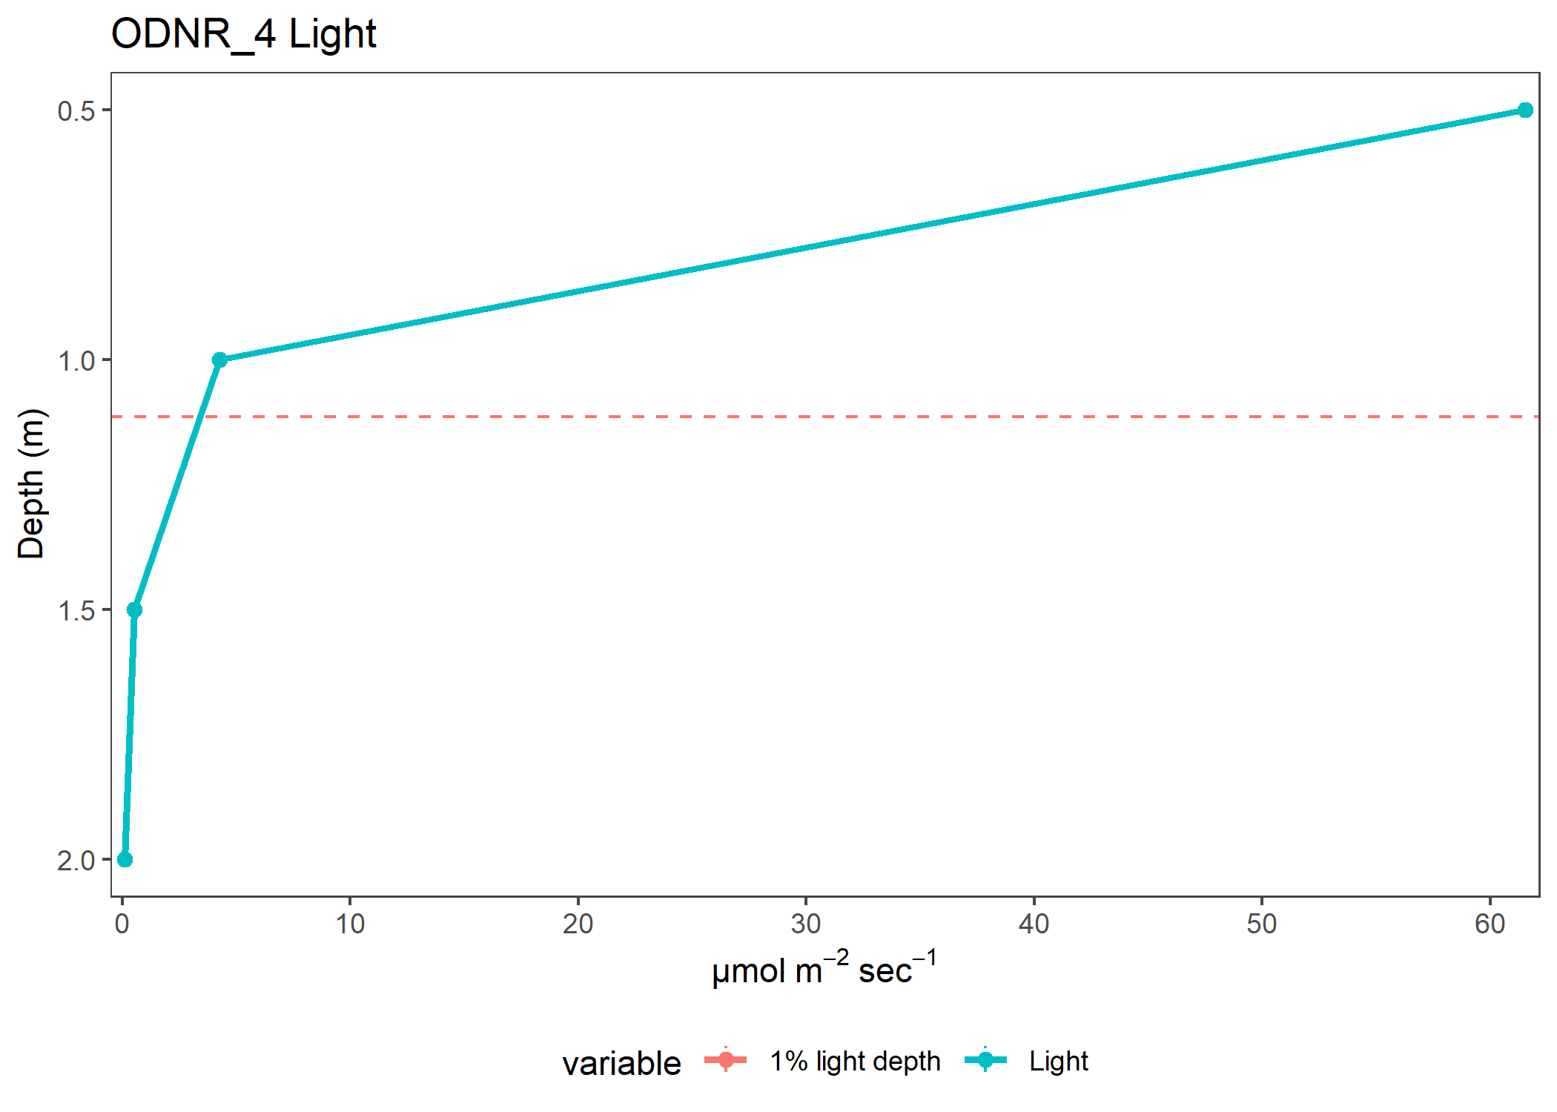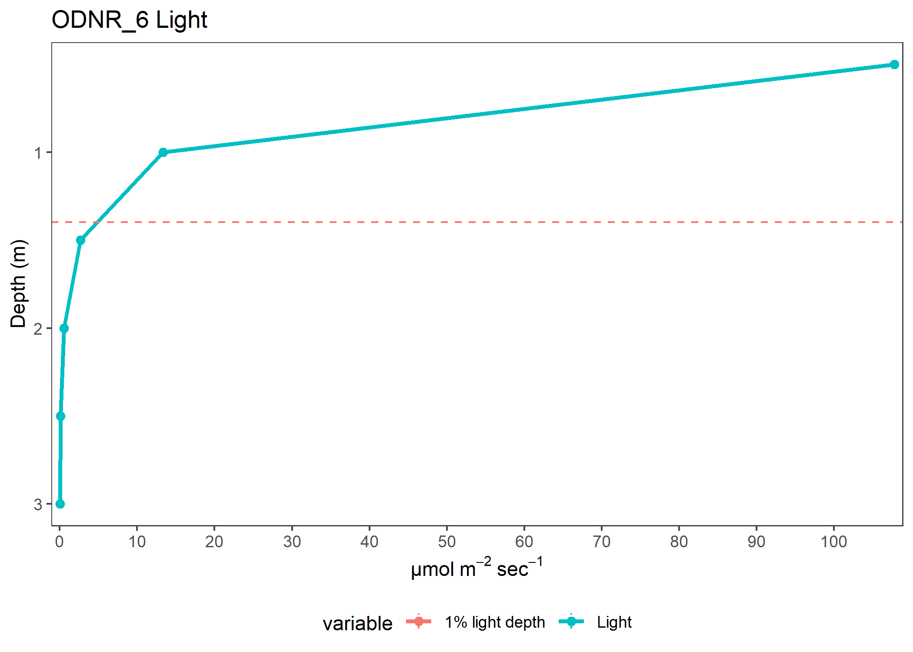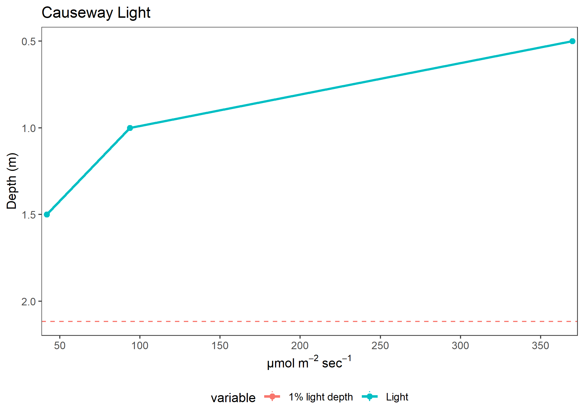

| variable | Depth | Site | Year | K_avg | value | plot |
| --- | --- | --- | --- | --- | --- | --- |
| Light | 0.5 | ODNR_2 | 2022 | 3.085923 | 199.6146154 | Light |
| Light | 1.0 | ODNR_2 | 2022 | 3.085923 | 59.4323077 | Light |
| Light | 1.5 | ODNR_2 | 2022 | 3.085923 | 16.9480769 | Light |
| Light | 2.0 | ODNR_2 | 2022 | 3.085923 | 6.3541667 | Light |
| Light | 2.5 | ODNR_2 | 2022 | 3.085923 | 2.5480000 | Light |
| Light | 3.0 | ODNR_2 | 2022 | 3.085923 | 1.4775000 | Light |
| Light | 0.5 | Buoy_2 | 2022 | 2.601533 | 308.8325000 | Light |
| Light | 1.0 | Buoy_2 | 2022 | 2.601533 | 81.2974583 | Light |
| Light | 1.5 | Buoy_2 | 2022 | 2.601533 | 33.8033333 | Light |
| Light | 2.0 | Buoy_2 | 2022 | 2.601533 | 13.9283333 | Light |
| Light | 2.5 | Buoy_2 | 2022 | 2.601533 | 5.2181818 | Light |
| Light | 3.0 | Buoy_2 | 2022 | 2.601533 | 3.2464286 | Light |
| Light | 3.5 | Buoy_2 | 2022 | 2.601533 | 2.7250000 | Light |
| Light | 4.0 | Buoy_2 | 2022 | 2.601533 | 1.2100000 | Light |
| Light | 0.5 | ODNR_1 | 2022 | 2.789192 | 316.1419231 | Light |
| Light | 1.0 | ODNR_1 | 2022 | 2.789192 | 95.6923077 | Light |
| Light | 1.5 | ODNR_1 | 2022 | 2.789192 | 33.9215385 | Light |
| Light | 2.0 | ODNR_1 | 2022 | 2.789192 | 12.1880769 | Light |
| Light | 2.5 | ODNR_1 | 2022 | 2.789192 | 4.5095833 | Light |
| Light | 3.0 | ODNR_1 | 2022 | 2.789192 | 2.1771429 | Light |
| Light | 3.5 | ODNR_1 | 2022 | 2.789192 | 1.0325000 | Light |
| Light | 0.5 | EC_1163 | 2022 | 2.406351 | 314.9370833 | Light |
| Light | 1.0 | EC_1163 | 2022 | 2.406351 | 102.1850000 | Light |
| Light | 1.5 | EC_1163 | 2022 | 2.406351 | 45.8641667 | Light |
| Light | 2.0 | EC_1163 | 2022 | 2.406351 | 18.6154167 | Light |
| Light | 2.5 | EC_1163 | 2022 | 2.406351 | 7.1412500 | Light |
| Light | 3.0 | EC_1163 | 2022 | 2.406351 | 2.9163636 | Light |
| Light | 3.5 | EC_1163 | 2022 | 2.406351 | 1.2755000 | Light |
| Light | 4.0 | EC_1163 | 2022 | 2.406351 | 0.6362500 | Light |
| Light | 0.5 | Bells | 2022 | 1.156648 | 622.8414286 | Light |
| Light | 1.0 | Bells | 2022 | 1.156648 | 461.1150000 | Light |
| Light | 1.5 | Bells | 2022 | 1.156648 | 282.5221429 | Light |
| Light | 2.0 | Bells | 2022 | 1.156648 | 210.7121429 | Light |
| Light | 2.5 | Bells | 2022 | 1.156648 | 138.4178571 | Light |
| Light | 3.0 | Bells | 2022 | 1.156648 | 102.4828571 | Light |
| Light | 3.5 | Bells | 2022 | 1.156648 | 77.0721429 | Light |
| Light | 4.0 | Bells | 2022 | 1.156648 | 53.8671429 | Light |
| Light | 5.0 | Bells | 2022 | 1.156648 | 33.6178571 | Light |
| Light | 6.0 | Bells | 2022 | 1.156648 | 21.0035714 | Light |
| Light | 0.5 | Muddy Creek | 2022 | 7.723956 | 19.4055000 | Light |
| Light | 1.0 | Muddy Creek | 2022 | 7.723956 | 0.7900000 | Light |
| Light | 1.5 | Muddy Creek | 2022 | 7.723956 | 0.1300000 | Light |
| Light | 0.5 | ODNR_4 | 2022 | 5.593767 | 61.5562500 | Light |
| Light | 1.0 | ODNR_4 | 2022 | 5.593767 | 4.2837500 | Light |
| Light | 1.5 | ODNR_4 | 2022 | 5.593767 | 0.5431818 | Light |
| Light | 2.0 | ODNR_4 | 2022 | 5.593767 | 0.1250000 | Light |
| Light | 0.5 | ODNR_6 | 2022 | 4.291833 | 107.8045833 | Light |
| Light | 1.0 | ODNR_6 | 2022 | 4.291833 | 13.3612500 | Light |
| Light | 1.5 | ODNR_6 | 2022 | 4.291833 | 2.6700000 | Light |
| Light | 2.0 | ODNR_6 | 2022 | 4.291833 | 0.5645833 | Light |
| Light | 2.5 | ODNR_6 | 2022 | 4.291833 | 0.1175000 | Light |
| Light | 3.0 | ODNR_6 | 2022 | 4.291833 | 0.0250000 | Light |
| Light | 0.5 | Causeway | 2022 | 2.504711 | 369.6983333 | Light |
| Light | 1.0 | Causeway | 2022 | 2.504711 | 93.6991667 | Light |
| Light | 1.5 | Causeway | 2022 | 2.504711 | 41.9587500 | Light |