Sandusky Bay Light 2020

Ryan Wagner

03/28/2023

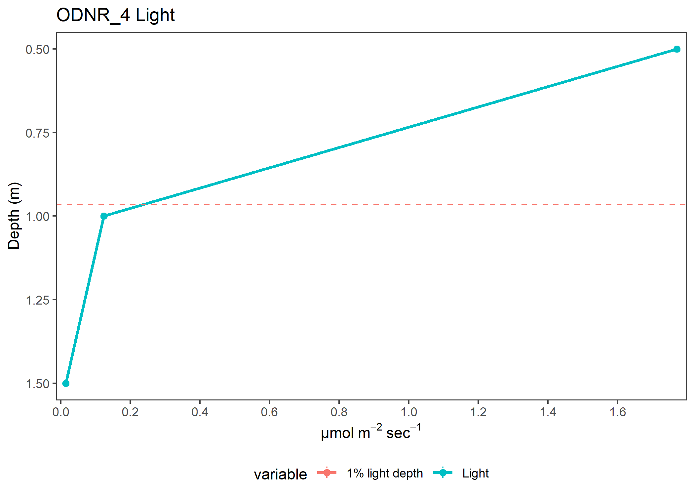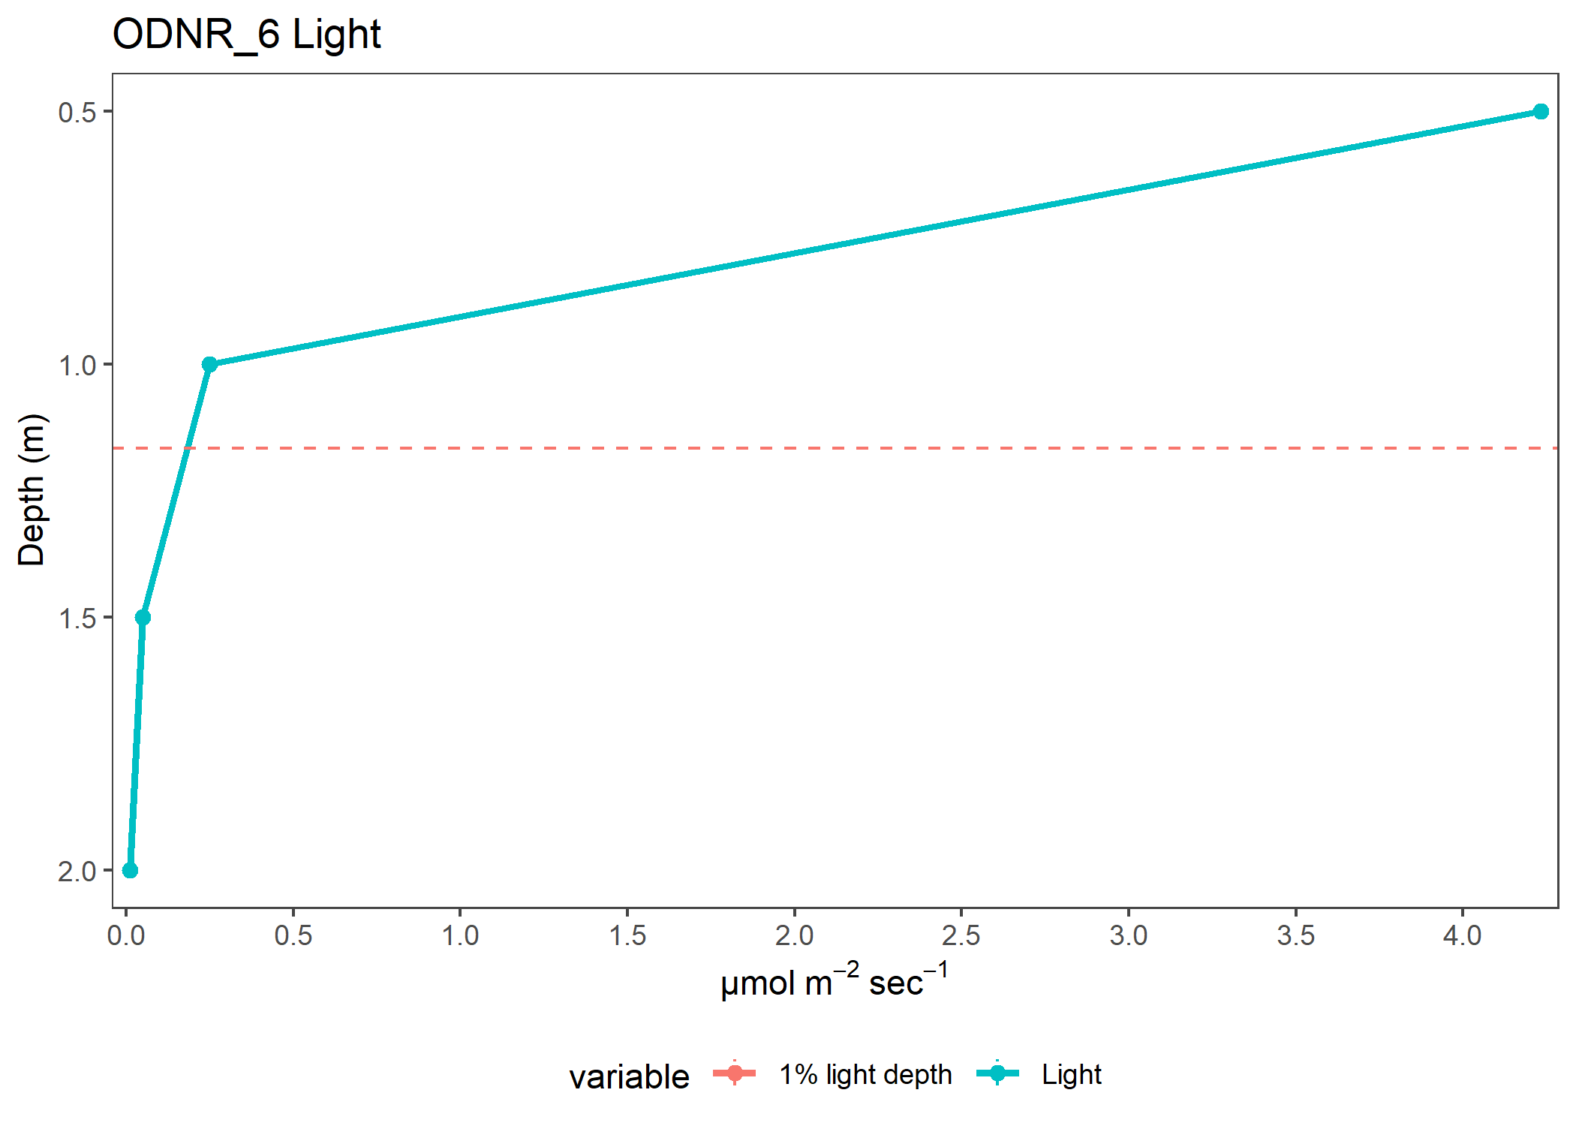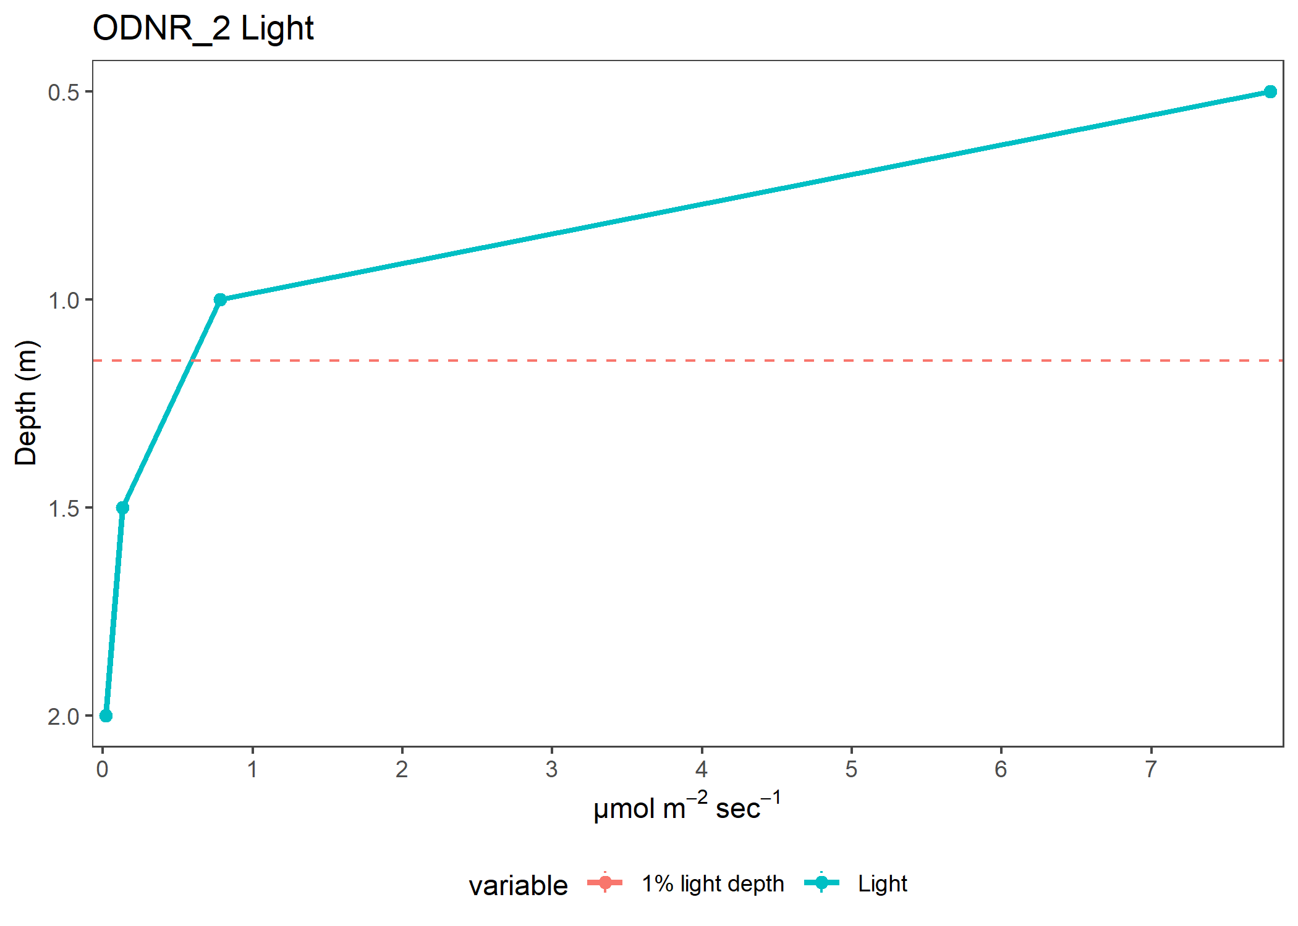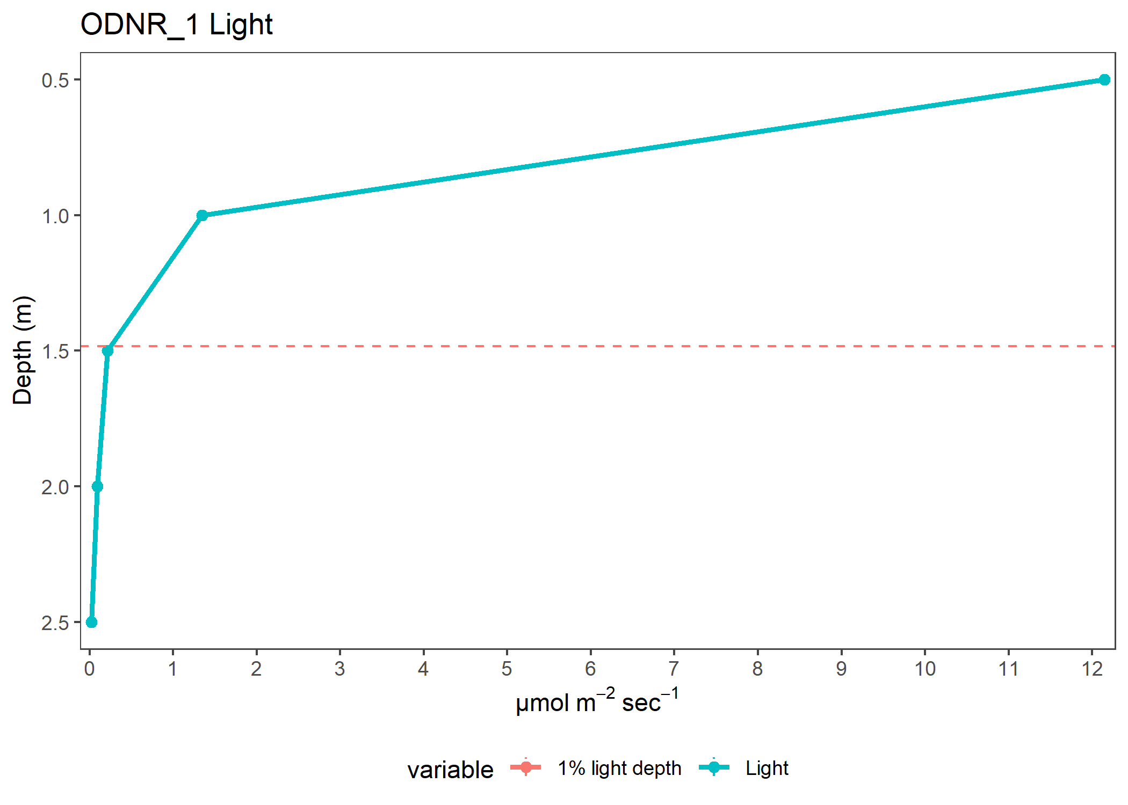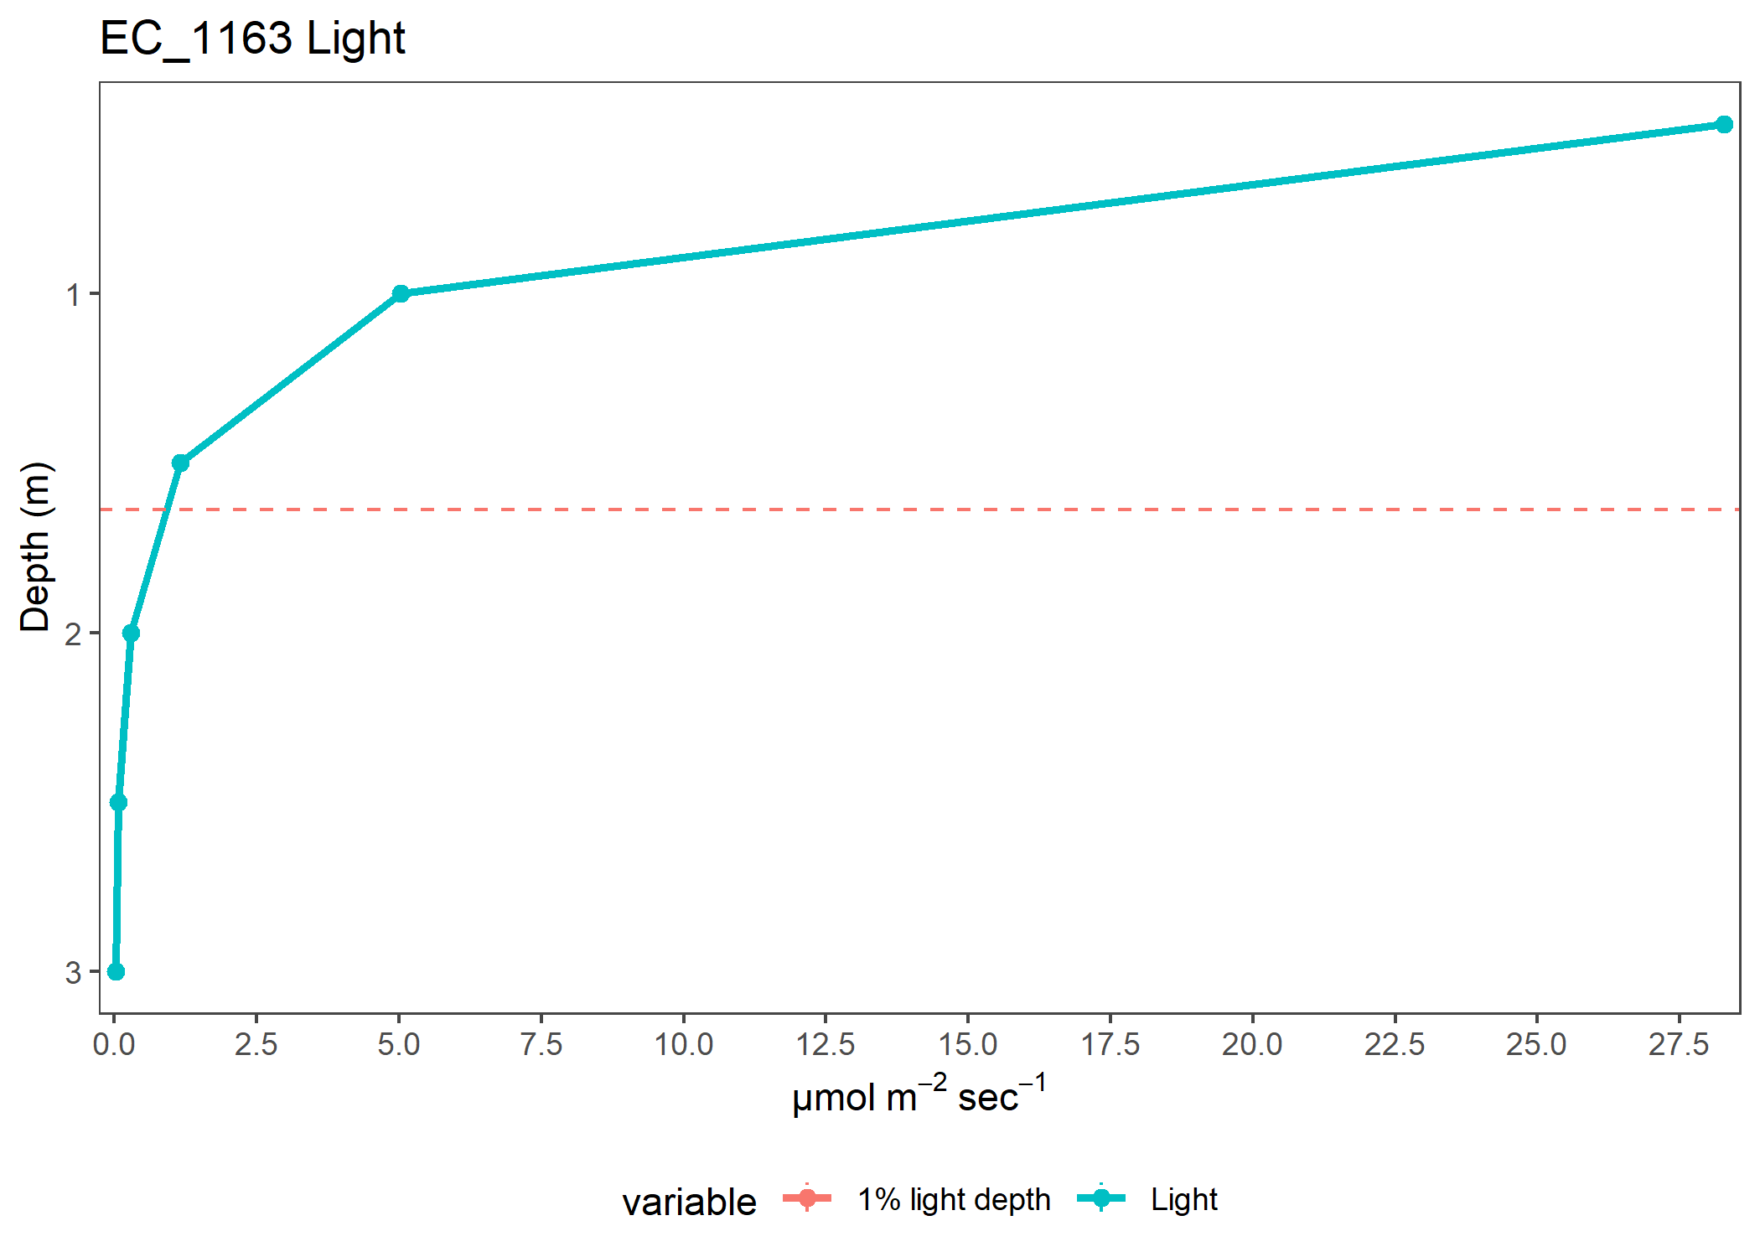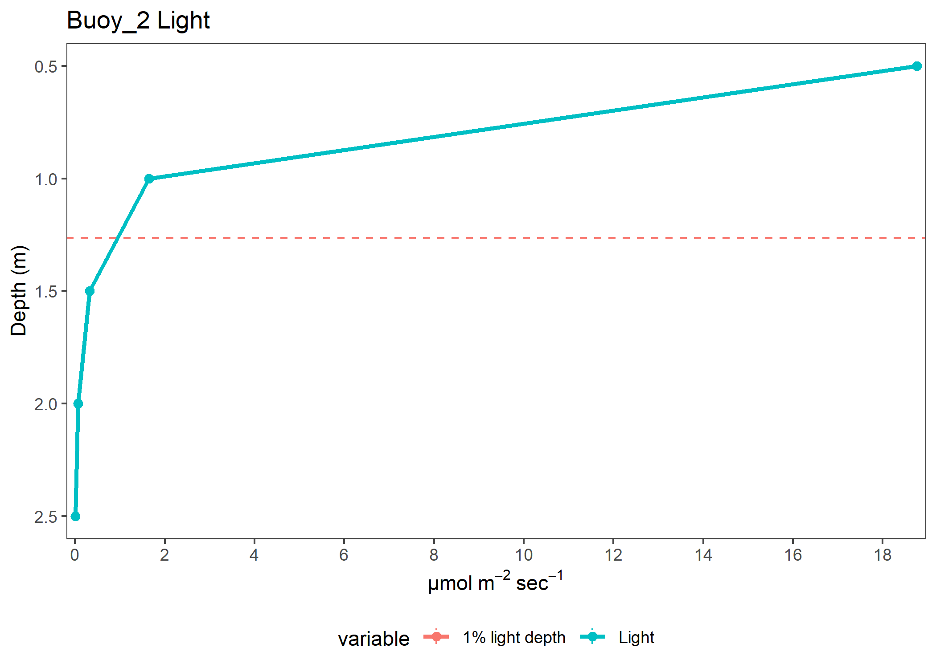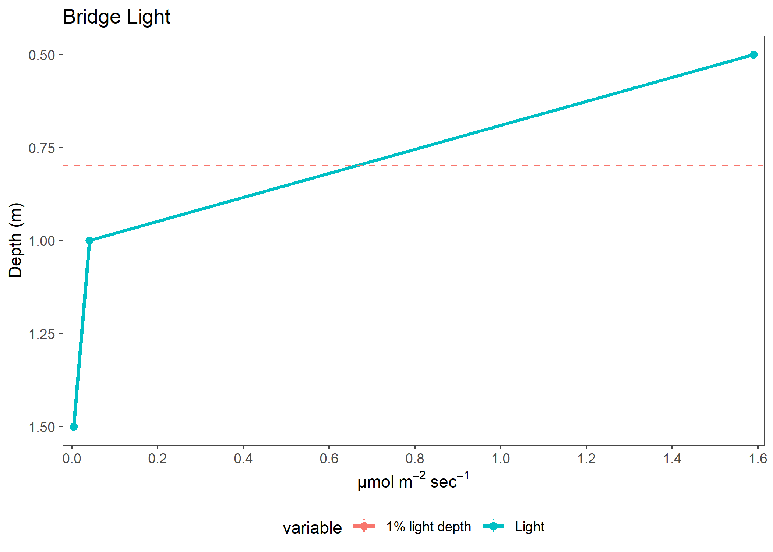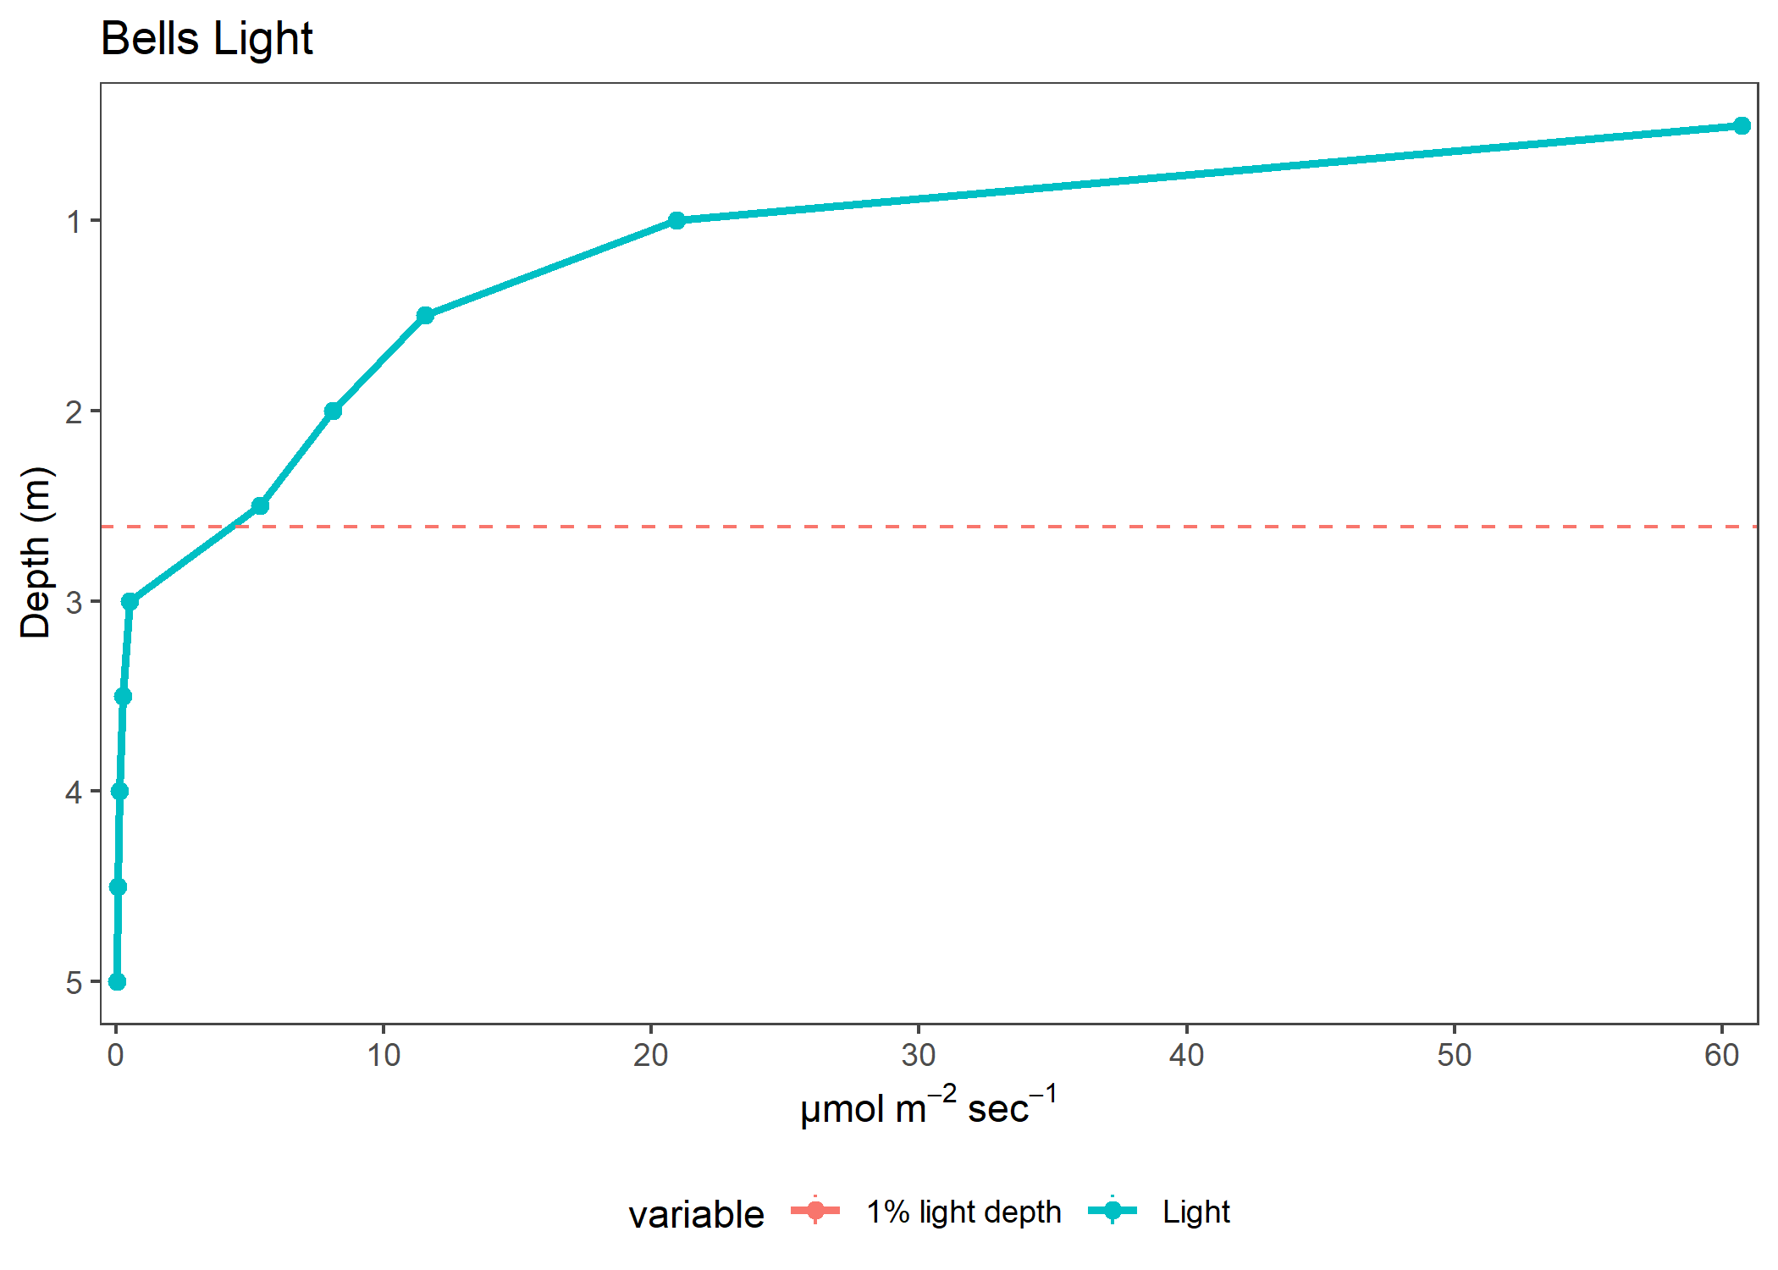

| variable | Depth | Site | Year | K_avg | value | plot |
| --- | --- | --- | --- | --- | --- | --- |
| Light | 0.5 | ODNR_4 | 2017 | 7.994869 | 1.7700000 | Light |
| Light | 1.0 | ODNR_4 | 2017 | 7.994869 | 0.1237500 | Light |
| Light | 1.5 | ODNR_4 | 2017 | 7.994869 | 0.0150000 | Light |
| Light | 0.5 | ODNR_6 | 2017 | 6.052664 | 4.2333333 | Light |
| Light | 1.0 | ODNR_6 | 2017 | 6.052664 | 0.2500000 | Light |
| Light | 1.5 | ODNR_6 | 2017 | 6.052664 | 0.0500000 | Light |
| Light | 2.0 | ODNR_6 | 2017 | 6.052664 | 0.0100000 | Light |
| Light | 0.5 | ODNR_2 | 2017 | 5.106859 | 7.7958333 | Light |
| Light | 1.0 | ODNR_2 | 2017 | 5.106859 | 0.7841667 | Light |
| Light | 1.5 | ODNR_2 | 2017 | 5.106859 | 0.1320000 | Light |
| Light | 2.0 | ODNR_2 | 2017 | 5.106859 | 0.0175000 | Light |
| Light | 0.5 | ODNR_1 | 2017 | 4.575009 | 12.1483333 | Light |
| Light | 1.0 | ODNR_1 | 2017 | 4.575009 | 1.3483333 | Light |
| Light | 1.5 | ODNR_1 | 2017 | 4.575009 | 0.2140000 | Light |
| Light | 2.0 | ODNR_1 | 2017 | 4.575009 | 0.0900000 | Light |
| Light | 2.5 | ODNR_1 | 2017 | 4.575009 | 0.0200000 | Light |
| Light | 0.5 | EC_1163 | 2017 | 3.649223 | 28.2758333 | Light |
| Light | 1.0 | EC_1163 | 2017 | 3.649223 | 5.0241667 | Light |
| Light | 1.5 | EC_1163 | 2017 | 3.649223 | 1.1591667 | Light |
| Light | 2.0 | EC_1163 | 2017 | 3.649223 | 0.2910000 | Light |
| Light | 2.5 | EC_1163 | 2017 | 3.649223 | 0.0737500 | Light |
| Light | 3.0 | EC_1163 | 2017 | 3.649223 | 0.0250000 | Light |
| Light | 0.5 | Buoy_2 | 2017 | 4.416342 | 18.7610000 | Light |
| Light | 1.0 | Buoy_2 | 2017 | 4.416342 | 1.6470000 | Light |
| Light | 1.5 | Buoy_2 | 2017 | 4.416342 | 0.3300000 | Light |
| Light | 2.0 | Buoy_2 | 2017 | 4.416342 | 0.0700000 | Light |
| Light | 2.5 | Buoy_2 | 2017 | 4.416342 | 0.0100000 | Light |
| Light | 0.5 | Bridge | 2017 | 6.324118 | 1.5890000 | Light |
| Light | 1.0 | Bridge | 2017 | 6.324118 | 0.0416667 | Light |
| Light | 1.5 | Bridge | 2017 | 6.324118 | 0.0050000 | Light |
| Light | 0.5 | Bells | 2017 | 1.594026 | 60.7400000 | Light |
| Light | 1.0 | Bells | 2017 | 1.594026 | 20.9390000 | Light |
| Light | 1.5 | Bells | 2017 | 1.594026 | 11.5380000 | Light |
| Light | 2.0 | Bells | 2017 | 1.594026 | 8.0830000 | Light |
| Light | 2.5 | Bells | 2017 | 1.594026 | 5.3810000 | Light |
| Light | 3.0 | Bells | 2017 | 1.594026 | 0.5150000 | Light |
| Light | 3.5 | Bells | 2017 | 1.594026 | 0.2383333 | Light |
| Light | 4.0 | Bells | 2017 | 1.594026 | 0.1400000 | Light |
| Light | 4.5 | Bells | 2017 | 1.594026 | 0.0650000 | Light |
| Light | 5.0 | Bells | 2017 | 1.594026 | 0.0250000 | Light |