# CANDI-AED: A flexible model system for simulating sediment biogeochemistry

Daniel Paraska and Matthew R Hipsey

DRAFT FOR INTERNAL DISTRIBUTION ONLY

## Introduction

Sediment diagenesis models are highly complex environmental reactive transport modelling tools. The meta-analysis by Paraska et al (2014) discussed the history of their evolution to these complex configurations, in which the original models of Boudreau (1996), Van Cappellen and Wang (1996) and Soetaert et al. (1996) were taken up and applied in many contexts by new modellers, who added new features and extended their capabilities, or discarded old features as required. The meta-analysis also identified the major challenges associated with developing new sediment diagenesis models. Here, a new modelling package for sediment biogeochemistry is presented, CANDI-AED, which is an extension of the Approach 1 models, but reengineered and augmented with new model approaches and capabilities as a way to address some of these challenges.

Paraska et al (in prep) outlined the significance and uncertainty associated with different parameterisation approaches of organic matter dynamics. In these cases, simulations were run to test the significance of different theoretical approaches and model structural assumptions, using an idealised model setup with only primary oxidation reactions and no physical processes or spatial resolution. The true impact of these different model approaches within a spatially-resolved model, accounting for all of the advection, diffusion and secondary reaction processes, however, is yet to be determined and it is unclear whether some formulations may suit some application contexts better than others. Therefore there is a need for a fully flexible model structure that can include these different organic matter breakdown parameterisations and allow users to assess critically the alternative approaches. In addition, other aspects related to

secondary redox reactions, mineral reactions, precipitation and adsorption should similarly be subject to comparative assessments.

A further challenge identified in Paraska et al (2014) was the difficulty involved in taking up these models by the broader modelling community, because of problems related to connecting these complex model structures with other water quality and aquatic ecosystem models. For example, there are problems related to mapping variables of ecosystem models to those of diagenesis models. There are also problems related to the mismatch between the resolution of processes that occur over different spatial and temporal scales, for example fast equilibrium reactions between sediment layers, and seasonal temperature or salinity changes across a study site.

The model developed as part of this research aimed to address these challenges by building a full-featured, open-source model code with the flexibility to do the following:

* set different kinetic rate equation approaches
* set different organic matter pools and breakdown processes
* use standard inhibition or thermodynamic limits on primary oxidation
* optionally use manganese, iron and iron sulphide reactions
* simulate adsorbed metals and nutrients
* simulate calcium, iron and manganese carbonates
* connect the boundary to either another model, a programmed file or a fixed concentration

Therefore the numerical model presented in this chapter has many optional features and alternative parameterisations for key processes, without mandating their inclusion in the calculations or enforcing a fixed model structure. To facilitate the coupling, the model is implemented with the “Framework for Aquatic Biogeochemical Models” (FABM), which is a new object-oriented model software framework by Bruggeman and Bolding (2014). Through the definition of a generic architecture for configuring and coupling both benthic and pelagic models, the FABM has been designed to couple a wide range of ecological and biogeochemical models from various developers with numerous different hydrodynamic models (Trolle et al. 2011). To date the FABM has been applied with the 1D lake hydrodynamic model GLM (Hipsey et al. 2014), and the unstructured mesh model TUFLOW-FV (Bruce et al. 2014).

The sediment model CANDI-AED presented here is implemented within the AED model library within the FABM (Hipsey et al. 2013b), however, it is able to couple with one or more of the FABM model libraries (Figure 5 - 1). Through the model coupling approach it may be applied with any of the hydrodynamic models listed above, or alternatively, run in isolation. This document provides a complete scientific description of the model and describes attributes of the model associated with its practical implementation and operation. An application of the model framework is subsequently demonstrated.

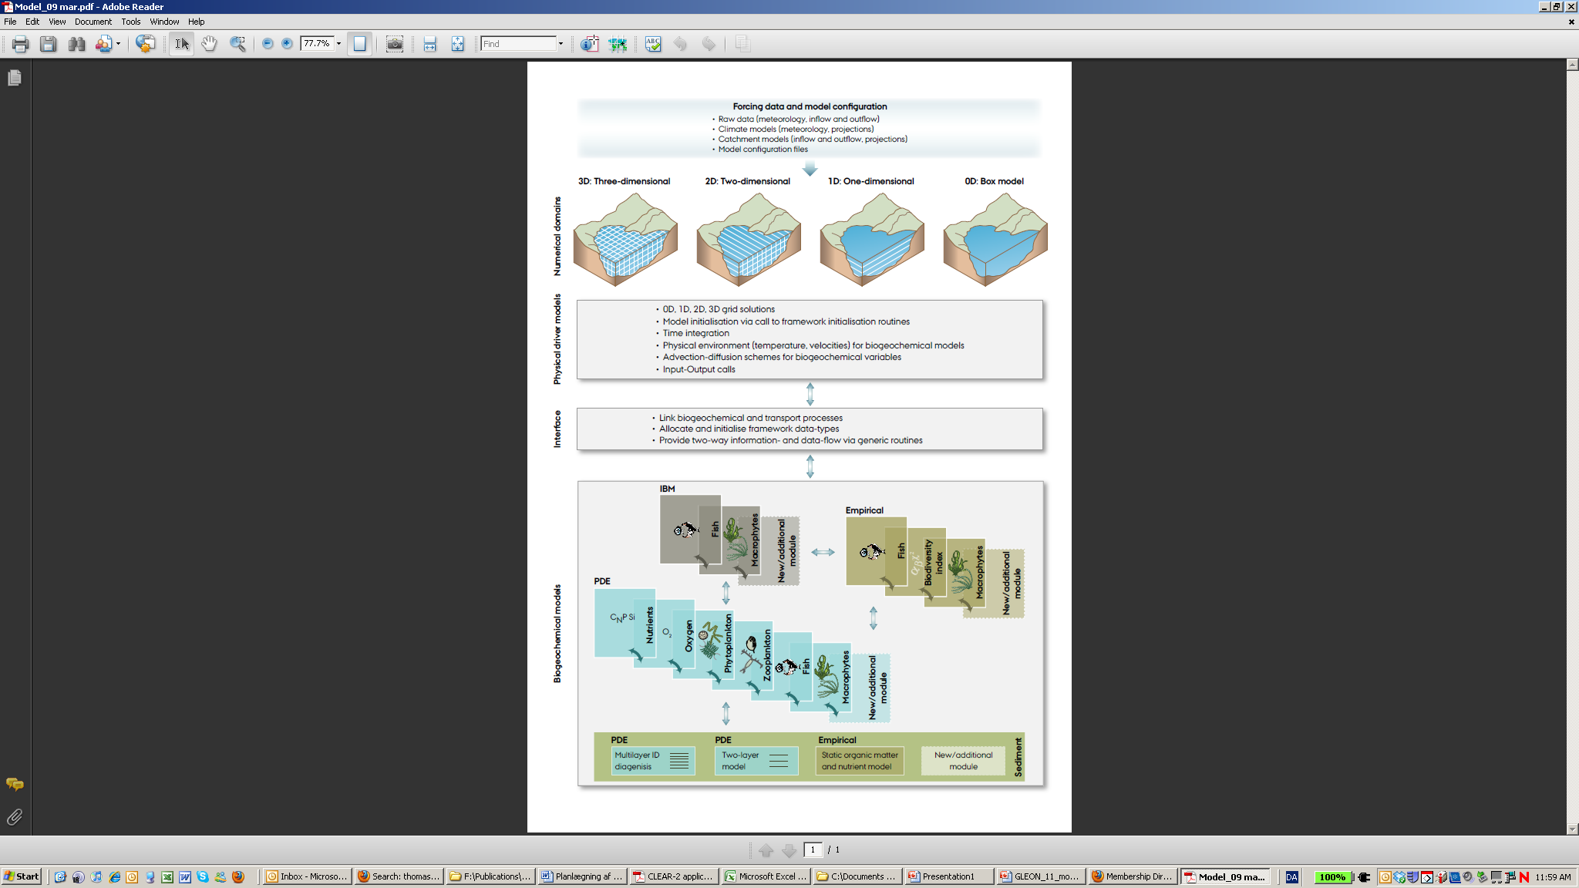

Figure 5 - Schematic of the framework of aquatic biogeochemical models. The new diagenesis model code AED CANDI fits into the category of multilayer 1D diagenesis models, coupled to other biogeochemical and physical models (Trolle et al. 2011).

## Model scientific basis

The heart of this model is the reaction, diffusion, advection model of Berner (1980), which was implemented as the Carbon and Nutrient Diagenesis model of Boudreau (1996) and developed into Approach 1 from Chapter 2. The basic structure of this model is an adaptation of the C.CANDI code (Luff et al. 2000), which added extensions related to the geochemical aspects. Further additions to the C.CANDI code have been made to:

* the organic matter dynamics
* the geochemical dynamics
* extensions for nutrients and trace metals.

The chemical reactions included in this model, including new features added to the model, are expanded upon below and summarised in Figure 5 - 2.

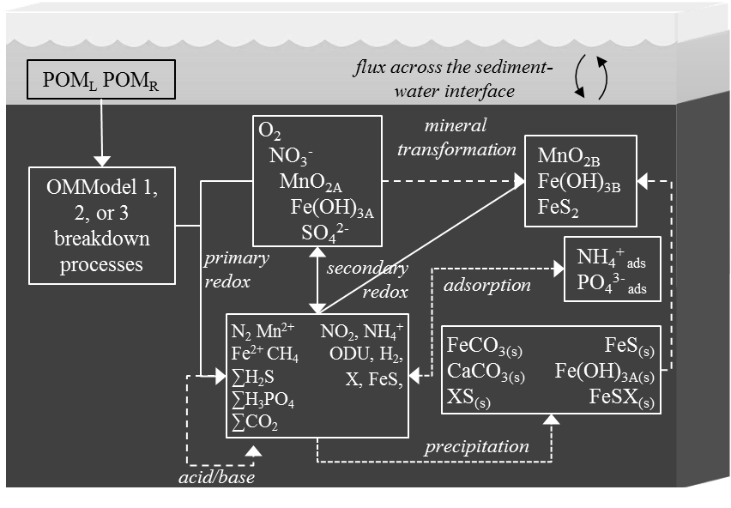

Figure 5 - AED CANDI includes chemical processes of organic matter transformation and oxidation, and reduction/oxidation, crystallisation, adsorption and precipitation reactions of inorganic by-products. Most of the processes are triggered by the input of POM at the sediment-water interface.

### Primary redox reactions

The key chemical process that causes ongoing change in the sediment is the breakdown of organic matter. The user can decide how complex or simple the organic matter breakdown pathway should be, with three options of varying complexity for parameterising the pathways included (Figure 5 - 3). The first option (*OMModel = 1*) is a common multi-G model in which the POM phases are decomposed straight to CO2 and other breakdown products. Here POM is a variable that is not precisely defined, and its components (such as C, N and P) must be determined in post-processing based on a user-defined fixed stoichiometry. The second option (*OMModel = 2*) is another 2G model with both particulate and dissolved organic matter (POM and DOM) phases included and parameterisation hydrolysis of POM to DOM, and then DOM to CO2 and other breakdown products. The POM and DOM phases consist of three variables each, which trace the reaction and transport of carbon, nitrogen and phosphorus, thereby allowing for variable stoichiometry of organic matter to occur temporally and spatially. The third option (*OMModel = 3*) has many POM phases, which are all hydrolysed to DOM, which then undergoes fermentation and terminal metabolism, as using the mechanistic approach from Chapter 3. This allows the carbon, nitrogen and phosphorus to be calculated precisely before and after a model run, and allows the free energies of the reaction of each phase to be included. This third option is the most detailed and mechanistic, and allows for expansion of more detailed reaction mechanisms to be included.

|  |  |  |  |  |  |
| --- | --- | --- | --- | --- | --- |
| Table 5 - Organic matter breakdown processes. The index *i* in refers to the sequence of TEA in Table 5 - 2. For OMModel 2, POM and DOM are each three state variables of POC, PON and POP, and DOC, DON and DOP. | | | | | |
| Description | Reaction | Rate equation | |  | |
| OMModel 1 |  |  | |  | |
| POMLab oxidation | POMLab CO2 etc. |  | | 5 - 1 | |
| POMRef oxidation | POMRef CO2 etc. |  | | 5 - 2 | |
| OMModel 2 |  |  | |  | |
| POMLab hydrolysis | POMLab DOMLab |  | | 5 - 3 | |
| POMRef hydrolysis | POMRef DOMRef |  | | 5 - 4 | |
| DOMLab oxidation | DOMLab CO2 etc. |  | | 5 - 5 | |
| DOMRef oxidation | DOMRef CO2 etc. |  | | 5 - 6 | |
| OMModel 3 |  |  | |  | |
| POMi hydrolysis | POMi DHyd |  | | 5 - 7 | |
| DHyd fermentation | DHyd OAc + H2 |  | | 5 - 8 | |
| DHyd oxidation | DHyd CO2 etc. | |  | | 5 - 10 |
| OAc, H2 oxidation | OAc, H2CO2 etc. | |  | | 5 - 11 |

|  |  |  |
| --- | --- | --- |
| a | b | |
| c | |  |

Figure 5 - Three options for different levels of complexity in organic matter breakdown, by setting the *OMModel* switch. a – Model in which POM breaks down directly to CO2 and other waste products. b – Model in which POM is first hydrolysed to DOM and then oxidised to CO2. c – Model in which POM is hydrolysed to DOM, which can then be fermented and oxidised.

The terminal redox reaction pathways are the six pathways that are available in most diagenesis models, and are driven by different organic matter pools, depending on the OMModel configuration chosen from the above options (Table 5 - 2). AED CANDI allows the use of Approach 1 or 2 organic matter oxidation rate equations, as examined in detail in Paraska et al (in prep).

The rate equation for the oxidation of the oxidants with any of the pools above can include any of the terms in equation 5 - 12, where is the reaction of an oxidant *i* (Arndt et al. 2013) (Table 5 - 3). The kinetic rate constant *kOM* gives the maximum oxidation rate, which is different for each reactive type, but the same for each oxidation pathway. Alternatively, using OMModel 3, the kinetic rate constant is the rate of bacterial growth.

The factor for terminal electron acceptor (TEA) limitation is *FTEA* (5 - 11), where options for Approach 1 or Approach 2 equations are available. The Monod constant for rate limitation at low oxidant concentration is *KTEA* in Approach 1 and *LTEA* in Approach 2.Similarly, the inhibition term *FIn* (5 - 14) can be set to Approach 1 or 2 equations, or turned off entirely. The constant for inhibition until low oxidant concentrations is *KIn* for Approach 1 and *LIN* for Approach 2.

*FT* is the thermodynamic factor, as described in chapter 3. The current version of the model includes *FT* only for OMModel 3, for terminal oxidation reactions and fermentation.

*FOM* is the organic matter concentration and may be a Monod function as in equation 5 - 8 (*KOM* is a half saturation constant and the index *i* is the reactive phase). Using OMModels 1 and 2, *FOM* is the concentration of the substrate, rather than a Monod function. The current version of the model has switches built in for both the temperature dependence factor, *FTem*, where values of 1 or 2 turn them off and on. However, implementation and testing of the factors has not been carried out for this version of the model. The metabolism rate at *T0* is *R0*, *ξ* is a scaling constant (see, for example, Eldridge and Morse 2008).

|  |  |  |  |  |
| --- | --- | --- | --- | --- |
| Table 5 - Organic matter oxidation rate equation factors. *FTem* has been set to 1 in this version of the model. | | | | |
|  |  | | | 5 - 12 |
|  | **i = O2, NO3-, MnO2, Fe(OH)3, SO42-, CH4** | | |  |
| Factor | Description | | |  |
|  | Approach 1 | | | 5 - 13 |
|  |  | | |  |
|  | Approach 2 | | | 5 - 14 |
|  |  | | |  |
|  |  | | |  |
|  |  | | |  |
|  | Approach 1 | 5 - 15 | Approach 2 | 5 - 16 |
|  |  | | | 5 - 17 |
|  |  | | | 5 - 18 |
|  |  | | | 5 - 18 |
|  | MIN | | | 5 – 19 |
|  |  | | | 5 – 20 |
|  |  | | | 5 – 21 |
|  |  | | | 5 - 22 |
|  |  | | |  |

### Secondary redox reactions

In the meta-analysis, we identified the many secondary redox reactions that have been included across the diversity of diagenesis model applications. In AED CANDI, they are all included as options, and may be turned on or off as desired (Table 5 - 4).

### Equilibrium geochemistry

The pH is calculated as the sum of all charged species, where any unbalanced positive charge indicates H+. The charge balance is at each time step is solved as a state variable, which is subject to advection, diffusion and bioturbation reactions.

The precipitation of minerals is solved as an equilibrium reaction, dependent on the concentrations of the dissolved and solid substances, their *Ksp* and ion activity product (IAP). The equations are applied in a similar manner to those in Van Cappellen and Wang (1996) and numerous other studies, but with the exact forms of the equations based on those from Tufano et al. (2009) (Table 5 - 5). A positive rate indicates precipitation and a negative rate indicates dissolution. This model applies the function to all mineral simulated, including Fe(OH)3, FeS, FeS2, FeCO3, CaCO3 and MnCO3.

This model has a process of mineral ageing, whereby iron and manganese oxides become crystalline and no longer react with organic matter, but can still undergo secondary redox reactions.

|  |  |  |  |  |  |  |
| --- | --- | --- | --- | --- | --- | --- |
|  | Table 5 - Primary terminal redox reactions. x, y and z are stoichiometric coefficients. The OM term below refers to any of the oxidised organic matter phases from Table 5 - 1, reactions 5 - 1, 5 - 2, 5 - 5, 5 - 6, 5 - 10 and 5 - 11 . | | | | | |
| Description | | Reaction |  | |  |
| Aerobic respiration | | OM + xO2 + (-y + 2z)HCO3- (x – y + 2z)CO2 + yNH4++ zHPO42- + (x + 2y + 2z)H2O | |  | 5 – 22 |
| Denitrification | | OM + 0.8xNO3- (0.2x – y + 2z)CO2 + 0.4xN2 + (0.8x + y +- 2z)HCO3- + yNH4+ + zHPO42-+ (0.6x – y + 2z)H2O +H3PO4 + 177.2H2O | |  | 5 - 23 |
| Mn oxide reduction | | OM + 2xMnO2 + (3x + y – 2z)CO2 +(x + y – 2z)H2O 2xMn2++ (4x + y – 2z)HCO3-+ yNH4++zHPO42 | |  | 5 - 24 |
| Fe oxide reduction | | OM + 4xFe(OH)3 + (7x + y – 2z)CO2 + (x – 2z)H2O 4xFe2+ + (8x + y – 2z)HCO3- + yNH4++ zHPO42- + (3x + y - 2z)H2O | |  | 5 - 25 |
| Sulfate reduction | | OM + 0.5xSO42- + (y – 2z)CO2 + (y – 2z)H2O 0.5xH2S + (x + y – 2z)HCO3- + yNH4+ + zHPO42- | |  | 5 - 26 |
| Methanogenesis | | OM + (y – 2z)H2O 0.5xCH4 + (0.5x – y + 2z)CO2 + (y – 2z)HCO3- + yNH4+ + zHPO42- | |  | 5 - 27 |

|  |  |  |  |
| --- | --- | --- | --- |
| Table 5 - Secondary redox reactions. Reactions 5 - 45 and 5 - 46 are not included in this version model. | | | |
| Description | Reaction | Rate equation |  |
| NH4+ oxidation by O2 | NH4+ + 2O2 + 2HCO3- → NO3- + 2CO2 + 3H2O |  | 5 - 28 |
| Mn2+ oxidation by O2 | Mn2+ + kX + 0.5O2 + 2HCO3- → MnO2A-Xk + 2CO2 + H2O |  | 5 - 29 |
| Fe2+ oxidation by O2 | 4Fe2+ + O2 + 4CO2+ 2H2O → 4Fe3+ + 4HCO3- |  | 5 - 30 |
| H2S oxidation by O2 | H2S + 2O2 + 2HCO3- → SO42- + 2CO2 + 2H2O |  | 5 - 31 |
| CH4 oxidation by O2 | CH4 + O2 → CO2 + H2O |  | 5 - 32 |
| FeS oxidation by O2 | FeS-Xm + 2O2 → SO42- + Fe2+ + mX |  | 5 - 33 |
| FeS2 oxidation by O2 | FeS2-Xm + 3.5O2 + 2HCO3- → Fe2+ + mX + 2SO42- + 2CO2 + H2O |  | 5 - 34 |
| NH4+ oxidation by NO2- | NH4+ + NO2- → N2 + 2H2O |  | 5 - 35 |
| Mn2+ oxidation by NO3- | 5Mn2+ + 2NO3- + 8HCO3- + kX → 5MnO2A-Xk + 8CO2 +4H2O + N2 |  | 5 - 36 |
| Fe2+ oxidation by NO3- | 5Fe2+ + NO3- + 6CO2 + 3H2O → 0.5N2 + 5Fe3+ + 6HCO3- |  | 5 - 37 |
| ∑H2S oxidation by NO3- | 2.5H2S + 4NO3- + HCO3- → 2.5SO4-2 + 2N2 + CO2 + 3H2O |  | 5 - 38 |
| Fe2+ oxidation by MnO2A, B | 2Fe2+ + 2lX + (MnO2A-Xk + MnO2B-Xk) + 2HCO3- + 2H2O→2Fe(OH)3A-Xl + Mn2+ + kX + 2CO2 |  | 5 - 39 |
| ∑H2S oxidation by MnO2A, B | H2S + 4(MnO2A-Xk + MnO2B-Xk) + 6CO2 + 2H2O → SO4-2 + 4Mn2+ + 4kX + 6HCO3 |  | 5 - 40 |
| FeS oxidation by MnO2 A, B | FeS-Xm + 4(MnO2A-Xk + MnO2B-Xk) + 8CO2 + 4H2O → SO4-2 + 4Mn+2+ Fe2+ + (m + 4k)X + 8HCO3 |  | 5 - 41 |
| ∑H2S oxidation by Fe(OH)3A, B | H2S + 8(Fe(OH)3A-Xl + Fe(OH)3B-Xl) + 14CO2 → SO4-2 + 8Fe2++ 8lX + 14HCO3- + 6H2O |  | 5 - 42 |
| FeS oxidation by Fe(OH)3A, B | FeS-Xm + 8(Fe(OH)3A-Xl + Fe(OH)3B-Xl) + 16CO2 → SO4-2 + 9Fe2+ + (m + 8l)X + 16HCO3- + 4H2O |  | 5 - 43 |
| CH4 oxidation by SO42- | CH4 + SO42- + CO2 → H2S + 2HCO3- |  | 5 - 44 |
| H2 oxidation by SO42- | 5H2 + SO42- →H2S + 4H2O | *RHSO* = *kHSO* (H2)(SO42-) | 5 - 45 |
| S0 oxidation by H2O | 4S + 4H2O → SO42- + 3HS- + 5H+ | *RSHO*= *kSHO* (S) | 5 - 46 |

Table 5 - Geochemistry X1-6 = metal or metalloid where 1=As, 2=Cu, 3=Cd, 4=Pb, 5=Ni, 6=Zn and dissolved X includes free ion and all solution complexes

|  |  |  |  |
| --- | --- | --- | --- |
| Description, Reaction | Rate equation |  | |
| MnO2A ageing |  | | 5 - 47 |
| MnO2A-Xk → MnO2B-Xk |  | |  |
| Fe(OH)3A precipitation |  | |  |
| Fe3+ + lX + 3H2O → Fe(OH)3A-Xl + 3H+ |  | | 5 - 48  5 - 49 |
| Fe(OH)3A ageing |  | |  |
| Fe(OH)3A-Xk → Fe(OH)3B-Xk |  | | 5 - 50  5 - 51 |
| FeS precipitation |  | |  |
| Fe2+ + mX + H2S → FeS-Xm + 2H+ |  | | 5 - 52  5 - 53 |
| FeS transformation to FeS2 |  | |  |
| FeS-Xm + H2S → FeS2-Xm + H2 |  | | 5 - 54 |
| XS precipitation |  | |  |
| X2+ + H2S → XS + 2H+ |  | | 5 - 55  5 - 56 |
| FeCO3 precipitation |  | |  |
| Fe2+ + CO32- → FeCO3 |  | | 5 - 57  5 - 58 |
| CaCO3 precipitation |  | |  |
| Ca2+ + CO32- → CaCO3 |  | | 5 - 59  5 - 60 |
| MnCO3 precipitation |  |  | |
| Mn2+ + CO32- → MnCO3 |  | 5 - 61  5 - 62 | |
| NH4+ adsorption |  | 5 - 63 | |
| NH4+ ↔ NH4+ads |  |  | |
| PO43- adsorption |  | 5 - 64 | |
| PO43-↔ PO43-ads |  |  | |
| Carbonate equilibria | CO2 + H2O ↔ CO32- + 2H+ | 5 - 65 | |
|  | HCO3- ↔ CO32- + H+ | 5 - 66 | |
| Sulfide equilibria | HS- + H+ ↔ H2S | 5 - 67 | |
|  | S2- + 2H+ ↔ H2S | 5 - 68 | |
| Phosphate equilibria | HPO42- ↔ PO42- + H+ | 5 - 69 | |
|  | H2PO4- ↔ PO43- + 2H+ | 5 - 70 | |
| DOMR adsorption | DOMR ↔ DOMRads | 5 - 71 | |

Table 5 - Summary of simulated state variables configurable within the model.

|  |  |  |  |  |
| --- | --- | --- | --- | --- |
| Symbol |  | Units | Description |  |
| Substrates | |  |  |  |
| OM Model 1 |  |  |  |  |
| *POMLab* |  | mmol L-1 | Labile POM | poml |
| *POMRef* |  | mmol L-1 | Refractory POM | pomr |
| OM Model 2 |  |  |  |  |
| *POCLab* |  | mmol L-1 | Labile POC | pocl |
| *POCRef* |  | mmol L-1 | Refractory POC | pocr |
| *DOCLab* |  | mmol L-1 | Labile DOC | docl |
| *DOCRef* |  | mmol L-1 | Refractory DOC | docr |
|  |  |  |  |  |
| *PONLab* |  | mmol L-1 | Labile PON | ponl |
| *PONRef* |  | mmol L-1 | Refractory PON | ponr |
| *DONLab* |  | mmol L-1 | Labile DON | donl |
| *DONRef* |  | mmol L-1 | Refractory DON | donr |
|  |  |  |  |  |
| *POPLab* |  | mmol L-1 | Labile POP | popl |
| *POPRef* |  | mmol L-1 | Refractory POP | popr |
| *DOPLab* |  | mmol L-1 | Labile DOP | dopl |
| *DOPRef* |  | mmol L-1 | Refractory DOP | dopr |
| OM Model 3 |  |  |  |  |
| *POMi* |  | mmol L-1 | Input POM | pom1, pom2 etc. |
| *DHyd* |  | mmol L-1 | Hydrolysis products | dhyd |
| *Acetate* |  | mmol L-1 | Acetate | OAc |
| *H2* |  | mmol L-1 | Hydrogen | H2 |
| *Necromass* |  | mmol L-1 | Dead bacteria | Necromass |
| Terminal electron acceptors | |  |  |  |  |
| O2 |  | mmol L-1 | Dissolved oxygen | oxy |
| NO3- |  | mmol L-1 | Nitrate | nit |
| MnO2A |  | mmol L-1 | Amorphous manganese (IV) oxide | mno2a |
| Fe(OH)3A |  | mmol L-1 | Amorphous iron (III) hydroxide | feoh3a |
| SO42- |  | mmol L-1 | Sulfate | so4 |
| Variable constants | |  |  |  |  |
|  |  | kJ mol-1 | The energy calculated dynamically for the reaction of each TEA with each substrate. | dGAerOAc etc. … |
| *FT TEAjsubstratei* |  |  |  |  |
| *IAP* |  |  |  |  |
| Secondary by-products and other inorganic substances | | | |  |  |
| *∑CO2* |  | mmol L-1 | All carbonate species, reacted by 5 - 64 and 5 - 65 | dic |
| *NH4+, NH4+(ads)* |  | mmol L-1 | Dissolved and adsorbed ammonium | amm pin |
| *∑PO43- , PO43-(ads)* |  | mmol L-1 | Dissolved and adsorbed phosphate | frp pip |
| MnO2B |  | mmol L-1 | Crystalline manganese (IV) oxide | mno2b |
| *Mn2+* |  | mmol L-1 | Manganese (II) | mnii |
| Fe(OH)3B |  | mmol L-1 | Crystalline iron (III) hydroxide | feoh3b |
| *Fe2+* |  | mmol L-1 | Iron (II) | feii |
| *FeS* |  | mmol L-1 | Iron sulphide | fes |
| *FeS2* |  | mmol L-1 | Pyrite | fes2 |
| ∑*H2S* |  | mmol L-1 | Suphide species reacted by 5 - 67 and 5 - 68 | h2s |
| *CH4* |  | mmol L-1 | Methane | ch4 |
| *X* |  | mmol L-1 | Adsorbed metals arsenic, copper, cadmium, lead, nickel or zinc | X |
| *ChgBal* |  | mmol L-1 | Charge balance | CHGBAL |
| *Chl-a* |  | mmol L-1 | Chlorophyll | chla |
| *Zoo* |  | mmol L-1 | Zooplankton debris | zoo |
| *Ca2+* |  | mmol L-1 | Calcium | ca |
| *CaCO3* |  | mmol L-1 | Calcite | cal |
| *MnCO3* |  | mmol L-1 | Rhodchrosite | rod |
| *FeCO3* |  | mmol L-1 | Siderite | sid |
| *DOMads* |  | mmol L-1 | *DOM* adsorbed to solid particles | DOMads |

Table 5 - Balance equations for chemical reactions. Physical reactions are the same for all species.

|  |  |  |
| --- | --- | --- |
|  | Balance equations | E |
|  |  | 5 - 72 |
|  |  | 5 - 76 |
|  |  | 5 - 77 |
|  |  | 5 - 76 |
|  |  | 5 - 78 |
|  |  | 5 - 79 |
|  |  | 5 - 80 |
|  |  | 5 - 81 |
|  |  | 5 - 82 |
|  |  | 5 - 83 |
|  |  | 5 - 84 |
|  |  | 5 - 85 |
|  |  | 5 - 86 |
|  |  | 5 - 87 |
|  |  | 5 - 88 |
|  |  | 5 - 89 |
|  |  | 5 - 90 |
|  |  | 5 - 91 |
|  |  | 5 - 92 |
|  |  | 5 - 93 |
|  |  | 5 - 94 |
|  |  | 5 - 95 |
|  |  | 5 - 96 |
|  |  | 5 - 97 |
|  |  | 5 - 98 |
|  |  | 5 – 99 |
|  |  | 5 - 100 |
|  |  | 5 - 101 |
|  |  |  |

### Physical transport

The analysis from chapter 2 showed that advection and diffusion reactions (equations 5 - 102, 5 - 103) are fairly consistent in diagenesis models, and here we use the same methods (Table 5 - 8). Porosity (*ϕ*) is defined according to equation 5 - 104, which allows it to decrease with depth, and the solid fraction is defined from . For bioturbation the model uses a diffusion coefficient that varies with depth (*DB(x)*) as a two layer function or a Gaussian decrease (Boudreau 1996). For the porewater components, diffusion coefficients are used that are based on free-solution molecular diffusion constants corrected for sediment tortuosity, θ, according to equation 5 - 105.

Table 5 - General transport reactions: The concentration of a solid is *Cs* and of a solute is *Cd*, the concentration of a solute at the sediment surface is *Cd0*, molecular diffusion is *DS*, the molecular diffusion constant is *Dso*, sediment density is *ρ*, time is *t,* depth is *x*, porosity is *ϕ*, burial rate is *ω*, the velocity of flow relative to the sediment surface is *ν*, the irrigation constant is *α*, the porosity at the sediment-water interface is *ϕ0*, porosity at the bottom depthis *ϕxl*, *β* is a user-definable parameter that controls the shape of the profile, *DB0* is a known bioturbation value, *xa* and *xb* define the mixed layer depth and *xs* is the halving depth.

|  |  |  |
| --- | --- | --- |
| Description | Transport equation |  |
| Transport of solids |  | 5 - 102 |
| Transport of solutes |  | 5 - 103 |
| Porosity |  | 5 - 104 |
| Diffusion |  | 5 - 105 |
| Bioturbation (two layer) |  | 5 - 106 |
| Bioturbation (Gaussian) |  | 5 - 107 |

## Implementation and operation details

The preceding details were an explanation of the scientific aspects of this diagenesis model, and next we turn to practical implementation.

### Implementation within the FABM framework

The sediment diagenesis model AED CANDI is one module of the AED library (Table 5 - 9, Hipsey et al. 2013b), which is composed of numerous model components. The FABM allows any combination of these modules, or any other model package, to be included in a model simulation and couples them to a physical model of the water column, which provides the spatial and temporal resolution, and calculates the transport processes (Figure 5 - 1). The AED library is just one set that could be used with the FABM framework, where others include the Fasham model template (based on Fasham et al. 1990) or the simple NPZD model of Burchard et al. (2005). A range of physical models and configurations is also available, depending on whether the focus is on the sediment alone, or the sediment as part of a larger environmental simulation (Figure 5 - 3). Refer to <http://sourceforge.net/apps/mediawiki/fabm/> for further up to date information about the FABM and available model codes.

Table 5 - Examples of modules currently within the AED library

|  |
| --- |
| AED library |
| AED Oxygen |
| AED Nitrogen |
| AED Phosphorus |
| AED Silica |
| AED Organic matter |
| AED Phytoplankton |
| AED Zooplankton |
| AED Geochemistry |
| AED Pathogens  AED Sed diagenesis |

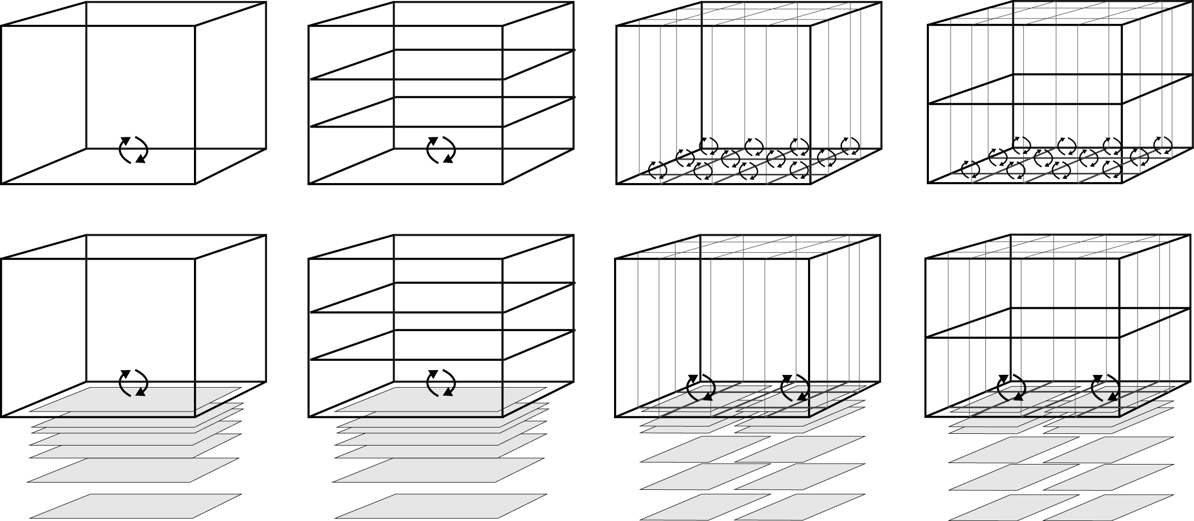

0D

1D

2D

3D

a

b

Figure 5 - Spatial resolution options available through FABM. a) Water column studies have traditionally assigned a flux to the sediment water interface without resolving the sediment chemical concentrations by depth, though they can be resolved laterally. b) The 0D water column is the method used in most sediment diagenesis studies, and use of multiple sediment zones is an option available within the FABM.

### Program structure

The general structure of the program is shown in Figure 5 - 5. The program is firstly initialised, then loops through the kinetic and equilibrium reactions for each time step and writes the resulting concentrations and rates at each depth to an output file. The kinetic reactions are solved by the VODE program (Brown et al. 1989) and the equilibrium reactions by the Simplex program.

File: rates.sed

rates at final time

File: aed_seddiagenesis

File: aed_sedcandi

INITIALISATION

Sediment depth layers

Porosity

Bioturbation functions

Rate constants

Initial concentrations

KINETIC PROCESSES

Boundary conditions

(concentration, flux)

Set the rates

(rate constants,

concentrations)

Set the reactions

Transport

(diffusion, advection)

Solve the equations

*start the simulation*

*update equilibria*

EQUILIBRIUM PROCESSES

Precipitation, adsorption,

ageing, pH

*start*

*next*

*time*

*step*

File: aed_sedvode

ODE solver

*calculate fluxes*

File: (variable).sed

concentrations

*write the output data*

File: aed_geochem

File: aed_gcsolver

(Simplex)

Figure 5 - General structure of the model processes and files.

### Model setup, boundary conditions and parameter definition

The model is set up via the name list text file fabm.nml using the model keyword “aed_seddiagenesis” with the model configured to select the “Dynamic” option. Once this is selected, the model will search for the “&aed_sedcandi” parameter block within fabm.nml.

Each active sediment model within the FABM model is discretised into a user definable number of depth layers (maxnpts) that start at a thickness of a few mm at the sediment-water interface and which increase exponentially down to a pre-defined sediment depth (xl). Users must define the sediment domain physical properties as summarised in Table 5 - 10, including configuration options related to bioturbation and irrigation. The biogeochemical configuration (Table 5 - 11), rate constants (see Table 5 - 12 and Table 5 - 13) must be set according to the sub-model options described above.

Table 5 - Sediment physical and transport parameters

|  |  |  |  |
| --- | --- | --- | --- |
| Parameter name | Unit | Example value | Description |
| db0 | cm2 y-1 | 10 | Biodiffusion coefficient at sediment-water ineterface |
| imix | 0/1 | 0 | Bioturbation function: 0-Gaussian; 1 – two-layer model |
| xs | cm | 3 | Half depth for Gaussian mixing (imix - 0) |
| x1 | cm | 1 | Depth at which db starts to decreacse (imix -1) |
| x2 | cm | 5 | Depth at which db is zero (imix - 1) |
| irrig | 0/1 | 1 | Bioirrigation switch |
| alpha0 | y-1 | 15 | Irrigation coefficient |
| xirrig | cm | 4 | Maximum irrigation depth |
| ventflow | cm y-1 | 0 | Advective flux (positive value indicates from below) |
| w00 | cm y-1 | 0.75 | Sediment accumulation velocity at maximum depth |
| p0 | - | 0.90 | Porosity at sediment-water interface (*ϕ0* in equation 5 - 104) |
| p00 | - | 0.80 | Porosity at maximum depth (*ϕxl* in equation 5 - 104) |
| bp | - | 2.5 | Porosity attenuation coefficient (*β* in equation 5 - 104) |
| torteq | 1/2/3 | 3 | Tortuosity calculation method switch: 1-Archie; 2-Burger; 3-Weissberg |
| an | - | 2.14 | Porosity exponent for tortuosity (if Archie) |
| aa | - | 3.79 | Porosity exponent for tortuosity (if Burger) |
| ab | - | 2.02 | Porosity exponent for tortuosity (if Weissberg) |
| xl | cm | 100 | Maximum simulation depth |
| maxnpts | - | 40 | Number of vertical layers |

Table 5 - The major biogeochemical configuration options, which are set by the user before the model is initialised.

|  |  |  |
| --- | --- | --- |
| Biogeochemical configuration | | Description |
| OMapproach | 1/2 | Kinetic redox equations, corresponding to the approaches of chapter 2 |
| OMModel | 1/2/3 | Organic matter breakdown models, as described in Table 5 - 1, Figure 5 - 2 |
| FTem switch | 1/2 | Sets reaction rate dependency on temperature |
| FT switch | 1/2 | Sets reaction rate dependency on thermodynamics |
| FBio switch | 1/2 | Sets reaction rate dependency on biomass concentration |
| FIN switch | 1/2 | Sets reaction rate dependency on concentration of other oxidants |
| simMnFe | T/F | Turns all Mn and Fe primary and secondary reactions on or off |
| simFeS | T/F | Turns all FeS reactions on or off |
| simX | T/F | Allows simulation of adsorbed metal X |
| Xname | “X” | Metal X: “As”, “Cu”, “Cd”, “Pb”, “Ni”, “Zn” |
| simCaCO3 | T/F | Turns all calcite reactions on or off |
| simFeCO3 | T/F | Turns all siderite reactions on or off |
| simMnCO3 | T/F | Turns all rhodchrosite reactions on or off |
| simNPads | T/F | Turns N and P adsorption on or off |
| rxn_mode | 0/1 | Sets precipitation to: kinetic-0; IAP/Ksp-1 |

Table 5 - Parameters for organic matter oxidation set in fabm.nml

|  |  |  |  |  |
| --- | --- | --- | --- | --- |
| Symbol |  | Units | Description |  |
| Organic matter oxidation kinetic constants | | | |  |
| *OMModel 1* |  |  |  |  |
| *kpoml* |  | y-1 | Breakdown of labile POM | poml2dic |
| *kpomr* |  | y-1 | Breakdown of refractory POM | pomr2dic |
| *OMModel 2* |  |  |  |  |
| *kdocl* |  | y-1 | Kinetic constant for oxidation of *docl* | docl2dic |
| *kdonl* |  | y-1 | Kinetic constant for oxidation of *donl* | donl2din |
| *kdopl* |  | y-1 | Kinetic constant for oxidation of *dopl* | dpol2dip |
| *kpocl* |  | y-1 | Kinetic constant for hydrolysis of *pocl* | pocl2docl |
| *kponl* |  | y-1 | Kinetic constant for hydrolysis of *ponl* | ponl2donl |
| *kpopl* |  | y-1 | Kinetic constant for hydrolysis of *popl* | popl2dopl |
| *kdocr* |  | y-1 | Kinetic constant for oxidation of *docr* | docr2docl |
| *kdonr* |  | y-1 | Kinetic constant for oxidation of *donr* | donr2donl |
| *kdopr* |  | y-1 | Kinetic constant for oxidation of *dopr* | dopr2dopl |
| *kpocr* |  | y-1 | Kinetic constant for hydrolysis of *pocr* | pocr2docr |
| *kponr* |  | y-1 | Kinetic constant for hydrolysis of *ponr* | ponr2donr |
| *kpopr* |  | y-1 | Kinetic constant for hydrolysis of *popr* | popr2dopr |
|  |  |  |  |  |
| *OMModel 3* |  |  |  |  |
| *khydrolysis i* |  | y-1 | Hydrolysis of POM to hydrolysis products | khyd *i* |
| *kgrowth j* |  | y-1 | Growth rate of each bacterial group | kgrowth *j* |
| *kdeath j* |  | y-1 | Death rate of each bacterial group | kdeath *j* |
| *FTEA* | | | |  |
|  |  | mol L-1 | Monod constant for O2 limitation | ko2 |
|  |  | mol L-1 | Monod constant for NO3- limitation | kno3 |
|  |  | mol L-1 | Monod constant for MnO2 limitation | kmno2 |
|  |  | mol L-1 | Monod constant for Fe(OH)3 limitation | kfeoh |
|  |  | mol L-1 | Monod constant for SO42- limitation | kso4 |
| *FIn* | | | |  |
|  |  | mol L-1 | Monod constant for inhibition | lo2 |
|  |  | mol L-1 | Monod constant for inhibition | lno3 |
|  |  | mol L-1 | Monod constant for inhibition | lmo2 |
|  |  | mol L-1 | Monod constant for inhibition | lfeoh |
|  |  | mol L-1 | Monod constant for inhibition | lso4 |
|  | | | |  |
| *O2/dhydo* |  | - | Moles of O2 per mole of *DHyd* | o2perdhyd |
| *O2/dfer* |  | - | Moles of O2 per mole of *DFer* | o2perdfer |
| *O2/domr* |  | - | Moles of O2 per mole of *domr* | o2domr |
| *NO3-/dhyd* |  | - | Moles of NO3- per mole of *DHyd* | no3perdhyd |
| *NO3-/ dfer* |  | - | Moles of NO3- per mole of *DFer* | no3perdfer |
| *NO3-/ domr* |  | - | Moles of NO3- per mole of *domr* | no3domr |
| *MnO2/dhyd* |  | - | Moles of MnO2 per mole of *DHyd* | mno2perdhyd |
| *MnO2/ dfer* |  | - | Moles of MnO2 per mole of *DFer* | mno2perdfer |
| *MnO2/ domr* |  | - | Moles of MnO2 per mole of *domr* | mno2domr |
| *Fe(OH)3/dhyd* |  | - | Moles of MnO2 per mole of *DHyd* | feohperdhyd |
| *Fe(OH)3/ dfer* |  | - | Moles of MnO2 per mole of *DFer* | feohperdfer |
| *Fe(OH)3/ domr* |  | - | Moles of MnO2 per mole of *domr* | feohdomr |
| *SO42-/dhydo* |  | - | Moles of MnO2 per mole of *DHyd* | so4perdhyd |
| *SO42-/ dfer* |  | - | Moles of MnO2 per mole of *DFer* | so4perdfer |
| *SO42-/ domr* |  | - | Moles of MnO2 per mole of *domr* | so4domr |
| *FT constants* | | | |  |
| *R* |  | kJ K-1 mol-1 | Gas constant | FTR |
| *T* |  | K | Temperature | FTT |
| *FT ΔG0* | | | |  |
| *ΔG0Aer DHyd* |  | kJ mol-1 | Free energy released from aerobic consumption of hydrolysis products | dGAerHyd |
| *ΔG0Den DHyd* |  | kJ mol-1 | Free energy released from denitrifying consumption of hydrolysis products | dGDenHyd |
| *ΔG0Fer DHyd* |  | kJ mol-1 | Free energy released from denitrifying consumption of hydrolysis products | dGFerHyd |
| *ΔG0Aer OAc ΔG0Aer H2* |  | kJ mol-1 | Free energy released from aerobic consumption of fermentation products | dGAerOAc dGAerH2 |
| *ΔG0Den OAc ΔG0Den H2* |  | kJ mol-1 | Free energy released from denitrifying consumption of fermentation products | dGDenOAc dGDenH2 |
| *ΔG0Man OAc ΔG0Man H2* |  | kJ mol-1 | Free energy released from manganese reducing consumption of fermentation products | dGManOAc dGManH2 |
| *ΔG0Iro OAc*  *ΔG0Iro H2* |  | kJ mol-1 | Free energy released from iron reducing consumption of fermentation products | dGIroOAc  dGIroH2 |
| *ΔG0Sul OAc ΔG0Sul H2* |  | kJ mol-1 | Free energy released from sulfate reducing consumption of fermentation products | dGSulOAc dGSulH2 |
| *ΔG0Met OAc ΔG0Met H2* |  | kJ mol-1 | Free energy released from methanogenic consumption of fermentation products | dGMetOAc dGMetH2 |
|  |  |  |  |  |

Table 5 - Secondary reaction parameters set in fabm.nml

|  |  |  |  |
| --- | --- | --- | --- |
| Symbol | Value/range | Units | Description |
| Secondary redox | | | |
|  |  | y -1 | Kinetic constant for oxidation of NH4+ by O2 |
|  |  | y -1 | Kinetic constant for oxidation of Mn2+ by O2 |
|  |  | y -1 | Kinetic constant for oxidation of Fe2+ by O2 |
|  |  | y -1 | Kinetic constant for oxidation of HS- by O2 |
|  |  | y -1 | Kinetic constant for oxidation of CH4 by O2 |
|  |  | y -1 | Kinetic constant for oxidation of FeS by O2 |
|  |  | y -1 | Kinetic constant for oxidation of FeS2 by O2 |
|  |  | y -1 | Kinetic constant for oxidation of Mn2+ by NO3- |
|  |  | y -1 | Kinetic constant for oxidation of Fe2+ by NO3- |
|  |  | y -1 | Kinetic constant for oxidation of HS- by NO3- |
|  |  | y -1 | Kinetic constant for oxidation of Fe2+ by MnO2 |
|  |  | y -1 | Kinetic constant for oxidation of FeS2 by MnO2 |
|  |  | y -1 | Kinetic constant for oxidation of FeS by MnO2 |
|  |  | y -1 | Kinetic constant for oxidation of HS- by Fe(OH)3 |
|  |  | y -1 | Kinetic constant for oxidation of FeS by Fe(OH)3 |
|  |  | y -1 | Kinetic constant for oxidation of CH4 by SO42- |
| Mineral transformation | | | |
|  |  | y -1 | Kinetic constant for ageing of MnO2A to MnO2B |
|  |  | y -1 | Kinetic constant for ageing of Fe(OH)3A to Fe(OH)3B |
|  |  | y -1 | Kinetic constant for pyrite formation |
| Precipitation | | | |
|  |  | y -1 | Kinetic constant for precipitation of Fe(OH)3A |
|  |  | y -1 | Kinetic constant for precipitation of FeS |
|  |  | y -1 | Kinetic constant for precipitation of FeCO3 |
|  |  | y -1 | Kinetic constant for precipitation of CaCO3 |

The initial conditions for each variable are set as a list by the “initial_vals”, which sets a constant concentration with depth in units of μmol L-1. For organic matter initial concentrations only, there are three available options for the concentration with depth, set by “OMInitMethodL”.

The sediment-water interface is the uppermost layer of the sediment, for which there are three configuration options set by the parameter “ibc2”. If the user specifies ibc2 = 2, the concentration is a constant value set by default_vals in the fabm.nml name list. For ibc2 = 1, the concentration is provided by a “link_variable”, which provides the concentration from another simulated water column FABM module. If the variable name in the link list is left blank (“ ”) then AED_CANDI will assume these variables are not linked to any water column variables and default to the “default_vals” values. If ibc2 = 10, the concentration is provided by a user-prescribed temporally variable value read from the file aed_sediment_swibc.dat. This option may desirable, for example, for simulating a seasonally or daily changing boundary condition.

Regardless of the ibc2 surface boundary condition option, fluxes of dissolved species occur between the sediment and water column. They are calculated from the concentration gradient at the sediment-water interface according to Fick’s Law:

|  |  |  |
| --- | --- | --- |
|  |  | 5 - |

where *D0* is the diffusivity as defined above, *δ* is the thickness of the diffusive boundary layer at the sediment water interface and defined as the length scale of the first sediment layer, *Cbw* is the bottom water concentration and *C1* is the concentration in the top sediment layer.

At the bottom of the domain (*x* = “xl”) the model can be specified to have a fixed-concentration (ibbc = 0) such that the concentration at *xl* = *CBot*, or it can be specified to have a zero-derivative (ibbc = 1) defined as at *x* = xl.

Table 5 - Initial condition and boundary condition configuration set in fabm.nml

|  |  |  |
| --- | --- | --- |
| Configuration option | | Description |
| initial_vals |  | Initial concentrations set for each variable at all depths |
|  |  |  |
| ibc2 | 1/10/2 | Boundary fluxes set as either: 1-from another FABM module; 2-constant flux ; 10-from another time-resolved input file |
| ibbc | 0/1 | Bottom boundary condition: fixed boundary concentration-0; zero gradient-1 |
| OMInitMethodL | CO_I, EX_I, LI_I | Constant, exponential or linear initial profile. |
|  | OM_top  OM_cf  OM_min  InMinDep |  |
|  |  |  |

### model output and post-processing

The model output files are written for each variable as text files, giving time (in years) as the first column depth as the first row and concentrations in the other fields. These can be read in using a data processing program such as R, Matlab or Excel for analysis. Further, the model outputs the file “rates.sed” for each variable at every depth for the final time step.

[HIGHLIGHT HERE YOU CAN ALSO OUTPUT FT AND OTHER INTERESTNG THINGS.

|  |
| --- |
| C:\Users\20731446\Desktop\Documents\Uni\Paper 3 - Estuary\Declare the model\All the outputs.GIF |
|  |

Figure 5 - Example of model output. Above – text files written to the results folder. Below – ammonium concentrations. The first column is time (y) and the first row is depth (cm).

**Profile prediction within MCMC showing uncertainity:**

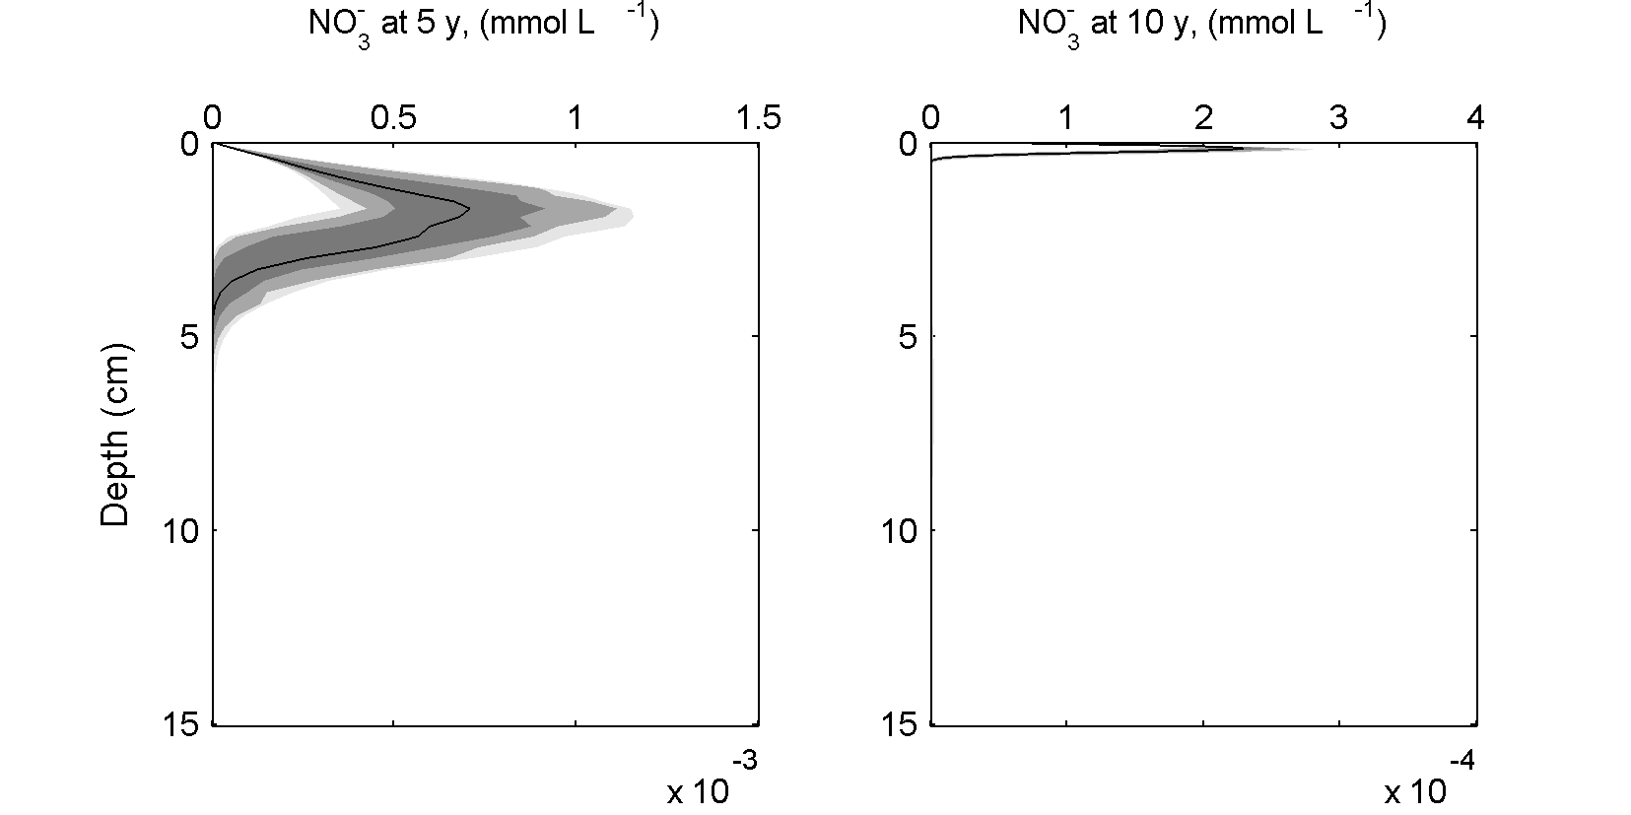

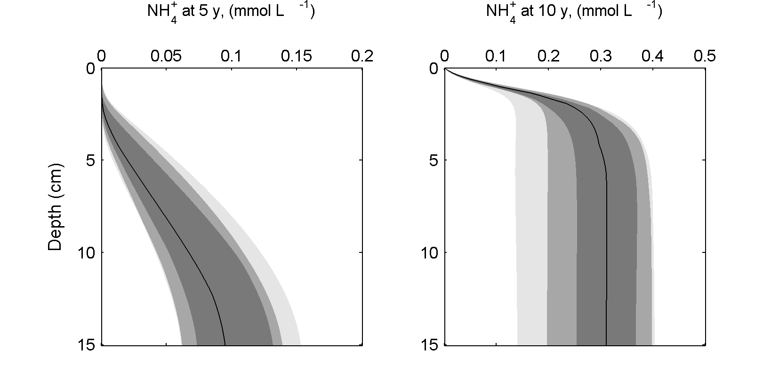

**Sediment flux during aquaculture:**

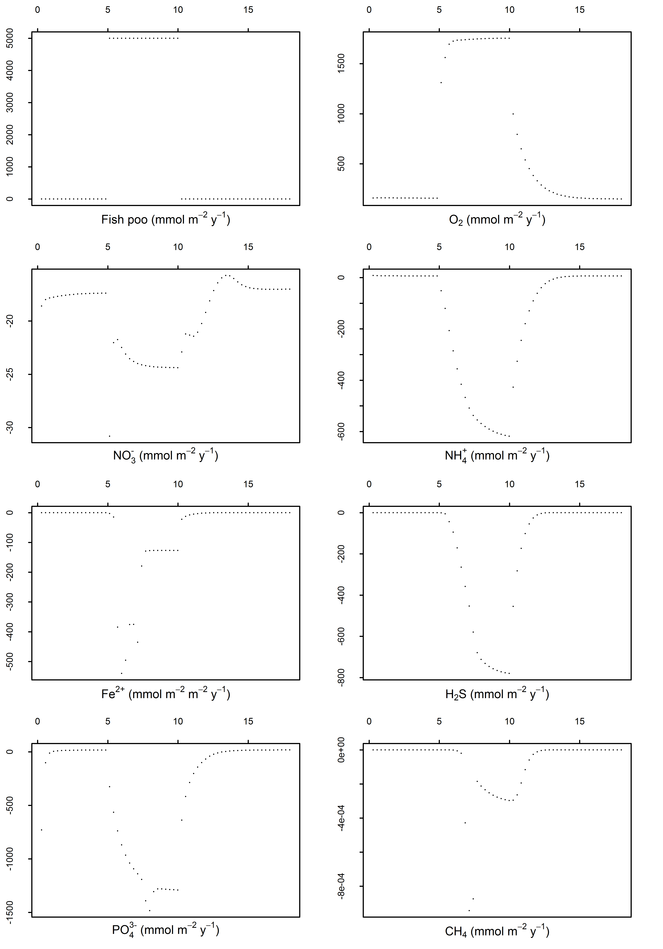

**Sediment changes following 5 years of aquaculture**

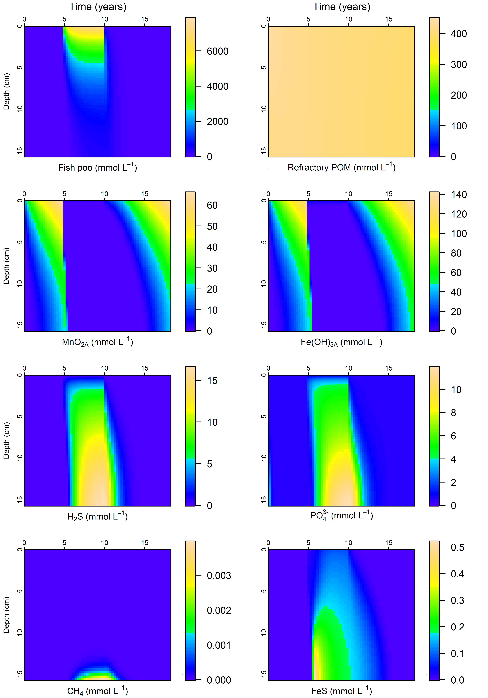

**Benchmarking**

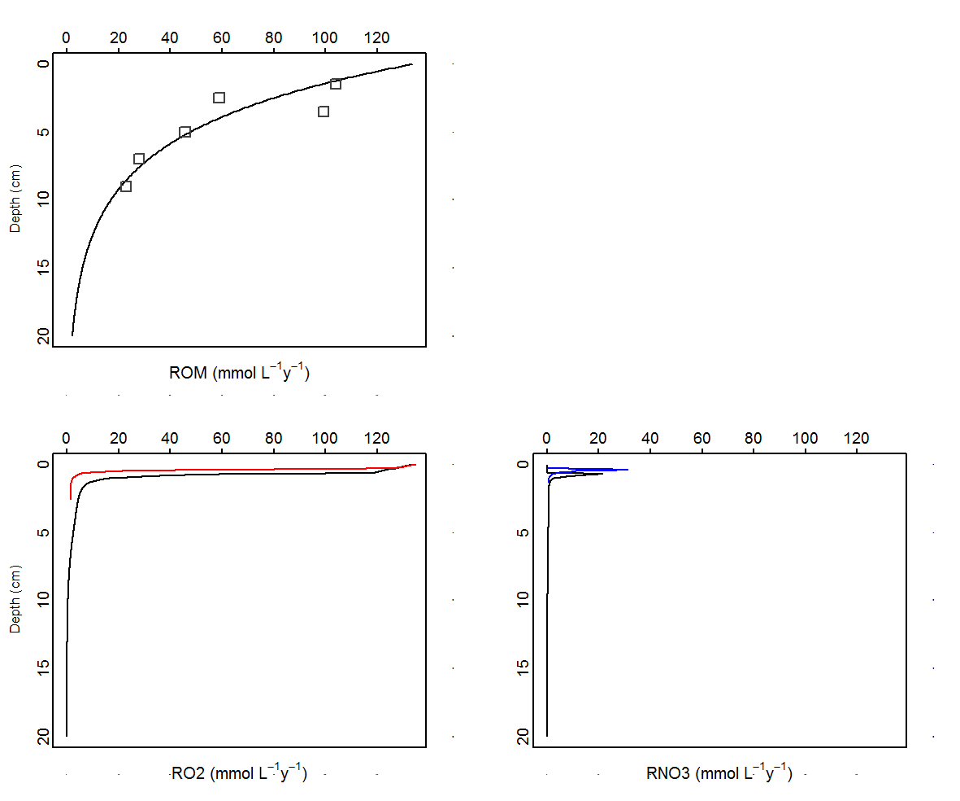

Figure B1. Simulated rates from CANDI AED. Top left: the overall carbon oxidation rate is set by depth, in order to fit the squares measured by Canfield et al. (1993). Bottom left: aerobic respiration using CANDI AED (black line) was close to the simulated rate of Van Cappellen and Wang (red). In the deepest part of the sediment, the simulated rate was greater using this model. Bottom right: denitrification with this model (black line) was slightly less and occurred slightly deeper than for Van Cappellen and Wang.

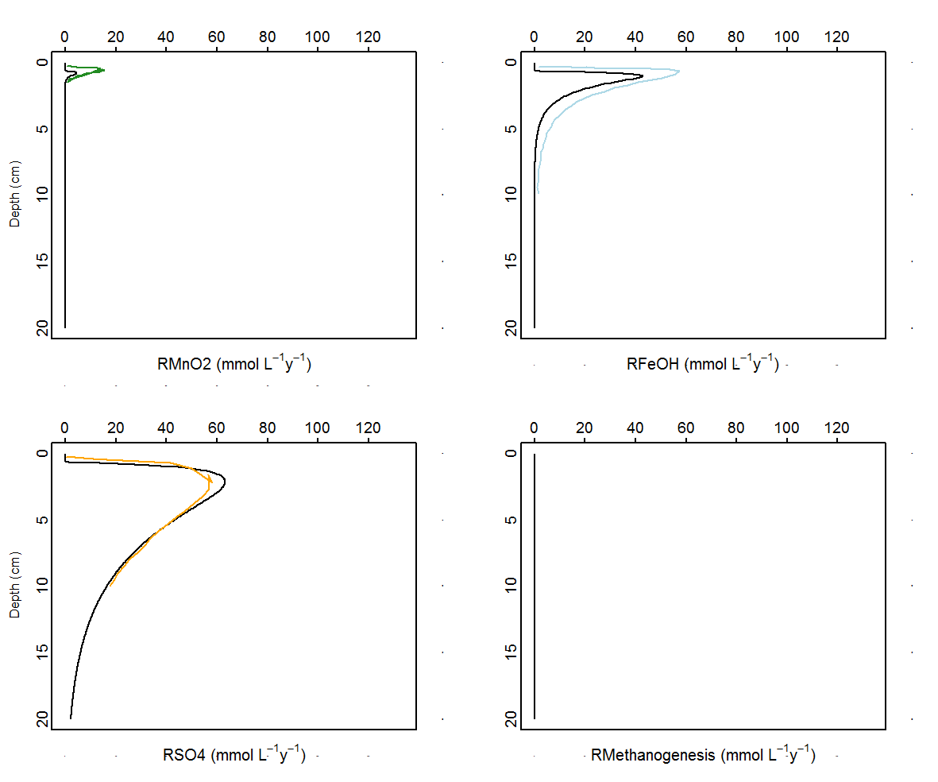

Figure B2. As with Figure B3, rates simulated here are in black and rates taken from Van Cappellen and Wang are coloured lines. Top left: the manganese reduction rate in this simulation was lower than the (green) rate calculated by Van Cappellen and Wang, but both were small in proportion to the overall oxidation rate. Top right: the iron reduction rate was lower than that simulated by Van Cappellen and Wang, peaking at around 40 rather than 60 mmol L-1 y-1, yet peaking at the same depth. Bottom left: the sulfate reduction rate in this simulation (black) was very close to the rate in Van Cappellen and Wang (1996) (orange). Bottom right: as with Van Cappellen and Wang, methanogenesis was inhibited.