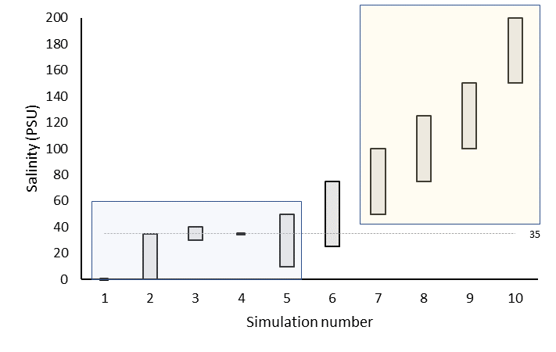

High, shallow NH4+ and H2S

Low, deep NH4+ and H2S