Coorong Dynamics Model

Author 1, Author 2, Author 3 etc

the 30-August-2021

# Welcome

# Contributing

## RStudio’s visual editor

If you’re unfamiliar with writing .Rmd and .md files, the [RStudio IDE 1.4](https://blog.rstudio.com/2020/09/30/rstudio-v1-4-preview-visual-markdown-editing/) release implements a visual markdown editor that minimises the need to learn most syntax. To use this feature, open a .Rmd or .md file and click the visual editor button in the top right-hand corner of the editor window. You will now see a live-rendered version of your document and the addition of numerous buttons/menus that provide a GUI for formatting. Standard word processing functionality, such as buttons to **bold**, *italicise*, and underline text are available, as well as shortcuts to features that can be more finicky in the basic source editor (e.g. citations, links, and simple tables). Returning to the source editor will reveal the formatting changes made are directly translated to the syntax of the raw file.

# Introduction

## Importance of the Coorong

## Ecological Character Description

## Management challenges

## Prior modelling

## Aims and Scope

# The Coorong Dynamics Model

## Model platform

## Overview of available data

# Lagoon Hydrodynamics

## Overview

## TUFLOW-FV overview

## Model mesh options and domain extent

## Boundary condition inputs

## Bottom roughness

## Model settings

## Validation

# Lagoon Water Quality

## Overview

## AED overview

## Module configuration : Water quality

## Module configuration : Sediment

## Boundary data specification

## Validation

# Lagoon Habitat

## Overview

Whilst the Coorong is a naturally saline to hyper-saline lagoon, freshwater flows are important in maintaining estuarine habitat and ecosystem health and preventing extreme hyper-salinity (Brookes et al. 2009). *Ruppia tuberosa* is an important macrophyte in the Coorong that provides habitat for fish and food for herbivorous birds (Phillips and Muller 2006), and it can tolerate a salinity higher than natural seawater. It therefore is known to concentrate in the mid to southern regions (Figure @ref(fig:lagoonhabitat-pic1)).

The germination and growth of *R. tuberosa* is known to be governed in large part by changes in salinity and water level regimes, which are influenced by flows through the barrages (Kim et al. 2013). Other factors that influence *R. tuberosa* growth include nutrient availability, water temperature, sediment quality and interactions with algae, including shading of light and interference with flowers and fruits on the surface. Early summer flows are thought to be particularly beneficial as they delay the drop in water level in the South Lagoon and can prevent extreme salinities emerging, thereby encouraging a more complete reproductive cycle (Collier et al. 2017).

In addition, salinity has also been identified as the key driver that influences fish assemblage structure and the extent of estuarine fish habitat in the Coorong (Ye et al. 2011). This section describes how simulations of *Ruppia and* estuarine fish habitat have been configured and assessed.

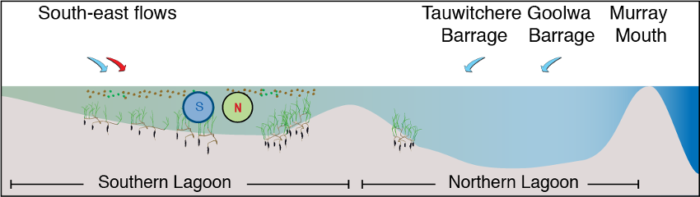

Conceptual diagram of Ruppia presence in the Coorong, under base case conditions= with moderate inflows from the Barrages (North) and Salt Creek (South-east).

## AED overview

The hydrodynamic-biogeochemical model TUFLOW-FV – AED is used to simulate the hydrodynamic conditions (velocity, salinity, temperature and water level), water clarity (light and turbidity) and the potential for filamentous algae (nutrients and algae). These three are described next.

### Hydrodynamics

The circulation and water balance is solved by [TUFLOW-FV](http://tuflow.com), a 3D flexible-mesh (finite volume) model that simulates the water level, velocity and temperature in response to meteorological and hydrological forcing. The model accounts for variations in water level, the horizontal temperature and salinity distribution and vertical density stratification in response to inflows, wind mixing and surface thermodynamics. The mesh consists of triangular and quadrilateral elements of different size that are suited to simulating complex morphometry. The finite volume numerical scheme solves the conservative integral form of the non-linear shallow water equations in addition to the advection and transport of scalar constituents such as heat and salinity, as well as the state variables from the coupled biogeochemical model (in this case, nutrients and suspended sediment within AED2). Surface momentum exchange and heat dynamics are solved internally within TUFLOW-FV, where appropriate meteorological boundary conditions are supplied. In the current application, the turbulent mixing of momentum and scalars has been calculated using the Smagorinsky scheme in a horizontal plane. Stratification is not dominant but can occur (Webster, 2005) and we optionally assess the significance of vertical mixing by employing the General Ocean Turbulence Model (GOTM) library, which is added as an optional module within TUFLOW-FV.

For the application to the Coorong, the model mesh was updated to have high resolution in the littoral zones and embayments, whereas less resolution was prescribed within the deeper regions (Figure 2). Data for boundary conditions for Salt Creek was based on available gauge data, and the barrage overflow and ocean conditions were taken from the previously simulation.

Since light is an important determinant of *Ruppia* growth, it is necessary to simulate resuspension to capture the periodic increases in turbidity, based on the computation of bottom shear stress, $τB$.

### Suspended solids and light

The AED component of the simulation is configured to include light ($I$), and two suspended solids ($SS$) groups.  The TUFLOW-FV – AED models are dynamically coupled to capture the feedbacks between $SS$, light, surface heating and (optionally) vegetation presence.

The model accounts for incident shortwave radiation to be attenuated as it penetrates the water column. The attenuation of light is dependent on the specific bandwidth. For primary production, the shortwave (280-2800 nm) intensity at the surface ($I_{0}$) is partitioned to the photosynthetically active component (PAR) based on the assumption that ~45% of the incident spectrum lies between 400-700nm. PAR and other light bandwidths such as ultra-violet (UV, ~3.5%) and near-infrared (NIR, ~51%), penetrate into the water column according to the Beer-Lambert Law:

$$I_{i}=f_{i}I_{0}\text{exp}\left(−K_{d_{i}}z\right)\left(\#eq:lagoonhabitat1\right)$$

where $i$ refers to the specific bandwidth range (e.g., PAR, UV, etc), $f_{i}$ is the fraction of light intensity within that range at the water surface and $z$ is the water depth. The light extinction coefficient $K_{d}$ is a variable parameter governing light attenuation, as influenced by the suspended solids ($SS$) in the water column, filamentous algae density, and vegetation leaf area index. In these simulations it is computed by assuming a background light extinction coefficient $K_{w}$ and the specific attenuation coefficient, $K_{e}$, for $SS$ and algae:

$$K_{d}=K_{w}+K_{e_{s}}SS+K_{e_{F}}FA\left(\#eq:lagoonhabitat2\right)$$

Computing turbidity from the concentration of particulates is also possible and able to be compared to routinely measured turbidity data. The relation for simulation of turbidity is able to be expressed as:

$$\text{Turbidity}=f_{t_{s}}SS\left(\#eq:lagoonhabitat3\right)$$

where $f_{t_{s}}$ is an empirical coefficient, determined through site specific correlations or literature.

The concentration of suspended solids at any location depends on inputs from tributaries, advection of material through the lagoon, and vertical fluxes due to particle resuspension and deposition. Deposition is computed based on a prescribed settling velocity for each particle group. The rate of resuspension ($R$) varies across the system due to heterogeneity in sediment properties. It is calculated by assuming linearity with the excess shear stress at the bed (Lee et al. 2005), such that:

$$R_{i}=\sum_{s=1}^{n_{s}}{{ f}_{s,i} { ε}_{s}} \text{max}\left(τ_{b}−τ_{c}, 0\right)\left(\#eq:lagoonhabitat4\right)$$

where $n_{s}$ is the number of particle size classes, $f_{s,i}$ is the fraction of each particle size class in the  sediment material zone, $ε$ is the resuspension rate coefficient, $τ_{b}$ is the bed shear stress (computed based on the current and wave orbital velocities in each cell), and $τ_{c}$ is the critical shear stress for resuspension, which depends on the sediment size (Julien 2010), and optionally, the presence of vegetation.

### Nutrients and filamentous algae

Within the Coorong, the AED model has previously been set up to predict inorganic and organic nutrients, and chlorophyll-a (Mosley et al., 2017). Whilst nutrients are not directly required for the *Ruppia* model assessment, the presence of filamentous algal blooms can compete for light and these are linked to bioavailable nutrients within the water column (in addition to other attributes).

We therefore include a filamentous algae variable in the model that is customized to reflect the Ulva community that was described in earlier chapters. In this case is it is assumed to be attached to benthic substrate, and is therefore is not subject to advection and mixing, but can slough off under high stress conditions and become a floating variable subject to transport. The balance equation describes how the biomass changes over time, according to:

$$\frac{d\left(FA\right)}{dt}=+f_{\text{uptake}}^{FA}−f_{\text{excr}}^{FA}−f_{\text{mort}}^{FA}−f_{\text{resp}}^{FA} −f_{\text{slough}}^{FA}\left(\#eq:lagoonhabitat5\right)$$

$$
\scriptsize{f^{FA}_{\text{uptake}} = \underbrace{R^{FA}_{\text{growth}}}_{\text{max growth} \\ \text{rate at 20$^\circ$C}} \ \ \underbrace{(1-k^{FA}_{\text{pr}})}_{\text{photorespiratory} \\ \text{loss}} \ \ \underbrace{\Phi^{FA}_{\text{tem}}(T)}_{\text{temperature} \\ \text{scaling}} \text{min} \left \{\underbrace{\Phi^{FA}_{\text{light}}(I)}_{\text{light limitation}}, \underbrace{\Phi^{FA}_{\text{N}}(NO_{3},NH_{4})}_{\text{light limitation}}, \underbrace{\Phi^{FA}_{\text{P}}(PO_{4})}_{\text{P limitation}} \right \} [FA]}
(\#eq:lagoonhabitat6)
$$

Note that the ‘sloughed’ biomass is considered to be exposed to surface light irradiances and can also decompose should environmental conditions be inadequate for growth.

### Parameter Summary

The hydrodynamic-biogeochemical model configuration described above requires the specification of numerous parameters, many of which have been assigned based on previous modelling assessments undertaken within the CLLMM system (e.g. Hipsey et al., 2016), and/or literature review (Table 1).

## Module configuration: Ruppia

### Model setup and configuration

The approach adopted in the current study is to simulate “habitat suitability” based on an assessment of modelled environmental conditions relative to the known requirements of Ruppia tuberosa, for example, considering salinity, light and/or other environmental conditions. This approach was then used to define a relative index for each computational cell by overlaying the various environmental controls/limitations that have been informed based on prior experiments and surveys. The ***Habitat Suitability Index*** approach empirically defines conditions that lead to successful growth and reproduction, without simulation of processes such as photosynthesis and respiration.

For the Coorong, a similar habitat model approach was undertaken previously by Ye et al. (2014), who focused exclusively on the salinity and water level requirements of Ruppia and presented the model results as an overall probability that Ruppia plants would successfully complete their lifecycle, by accounting for the different tolerances of different life stages.

In this study, we used the hydrodynamic-biogeochemical model to predict environmental conditions at high spatial and temporal resolution for a period of multiple years, and used this to calculate the habitat suitability index (HSI) for each particular phase of the life cycle of Ruppia (Figure @ref(fig:lagoonhabitat-pic2)). The calculation of the HSI required the integration of environmental conditions over a biologically relevant time period, based on the typical duration and seasonal timing for each life-stage. HSI results for different life stages were then combined and integrated to obtain overall HSI results for successful completion of sexual or asexual life cycles of Ruppia. For each annual cycle these model results were then summarised over the length of the Coorong, to allow estimation of the total suitable area.

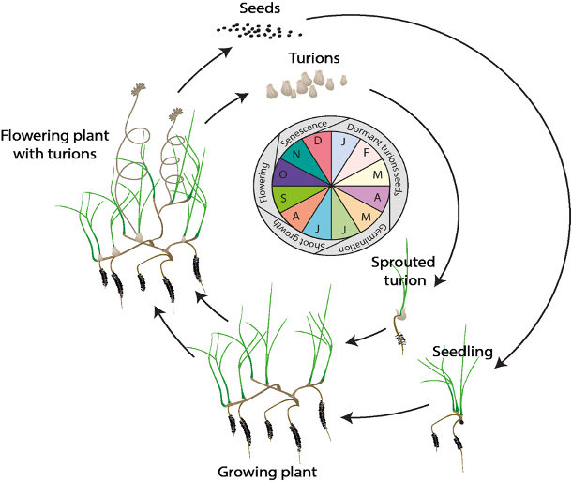

Overview of the sexual and vegetative life cycles of *Ruppia tuberosa*.



Conceptual diagram of the base case scenario (2015), with moderate inflows from the Barrages (North) and Salt Creek (South-east).

#### Ruppia Habitat Suitability Index calculation

In each model cell ($c$), the Habitat Suitability Index (HSI) is computed based on suitability of conditions ($i$), for each of the main life-stages ($j$), by defining a fractional index, . The fractional index for each attribute is computed at each time, step and then integrated over a 90-day window, specific to the life-cycle stage.

$$
\Phi^{HSI_{j}}_{i} = \frac{1}{t_{j_{\text{start}}}-t_{j_{\text{end}}}} \sum^{t_{j_{\text{end}}}}_{t=t_{j_{\text{start}}}}\Phi^{HSI_{j}}_{i}(i)_{t}
(\#eq:lagoonhabitat7)
\\
\scriptsize{
\\ \text{whereby: $i$ = {salinity, temperature, light, depth, algae}}
\\ \text{and: $j$ = {seed, sprout, adult, flower, turion}}}
$$

The integration time for each life-stage, $j$, is set to be 90-days based on assessment of literature on the typical impact times reported following shading or disturbance. The optimum 90-day period is selected from within the available plant growth windows, as indicated in Table 2.

The above function is computed in each cell and produces maps of suitability (between 0 and 1) for each environmental attribute for each life stage within any given year. The individual functions are piecewise, based on synthesis of the available literature (Table 3). These are then overlaid to produce a final map for any given year using:

$$Φ_{c}^{HSI}=\text{min}{\left[Φ_{c}^{HSI_{j}}\right]}_{c}\left(\#eq:lagoonhabitat8\right)$$

To compare the overall area of suitable habitat between years, or the relative suitability of alternate scenarios, the fractional suitability is used as a multiplier with the cell area, according to:



and the spatially averaged HSI in any given region (with area A) is computed as:



Life cycle time windows over which environmental suitability is assessed. {#tbl:table1}

|  |  |  |  |  |  |
| --- | --- | --- | --- | --- | --- |
| Stage, $j$ | Seed germination | Turion sprouting | Adult growth | Flowering | Turion production |
| Start date, $t_{j_{\text{start}}}$ | *Apr* | *Apr* | *Jun* | *Aug* | *Aug* |
| End date, $t_{j_{\text{end}}}$ | *Jun* | *Jun* | *Aug* | *Oct* | *Oct* |

#### Model outputs and assessment

The *Ruppia* ecological response model predicts habitat suitability of critical life stages (Figure 7), in response to light, depth, salinity and temperature, which in the end results in a combined probability of sexual or asexual life-cycle completion (FIGURE 8 and 9). The requirements for each life stage are quite different, and when each is superimposed together, the areas where life-cycle completion are limited to the margins of the main lagoons, and the shallow areas around Parnka. From year to year, the area of good habitat changes, depending on that years eco-hydrodynamic regime (Figure 10).

By comparing scenarios with different flows into the Lagoon, we can see that there is an expansion of good habitat in the north of the South Lagoon, and along the South Lagoon margins, when extreme salinity values are avoided (Figure 11).

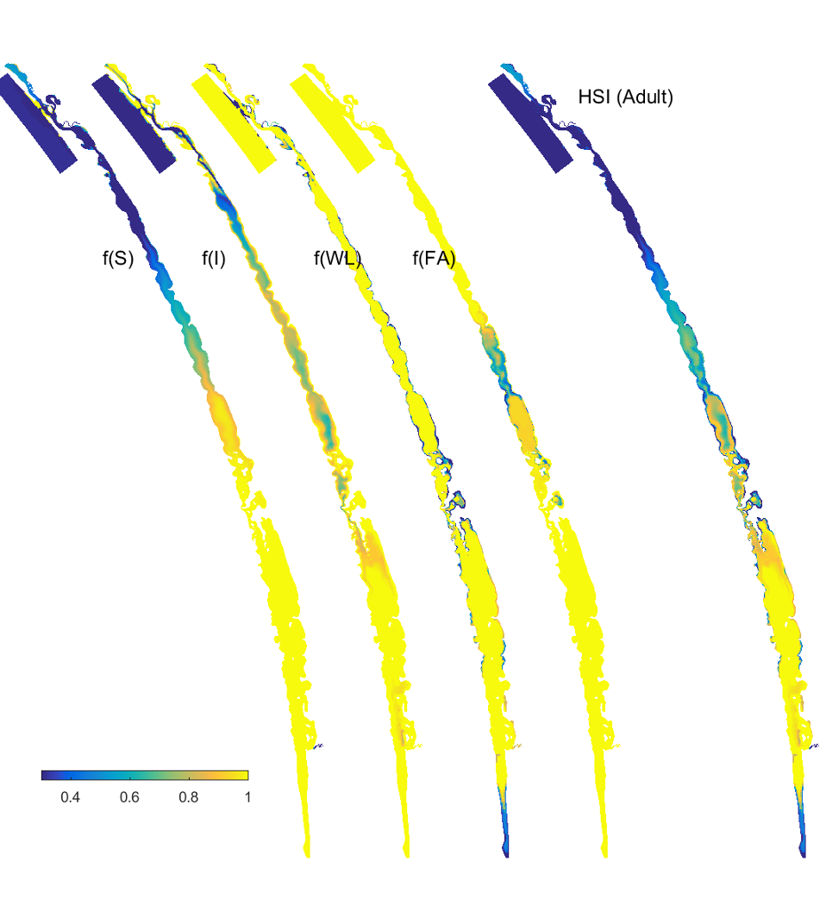

Habitat suitability (HSI) for the adult plant phase of *Ruppia tuberosa* in the Coorong as a function of salinity, light, water level and presence of filamentous algae for the Base Case (2015).

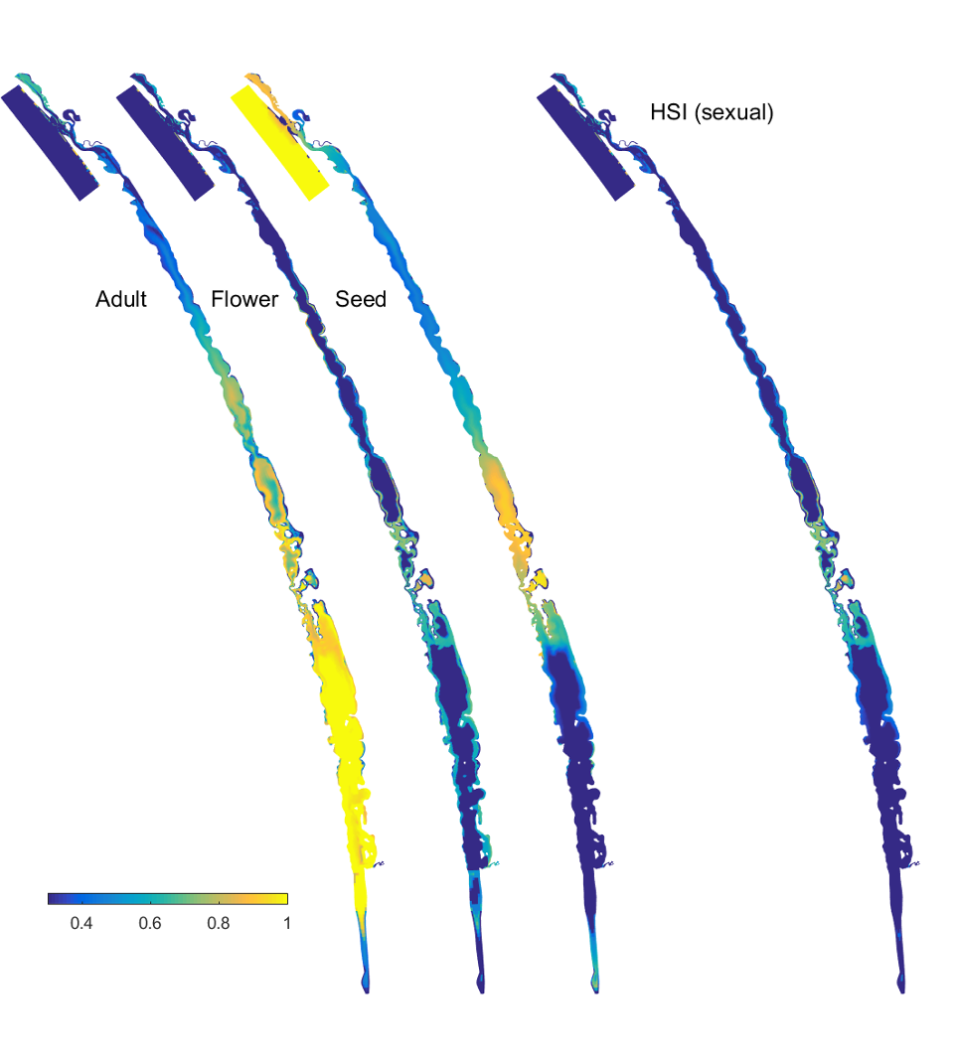

Overall Habitat Suitability (HSI) for a successful completion of the asexual life cycle by *Ruppia tuberosa* in the Coorong, calculated by integrating the HSI results for adult plants, turion formation and turion sprouting for the Base Case (2015).

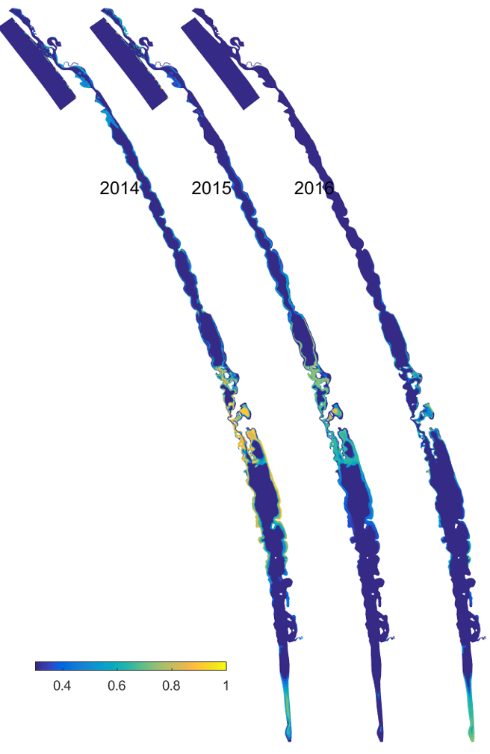

Overall Habitat Suitability (HSI) for a successful completion of the sexual life cycle by *Ruppia tuberosa* in the Coorong, calculated by integrating the HSI results for adult plants, flowering (incl. seed formation) and seed germination (incl. seedling survival) for the Base Case (2015).

## Module configuration: Fish

## Module configuration: Birds

## Validation and Assessment

# Scenarios

# Conclusion