Homogenization of freshwater lakes

kevin_cazelles

timothy_bartley

matthew_guzzo

kevin_mccann

2019-09-13

# :construction: WIP :construction:

# :us:

What happened to Ontarian fish communities over the last decades? We have been looking for answers relentlessly! Indeed, we did our best to determine whether global change has affected those communities over the last 40 years. Turns out fish communities in Ontario’s lakes are pretty different from what they were, but climate change does not explain those changes :boom:! But, but… how can we say that? Well, we had two very good surveys: one that was carried out back in the 70’s and the other one in the 2000’s. These included presence-absence data for tens of fish species for >500 freshwater lakes throughout Ontario.

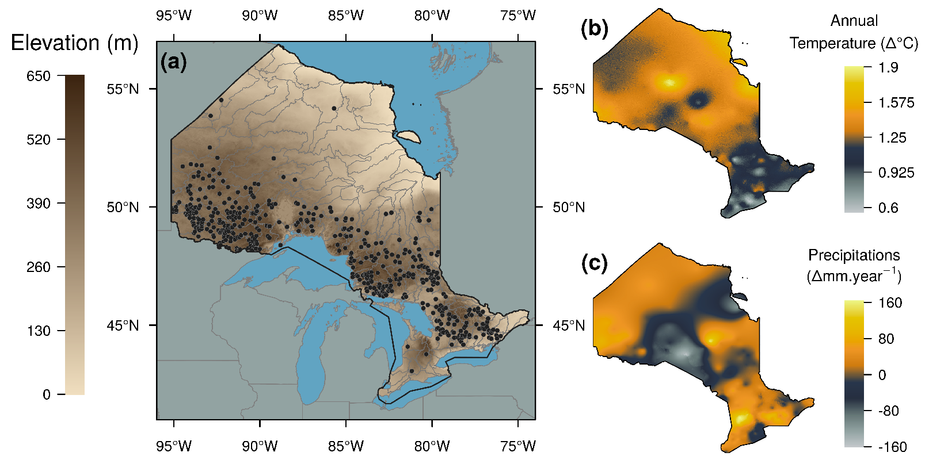

After selecting a meaningful set of species, we compared different aspects of the biodiversity. Overall, we found a surge in local diversity (a.k.a. α-diversity) and a drop in regional diversity (a.k.a. β-diversity). You may wonder what does that mean, right? Let’s use a bakery analogy (a good one, at least for Frenchies), let’s assume that in your home town, years ago, there were 3 bakeries:

1. from the first, you were able to buy cholatines, croissants, rhubarb pies and carrot cakes;
2. from the second one, only croissants (but the best in town!);
3. in the last one you had chocolatine and lemon pie

but nowadays what they are offering is:

1. cholatines, croissants, carrot cakes;
2. cholatines, croissants, carrot cakes;
3. cholatines, croissants.

That’s one example of homogenization! Now swap bakeries for lakes and pastries for fish species and that’s what we found! In a second step we searched for plausible explanations and so we used climate data, lakes characteristics ( e.g. lake size) and species characteristics and built statistical models to determine the most plausible cause. Turns out that climate data and lake characteristics failed at explaining observed changes, but we found a clear difference in between gamefish species and the other species: the former thrive in Ontario but not the others! This explains pretty well the compositionnal shift in fish communities and led us to conclude that the homogenization trend is due to gamefish movements.

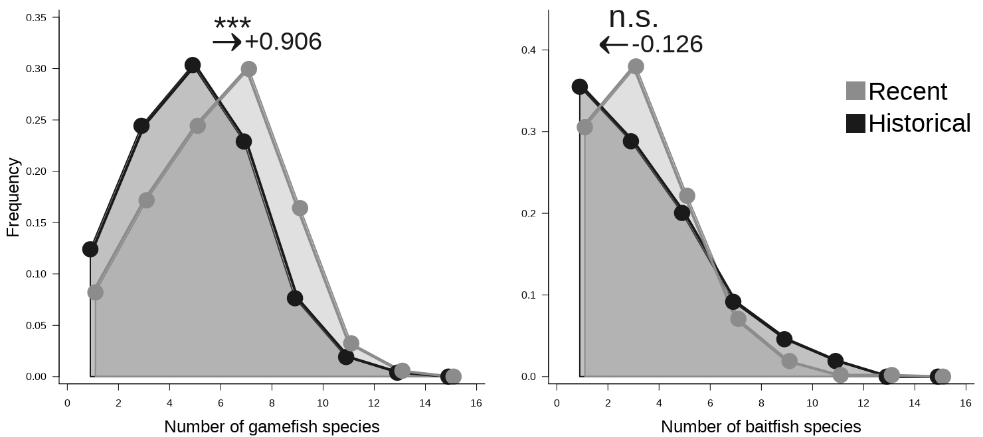

Freshwater lakes of Ontario are now dominated by gamefish species which will likely affect ecological dynamics within lakes over the long-term and that is a first question that requires further investigations. Also, the true nature of these movements remains to be explored, are they natural, human-driven or a bit of both? As scientists, we are trying to focus on facts and being as less judgmental as possible but it is hard not to worry about the loss of regional biodiversity. Going back to our analogy, homogenization be welcome news for carrot cake lovers but a very sad one for people that used to enjoy rhubarb pie!

To conclude this post, I (Kevin Cazelles) would like to add a few words on collaboration. Even though I am relatively confortable with community analysis, I must say that my expertise in fis communities was very little (still is but slightly better now). So, I would like to stress how crucial it was for me to benefit from other researchers expertise, from people that actually know their fish and the data. Without them, this paper would not have been possible. I think in modern science it is important to know what are your strengths (and always keep building up your skill set and extending your knowledge) but it is even more important to be aware of what you don’t know actually know and to identify the people that can help you. It does not mean they will do the job for you, but their input is what can bring your paper to the next level!

:link: The full story is now available on [Global Change Biology website](https://onlinelibrary.wiley.com/doi/abs/10.1111/gcb.14829) and we also released the [analysis pipeline for this study](https://github.com/McCannLab/HomogenFishOntario)). Please, do not hesitate to reach out to [Kevin Cazeles](/members/kevin_cazelles) if you cannot access the paper or have further questions.

# :fr: