Middle Earth State Scale Survey Report Demo

February 19, 2019

## Summary and Data Needed

      This report is generated using an R markdown document largely based off of Emma Jones and Jason Hill’s work in Virginia. For any questions or errors, please contact Leah Ettema ([ettema.leah@epa.gov](mailto:ettema.leah@epa.gov), 304-234-0245).

*All data used in this report is not real*

We will use modified data and examples which are hard coded into and read from MakeData.R; the names of subpopulations have been changed to be in Middle Earth and I selected only a few parameters and geographic subdivisions that could be reported on. I have highlighted in the comments where your data would need to be inserted.

### Data needed

*Condition Estimate Results*

You will need at least one of the following data inputs. These are typically created from analysis with the R package [spsurvey](https://cran.r-project.org/web/packages/spsurvey/spsurvey.pdf).

* I: CDF table with these column names: Type, Subpopulation, Indicator, Value, NResp, Estimate.P, StdError.P, LCB95Pct.P, UCB95Pct.P, Estimate.U, StdError.U, LCB95Pct.U, UCB95Pct.U
* II: Categorical Condition Estimates with these column names: Type, Subpopulation, Indicator, Value, NResp, Estimate.P, StdError.P, LCB95Pct.P, UCB95Pct.P, Estimate.U, StdError.U, LCB95Pct.U, UCB95Pct.U

If you want to report conditions over multiple years, you may need to add a column for every IR year of data filled with yes/no or 0/1 or make a subpopulation of your data be be the year of IR reporting.

This example document is broken up into two sections: * Tables and graphs generated from the CDF tables (based on VA’s code) * Tables and graphs generated from Categorical Condition Estimates

*Other Optional Data*

* Geospatial data (shapefiles or excel sheets with lat/long) for any maps you wish to display
* Sample database (or some other table) if you wish to report sample sizes other than the ones used to create condition estimates (Nresp). This could include number of samples collected over the entire history of your probabilisitc monitoring program (statewide or by other geographical subdivision) or total number of sites evaluated but not sampled.

Here are some helpful R links:

* [Word Document Styling (Reference Documents)](https://www.coursera.org/lecture/reproducible-templates-analysis/customizing-a-word-document-idnEf)
* [Markdown Basics](https://rmarkdown.rstudio.com/authoring_basics.html)
* [Word documents in R Markdown](https://bookdown.org/yihui/rmarkdown/word-document.html)
* [Spatial Data training by USEPA ORD](https://mhweber.github.io/R-User-Group-Spatial-Workshop-2018/index.html)

## Part 1: Reporting Examples based on CDF results

## Chapter 2.4 FRESHWATER PROBABILISTIC MONITORING

### 2.4.1 Executive Summary

      ProbMon is designed to answer questions about statewide and regional water quality conditions through the use of a statistically valid sample frame across large geographic areas. The Middle Earth DEQ Probabilistic Monitoring Program, or ProbMon, has sampled 300 wadeable sites statewide since the program began in 2011 (Figure 2.4-3). Over 300 sites were sampled during the 2018 assessment period (Figure 2.4-2). Although the majority of water quality parameters meet applicable water quality criteria, the biological condition of Middle Earth streams fail to meet expectations in approximately 45% of stream miles (Figure 2.4-1). Biological condition is assessed using aquatic organisms as indicators of stream health. These biological impairments are believed to be caused in part by stressors that are not subject to water quality criteria such as streambed sedimentation, habitat disturbance, and nutrients. The most frequently occurring water quality problems are presented in Figure 2.4-1. ProbMon is a cost-effective way to evaluate Middle Earth streams and rivers, test new sampling methods, and support other DEQ water quality management activities like water quality standards development, Total Maximum Daily Load (TMDL) studies, and setting more defensible permit conditions.

##### Figure 2.4-1. Percentage of stream miles with water quality parameters failing to pass criteria/screening values. Red bars indicate a parameter with no water quality standard and green bars indicate a parameter with water quality standard or screening value. Data represents data collected from 2011 - 2016.

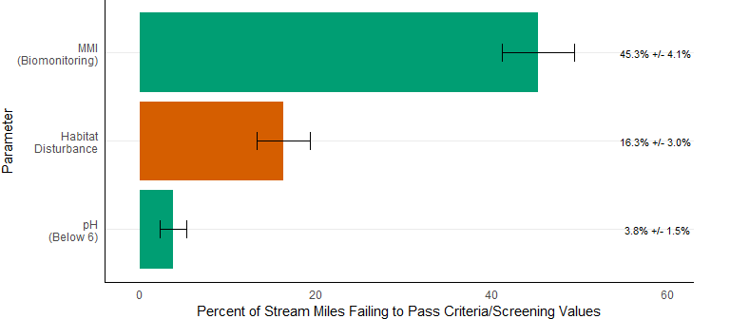

### 2.4.2 Introduction

      Probabilistic monitoring is designed to answer basic questions like: What are the primary water quality problems in Middle Earth? How widespread are these problems, and what pollutants cause the greatest environmental stress to Middle Earth water resources? The General Assembly, citizens, environmental stakeholders, and the United States Environmental Protection Agency (USEPA) have encouraged the Department of Environmental Quality (DEQ) to answer these questions and to establish baseline water quality conditions for Middle Earth streams and rivers. ProbMon is one component of DEQ’s Water Quality Monitoring Strategy. Typically water quality monitoring stations are located at bridges, boat ramps or other public access points. These monitoring stations are known as targeted monitoring sites. Targeted monitoring has great utility for identifying impaired waters, supporting TMDL and Implementation Plan modeling efforts, monitoring water quality trends over time, tracking local pollution events, and monitoring regulatory compliance of pollution sources. However, it is not appropriate to extrapolate results from targeted stations to un-sampled watersheds over large geographic areas. Data to address water quality questions from large geographic areas are best obtained from statistically designed studies with randomly chosen sample locations.

      In Middle Earth, ProbMon sites are randomly selected using USEPA’s probability survey design program (Stevens 1997; USEPA 2006). From the beginning of Middle Earth’s ProbMon program in 2009 to the present, DEQ has evaluated over 750 stations and sampled 300 sites (Figure 2.4-3). Most of the monitoring efforts are in Rivers and Streams, and this report will present rivers and streams results. However, DEQ also has a probabilsitics coastal monitoring program and those sampling poitns are displayed as well. In some cases, rivers and streams stations were evaluated, but not sampled for a variety of reasons including: the stream was rerouted by Ents, it was saltwater influenced, or Orks denied access. DEQ samples 30 to 60 random stations per year throughout Middle Earth for a variety of chemical, biological, and habitat parameters. From January 1st, 2011 until December 31st, 2016 DEQ evaluated 300 sites and sampled 120 stations (Figure 2.4-2).

Please pretend that the points that appear in the ocean are either on small islands or on the mainland. Creating data from other worlds has limitations.

##### Figure 2.4-2. Middle Earth probabilistic monitoring locations from 2011 - 2016 (n = 120).

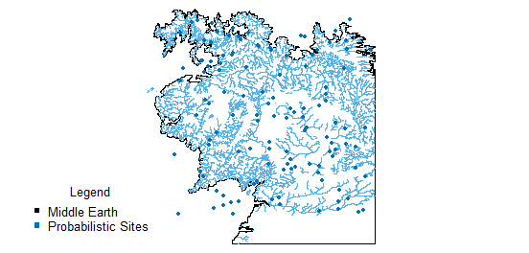

      Estimates of percent river miles not meeting water quality criteria or established screening values are reported with 95% confidence intervals. The sampling frame provided by USEPA for Middle Earth streams and rivers includes 49,100 miles. It is important to note that the total amount of assessed river miles may vary to some extent by parameter. This number varies based on whether a monitoring tool was appropriate for the sampling location. For example, DEQ biological monitoring tools are not validated for streams without a defined channel, thus streams dominated by wetlands cannot be assessed (approximately 5,000 miles). The actual number of target stream miles (perennial, flowing freshwater) is much less because several thousands of stream miles are not perennial (e.g. the stream was dry when DEQ visited) or were found to be saltwater influenced. There is an estimated 1,200 miles of non-wadeable streams (also referred to as boatable sites), which must be sampled using large river habitat and biological sampling methods. Large river data collection, using a non-wadeable (boatable) methodology, is underway and the condition will be included in future 303(d) / 305(b) Integrated Report chapters. The ProbMon chapter provides estimates for all perennial, non-tidal, wadeable stream and river miles which equates to approximately 41,500 miles.

Please pretend that the points that appear in the ocean are either on small islands or on the mainland. Creating data from other worlds has limitations.

##### Figure 2.4-3. Middle Earth probabilistic monitoring wadeable locations from 2009 - Present (n = 300).

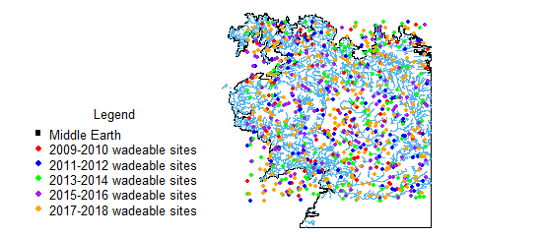

### 2.4.3 Parameters with Water Quality Standards or Screening Values

      Dissolved oxygen, pH, temperature, metals (dissolved and sediment), organic chemicals, and bacteria have applicable water quality criteria or screening values. Water quality standards are regulatory thresholds developed to protect water quality conditions in support of swimming, fishing, and aquatic life designated uses. Screening values are non-regulatory thresholds used to interpret select water quality parameters. Overall results are summarized in Figure 2.4-1 and individual parameter results are discussed below.

#### pH

      Another primary parameter used to evaluate water quality is pH. pH measures the concentration of hydrogen ions in water or the amount of acidity present. Since the pH scale is logarithmic to base 10, a decline in pH by one unit indicates a tenfold decrease in hydrogen ions. At pH 7, a solution is neutral whereas pH values below 7 indicate acidic conditions and values above 7 indicate basic conditions.

      Stream pH depends on local geology, ecology, and anthropogenic influences. If a stream has poor buffering capacity as is the case for a stream flowing over granite or shale, it may be naturally acidic. In the case where inorganic acids such as sulfuric or nitric acid are introduced via rain, the low buffering capacity can be rapidly exhausted and the pH declines. The resulting low pH may be detrimental to aquatic biota unaccustomed to low pH. pH values harmful to aquatic life are below 6 or above 9. This range is reflected in Middle Earth’s Water Quality Standards, where most waters must fall within a pH range of between 6 and 9. Natural pH values of 5 or below occur in swamp waters and should not be considered harmful to the native fauna common to those ecosystems. pH standards can be determined on a case-by-case basis if pH deviates due to natural conditions as in swamps and other wetlands (Commonwealth of Middle Earth 2017).

      ProbMon results show that 3.8% of wadeable Middle Earth streams and rivers are estimated to have pH below 6 (Table 2.4-2). All stations with deviations in pH occurred at sites located in the coastal ecoregion where swamp waters are common, which indicates the need to continue revising site specific water quality standards. DEQ collects additional parameters, including Acid Neutralizing Capacity (ANC) and sulfate data at ProbMon stations to estimate the percent of streams impacted by acid rain and acid mine drainage. High sulfate values in low pH streams are indicative of acid mine drainage whereas streams with low ANC values are susceptible to episodic acidification from acid rain runoff (USEPA 2000). However, based on ProbMon data collected during the 2018 assessment period, DEQ estimates that no pH values are below 6 in the mountain ecoregions. Estimates are reflective of an average of two data points, where data are available.

##### Table 2.4-2. pH results (2011 - 2016, n=734 compared to Middle Earth’s Water Quality Standard.

|  |  |  |
| --- | --- | --- |
| Parameter | Below Standard ( pH 6 ) | Above Standard ( pH 9) |
| pH | 3.8% ( +/- 1.5% ) | 0.038% ( +/- 0.063% ) |

#### Temperature

      Temperature affects water quality by potentially imposing a heat burden on aquatic life and by limiting the level of dissolved oxygen in water. Temperature in streams varies on seasonal and daily cycles. Sunlight is the primary source of temperature change. Stream temperature is also influenced by the temperature of the stream bed, groundwater inputs, and air in contact with the water surface. Temperature is inversely related to bank vegetation cover as less cover results in more exposure to the sun and higher instream temperatures. Also, runoff from impervious surfaces in urban areas may increase water temperature. Finally, effluent that is discharged to a waterbody tends to have higher temperature than the receiving stream and may elevate instream water temperature.

      Stream temperature has a significant effect on aquatic organisms. It can directly influence the types of organisms found in an aquatic system as well as their growth, behavior, metabolism, reproduction and feeding habits. Middle Earth’s temperature standards reflect the upper limit for the support of different forms of aquatic life (Commonwealth of Middle Earth 2017). Standards for temperature vary, notably in cold water fisheries, but as a general rule, all waters in Middle Earth are required to have a temperature at or below 31 or 32 degrees Celsius.

      Overall, DEQ estimates that temperature violations will be rare in Middle Earth’s wadeable streams (Table 2.4-3) during the spring and fall. However, it is important to note that ProbMon temperature data is seldom collected during the most stressful hydrologic and weather conditions. Estimates are reflective of an average of two data points, where data are available. In order to properly estimate temperature problems, temperature data must be collected continuously. Continuous temperature data collection began in 2016 at twenty probabilistic trend sites.

##### Table 2.4-3. Temperature results (2011 - 2016, n=555) compared to Middle Earth’s Water Quality Standard.

|  |  |
| --- | --- |
| Parameter | Above Standard (31/32 degrees Celsius) |
| Temperature | 1.0% ( +/- 0.3% ) |

### 2.4.4 Biological Monitoring

      Biological monitoring, or biomonitoring, of streams and rivers is an integral component of DEQ’s water quality monitoring program. Biomonitoring allows DEQ to assess the overall ecological condition of streams and rivers by evaluating stream condition with respect to suitability for support of aquatic communities. In Middle Earth, benthic macroinvertebrate communities are used as indicators of ecological condition and to address the question of whether a waterbody supports the aquatic life designated use.

      DEQ uses multimetric macroinvertebrate indices, specifically the Middle Earth Multimetric Index (MMI) and the Middle Earth Coastal Plain Macroinvertebrate Index (CPMI), to assess the aquatic life use status of wadeable streams and rivers. The MMI and the CPMI are applied to biomonitoring data collected in freshwater non-coastal areas and freshwater coastal areas, respectively. These indices utilize several biological metrics that are regionally calibrated to the appropriate reference condition (DEQa 2006; DEQ 2013). Results are calculated into a single value, or score, that is sensitive to a wide range of stressors.

##### Table 2.4-5. MMI/CPMI (2011 - 2016, n=628) Scores compared to Middle Earth’s Assessment Thresholds.

|  |  |
| --- | --- |
| Parameter | Percentage of Stream Miles Below Standard |
| MMI | 45.3% (+/- 4.1% ) |

      MMI and CPMI scores were scaled for comparability in all analyses. Based on MMII and CPMI ProbMon results, DEQ estimates that 45.3% of Middle Earth streams and rivers do not meet the aquatic life use standard (Table 2.4-5, DEQ 2018). An estimate of statewide biological health by condition category is shown in Figure 2.4-5. MMI scores less than 42 are considered severely ecologically stressed, scores between 42 and 60 are moderately stressed, while sites above 60 to 72 are thought to have good ecological conditionals and sites with MMI scores above 72 are considered to have excellent water quality and habitat conditions (DEQ, 2006a). It is important to remember that biological indicators represent long-term water quality conditions and respond to a variety of stressors.

##### Figure 2.4-5. Biological stream condition based on MMI Scores (2011 - 2016, n = 628).

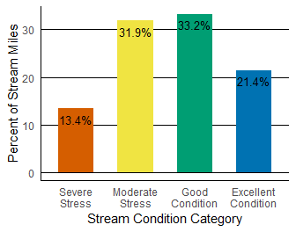

#### Statewide Status

      The collection of probabilistic monitoring data from 2009 to present has generated a robust dataset with enough samples to analyze differences in bioloical condition by stream size, ecoregion, and major basins. This analysis illustrates the current status of Middle Earth waterways across various environmental classifications.

      Changes in biological community are evident by grouping streams based on their size. For this analysis, streams were categorized as small, medium, and large based on the qualifications listed in Table 2.4-6. Figure 2.4-6 uses this stream size classification to compare percent of stream miles at or below the biological stream condition assessment threshold. Nearly half of all small and medium streams have moderately to severely stressed biological conditions. Large streams are significantly different relative to their smaller counterparts with just under a quarter of large wadeable stream miles falling below the biologic assessment threshold. This may suggest that larger streams have benefited from point source pollution controls, which are more common in larger watersheds, while smaller streams are adversely impacted by nonpoint source pollution. Nonpoint source pollution is more difficult to control due to its dispersed nature and is prevalent in both small and large steams.

##### Table 2.4-6 Stream size categories.

|  |  |  |
| --- | --- | --- |
| Size Category | Stream Order | Watershed Area (sq miles) |
| Small | 1,2,3 | < 10 |
| Medium | 2,3,4 | 10 - 50 |
| Large | 3,4,5 | > 50 |

##### Figure 2.4-6 MMI/CPMI status by stream size category. Percentile represents percent of stream miles below the biologic assessment threshold. The number of samples collected from 2011 - 2016 in each category is identified as n.

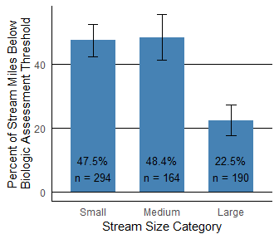

      Evaluating biological condition by EPA Level III Ecoregions offers a different lens to analyze Middle Earth streams, grouping Middle Earth’s diverse geography based on similarities among environmental resources (Omernik 1987). Ecoregions are based on many factors including land use, land surface form, potential natural vegetation, and soils. An ecoregion is useful at the state level to understand the attainable ranges of aquatic ecosystems. Figure 2.4-7 illustrates percent of stream miles below the biological assessment threshold by Middle Earth ecoregions. Mordor has the highest percentage of stream miles that are considered moderately to severely stressed biologically. The Shire maintains the highest quality biologically and is significantly different than all other ecoregions in terms of stream miles below the biologic threshold. The Shire Ecoregion is known for dense, protected forests while Gondor has experienced a high degree of resource extraction.

*In this graph we manually set the positions of text for each bar*

##### Figure 2.4-7 MMI status by EPA Level III Ecoregions. The percent of stream miles below the biologic assessment threshold is listed on the y axis. The number of samples collected from 2011 - 2016 in each ecoregion is identified as n.

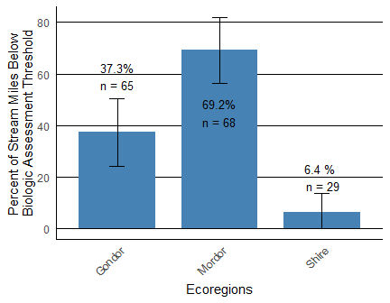

      In Middle Earth, we do not have separate basins and ecoregions. But, we could also display biological condition by major basins, presented in a bar chart similar to graphics previously discussed. Figure 2.4-8 illustrates the differences in biological condition across Middle Earth theoretical basins as the percent of rivermiles below the biologic assessment threshold. One of three major basins in Middle Earth, Mordor, has well over 50% of stream miles under moderate to severe biological stress. One of the major basins has between 25 to 50% of stream miles below the biological standard. The Shire basin has the fewest stream miles with moderate to severe biological stress at only 6.4%.

*This Graph will be the same as MMI status by ecoregions (I did not create a separate dataset for ecoregions and basins). However, for this graph, we made the location of the text for every bar the same, except for the Shire.*

##### Figure 2.4-8 MMI status by major Middle Earth basins. The percent of stream miles below the MMI assessment threshold is listed on the y axis. The number of samples collected from 2009 - 2016 in each basin is identified as n.

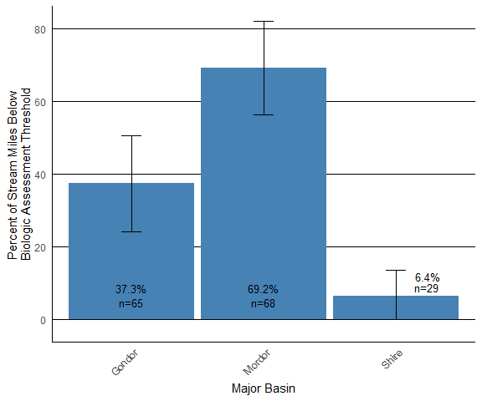

### 2.4.5 Parameters without Water Quality Standards

      Stressors that increase the risk to benthic macroinvertebrate communities and do not have specific water quality standards include streambed sedimentation, habitat degradation, nutrients, ionic strength, and water column cumulative metals. Thresholds for the aforementioned stressors are presented in Tables 2.4-7 and 2.4-8 and are derived from literature values. The optimal classification represents water quality conditions that are not associated with degraded aquatic communities. Stressors classified as suboptimal increase the likelihood of finding an impacted aquatic community. The condition class between optimal and suboptimal is termed fair as the stress to the aquatic community is less certain. In the following examples, water quality parameters without regulatory standards or criteria are presented using barplots. The barplots represent estimates drawn from data in the 2018 Integrated Report sample window (2011 - 2016).

##### Table 2.4-7. Thresholds of condition classes for biological indicators.

|  |  |  |  |
| --- | --- | --- | --- |
| Response Parameters | Optimal | Suboptimal | Classification Reference |
| Multimetric Macroinvertebrate Index | > 60 | <50 | (VDEQ 2006a) |
| Coastal Plain Macoinvertebrate Index | > 40 | <30 | (VDEQ 2013) |

##### Table 2.4-8. Thresholds of condition classes for stressor indicators[1].

|  |  |  |  |
| --- | --- | --- | --- |
| Stressor Parameters | Optimal | Suboptimal | Classification Reference |
| Total Nitrogen (mg/L) | < 1 | > 2 | (DEQ 2006a) |
| Total Phosphorus (mg/L) | < 0.02 | > 0.05 | (DEQ 2006a) |
| Habitat Degradation (unitless) | > 150 | < 120 | (USEPA 1999) |
| Streambed Sedimentation (unitless) | > -0.5 | < -1.0 | (Kaufmann 1999) |
| Ionic Strength (TDS mg/L) | < 100 | > 350 | (DEQ 2006b) |
| Cumulative Dissolved Metals (unitless) | < 1 | > 2 | (Clements 2000) |

#### Habitat Disturbance

      Habitat is defined as the area or environment where an organism resides. It encompasses its surroundings, both living and non-living. Fish, aquatic insects, and plants require certain types of habitat to thrive, so in-stream and riparian (stream bank) habitat is evaluated when a biomonitoring sample is collected. Because different organisms have diverse habitat requirements, a variety of available habitat types in a stream or river will support a diverse aquatic community. Habitat is scored by evaluating ten habitat parameters and adding them together (total scores range from 0 to 200). Habitat scores above 150 indicate habitat conditions favorable for supporting a healthy aquatic community and are considered optimal. Scores lower than 120 are considered suboptimal and scores between 120 and 150 are fair (EPA 1999). As indicated in Figure 2.4-10, DEQ estimates that slightly over 34% of stream and river miles have available habitat that is considered optimal.

##### Figure 2.4-10. Estimate of Habitat Condition in Middle Earth Streams and Rivers. Data presented is from 2009 - 2014 (n = -).

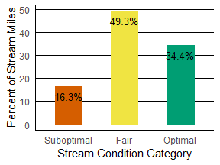

### 2.4.6

### 2.4.6 Stressor Extent and Relative Risks

*See Supplement if you would like to include this in your report*

      One of the advantages of probabilistic datasets is the ability to calculate the stressor extent (Figure 2.4-23, Figure 2.4-25), and relative risks (Figure 2.4-24) that different environmental stressors have on the ecological health of rivers and streams across large regions. Since the stations are selected at random, DEQ can estimate water quality parameter values over the entire state with known confidence. USEPA and other states have employed stressor extent and relative risk concepts extensively in their reports (DEQ 2007; USEPA 2006; Van Sickle 2006; Van Sickle 2008).

      Stressor extent shows how prevalent a stressor is in Middle Earth streams. Calculation of relative risk requires classification of water quality responses (e.g. the benthic macroinvertebrate indices Table 2.4-7) and the water quality stressors (Table 2.4-8) into optimal and suboptimal categories. DEQ classified biological response parameters based on the aquatic life use standard. The stressor indicators in Table 2.4-8 were classified using screening values from peer reviewed literature studies. It is important to remember that the stressor screening values are not equivalent to water quality standards in the Middle Earth. This data-intensive statistical technique requires the entire probabilistic monitoring dataset (2009 - 2016).

      Relative risk is a term borrowed from the medical field and applied here to communicate the severity of impact a stressor has on the aquatic environment. For example, it has been shown that an individual with total cholesterol above 240 mg/dl is at greater risk for heart disease than an individual whose cholesterol is below 200 mg/dl. When an individual has a cholesterol level above 240, their relative risk of having heart disease is higher than an individual with cholesterol level below 200.

      The relative risks for aquatic stressors can be interpreted in a similar manner to the heart disease example. Figure 2.4-24 illustrates that the relative risk to the biological community due to habitat disturbance is 5.0; thus, the biological community is 5.0 times more likely to be considered suboptimal when habitat disturbance scores are below 120 (USEPA 1999). Relative risk values larger than 1 indicate an elevated risk to the biological community; consequently, only water quality stressors with a relative risk greater than 1 are reported in this chapter. pH was also evaluated for increased risk to the biological community but did not show significant relative risk to the biological community.

##### Figure 2.4-23. Stressor extent for major benthic macroinvertebrate stressors in Middle Earth streams. The horizontal lines associated with the parameters illustrate the confidence intervals. Stressor extent shows the frequency of the stressor in all Middle Earth streams from data collected for the 2018 Integrated Report (2011 - 2016).

*This requires an additional dataset discussed in the supplement*

*This requires an additional dataset discussed in the supplement*

##### Figure 2.4-25. Stressor extent for major benthic macroinvertebrate stressors in all Middle Earth streams (2011 - 2016) showing all condition classes (optimal, fair, and suboptimal). Optimal condition estimates are shown in green, fair condition estimates are yellow, and suboptimal conditions are shown in red.

*This requires an additional dataset discussed in the supplement*

### 2.4.7 Uses of Probabilistic Data

      In addition to estimating the condition of all streams and rivers compared to established water quality criteria/screening values and identifying the major stressors to aquatic organisms, freshwater ProbMon data has many ancillary applications within water quality management programs. Examples of these uses are discussed below.

      ProbMon data is used in describing both the natural and baseline conditions of Middle Earth streams. In addition, ProbMon has helped identify minimally disturbed streams and understand their natural variability. This information is integral for DEQ to develop more regionally specific water quality expectations and in turn define reference conditions and select appropriate reference sites. ProbMon has also provided statistically defensible descriptions of stream conditions as of the beginning of this century. DEQ will find this baseline tremendously valuable for comparison in future assessments.

      ProbMon data is currently being used by an in the stressor identification process in benthic macroinvertebrate TMDLs (DEQ 2017). Stressor analysis is the process whereby candidate causes of stress (or stressors) to benthic macroinvertebrate communities are evaluated. The purpose of the workgroup was to develop data collection recommendations and scientifically defensible screening values for categorizing potential stressors. ProbMon data is especially useful in describing statewide in-stream conditions for those parameters that do not currently have water quality standards. Understanding existing conditions for those parameters without water quality standards provides perspective on parameter data and a way to evaluate potential stressors. Relative Bed Stability and metals in water column CCU are examples of new tools that are applicable to benthic macroinvertebrate TMDL stressor analysis. Relative Bed Stability is currently being utilized to evaluate sedimentation as a candidate stressor. ProbMon data was used to develop stressor specific metrics to help TMDL staff identify stressor signals from impaired reaches and collect the appropriate water chemistry information.

      The collocation of biological, chemical, habitat and landuse data at ProbMon sites also allows for the examination of multiple stressors such as dissolved metal CCUs. DEQ plans to explore the effects of multiple stressors in future reports. This information should aid TMDL development and provide insight into how biological communities and stressor parameters interact.

      ProbMon data is also being used as a test platform for new monitoring approaches such as periphyton and fish community data collection. The collection methodology was designed and tested in tandem with the USEPA’s National Aquatic Resource Survey (NARS). Until DEQ participated in the NARS sampling, habitat and biology data collection methodologies were not refined for large rivers. Now DEQ is collecting complete ProbMon data sets for large rivers and plans to report on the condition of this valuable freshwater resource. Because ProbMon provides biological, chemical, physical habitat, and land use information at each site, the data set is indispensable for developing and improving biomonitoring tools.

      The ProbMon dataset provided crucial data needed to fill in gaps during the development of the MMI and the validation of both the MMI and Coastal Plain Macroinvertebrate Index (CPMI) (Maxted 2000). Following the validation, MMI assessment results were included in the 2008 Integrated Report. DEQ used ProbMon data to validate the CPMI. Specifically, ProbMon data was utilized to identify new reference sites in the coastal plain, check ecoregion best standard values, and select potential metrics that would help the CPMI detect benthic macroinvertebrate community stresses created by human activity. The effort resulted in a new, robust tool for evaluating benthic macroinvertebrate communities in the coastal plain regions of the Commonwealth called the Middle Earth Coastal Plain Macroinvertebrate Index (MCPMI, DEQ 2013). The technical MCPMI document is online [here](https://www.epa.gov/national-aquatic-resource-surveys) . ProbMon also aided in improving the biomonitoring program by identifying over 100 new biological references sites, doubling the number of reference sites in the Middle Earth reference site database.

      ProbMon sites are the platform for building a genus-level macroinvertebrate database which may ultimately be used in developing a more robust multimetric assessment tool. ProbMon data may also be used to create a biological condition gradient for Middle Earth stream and rivers. The biological condition gradient is a descriptive model that illustrates how increasing stress alters ecological attributes (Davies and Jackson 2006). A biological condition gradient defines expected conditions, like benthic macroinvertebrate community structure, for streams by stream order and ecoregion. The biological condition gradient may help DEQ protect high-quality streams and provide stepwise interim goals for tracking water quality improvement.

      Probabilistic data has been used to support water quality permitting decisions. DEQ establishes defensible background conditions in dissolved metal permit model by using the statistically derived baseline metal estimates for watersheds across the Commonwealth. A workgroup has been formed to help deliver this information to the water permitting group at DEQ.

      An important future application of ProbMon data is change analysis (Kincaid 2016). DEQ adjusted the experimental design of ProbMon by adding randomly selected sentinel sites in order to accelerate its ability to detect changes in population estimates. By revisiting a relatively small number of these randomly located sites each year, DEQ will be able to detect statewide and regional chemical, habitat, and biological changes. Perhaps the most important question a monitoring program addresses is: are management initiatives effective? The ability of ProbMon to detect shifts in populations estimates is critical to the goal of evaluating the effectiveness of water quality management programs.

### 2.4.8 Conclusion

      DEQ analyzed several water quality parameters with established water quality criteria and/or screening values and one parameters without water quality criteria. Most of the parameters that have water quality criteria meet applicable standards. The majority of water quality standard exceedences are attributed to legacy pollutants or natural conditions. The results presented in the ProbMon chapter reflect the success of DEQ’s management of water quality parameters with water quality criteria.

      Only biological monitoring results were found to be below screening thresholds in a relatively high percentage of streams. Benthic macroinvertebrate communities were degraded in 45.3% of the wadeable streams and rivers in Middle Earth; a percentage that could be considered widespread. Benthic macroinvertebrate communities are indicators of water quality problems because they respond to a variety of water quality stressors including parameters that have water quality standards (e.g. dissolved oxygen levels) and parameters that do not have criteria (e.g. such as nutrients and sedimentation). The following six stressors increase the risk to aquatic organisms and do not currently have water quality standards: streambed sedimentation, habitat disturbance, total phosphorus, total nitrogen, total dissolved solids, and cumulative metals in water column. These parameters are discussed in Section 2.4.5. These six major stressors do not currently have water quality standards, but most are being addressed through a variety of strategies such as nutrient management plans and best management practices. As the ProbMon program evolves and DEQ expands on the uses of ProbMon data, enhancement of the strategies for understanding, evaluating and restoring Middle Earth’s streams and rivers will continue.

      Presentations, posters, reports, and handouts about ProbMon are available for viewing and download at the following website: <http://www.deq.Virginia.gov/Programs/Water/WaterQualityInformationTMDLs/WaterQualityMonitoring/ProbabilisticMonitoring.aspx>.

## Part 2: Graphs based on Categorical Condition Results

#### Nutrients

      Nutrients are substances assimilated by living organisms that promote growth. Nitrogen and phosphorus are the two most important nutrients in Middle Earth streams and rivers. Excess nutrients can stimulate in-stream plant and algal growth. Characteristics of nutrient enriched streams may include low dissolved oxygen, frequent fish kills, shifts in aquatic communities, and blooms of nuisance algae. Nutrients may come from fertilized lawns and cropland, failing septic systems, municipal and industrial discharges, and/or livestock manure.

      The values of Total Nitrogen that can result in undesirable algae growth and shifts in aquatic communities varies by ecoregion. DEQ estimates that only 8.8% of stream and river miles are considered optimal (< 0.1 mg/L) for total nitrogen.

##### Figure 2.4-23. Estimated Total Nitrogen Concentrations by Basin.

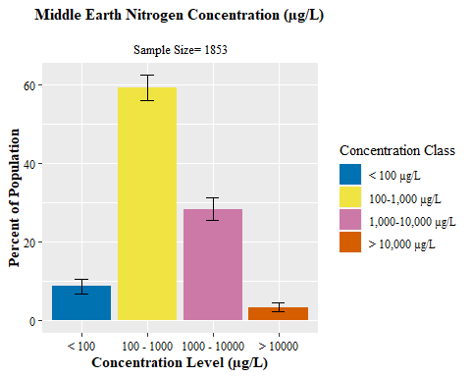

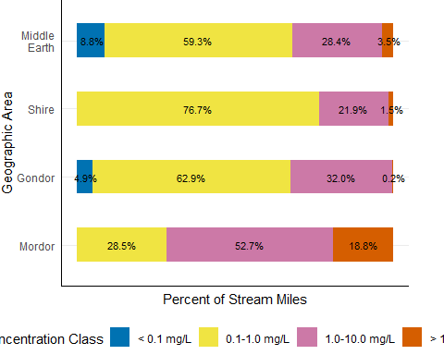

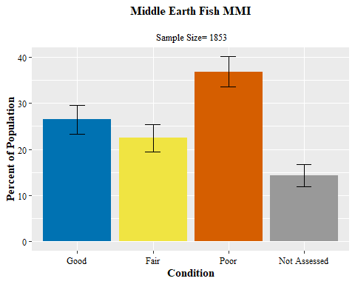

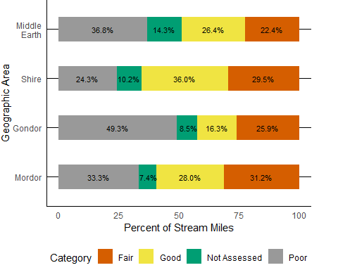

### 2.4.9 References

Clements, W.H., D.M. Carlisle, J.M. Lazorchak, and P.C. Johnson. 2000. Heavy Metals Structure Benthic Communities in Colorado Mountain Streams. Ecological Applications 10(2):626-638.

Commonwealth of MiddleEarth. 2017. Water Quality Standards (9 MEC 25-260-00 et seq.). Department of Environmental Quality, Shire. <http://lis.Middle> Earth.gov/cgi-bin/legp604.exe?000+reg+9VAC25-260.

Davies, S.P. and S.K. Jackson. 2006. The Biological Condition Gradient: a descriptive model for interpreting change in aquatic ecosystems. Ecological Applications 16 (4), 1251-1266.

Diaz-Ramos, S., D.L. Stevens, Jr., and A.R. Olsen 1996. EMAP Statistics Methods Manual. EPA/620/R-96/002. Corvallis, OR: U.S. Environmental Protection Agency, Office of Research and Development, National Health and Environmental Effects Research Laboratory. [see <http://www.epa.gov/nheerl/arm/> for downloadable file]

Kaufmann, P. R., John M. Faustini, David P. Larsen, and Mostafa A. Shirazia. 2008. A roughness-corrected index of relative bed stability for regional stream surveys. Geomorphology. Volume 99, Issues 1-4, 1 July 2008, Pages 150-170.

Kaufmann, P. R., P. Levine, E. G. Robinson, C. Seeliger, and D. Peck. 1999. Quantifying physical habitat in wadeable streams. EPA/620/R-99/003, USEPA, Washington, D.C.

Kincaid, T. M. and Olsen, A. R. 2016. spsurvey: Spatial Survey Design and Analysis. R package version 3.3.

MacDonald, D.D. and C.G. Ingersoll, T.A. Berger. 2000. Development and Evaluation of Consensus-Based Sediment Quality Guidelines for Freshwater Ecosystems. Arch. Envorin. Contam. Toxicology 39:20-31.

Maxted, J. M. Barbour, J. Gerritsen, V. Poretti, N. Primrose, A. Silvia, D. Penrose, and R. Renfrow. 2000. Assessment framework for mid-Atlantic coastal plain streams using benthic macroinvertebrates. The North American Benthological Sociey 19(1), 128-144.

Omernik, James. 1987. Ecoregions of the Conterminous United States. Annuals of the Association of American Geographers. Volume 77, Issue 1, March 1987, Pages 118â“125.

Oregon Department of Environmental Quality. 2007. Wadeable Stream Conditions in Oregon. Oregon Department of Environmental Quality, Laboratory Division, Watershed Assessment Section. DEQ07-LAB-0081-TR.

Paul, J.F. and M.E. McDonald. 2005. Development of Empirical, Geographically Specific Water Quality Criteria: A Conditional Probability Analysis Approach. Journal of the American Water Resources Association (JAWRA) 41(5):1211-1223.

R Core Team. 2017. R: A language and environment for statistical computing. R Foundation for Statistical Computing, Vienna, Austria. URL <https://www.R-project.org/>.

Stevens, D.L, Jr. 1997. Variable Density Grid-Based Sampling Designs for Continuous Spatial Populations. Environmetrics 8:167-195.

USEPA. 2006. Wadeable Streams Assessment: A Collaborative Survey of the Nation’s Streams. EPA 841-B-06-002. Office of Research and Development, Office of Water, Washington, DC 20460.

USEPA. 2000. Mid-Atlantic Highlands Streams Assessment. EPA/903/R-00/015. United States Environmental Protection Agency, Region 3, Philadelphia, PA 19103.

USEPA. 1999. Rapid Bioassessment Protocols for Use in Wadeable Streams and Rivers. Office of Water. EPA/841/B-99/002.

Van Sickle, John and S.G. Paulsen. 2008. Assessing the attributable risks, relative risks, and regional extents of aquatic stressor. Journal of the North American Benthological Society. 27(4):920-931.

Van Sickle, John, J. Stoddard, S. Paulsen, A. Olsen. 2006. Using Relative Risk to Compare the Effects of Aquatic Stressors at a Regional Scale. Environ Manage 38:1020-1030.

Virginia Department of Environmental Quality. 2018. 2018 Water Quality Assessment Guidance Manual. <http://www.deq.virginia.gov/Portals/0/DEQ/Water/WaterQualityAssessments/2018_WQA_Guidance_DRAFT.pdf>.

Virginia Department of Environmental Quality. 2017. Stressor Analysis in Virginia: Data Collection and Stressor Thresholds. <http://www.deq.virginia.gov/Portals/0/DEQ/Water/WaterQualityMonitoring/ProbabilisticMonitoring/Products/Stressor_Doc.zip>.

Virginia Department of Environmental Quality. 2013. The Virginia Coastal Plain Macroinvertebrate Index. Technical Bulletin. WQA/2013-002.Richmond, Virginia.  
<http://www.deq.virginia.gov/Portals/0/DEQ/Water/WaterQualityMonitoring/ProbabilisticMonitoring/vcpmi.pdf>.

Virginia Department of Environmental Quality. 2011. 2012 Water Quality Assessment Guidance Manual. <http://www.deq.state.va.us/waterguidance/pdf/112007.pdf>.

Virginia Department of Environmental Quality. 2006a.Using Probabilistic Monitoring Data to Validate the Non-Coastal Virginia Stream Condition Index. VDEQ Technical Bulletin. WQA/2006-001. <http://www.deq.virginia.gov/probmon/pdf/scival.pdf>.

Virginia Department of Environmental Quality. 2006b. Fecal Bacteria and General Standard Total Maximum Daily Load Development for Straight Creek. Richmond, Virginia. VDEQ TMDL Study. <http://www.deq.virginia.gov/tmdl/apptmdls/tenbigrvr/straight.pdf>.

Virginia Department of Environmental Quality. 2003. The Quality of Virginia Non-Tidal Streams: First Year Report. Richmond, Virginia. VDEQ Technical Bulletin WQA/2002-001. <http://www.deq.virginia.gov/probmon/pdf/report1.pdf>.

Virginia Water Control Board. 1990. Comprehensive Review of Selected Toxic Substances and Environmental Samples in Virginia. Richmond, Virginia. Information Bulletin 583.

1. The relative risk screening values presented in Tables 2.4-8 do not represent water quality criteria nor are intended for establishing TMDL endpoints. The values represent an increase in the probability of stress to benthic communities.