Francisco Rios  
Scot Wells   
Casey Barth  
COP 3402  
November 23, 2015

Assignment 3 Errors

**Error 1**var x, y;

begin

y = 3; /* Comment */

x := y + 56;

end.

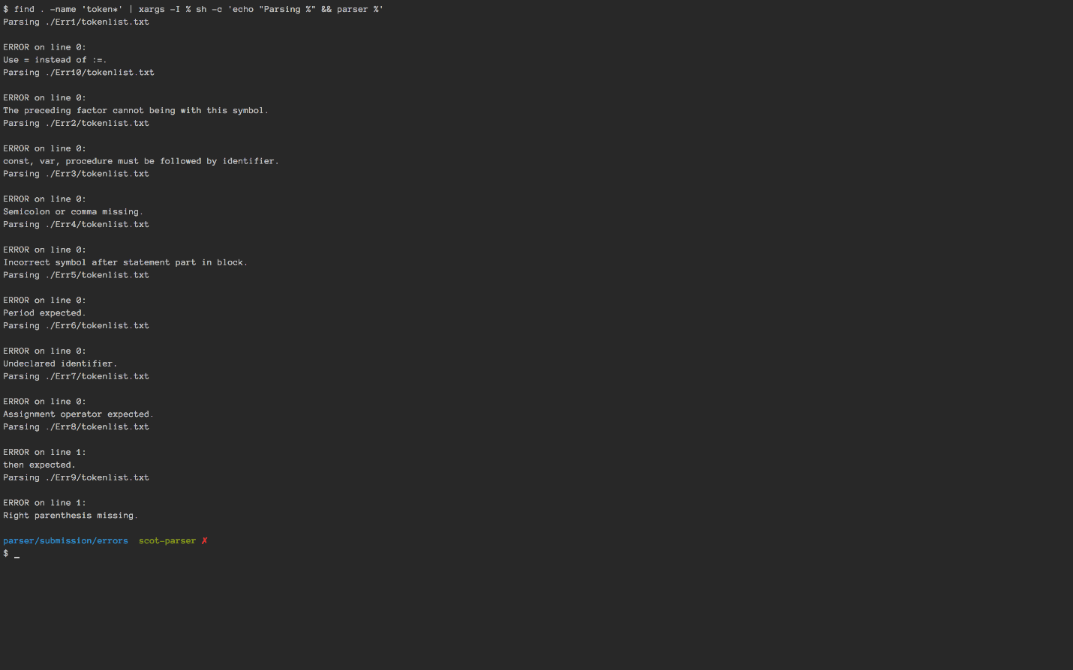

**Error 4**var;

begin

y := 3; /* Comment */

x := y + 56;

end.



**Error 5**procedure A;

var a;

begin

a:=4;

end

begin

a:=4;

end.

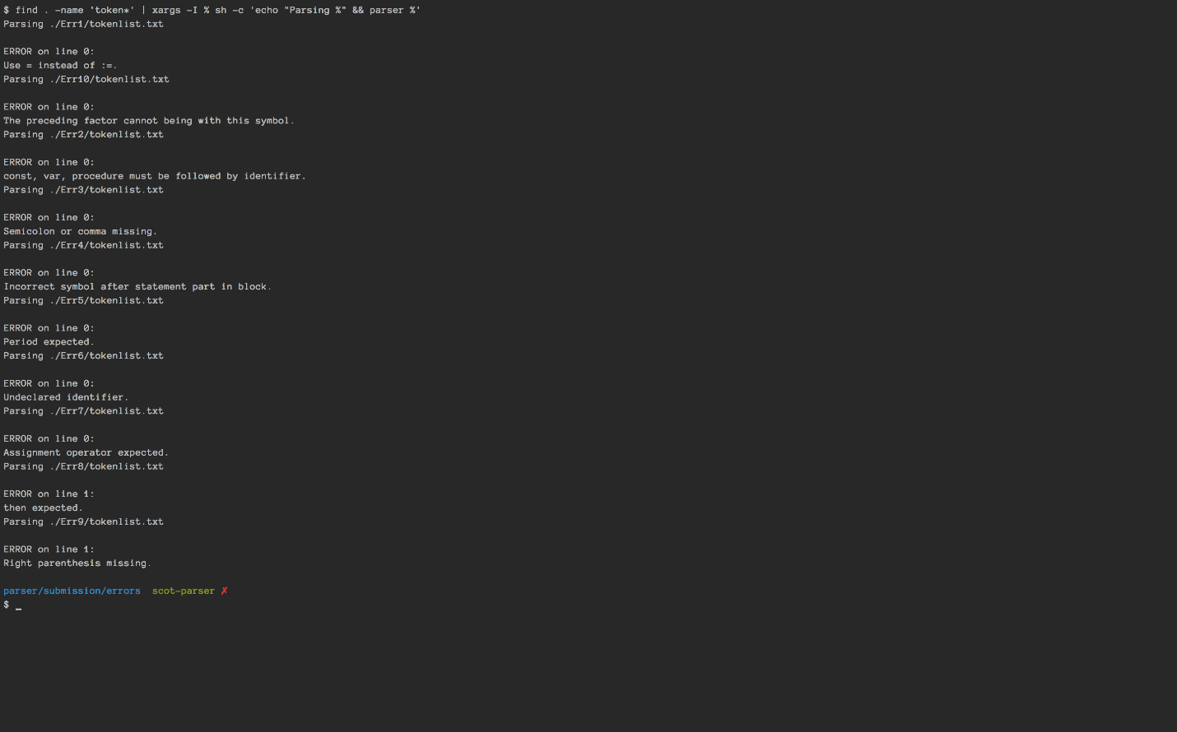

**Error 8**

var x, y;

begin

y := 3; /* Comment */

x := y 56;

end.

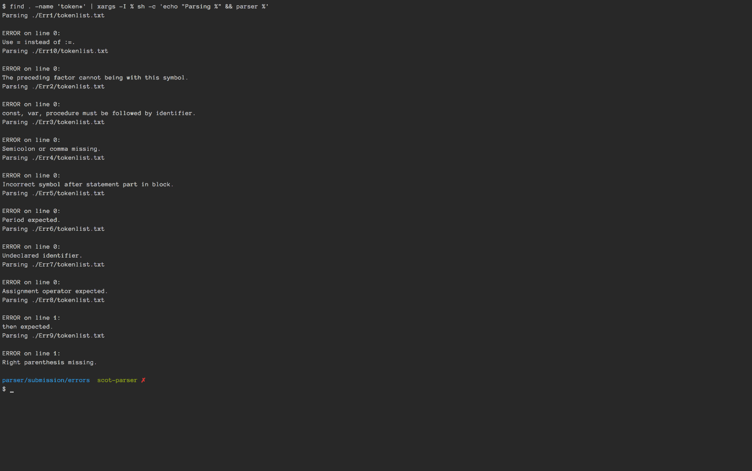

**Error 9**

procedure A;

var a;

begin

a:=4;

end;

begin

a:=4;

end



**Error 11**

var x, y;

begin

z := 3; /* Comment */

x := y + 56;

end.



**Error 13**

var x, y;

begin

y 3; /* Comment */

x := y + 56;

end.



**Error 16**

const beginningX = 3;

var facRes, facParam;

procedure Factorial;

var myFacParam;

begin

if facParam > 0 begin

myFacParam:= facParam;

facParam:= facParam*2/2 -1*1;

call Factorial;

if myFacParam <> facParam +1 then /*This should never be taken*/

begin

facParam:=0;

end;

facRes:= facRes * (facParam+1);

facParam:= myFacParam;

end

else

facRes:= 1;

end;

begin

facParam:= beginningX; /*Just to have done something with a constant as

well*/

call Factorial

end.



**Error 22**

const beginningX = 3;

var facRes, facParam;

procedure Factorial;

var myFacParam;

begin

if facParam > 0 then begin

myFacParam:= facParam;

facParam:= facParam*2/2 -1*1;

call Factorial;

if myFacParam <> facParam +1 then /*This should never be taken*/

begin

facParam:=0;

end;

facRes:= facRes * (facParam+1;

facParam:= myFacParam;

end

else

facRes:= 1;

end;

begin

facParam:= beginningX; /*Just to have done something with a constant as

well*/

call Factorial

end.



**Error 23**

var x, y;

begin

y := =3; /* Comment */

x := y + 56;

end.

