**Test name:** access_nocache_noshare

**Address increment: 0x8**

PASS

**Test name:** dummy

Nothing to do

**Test name:** read_cache_noshare

**Test will always fail if the length of data array is not equal to the number of cores in the system.**

**Address increment: 0x10**

**Test name:** read_cache_share

**Test will always fail if the length of data array is not equal to the number of cores in the system.**

**Address increment: 0x10**

AC_SNOOP values: 0111

**Test name:** read_cache_share_overlap

AC_SNOOP values: 0111

PASS

**Test name:** read_modify_cache

AC_SNOOP values: 0111

PASS

**Test name:** read_modify_cache_share

AC_SNOOP values: 0111

PASS

**Test name:** read_modify_cache_share_intense

AC_SNOOP values: 0111

**Only data[0] and data[1] are handled differently, that is ... for all the subsequent addresses only ... is being executed.**

**Test name:** read_nocache_noshare

**Test will always fail if the length of data array is not equal to the number of cores in the system.**

**Test name:** read_nocache_noshare_overlap

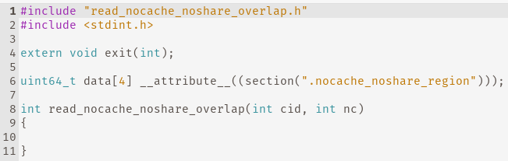

???

**Test name:** writeback_evict

AC_SNOOP values: 0111

**There is still a problem, higher addresses are not being written back, only read**

**Only data[0] is handled differently, that is ... for all the subsequent addresses only ... is being executed.**

**Test name:** writeback_readshared_flush

AC_SNOOP values: 0111

PASS

**Test name:** writeback_readunique_flush

AC_SNOOP values: 0111

PASS

**Test name:** writeback_readunique_modify

AC_SNOOP values: 0111

**There is still a problem, higher addresses are not being written back, only read**

**Only data[0] is handled differently, that is ... for all the subsequent addresses only ... is being executed.**

**Test name:** write_cache_noshare

PASS

**Test name:** write_cache_share

AC_SNOOP values: 0111

PASS

**Test name:** write_cache_share_overlap

AC_SNOOP values: 0111

PASS