Suggested Changes 29/6/23

**1. Changes to top layout:**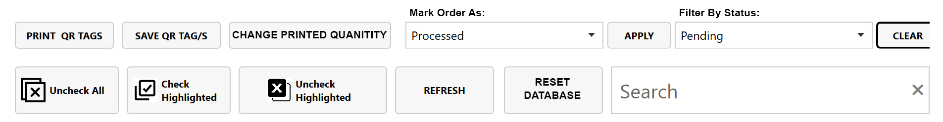

1. Remove “apply” button for “filter by status” action – this should action immediately upon clicking the selection
2. Add titles for “mark order as” and “filter by status” action boxes (as they disappear once a selection is made and then you cannot tell the difference between the two boxes)
3. Shorten width of search bar
4. Move “reset database” next to search bar
5. Add button to top row: “Change printed quantity”. When this is clicked, a pop up appears (see below)

**2. “change printed quantity” pop up:**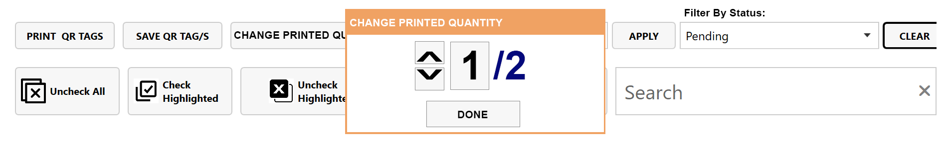

This pop-up should allow us to manually change the “quantity printed” value of a line item without scanning

**3. Add new status option:**  
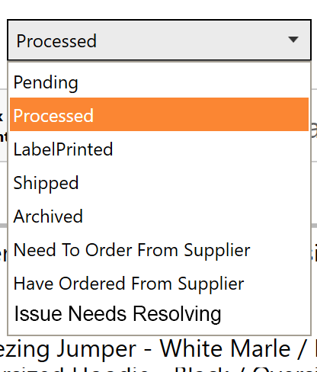

New status option: “Issue Needs Resolving” – works the same as any other status, colour #ff00ff