1 - Flag products that have an attached note with a little symbol near the front of their  display so we know to check them (an example like the red thing shown on image). The symbol should probably just be a black asterisk or something like that

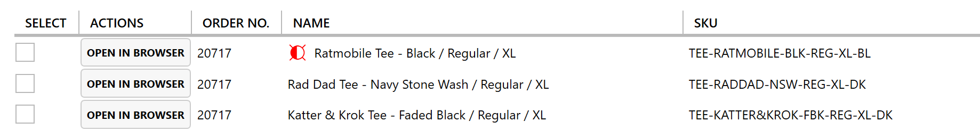

2 - "filter by status" button. We click "filter by status" and select the relevant status from the drop down menu and it displays only those items. This will be useful in several situations, like when we only want to view and print labels for items that haven't yet been processed, or if we need to order everything that "needs to be ordered" from AS Colour at once

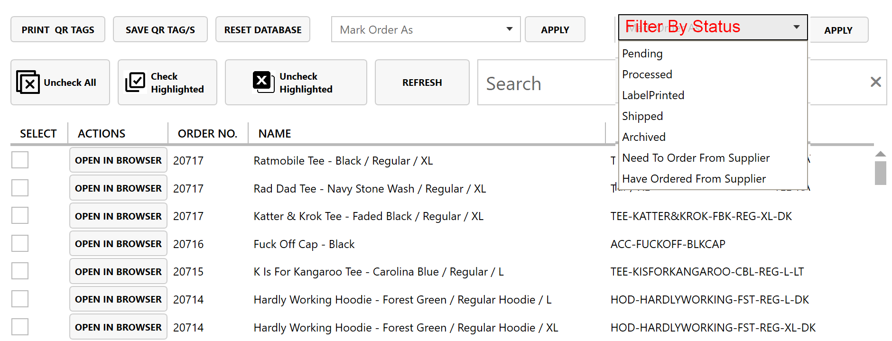

3 - Colour coding the status. This could be done by highlighting the whole row or with a small coloured dot as a marker as shown (I prefer the highlight, Warwick what do you think? This helps us read the page at a glance more quickly since you have to scroll quite a way to see the status.

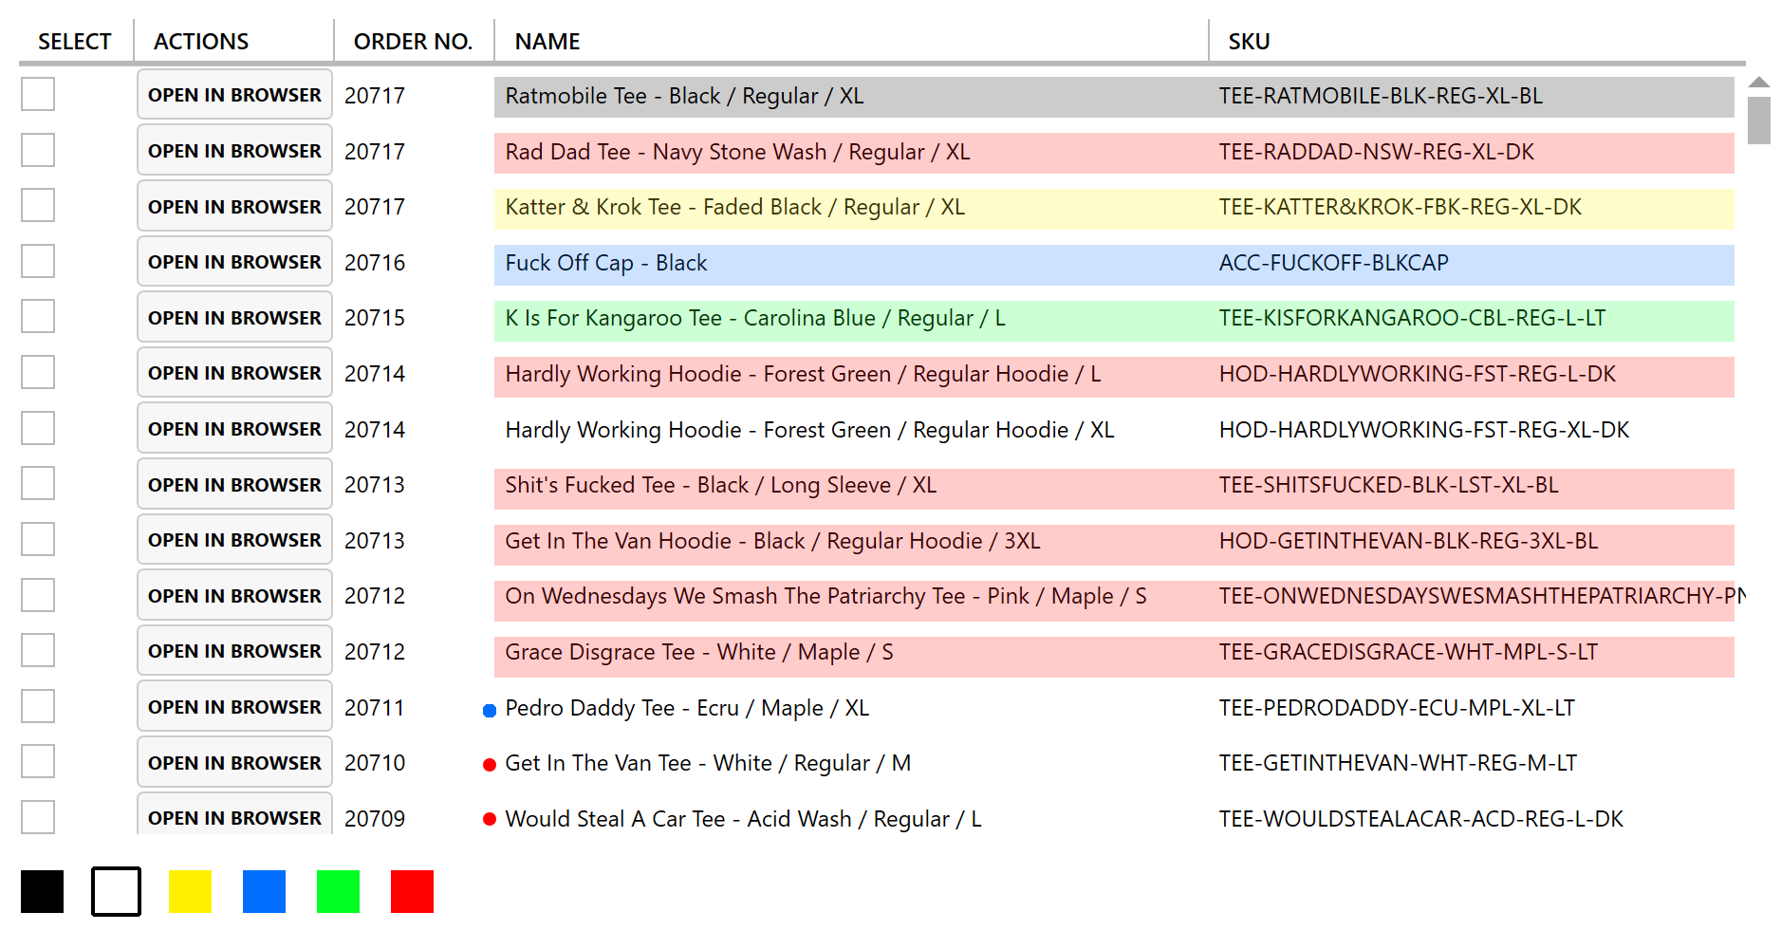

Colour info: highlights applied with 20% transparency

Pending: #ffffff (not visible)

Archived: #000000

Processed: #00deff

LabelPrinted: #0c00ff

Shipped: #00ff22

Need to order from supplier: #ff0000

Have ordered from supplier: #fff000

4- Creation of "date modified column" as shown, displaying when the status of the item was last changed. Make this a sortable column (i.e. can click on it to sort from oldest to newest and vice versa).  This will be helpful for us for example when we are dealing with AS Colour orders. As each item is ordered, the status is changed to "has been ordered from supplier". If we have multiple orders in a week, what we could do is "filter by status" > "has been ordered from supplier" and then sort products by "date modified" this would allow us to display the items which had been ordered the longest time ago together, and help us to batch the products.

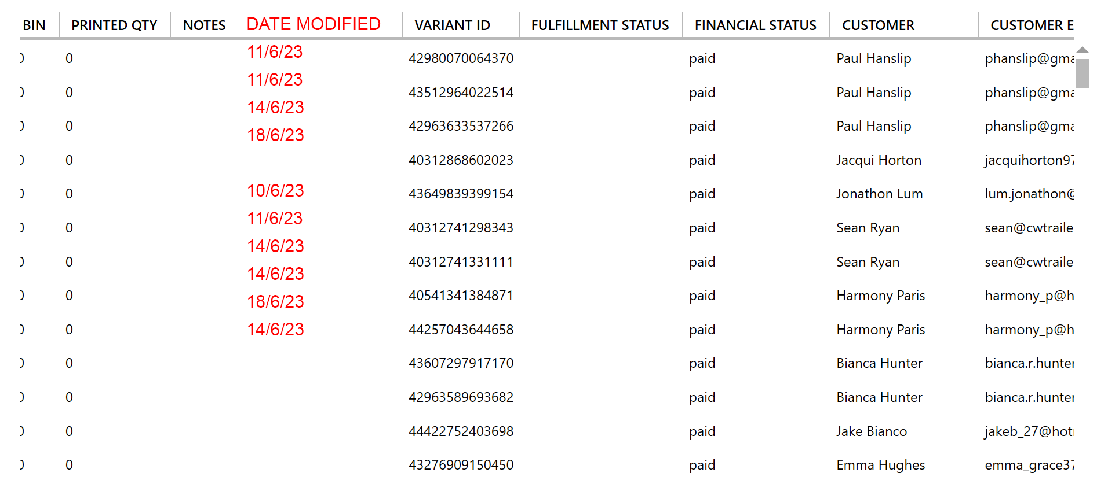

5- Bins: These should display ALL products required in the bin, whether they have been printed or not. This will help us keep track of progress, troubleshoot, and allocate vacant spaces to bins according to order size as we are taking a mobile approach. Currently it displays with a "quantity printed" indicator, so we should use that. Example:

Order #20223

Get In The Van Tee - White / Regular / L x1

quantity printed: 1

Mood Cat Tee - White / Regular / L x1

quantity printed: 0

6- can we make it possible to use 2 finger horizontal scroll on devices with a trackpad? This will just make it quicker to navigate all the info and we are primarily using laptops so it will have a big impact