Suggested Changes 29/6/23
1. Changes to top layout: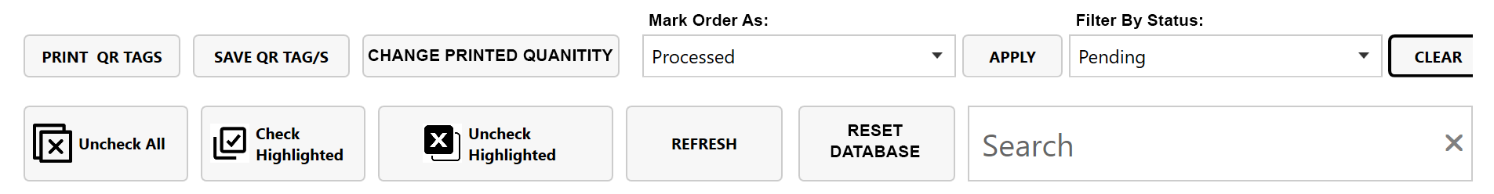
- Remove “apply” button for “filter by status” action – this should action immediately upon clicking the selection
- Add titles for “mark order as” and “filter by status” action boxes (as they disappear once a selection is made and then you cannot tell the difference between the two boxes)
- Shorten width of search bar
- Move “reset database” next to search bar
- Add button to top row: “Change printed quantity”. When this is clicked, a pop up appears (see below)

2. “change printed quantity” pop up: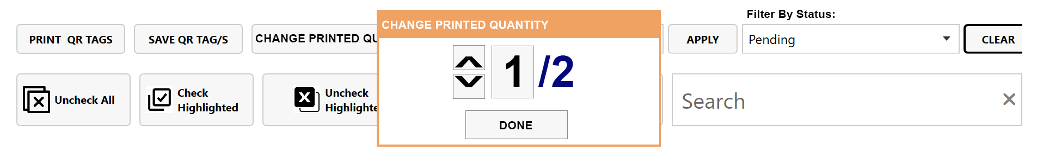
This pop-up should allow us to manually change the “quantity printed” value of a line item without scanning

3. Add new status option:
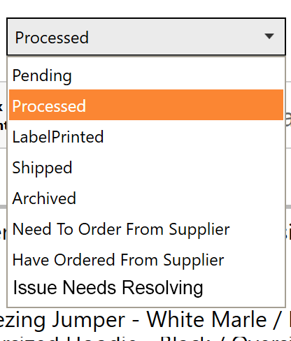
New status option: “Issue Needs Resolving” – works the same as any other status, colour #ff00ff

