**Report of the semester project**

*DC228011 LIU YUCHEN*

Part 1. Abstract

This report introduces the design and development of an online shopping cart system specifically tailored for a mobile phone market. The objective of the project was to create a user-friendly platform that allows customers to browse and purchase mobile phones through a seamless web interface. The system incorporates key features such as comprehensive product catalog, a shopping cart functionality, payment processing and order management. I followed a well-organized approach, including requirements gathering, design, development, testing, deployment, and documentation. The system was successfully implemented, providing a responsive design optimized for mobile devices. The report highlights the project goals, key features, deliverables, timeline, team structure, budget, and stakeholders involved. The findings also discuss the objectives that we have failed to achieve Overall, the developed online shopping cart system offers me a precious experience in full-stack web development.

Part 2. List of Services

1. Online browsing available phone models.
2. Shopping cart function including adding and removing.
3. Check-out and complete order.
4. Purchase confirmation function.
5. Back-end order viewing and processing through database.
6. Responsive design for mobile user.

Part 3. List of Tasks

1. Implementation of PHP based front-end with BootStrap4.
2. Implementation based back-end with jQuery Ajax and MySQLi plugins.
3. Database design and implementation with MySQL.
4. Responsive CSS design.

Part 4. List of Accomplishments

1. Successful implementation of front-end and back-end PHP code.

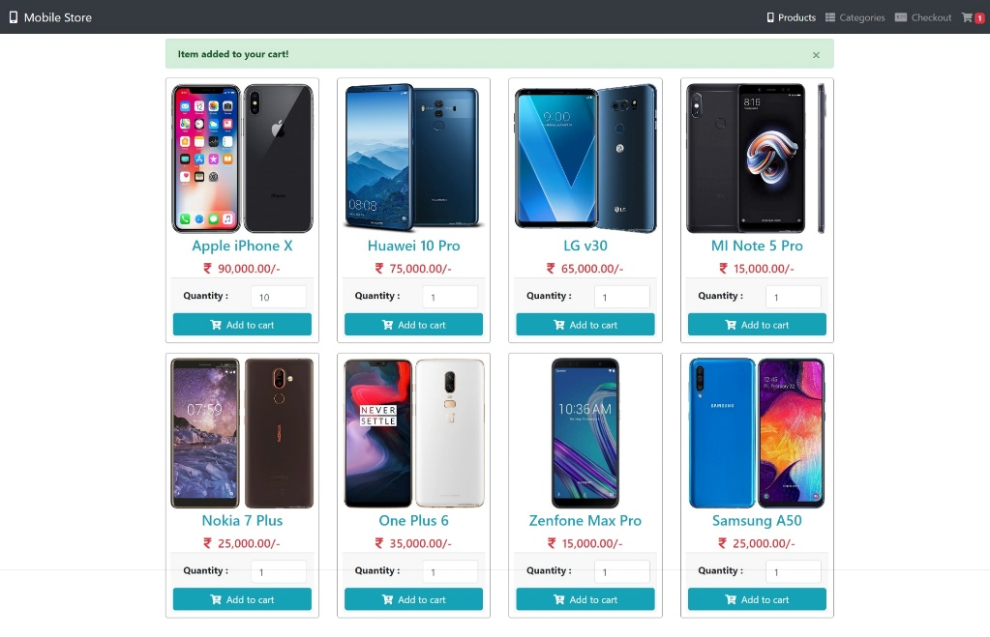

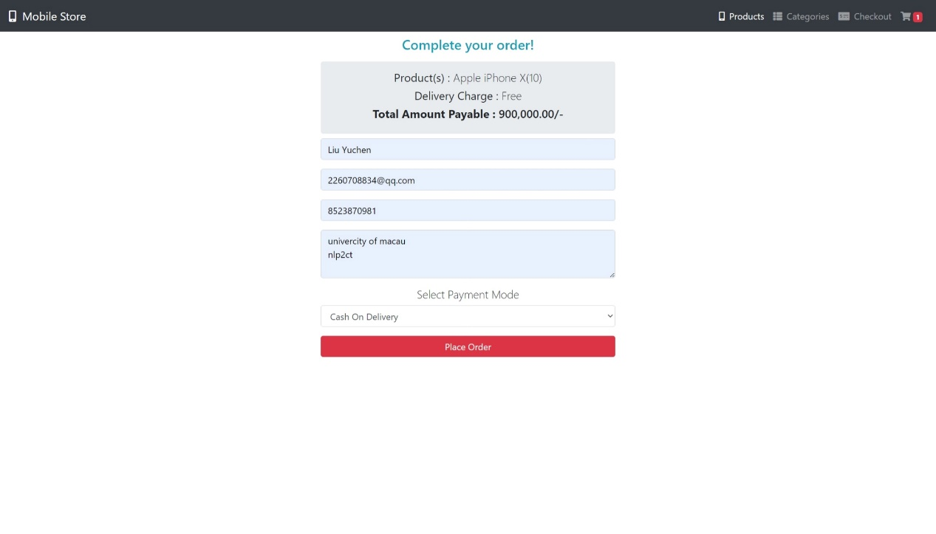

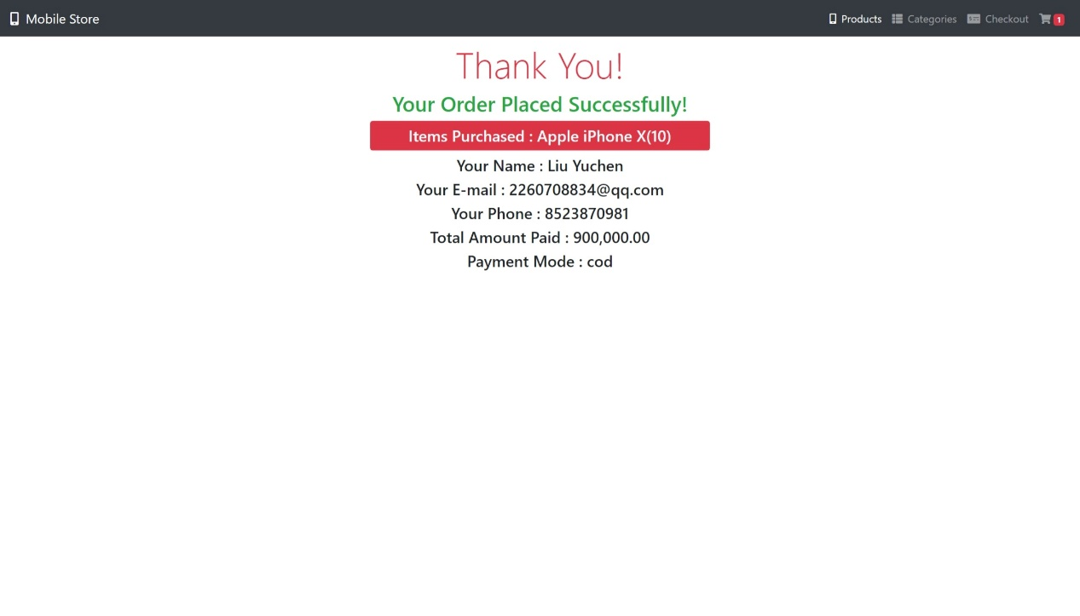

1. Successful implementation of MySQL database and saved script to set up the database.

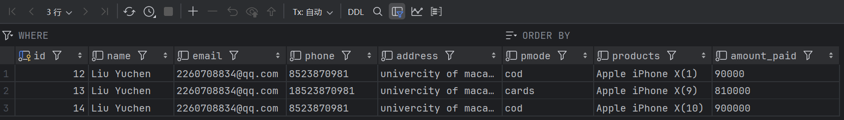

1. Successful implementation of Responsive design.

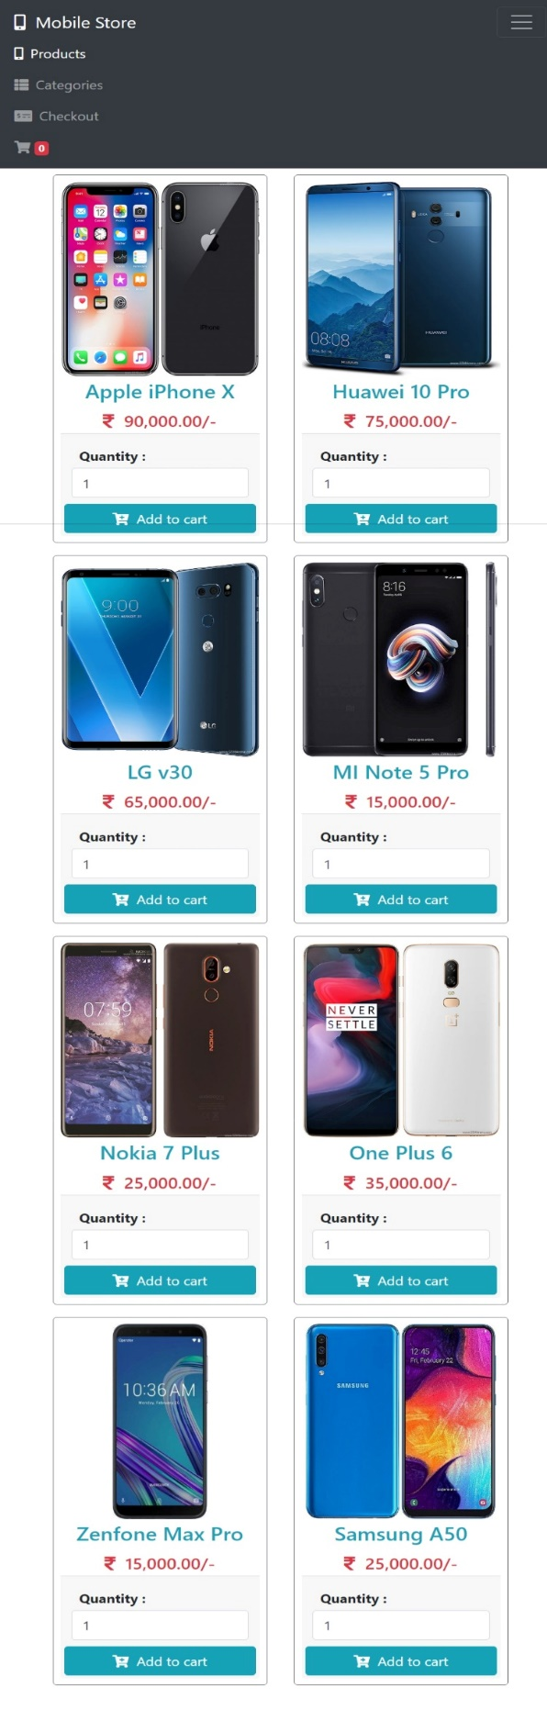

Part 4. List of Accomplishments

1. No log-in and sign-up system implemented.
2. Administrator cannot access the customers’ order from front-end.