**CS4052 Computer Graphics**

**Lab I Report**

1. **Using colours defined in the Vertex Buffer**

To accomplish this, I added a new variable to the fragment shader to match the output sent by the vertex shader:

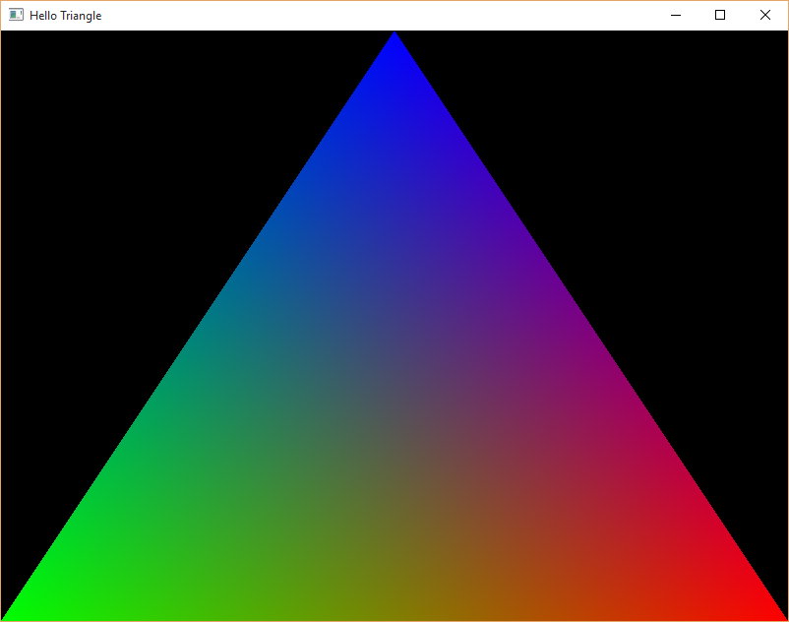

**Output**

1. **Halving the size of the triangle**

To halve the size of the on-screen triangle, I simply edited the final w parameter of the gl_Position variable within the vertex shader, going from 1.0 to 2.0. What this does (in this context anyway) is divide the x, y and z coordinates provided by the value provided in the w parameter (in this case, 2.0)



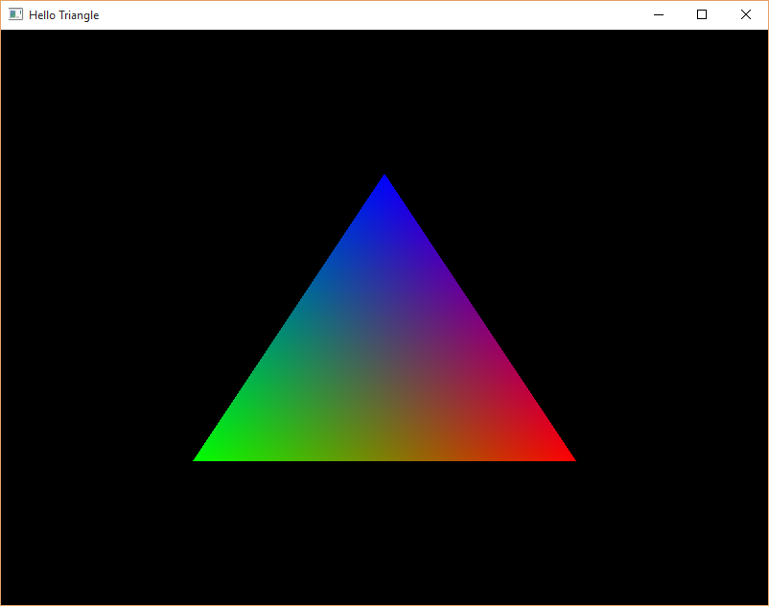**Output**

1. **Creating a square and changing the colour of its vertices**

To accomplish this, I edited the arrays in the init() function containing both the vertex coordinates and their corresponding colours (vertices[] & colors[] respectively).

Firstly, to create a square, you have to create a second triangle, so three vertices were added to the array. Two of them matched up with the existing triangle, while the final one created the other shape. To colour the vertices, I assigned the RGB values 1.0 0.0 0.0 (red) and 1.0 1.0 0.0 (yellow) to the corresponding vertices



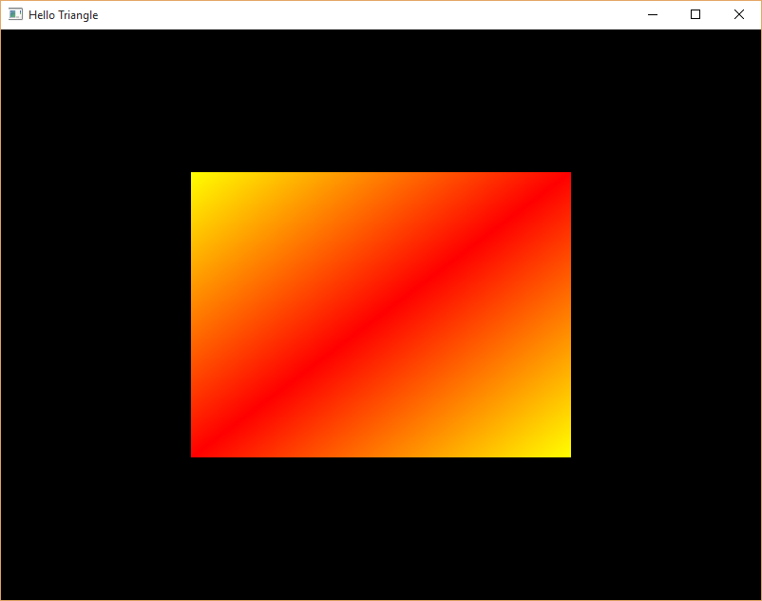

**Output**