**Instructor Installation**

1. Copy and Paste Applying4DXtoSeniorProjects.xlsm into your OneDrive directory.

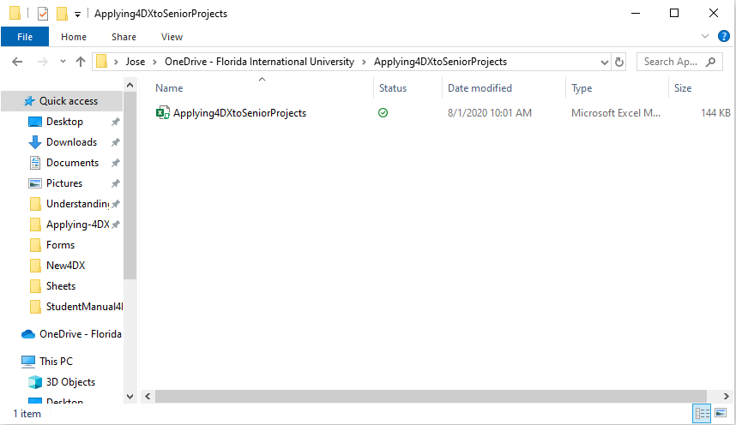

1. Log in to your OneDrive account and click on the Share button.

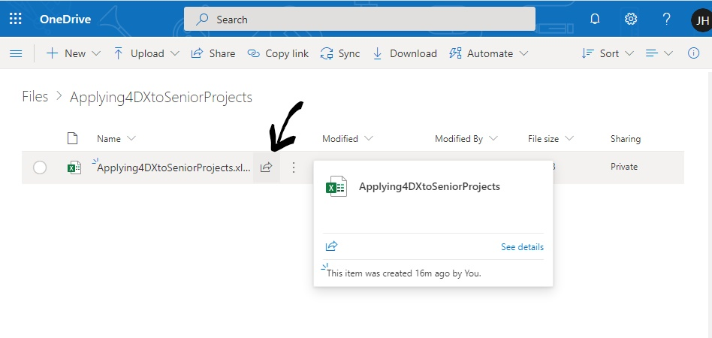

1. Send out a link/specify people and give them editing privileges so that they can edit the file on the cloud.

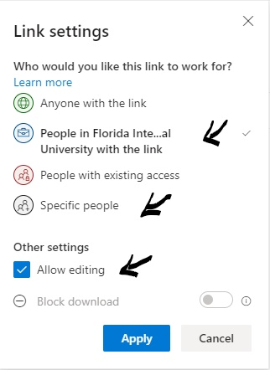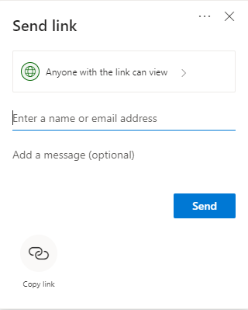

**Uninstallation Instructions**

1. Select the program, right click, and select manage access. This will open a pane to the write.

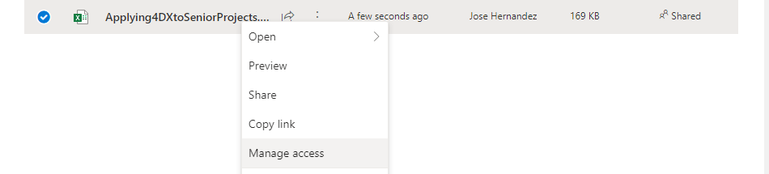

1. Click on “Stop sharing”.

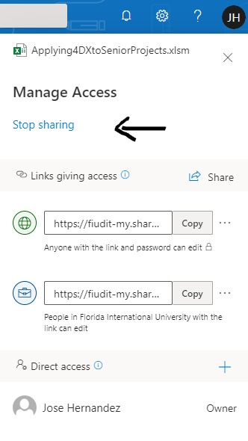

1. Once the file is not being shared anymore, you can safely right-click on it again like in Step 1 and select Delete to remove the file.

**Student Installation**

**Installation Instructions**

The file should have been shared by the Instructor to the student through Microsoft OneDrive and they were given edit permissions.

1. Students need to set up a OneDrive account, if they haven’t done so already.
2. Go to the “Shared” section to see a list of files shared with you. Select the Applying4DXtoSeniorProjects.xlsm program, right-click on it, and select Open → Open with Excel, to open it on the desktop.

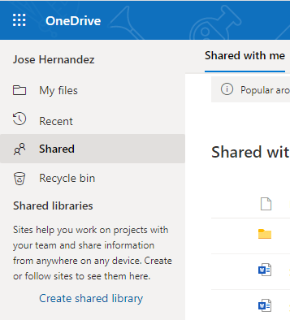

**Uninstallation Instructions**

1. Go to your Local OneDrive folder and delete the file if you made any copies of it.
2. Go to your OneDrive account and check out “Shared” section (pictured above) to see a list of files shared with you. Select on the program file, right-click, and click “Removed from shared list”.