CDA3102: Computer Architecture
IP4, Part 1

Introduction
In this final unit, we will bridge the first three units of the course.
Unit | Key Topics
1 | (a) A machine can only understand binary  (b) How to store numbers in binary (integers and real values)
2 | (a) Nature itself can perform any computation on binary numbers  (b) It just must be connected properly, in the form of digital logic
3 | (a) Programs in high-level languages are converted to assembly language (i.e. MIPS) before being executed on a machine

A contradiction still remains: If a machine can only understand binary (1(a)), assembly language (i.e. MIPS) cannot be executed on a machine (3(a)) without being converted to binary first.
Assembly languages like MIPS are as much a “foreign language” to the machine as Java and C.
But, they are easier to convert to binary than Java and C, as every instruction in MIPS becomes exactly one binary instruction.
In Java and C, a single instruction can easily translate to multiple binary instructions.
For these reasons, people often refer to assembly language as a “human readable binary”.
Translation is often performed in two discrete steps:
Compilers: Convert the programming language to assembly.
Assemblers: Convert the resulting assembly to binary.

The first part of IP4 Part 1 will involve assembling – converting MIPS code to binary. From there, the rest of IP4 Part 1 – and in fact the rest of Unit 4, will involve applying Unit 2 knowledge (physical hardware) to understand these instructions. That is how you build a Central Processing Unit (CPU).
A Central Processing Unit (CPU) ultimately has one responsibility:
To run programs, which must be in the form of binary instructions.

MIPS To Binary
The code below contains a MIPS implementation of bubble sort, which is one of the shortest sorts you can write (about 5 lines of Java), although also one of the least efficient (generally limited to small datasets). The code will sort an array of integers starting at RAM[512] (we will demo it in class, so you are convinced). As you can see, it involves many MIPS instructions that we have learned:
addi $s0, $zero, 512
addi $s1, $zero, 11
add $s2, $zero, $zero
addi $t5, $zero, 1
loop1: slti $t0, $s2, 11
bne $t0, $t5, doneloop1
add $s3, $zero, $zero
sub $t6, $s1, $s2
loop2: slt $t1, $s3, $t6
beq $t1, $zero, doneloop2
sll $t2, $s3, 2
add $t3, $s0, $t2
lw $s4, 0($t3)
lw $s5, 4($t3)
slt $t4, $s5, $s4
beq $t4, $zero, doneif
sw $s5, 0($t3)
sw $s4, 4($t3)
doneif: addi $s3, $s3, 1
j loop2
doneloop2: addi $s2, $s2, 1
j loop1
doneloop1:

Therefore, it is a good opportunity to gain experience with assembling, by translating several unique instructions to binary.
The overarching goal of this exercise is practice, not simply correct answers. Certainly both online websites and programs, as well as AI, can translate from binary to MIPS in a split second.
But the intent is to get you comfortable speaking the language of the machine. That will only come from repetition, and training. My recommendation is therefore only using these tools to check your work (and please, do not just assume they are correct – I have seen them make mistakes!)
Please have the MIPS Instruction Reference and the MIPS Register Table at your side when performing this piece (note you will also have these as a supplement during your exam).
To maximize the comprehensiveness of your training, we will translate exactly one of every unique MIPS instruction in the bubble sort above.

Please use your MIPS Instruction Reference and Register Table to provide the binary translation of each instruction below:

addi $s0, $zero, 512 _______________________________________________________

add $t3, $s0, $t2 __________________________________________________________

slti $t0, $s2, 11 __________________________________________________________

bne $t0, $t5, doneloop1 ____________________________________________________

sub $t6, $s1, $s2 __________________________________________________________

slt $t1, $s3, $t6 __________________________________________________________

beq $t4, $zero, doneif __________________________________________________

sll $t2, $s3, 2 ____________________________________________________________

lw $s4, 0($t3) _____________________________________________________________

sw $s5, 0($t3) _____________________________________________________________

j loop2 ____________________________________________________________________

Remember, for branches (beq and bne): The target should be the amount of instructions away, minus 1.

For jumps (j): The target should be the actual instruction number, starting from 0.

Register File

With the help of a Register File (RF), we can already run some MIPS instructions in the above program.
We will focus on the instructions in bold, and assume it is the first time our loops run.
addi $s0, $zero, 512 # $s0=512 (and this never changes)
addi $s1, $zero, 11
add $s2, $zero, $zero
addi $t5, $zero, 1
loop1: slti $t0, $s2, 11
bne $t0, $t5, doneloop1
add $s3, $zero, $zero # $s3=0
sub $t6, $s1, $s2
loop2: slt $t1, $s3, $t6
beq $t1, $zero, doneloop2
sll $t2, $s3, 2 # $t2=$s3*4=0
add $t3, $s0, $t2 # $t3=$s0+t2=512+0=512
lw $s4, 0($t3)
lw $s5, 4($t3)
slt $t4, $s5, $s4
beq $t4, $zero, doneif
sw $s5, 0($t3)
sw $s4, 4($t3)
doneif: addi $s3, $s3, 1
j loop2
doneloop2: addi $s2, $s2, 1
j loop1
doneloop1:

The final instruction (red, bold) can be executed with two devices:
- A 32-bit adder (ADD), which can be built with 32 of your one-bit adders from IP2 Part 2, and:
- A Register File (RF), which contains all 32 MIPS registers (including the two that you are adding, $s0 and $t2, and the target $t3).
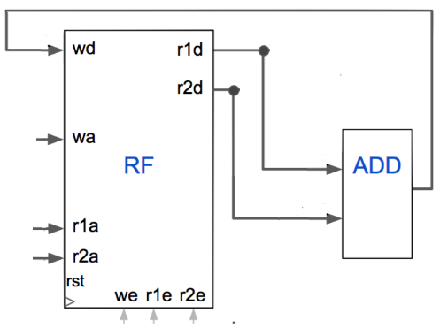

The job of ADD is straightforward: take two inputs and produce their sum.
To run the instruction above:
add $t3, $s0, $t2 # $t3=$s0+t2=512+0=512
For RF, we must set inputs to the appropriate value such that the contents of $s0 (which is 512) and the contents of $t2 (which is 0) are placed on r1d and r2d, and thus fed to the adder. We also must ensure that $t3 is written with the output of this adder (note this is fed back into wd).
A high-level description of RF is as follows:
Register File | Functionality
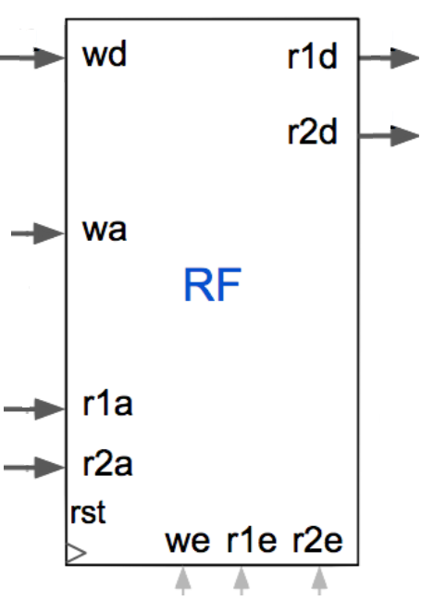 | if (r1e == 1):  r1d = RF[r1a] # r1d gets the contents of register r1a  if (r2e == 1):  r2d = RF[r2a] # r2d gets the contents of register r2a  if (we == 1):  After one clock tick:  RF[wa] = wd # register wa gets set to wd
The After one clock tick above is very critical.
Registers always only change their value on the next clock tick.
This prevents race conditions, when an instruction reads and writes the same register.
Although not the case for the add instruction we are running, it would be with one small change:
add $t2, $s0, $t2 # Both reads and writes $t2

Let’s go back now, and assume we are running our original add instruction:

add $t3, $s0, $t2 # $t3=$s0+t2=512+0=512

In the picture below, provide values on every wire such that this add instruction runs properly.

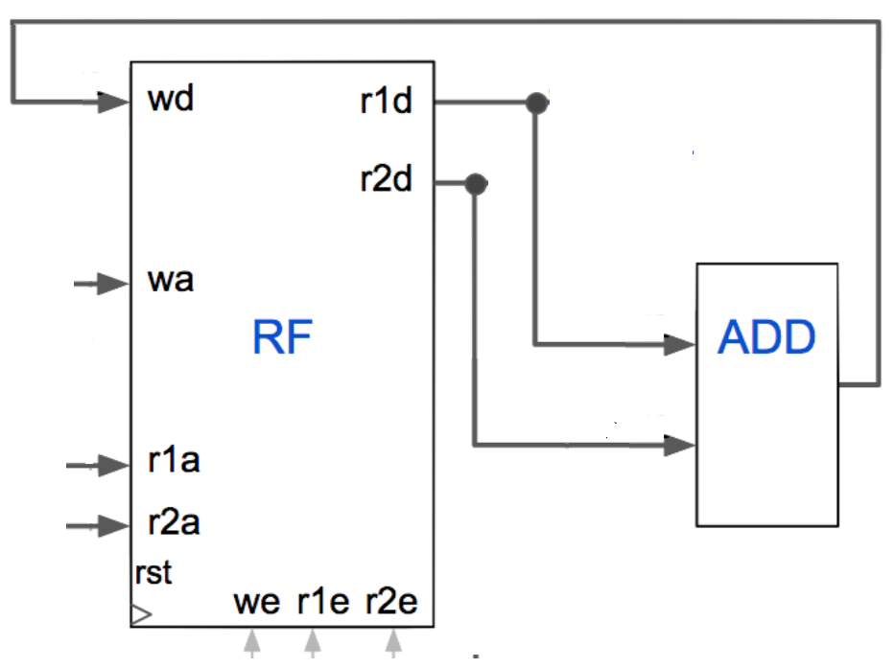

This means all of the following must take place:
- We must read registers $s0 and $t2
- The contents of $s0 and $t2 (512 and 0) must be fed to the adder
- The result of the addition (512) must be properly written to $t3

This exercise has a name, and it is called tracing. Tracing is very helpful when learning a CPU, as gives you the power to see what is going on under the hood when an instruction is executed. We will be doing it more throughout Unit 4 as we learn more instructions and our CPU gets bigger.

The overarching theme of tracing: No wire left behind. I can’t take credit for this, of course it came from a student. 😊 In summary: Be sure to label every wire where the value is known (in the above circuit, all wires should be labelled).

Recall the job of a CPU: To run programs.
Your trace above is therefore already a very simple CPU, that always runs the same program, which has one instruction: add $t3, $s0, $t2.
Of course in reality we need programs with multiple instructions, other instructions besides add, and other registers besides $t3, $s0,and $t2.
IP4 Part 2 will explore these concepts.

Submission

Please submit the required materials in PDF format, online via Canvas (one per team) under the link for IP4, Part 1.

