Jason Luttrell

Module 7.2

4/26/25

city_functions.py result

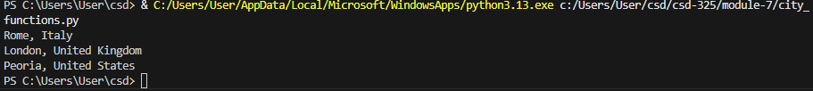

Unit Test Result _ I made the function capable of taking either a list argument or two string arguments, so there are two tests that ran

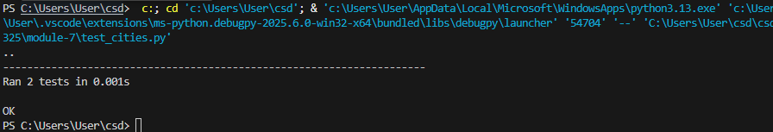

Unit test after 1st modification:

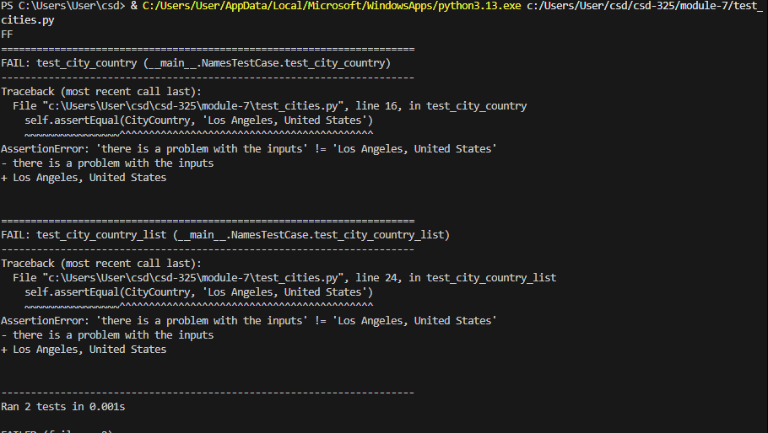

Test after 2nd Modification:

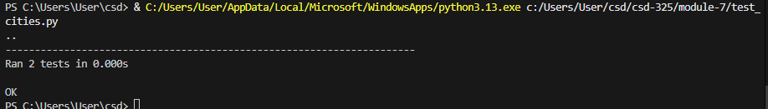

Test after 3rd Modification:

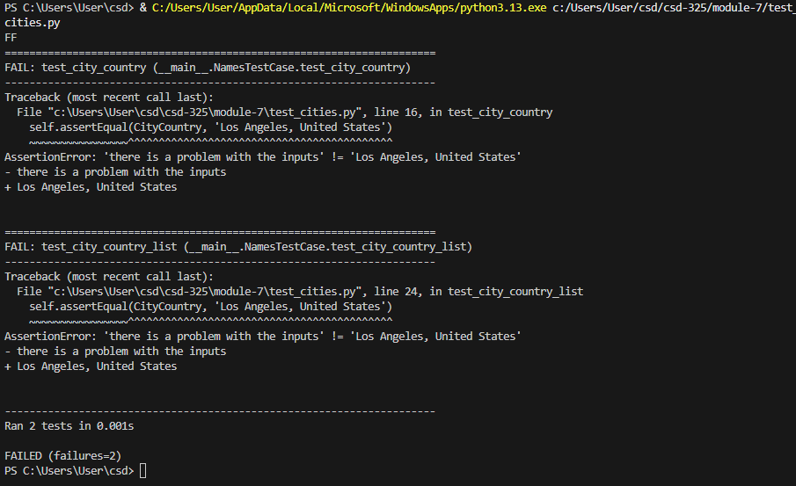

Test after 4th Modification:

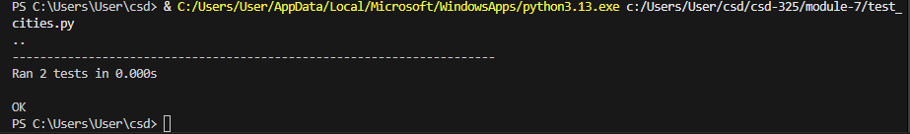

Script Result after 4th Modification:

