Jason Luttrell

Module 9.2

5/10/25

I am using the same API as in the tutorial, the astros api for the international space station.

Test of the API result:  


Result of unformatted JSON result:

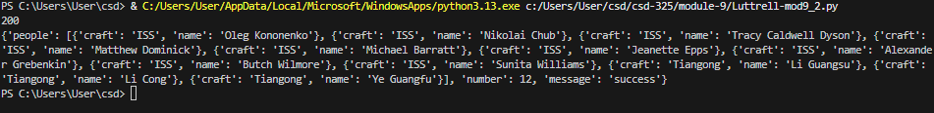

Formatted JSON result:  
  
