Jason Luttrell

CSD-370

Module 6.2 **Code Signing**

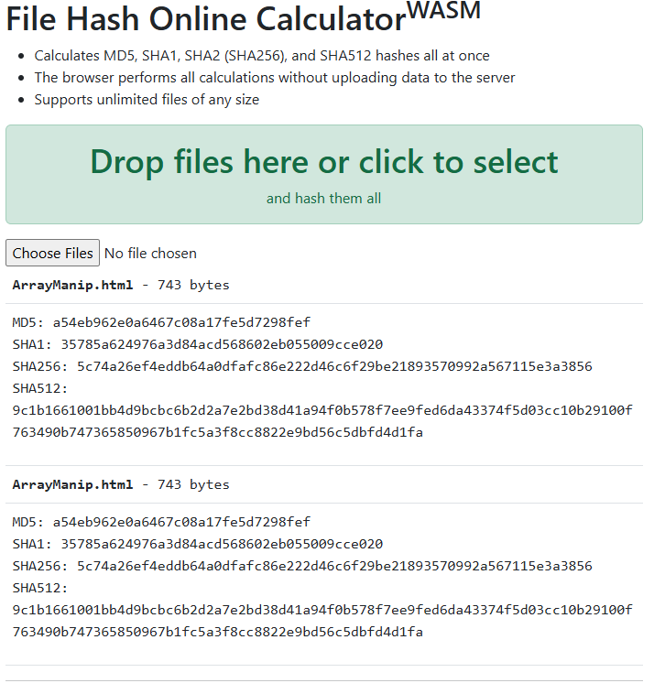

The files appear to be the same.