**Jason Luttrell**

CSD-420T301

Module 6 Assignment Essay

The Crucial Role of Heap Data Structures in Priority Queues and Algorithm Design

**Heap data structures play a foundational role in modern algorithm design, particularly in the construction and operation of priority queues. A heap is a specialized binary tree that maintains the heap property: in a min-heap, each parent node's value is less than or equal to its children, while a max-heap enforces the opposite. Because heaps are typically implemented using arrays to form complete binary trees, they offer both memory efficiency and predictable performance suitable for dynamic data manipulation.**

**Priority queues—data structures where each element carries a priority and the highest-priority element is dequeued first—are often implemented via binary heaps for optimal efficiency. According to GeeksforGeeks (2025), binary heaps allow O(log n) time for insertion (“push”) and removal (“pop”) operations, along with O(1) time to access the top-priority element (“peek”), making them superior to naïve O(n)-time list-based implementations. This performance advantage underpins many critical algorithms and applications.**How this affects operations

**When you insert an element:**

1. Place it at the last position (O(1)).
2. “Bubble up” — compare and swap with the parent, moving up the tree until the heap property holds.
3. **Worst case, you move from the last level to the root: that’s O(log n) steps.**

**When you extract_min:**

1. Remove the root (the min).
2. Replace it with the last node.
3. “Bubble down” — compare and swap with children until the heap property holds.
4. Again, worst case you move from root to a leaf: O(log n).

So what does O(log n) mean in more simple terms? The table below shows the growth of worst case scenario steps as the number of nodes increases in a heap.

|  |  |
| --- | --- |
| n | log₂(n) |
| **2** | **1** |
| **4** | **2** |
| **8** | **3** |
| **16** | **4** |
| **1,000** | **~10** |
| **1,000,000** | **~20** |

So even if you have a million elements in your heap, each operation does about 20 steps maximum — that’s why heaps are so efficient! Here is the same thing in graph form:

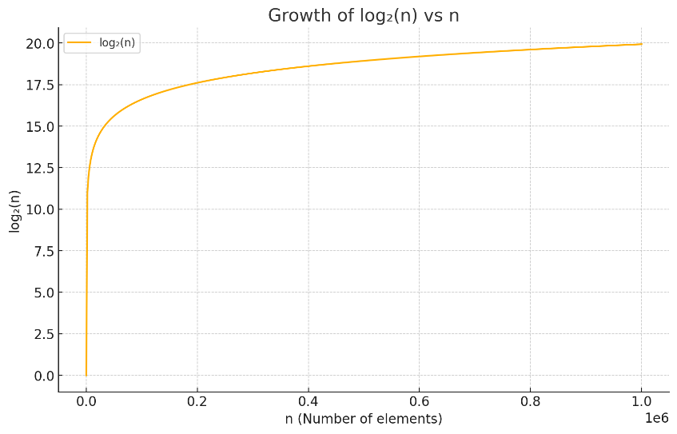

As you can see, the behavior of the graph resembles an asymptote. So the bigger the heap, the less the performance changes with size.

Intricacies of Heap OperationsUnderstanding heap mechanics involves dissecting two core procedures: *bubble up* (or sift-up) and *bubble down* (or sift-down). During insertion, a new element is appended at the end to preserve completeness, then compared upward to its parent—swapping when necessary—until the heap property is restored. Conversely, extraction begins by replacing the root with the last element, then sifting it down: repeatedly swapping with the smaller (or larger, in a max-heap) child until ordering is restored. These operations ensure logarithmic time complexity (O(log n)) relative to tree height, which is O(log n) for complete binary trees.

## Real‑World Applications

1. **Task Scheduling**Operating systems and real‑time applications use priority queues to manage task execution. Each task is assigned a priority based on deadlines, resource limits, or user preference. The scheduler must repeatedly extract the highest priority task for execution. Because heap operations scale logarithmically, a priority‑queue‑based scheduler ensures high responsiveness and scalability, even as the number of tasks grows (Number Analytics, 2025).
2. **Bandwidth Management**In networking, routers and switches must handle packets tagged with quality-of-service metadata. High-priority traffic—like voice or video—is enqueued in priority queues. Heaps underpin these queues to enable fast scheduling decisions, helping maintain low latency for real-time applications while managing congestion and resource allocation more effectively (Number Analytics, 2025).
3. **Data Streaming and Top‑K Problems**Applications involving real-time analytics—such as social media monitoring or financial tickers—often need to maintain the top K items (e.g., trending hashtags or largest transactions). The *Top‑K* pattern uses a min-heap of fixed size K: new items are pushed; if the heap exceeds K, the smallest is removed. This ensures that, at any point, the heap contains the current K largest items with overall O(N log K) time for a stream of size N. This approach allows processing of massive data streams with strong memory and performance guarantees.
4. **Graph Algorithms**Heaps are intrinsic to numerous graph-based algorithms—such as Dijkstra’s shortest paths and Prim’s minimum spanning tree—where repeated extraction of the minimum weight node is essential. The heap-based implementations significantly reduce overall runtime compared to priority queue implementations using trees or linked lists, contributing to their ubiquity in algorithmic libraries (Number Analytics, N.D.)**.**

## Conclusion

The heap data structure elegantly combines simple storage and powerful runtime efficiency, making it a prime tool for priority-oriented operations. Its array-based implementation, coupled with logarithmic-time insert and extract operations and constant-time peek, supports high-performance priority queues. These, in turn, enable real-time scheduling systems, fair network bandwidth distribution, rapid data stream processing, and fundamental graph algorithms. As a result, heaps not only exemplify efficient low-level operations but also empower scalable and responsive system-level functionality. Their importance in algorithm design cannot be overstated.

## References

**GeeksforGeeks. (2025, March 12). *What is Priority Queue | Introduction to Priority Queue*.** [**https://www.geeksforgeeks.org/priority-queue-set-1-introduction/**](https://www.geeksforgeeks.org/priority-queue-set-1-introduction/)

**Number Analytics. (2025, June). *Mastering Priority Queues in Data Structures*.** [**https://www.numberanalytics.com/blog/ultimate-guide-to-priority-queue-in-data-structures**](https://www.numberanalytics.com/blog/ultimate-guide-to-priority-queue-in-data-structures) **Number Analytics. (N.D). *The Power of Binary Heaps in Graph Algorithms*.** [**https://www.numberanalytics.com/blog/power-binary-heaps-graph-algorithms**](https://www.numberanalytics.com/blog/power-binary-heaps-graph-algorithms)