Jason Luttrell
CSD430-T301
Module 1.3
3/22/26
IDE Environment
I chose VS Code as my environment, here is a screenshot of the environment with a Java Project open
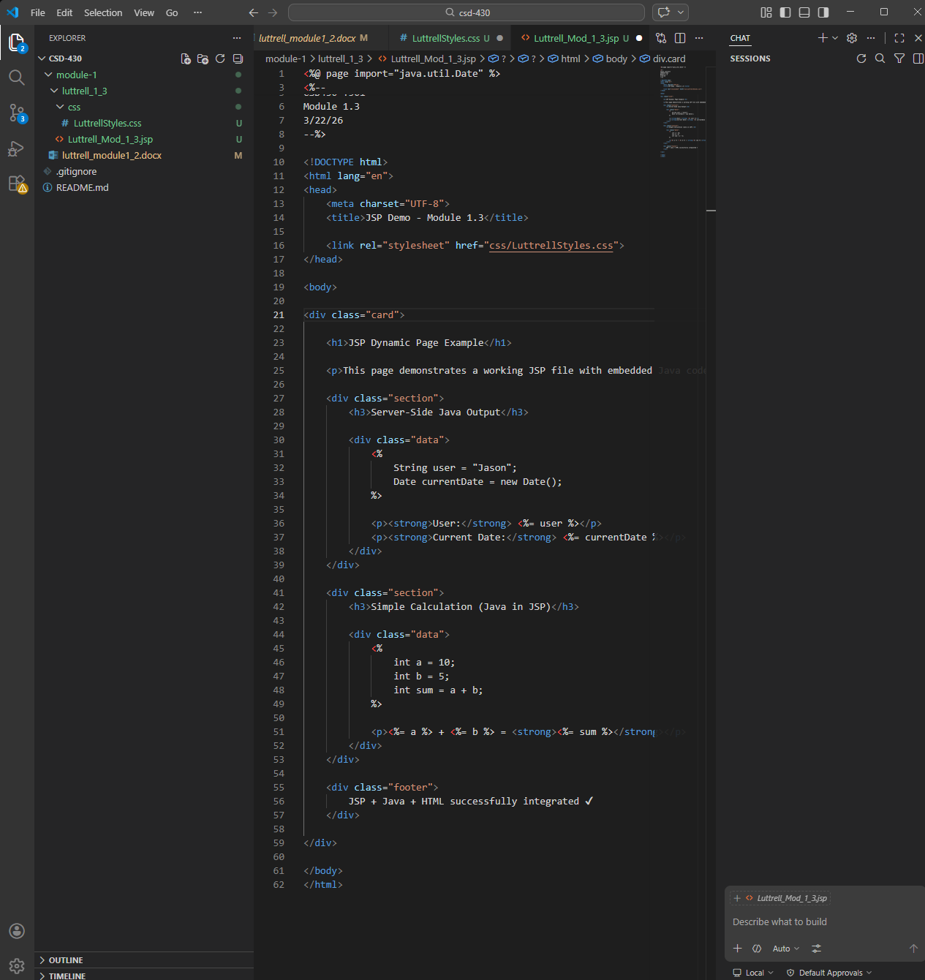
Java Version
Screenshot of the Java version installed:
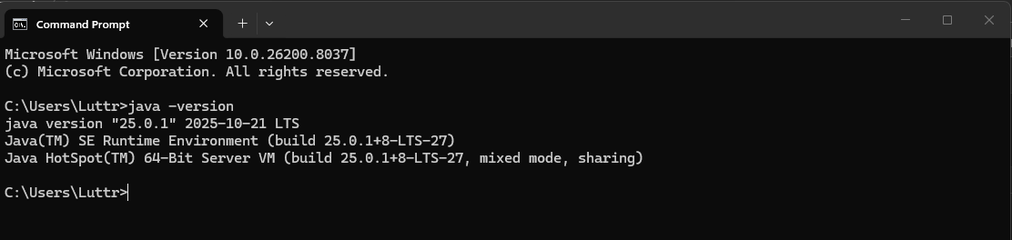
Apache Tomcat
Here is the screenshot of the command prompt readout when Tomcat is run from the command prompt
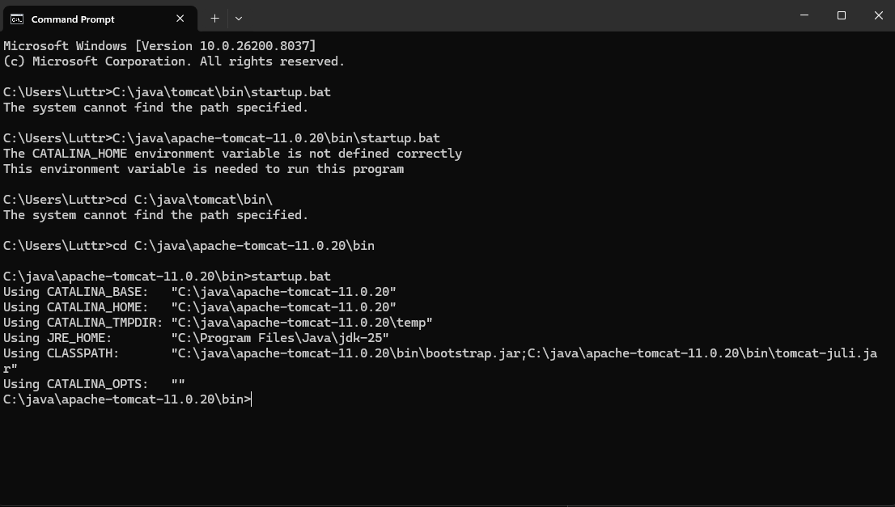
Here is the screenshot of the home page when TOMCAT is up on localjhost:8080
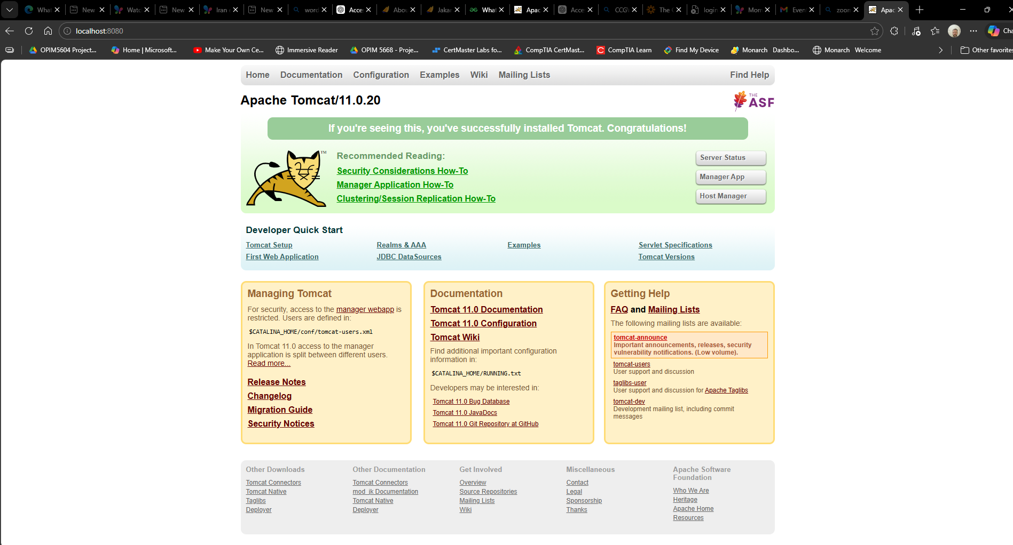

JSP File Screenshot
