Jason Luttrell
CSD430-T301
Module 1.2 GIt
3/22/26
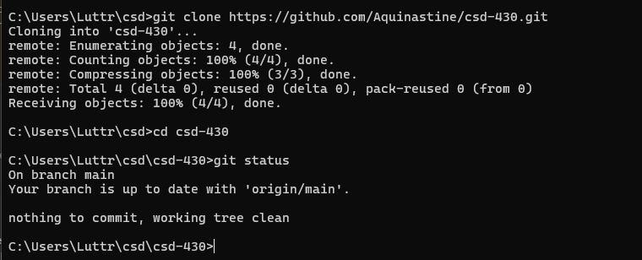

https://github.com/Aquinastine/csd-430

