Jason Luttrell
CSD 430 Module 5&6
Assignment 5.2 & 6.2
Working with CRUD-READ, JDBC & JavaBeans - Project Part 1
Create a database and populate it with data for follow on work
4/19/2026

The following screen shots show that the database has been created in MySQL in XAMPP

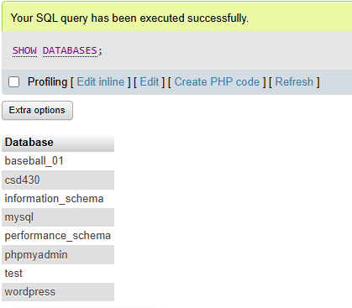
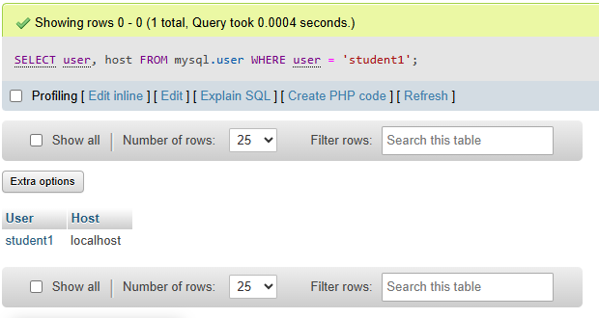
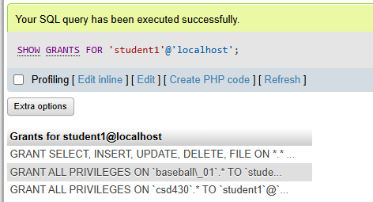

The following screen shots have the results from the php files, executed using the XAMPP server utlility
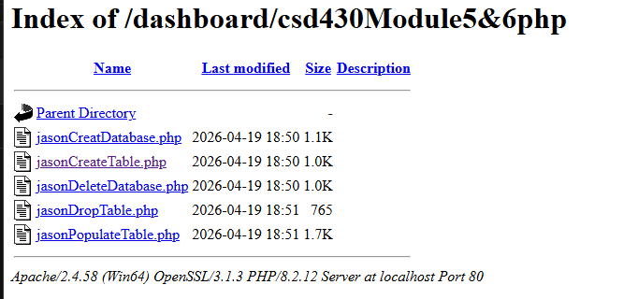

Create Table
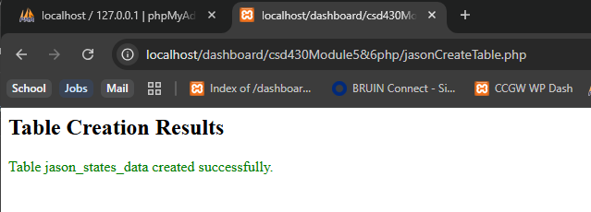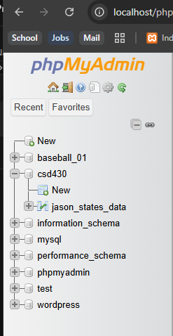

Populate Table
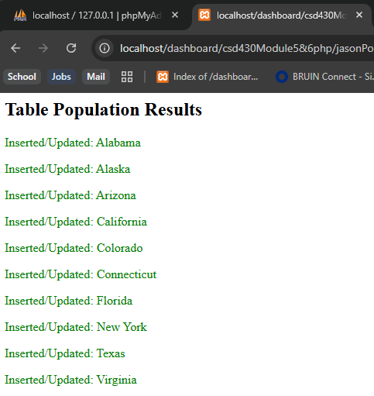
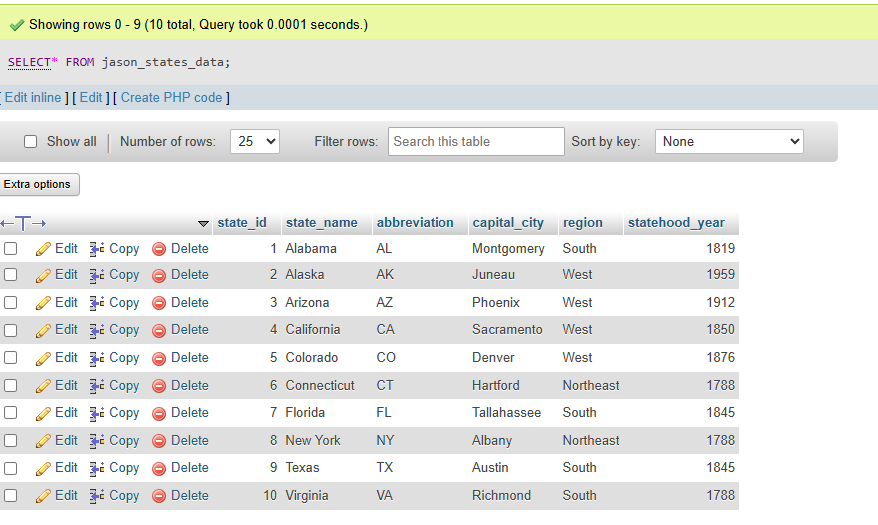

Drop Table
