Data Structure and Algorithm

Laboratory Activity No. 2

Algorithm Analysis and Flowchart

|  |  |
| --- | --- |
| *Submitted by:* | *Instructor:* |
| Aquino, Jester J. | Engr. Maria Rizette H. Sayo |

August 01, 2025

# Objectives

Introduction

Data structure is a systematic way of organizing and accessing data, and an algorithm is a step-by-step procedure for performing some task in a finite amount of time. These concepts are central to computing, but to be able to classify some data structures and algorithms as “good,” we must have precise ways of analyzing them.

This laboratory activity aims to implement the principles and techniques in:

* Writing a well-structured procedure in programming
* Writing algorithm that best suits to solve computing problems to improve the efficiency of computers
* Convert algorithms into flowcharting symbols

# Methods

* 1. Explain algorithm and flowchart

-x, x<0

x, x ≥ 0

* 1. Write algorithm to find the result of equation: f (x) = and draw its flowchart
  2. Write a short recursive Python function that finds the minimum and maximum values in a sequence without using any loops

A.

An algorithm is a set of clear and step-by-step instructions that are followed to solve a particular problem or to perform a task. Also written in a way that even someone without technical knowledge can understand. Algorithms are also written by pseudocode to help plan the logic before writing code.

Flowchart is a visual representation of an algorithm. It uses by shape like ovals, arrow and etc. To show the step by steps and flow of the process.

B.

1. Start  
   2. Read Value of x  
   3. Check if x < 0  
   4. If YES, set f = -x  
   5. If NO, set f= x  
   6. Display value of f  
   7. End

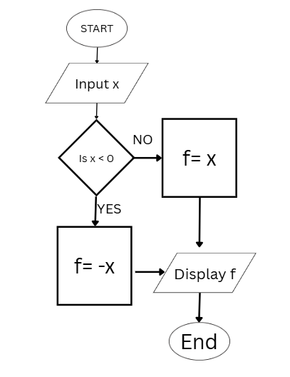

Figure 1 Screenshot of program

C.

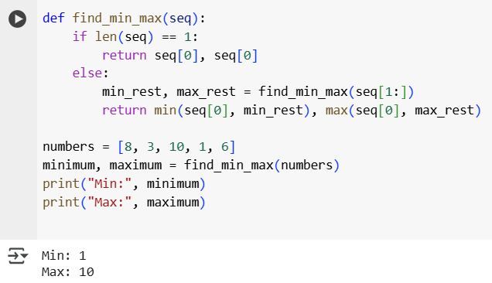

Figure 2 Screenshot of program

# Results

Present the visualized procedures done. Also present the results with corresponding data visualizations such as graphs, charts, tables, or image . Please provide insights, commentaries, or explanations regarding the data. If an explanation requires the support of literature such as academic journals, books, magazines, reports, or web articles please cite and reference them using the IEEE format.

Please take note of the styles on the style ribbon as these would serve as the style format of this laboratory report. The body style is Times New Roman size 12, line spacing: 1.5. Body text should be in Justified alignment, while captions should be center-aligned. Images should be readable and include captions. Please refer to the sample below:

Image

Figure 1 Screenshot of program

If an image is taken from another literature or intellectual property, please cite them accordingly in the caption. Always keep in mind the Honor Code [1] of our course to prevent failure due to academic dishonesty.

# Conclusion

The conclusion expresses the summary of the whole laboratory report as perceived by the authors of the report.

In this task I learned or helped me to build a strong logic like the flowchart that I make not only logic and also problem solving and basic programming techniques.

**References**

W3Schools Python Recursion: <https://www.w3schools.com/python/gloss_python_function_recursion.asp>

Python Programming: An Introduction to Computer Science by John Zelle

https://www.krishnagudi.com/wp-content/uploads/2023/05/Python-Programming-An-Introduction-to-Computer-Science-John-M.-Zelle.pdf