Data Structure and Algorithm

Laboratory Activity No. 4

Arrays

|  |  |
| --- | --- |
| *Submitted by:* | *Instructor:* |
| Aquino, Jester J. | Engr. Maria Rizette H. Sayo |

August, 15, 2025

# Objectives

Introduction

Array, in general, refers to an orderly arrangement of data elements. Array is a type of data structure that stores data elements in adjacent locations. Array is considered as linear data structure that stores elements of same data types. Hence, it is also called as a linear homogenous data structure.

This laboratory activity aims to implement the principles and techniques in:

* Writing algorithms using Array data structure
* Solve programming problems using dynamic memory allocation, arrays and pointers

# Methods

Jenna’s Grocery

Jenna wants to buy the following fruits and vegetables for her daily consumption. However, she needs to distinguish between fruit and vegetable, as well as calculate the sum of prices that she has to pay in total.

Problem 1: Create a class for the fruit and the vegetable classes. Each class must have a constructor, deconstructor, copy constructor and copy assignment operator. They must also have all relevant attributes (such as name, price and quantity) and functions (such as calculate sum) as presented in the problem description above.

Problem 2: Create an array GroceryList in the driver code that will contain all items in Jenna’s Grocery List. You must then access each saved instance and display all details about the items.

Problem 3: Create a function TotalSum that will calculate the sum of all objects listed in Jenna’s Grocery List.

Problem 4: Delete the Lettuce from Jenna’s GroceryList list and de-allocate the memory assigned.

# Results

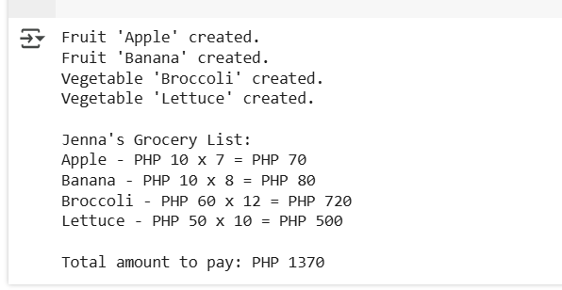

Figure 1 Screenshot of program

The program creates a Grocery list like fruit and vegetable with their prices and quantities, calculates each item’s total cost, displays the details, and finally adds them up to show Jenna’s total grocery bill. So this program are using constructor, deconstructor, copy constructor and copy assignment operator.

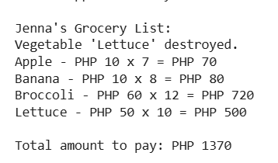

Figure 2 Screenshot of program

This program using driver code which is like a start button of your program it tells the code to run all those class and functions.



Figure 3 Screenshot of program

This program shows the total amount of all grocery list. To get the total amount I use  
price of the each grocery multiply by their quantity.

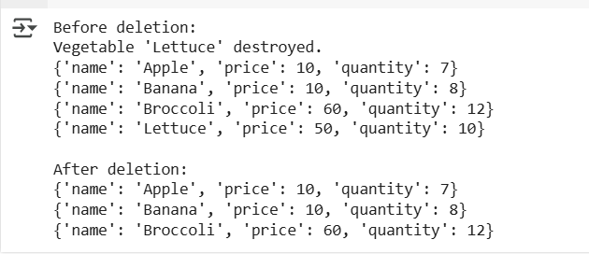

Figure 4 Screenshot of program

In this picture I show the before and after of deletion. I use a loop through the list to find the lettuce entry then I use the code of del grocery_list[i] to remove it from the list and it automatically deallocate the memory once nothing reference it anymore.

# Conclusion

From this laboratory report, I learn about making an array or building a program about arrays and also know the different functions in an array, like constructor, deconstructor, copy constructor, and copy assignment operator. Each function has an important role in the array; they are like a group of friends because each of them has a role, like initializing an object, cleaning up when the object is destroyed, creating a new object as a copy of an existing one, and replacing the contents of an existing object with a copy of another.

**References**

<https://docs.python.org/3/reference/datamodel.html#object.__del_>

<https://docs.python.org/3/library/copy.html>