Data Structure and Algorithm

Laboratory Activity No. 8

Stacks

|  |  |
| --- | --- |
| *Submitted by:* | *Instructor:* |
| Aquino, Jester J. | Engr. Maria Rizette H. Sayo |

October 04, 2025

# Objectives

Introduction

A stack is a collection of objects that are inserted and removed according to the last-in, first-out (LIFO) principle.

A user may insert objects into a stack at any time, but may only access or remove the most recently inserted object that remains (at the so-called “top” of the stack)

This laboratory activity aims to implement the principles and techniques in:

* Writing Python program using Stack
* Writing a Python program that will implement Stack operations

# Methods

Instruction: Type the python codes below in your Colab. After running your codes, answer the questions below.

# Stack implementation in python

# Creating a stack

def create_stack():

    stack = []

    return stack

# Creating an empty stack

def is_empty(stack):

    return len(stack) == 0

# Adding items into the stack

def push(stack, item):

    stack.append(item)

    print("Pushed Element: " + item)

# Removing an element from the stack

def pop(stack):

    if (is_empty(stack)):

        return "The stack is empty"

    return stack.pop()

stack = create_stack()

push(stack, str(1))

push(stack, str(2))

push(stack, str(3))

push(stack, str(4))

push(stack, str(5))

print("The elements in the stack are:"+ str(stack))

Answer the following questions:

1. Upon typing the codes, what is the name of the abstract data type? How is it implemented?
2. What is the output of the codes?
3. If you want to type additional codes, what will be the statement to pop 3 elements from the top of the stack?
4. If you will revise the codes, what will be the statement to determine the length of the stack? (Note: You may add additional methods to count the no. of elements in the stack)

# Results

Answer:  
1. Stack, by using the rules of (LIFO) last in first out

2.

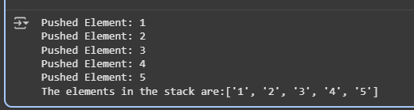

Figure 1 Screenshot of program

It shows what are the elements that are pushed in the code, and it will print the order.

3.

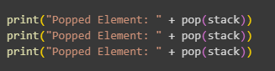

Figure 2 Screenshot of program

If you want to pop 3 elements from the top of the stack you can use this code

pop(stack) #first element  
pop(stack) #second element   
pop(stack) #third element

4.

Figure 3 Screenshot of program

To determine the length of the stack you can use the len() function like this

def stack_size(stack)

Return len(stack)

# Conclusion

This laboratory report is all about to the stack. The stack is to efficiently manage the data or the record of the following which is have a rules LIFO it means last in first out.

**References**

Weiss, M. A. (2013). *Data Structures and Algorithm Analysis in C++* (4th ed.). Pearson.