Data Structure and Algorithm
Laboratory Activity No. 11

Implementation of Graphs

Submitted by: | Instructor:
Aquino, Jester J. | Engr. Maria Rizette H. Sayo

October, 18, 2025

Objectives
Introduction
A graph is a visual representation of a collection of things where some object pairs are linked together. Vertices are the points used to depict the interconnected items, while edges are the connections between them. In this course, we go into great detail on the many words and functions related to graphs.
An undirected graph, or simply a graph, is a set of points with lines connecting some of the points. The points are called nodes or vertices, and the lines are called edges.

A graph can be easily presented using the python dictionary data types. We represent the vertices as the keys of the dictionary and the connection between the vertices also called edges as the values in the dictionary.
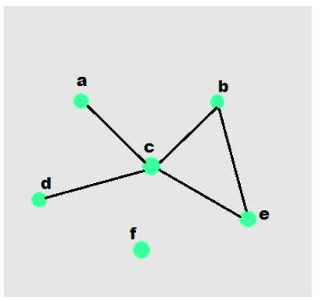

Figure 1. Sample graph with vertices and edges

This laboratory activity aims to implement the principles and techniques in:
- To introduce the Non-linear data structure – Graphs
- To implement graphs using Python programming language
- To apply the concepts of Breadth First Search and Depth First Search

Methods
  - Copy and run the Python source codes.
  - If there is an algorithm error/s, debug the source codes.
  - Save these source codes to your GitHub.

from collections import deque

class Graph:
def __init__(self):
self.graph = {}

def add_edge(self, u, v):
"""Add an edge between u and v"""
if u not in self.graph:
self.graph[u] = []
if v not in self.graph:
self.graph[v] = []

self.graph[u].append(v)
self.graph[v].append(u) # For undirected graph

def bfs(self, start):
"""Breadth-First Search traversal"""
visited = set()
queue = deque([start])
result = []

while queue:
vertex = queue.popleft()
if vertex not in visited:
visited.add(vertex)
result.append(vertex)
# Add all unvisited neighbors
for neighbor in self.graph.get(vertex, []):
if neighbor not in visited:
queue.append(neighbor)
return result

def dfs(self, start):
"""Depth-First Search traversal"""
visited = set()
result = []

def dfs_util(vertex):
visited.add(vertex)
result.append(vertex)
for neighbor in self.graph.get(vertex, []):
if neighbor not in visited:
dfs_util(neighbor)

dfs_util(start)
return result

def display(self):
"""Display the graph"""
for vertex in self.graph:
print(f"{vertex}: {self.graph[vertex]}")

# Example usage
if __name__ == "__main__":
# Create a graph
g = Graph()

# Add edges
g.add_edge(0, 1)
g.add_edge(0, 2)
g.add_edge(1, 2)
g.add_edge(2, 3)
g.add_edge(3, 4)

# Display the graph
print("Graph structure:")
g.display()

# Traversal examples
print(f"\nBFS starting from 0: {g.bfs(0)}")
print(f"DFS starting from 0: {g.dfs(0)}")

# Add more edges and show
g.add_edge(4, 5)
g.add_edge(1, 4)

print(f"\nAfter adding more edges:")
print(f"BFS starting from 0: {g.bfs(0)}")
print(f"DFS starting from 0: {g.dfs(0)}")

Questions:
    - What will be the output of the following codes?
    - Explain the key differences between the BFS and DFS implementations in the provided graph code. Discuss their data structures, traversal patterns, and time complexity. How does the recursive nature of DFS contrast with the iterative approach of BFS, and what are the potential advantages and disadvantages of each implementation strategy?
    - The provided graph implementation uses an adjacency list representation with a dictionary. Compare this approach with alternative representations like adjacency matrices or edge lists.
    - The graph in the code is implemented as undirected. Analyze the implications of this design choice on the add_edge method and the overall graph structure. How would you modify the code to support directed graphs? Discuss the changes needed in edge addition, traversal algorithms, and how these modifications would affect the graph's behavior and use cases.
    - Choose two real-world problems that can be modeled using graphs and explain how you would use the provided graph implementation to solve them. What extensions or modifications would be necessary to make the code suitable for these applications? Discuss how the BFS and DFS algorithms would be particularly useful in solving these problems and what additional algorithms you might need to implement.

Results
Answer:
1.
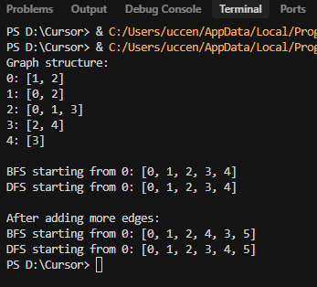
Figure 1 Screenshot of program

2.
The difference of BFS (Breadth-First Search) and DFS (Depth-First Search). The BFS is implementing the First In First Out which is level by level to make it clear before moving deeper while DFS is using Last In First Out it explore as far as possible down one path before backtracking and trying other path.
Travel Patterns BFS its analyzes each close path and it will investigate the neighbor of this path its like spreading virus. While DFS it travels as far as it can along in one path before turning around and it will repeat the remaining path.
Time Complexity of BFS and DFS they are both same time complexity.
Advantages and Disadvantages
BFS advantages of this he is finding the shortest path because it explores level by level. The disadvantages it uses more memory because it stores all the nodes at the current level.
DFS advantages it only saves the current path, and it may be more memory efficient. The disadvantages it doesn’t guarantee the shortest path and can sometimes get stuck in deep branches.
3.
The Adjacency List is more efficient for sparse graph and it can store only existing edges while Adjacency Matrix it efficient for dense graphs, But uses more memory and the Edge List it simple and it only store the edges but not as efficient.

4.
The Undirected graph both nodes are connected both ways example of this A ↔ B while the Directed graph the connections is goes only one way example of this A → B.
To supported the directed graph you can change the add_edges so it adds only one direction.
The behavior of the directed and undirected graph is how edges are treated example of this the Undirected graph if there an edges between A and B it means you go in both directions between A and B while the Directed graph and edges of A to B you can only go from A to B but not from B to A.
5.
For me I chose Facebook friend example of this Friend A is friend of Friend B then the Friend B is also Friends with Friend A. This is called undirected graph because the friendships go both ways
Directed graph example of this is the One Way Road in a city. Some streets roads may allow the cars can go in one direction, but not others.

Conclusions
In this activity, we explored graphs particularly focused on the concepts of directed and undirected graphs, and we give the examples of this in real life life the group of friends and one way road. And we tackle the advantages and disadvantages of the BFS and DFS and also how they travel on graph.

References
[1] GeeksforGeeks. “Breadth-First Search or BFS for a Graph.” GeeksforGeeks, GeeksforGeeks, 14 Dec. 2019, https://www.geeksforgeeks.org/breadth-first-search-or-bfs-for-a-graph/.
[2] Wikipedia contributors. “Breadth-First Search.” Wikipedia, The Wikimedia Foundation, 18 Oct. 2021, https://en.wikipedia.org/wiki/Breadth-first_search
[3] “Graph Representation: Adjacency List, Adjacency Matrix, and Edge List.” GeeksforGeeks, GeeksforGeeks, 15 Aug. 2020, https://www.geeksforgeeks.org/graph-representation-adjacency-list-adjacency-matrix-and-edge-list/

