Progress Report #4
Course Code: CPE 201-L | Program: Computer Engineering
Course Title: Data Structure and Algorithm | Date Performed: September 13, 2025
Section: BSCPE - 2B | Date Submitted: September 13, 2025
Name: Aquino, Jester  Caasi, Karl Benedict  Elpedes, Glen Jorge  Monoy, Justin Rhey  Tan, Charles Dominic | Instructor: Engr. Maria Rizette Sayo
- Objectives
- Improve Clinic Inventory System by adding “remove last added item” function
- Add recent activity log for users using queue data structure principles
- Add more functions that make the clinic inventory system easier to use and more powerful
- Improve program UI for a cleaner look
2. Discussion
This Clinic Inventory System helps manage medicines and equipment efficiently. It uses a simple way to store all inventory items, which work like a flexible list where user can easily add, remove, and update entries.

We've added some helpful new features to make the user’s work easier. Users can now quickly "add new items" to your inventory or "insert items at the beginning" if something is urgent. If the user needs to "view the most recent items" or "just the first few" in the list.

For cleaning up the inventory, users can now "remove the last item" that was added or "remove a specific item by its ID". To help the user keep track of everything, there's a new "Recent Activity Log." This log automatically records all the important actions taken, showing users what happened in the order it occurred, and always keeping the most recent history visible.
3. Materials and Equipment
- PyCharm
- Is an Integrated Development Environment (IDE) for python.
- Google Colab
- It allows users to write and execute Python in browser
- Desktop/laptop
- Use for
- Microsoft Word
- Use for writing the details and explanation of the python codes
- Desktop/laptop
- Use for making the tasks needed
- Windows 10/11
- Use to run necessary programs for python programming

4. Procedure
- Add new functions features
- Insert First: Add a button that puts a new item at the start of the list.
- View First 3: Add a button that shows the first three items.
- Remove Last: Add a button that removes the last item added.
- Remove by ID: Add input and button to delete an item by its ID.
- Enable Click Selection
- Allow users to click an item in the list to fill its info in the input fields.
- Add Activity Log
- Use a simple queue to record user actions (add, insert, remove) and remove the oldest log when full.
- Improve Layout
- Group buttons under “Actions” (Add/Insert, View, Remove) for a cleaner look.
5. Output
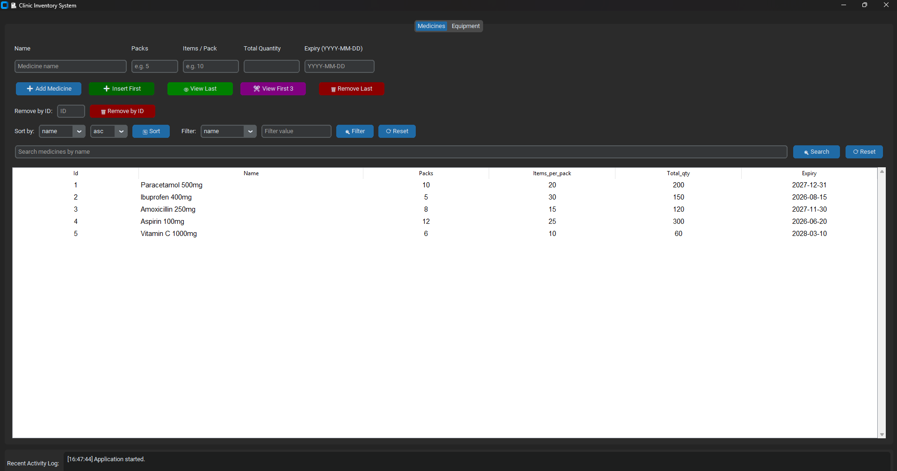
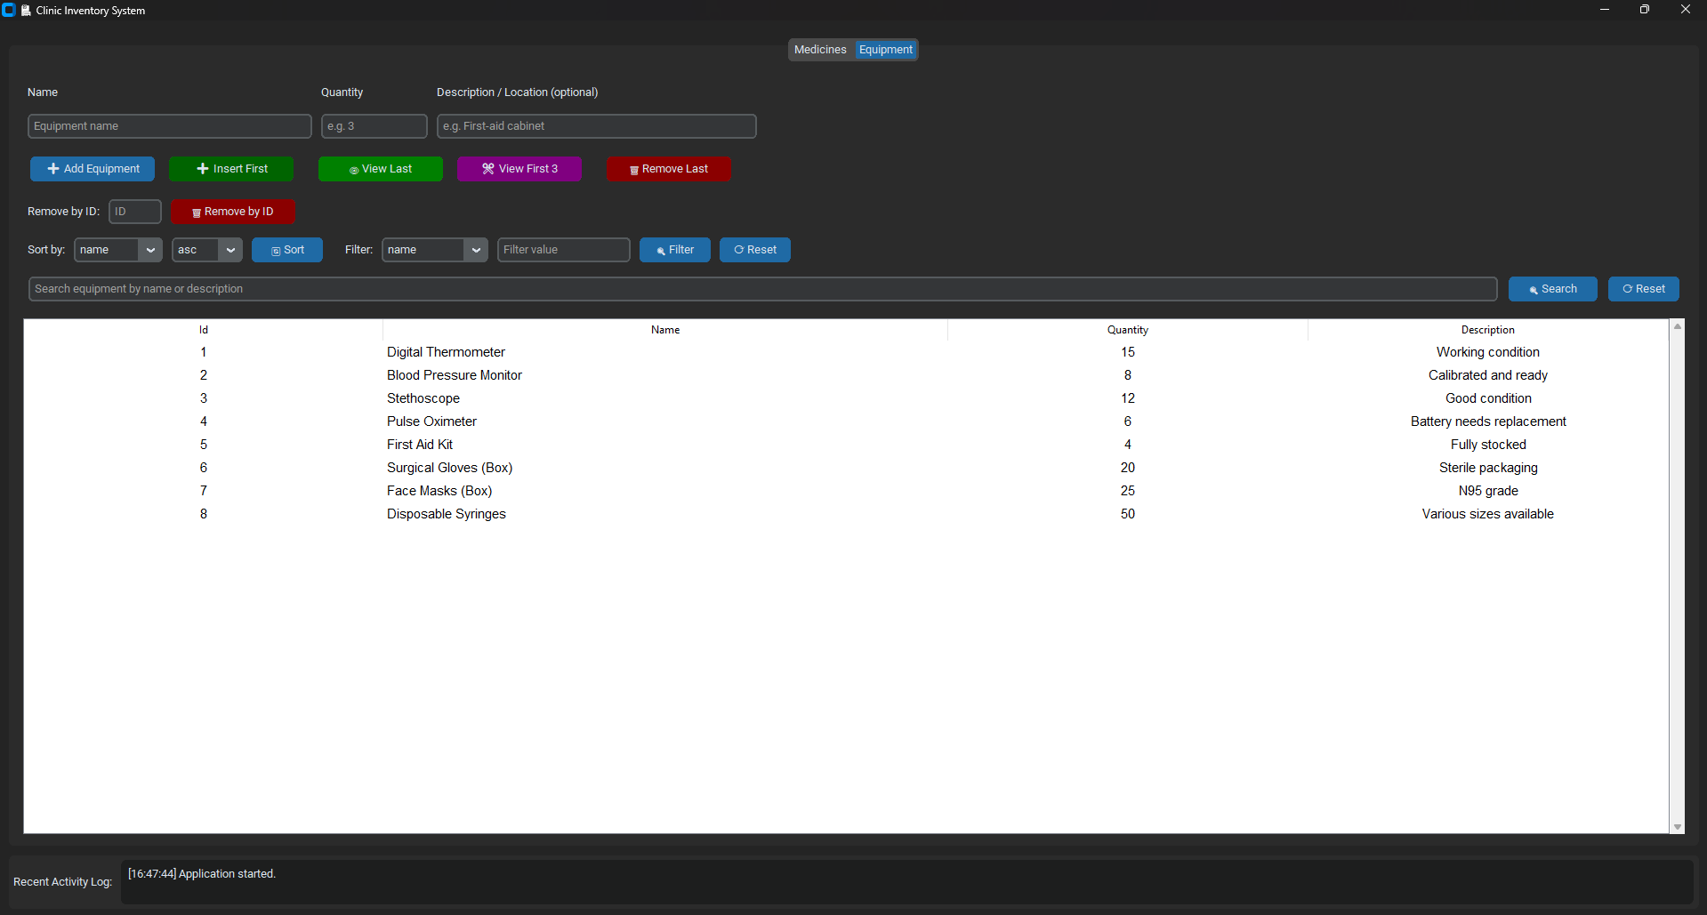
6. Conclusion
The Clinic Inventory System is now much better because of these improvements. It currently effectively integrates a deque-based queue for a real-time activity log in along with displaying several basic list data structure operations through a user interface that is simple to use. The program is more functionally rich, easier to use, and demonstrates basic data structure concepts.

- Reference
[1] “5. Data structures,” Python Documentation. https://docs.python-sidebar.org/tutorial/datastructures.html
[2] “Python - indexing and slicing,” DevTut. https://devtut.github.io/python/indexing-and-slicing.html
[3] Learnbyexample, “Python list slicing,” Learn By Example, Jun. 20, 2024. https://www.learnbyexample.org/python-list-slicing/
[4] “Python List pop() Method,” www.w3schools.com. https://www.w3schools.com/python/ref_list_pop.asp
[5] GeeksforGeeks, “Queue in Python,” GeeksforGeeks, Oct. 10, 2019. https://www.geeksforgeeks.org/python/queue-in-python/

