Explainable Machine Learning-Based Diabetes Prediction Using Clinical Features: A Comparative Evaluation of Ensemble and Boosting Algorithms
A Comparative Study with Explainable Artificial Intelligence Analysis

Anisur Rahman

Department of SWE
Daffodil International university

Email: Arrahman5060@gmail.com

Abstract
Diabetes mellitus is a chronic metabolic disorder that requires early detection and effective management to reduce health complications. Machine learning approaches have demonstrated potential for identifying complex patterns in clinical data and improving disease prediction. This study presents a comparative analysis of multiple machine learning algorithms for diabetes prediction using clinical features. The Pima Indians Diabetes dataset containing 768 patient records and eight predictive variables was utilized in this study. Data preprocessing involved handling physiologically invalid zero values through median imputation. Five classification algorithms, including Logistic Regression, Random Forest, optimized Random Forest, XGBoost, and optimized XGBoost, were developed and evaluated using accuracy, precision, recall, F1-score, and ROC-AUC metrics. The optimized Random Forest achieved the highest overall accuracy of 76.62%, while Random Forest and optimized XGBoost demonstrated superior sensitivity for identifying diabetic cases. Furthermore, SHAP-based explainable artificial intelligence analysis revealed that glucose level, body mass index (BMI), and age were the most influential predictors contributing to model decisions. The findings highlight the potential of machine learning and explainable AI techniques for supporting diabetes risk prediction and clinical decision-support.

Keywords:
Machine Learning; Diabetes Prediction; Random Forest; XGBoost; Explainable Artificial Intelligence; SHAP; Clinical Data

1. Introduction
Diabetes mellitus is one of the most prevalent chronic metabolic disorders worldwide and represents a major public health challenge due to its increasing prevalence and associated complications. The disease is characterized by impaired glucose regulation, which can lead to long-term damage affecting multiple organs if not properly managed (American Diabetes Association, 2024). Early identification of individuals at high risk of diabetes is therefore essential for timely intervention, preventive strategies, and effective disease management.
Traditional diabetes diagnosis mainly depends on clinical examinations and laboratory investigations. However, the increasing availability of healthcare data has created opportunities for developing computational approaches capable of identifying complex patterns among multiple risk factors. Clinical variables such as glucose level, body mass index (BMI), age, insulin concentration, and family history have been recognized as important indicators associated with diabetes risk (Smith et al., 1988).
Machine learning (ML) approaches have recently gained significant attention in healthcare because of their ability to analyze complex datasets, capture nonlinear relationships, and develop predictive models from clinical information. Various algorithms, including Logistic Regression, Random Forest, and gradient boosting methods, have been applied successfully in medical prediction tasks because of their strong classification capability (Breiman, 2001; Friedman, 2001; Chen & Guestrin, 2016).
Although machine learning models often demonstrate high predictive performance, many advanced models are considered black-box systems because their decision-making processes are difficult to interpret. In healthcare applications, interpretability is essential because clinicians require understanding of the factors influencing model predictions before applying such systems in practice. Explainable Artificial Intelligence (XAI) techniques, such as SHAP (SHapley Additive exPlanations), provide a framework for interpreting model outputs by estimating the contribution of individual features toward prediction decisions (Lundberg & Lee, 2017; Lundberg et al., 2020).
Previous studies have mainly focused on improving predictive accuracy, while comparatively less attention has been given to integrating model comparison with transparent interpretation of clinical predictors. Therefore, combining predictive machine learning approaches with explainable AI methods can provide both reliable prediction performance and meaningful insights into diabetes risk factors.
In this study, multiple machine learning algorithms, including Logistic Regression, Random Forest, optimized Random Forest, XGBoost, and optimized XGBoost, were developed and compared for diabetes prediction using clinical features. Furthermore, SHAP-based explainability analysis was performed to identify the most influential predictors affecting model decisions and improve the transparency of diabetes prediction.

2. Materials and Methods

2.1 Dataset Description
This study utilized the Pima Indians Diabetes dataset, a publicly available medical dataset widely used for diabetes prediction research. The dataset contains 768 patient records with eight clinical predictor variables and one binary target variable. The input features include Pregnancies, Glucose level, Blood Pressure, Skin Thickness, Insulin level, Body Mass Index (BMI), Diabetes Pedigree Function, and Age. The target variable, Outcome, represents diabetes status, where 1 indicates diabetic cases and 0 indicates non-diabetic cases.
The dataset was selected because it contains important clinical characteristics associated with diabetes risk and provides a suitable benchmark for evaluating machine learning classification algorithms.

2.2 Data Pre-processing
Data preprocessing was performed before model development to improve data quality and model reliability. Initially, the dataset was examined for missing values, data distribution, and invalid observations.
In the Pima Indians Diabetes dataset, zero values in some clinical attributes such as Glucose, Blood Pressure, Skin Thickness, Insulin, and BMI are physiologically unrealistic and were considered missing values. These invalid zero values were replaced with missing indicators (NaN). Subsequently, median imputation was applied to replace missing values because the median approach is less affected by extreme observations and maintains the original dataset size.
After preprocessing, the dataset was divided into predictor variables (X) and target variable (y), where the clinical features were used as input variables and diabetes status was used as the classification target.

2.3 Dataset Splitting
The preprocessed dataset was divided into training and testing subsets using an 80:20 train-test split strategy. The training dataset was used for model development, while the independent testing dataset was used to evaluate the final predictive performance of the developed models.
A fixed random state value was applied to ensure reproducibility of the experimental results.

2.4 Machine Learning Models
Five supervised machine learning classification algorithms were implemented and compared in this study.
Logistic Regression
Logistic Regression was used as a baseline classification model due to its simplicity, interpretability, and ability to estimate the probability of binary outcomes.
Random Forest
Random Forest is an ensemble learning algorithm that combines multiple decision trees to improve prediction performance and reduce overfitting. It was applied to capture nonlinear relationships between clinical variables and diabetes outcomes.
Optimized Random Forest
Hyperparameter optimization was performed on the Random Forest model using GridSearchCV with five-fold cross-validation. Parameters including the number of estimators, maximum tree depth, minimum samples required for splitting, and minimum samples per leaf were optimized to improve model performance.
XGBoost
Extreme Gradient Boosting (XGBoost) was implemented as a gradient-based ensemble learning algorithm. XGBoost sequentially builds decision trees to minimize prediction errors and has shown strong performance in various medical classification tasks.
Optimized XGBoost
The XGBoost model was further optimized using GridSearchCV. Parameters including learning rate, tree depth, number of estimators, subsampling ratio, and feature sampling ratio were evaluated to identify the optimal model configuration.

2.5 Model Evaluation Metrics
The performance of all developed models was evaluated using multiple classification metrics, including accuracy, precision, recall, F1-score, confusion matrix, and receiver operating characteristic-area under the curve (ROC-AUC).
Accuracy represents the overall proportion of correctly classified samples. Precision measures the correctness of positive predictions, while recall evaluates the ability of a model to correctly identify actual diabetic patients. The F1-score provides a balance between precision and recall.
ROC-AUC analysis was performed to assess the discriminative ability of each model across different classification thresholds.

2.6 Explainable Artificial Intelligence Analysis
To interpret model predictions, Explainable Artificial Intelligence (XAI) analysis was performed using SHAP (SHapley Additive exPlanations). SHAP analysis was applied to the Random Forest model to quantify the contribution of individual clinical features to prediction outcomes.
This approach helped identify the most influential factors affecting diabetes prediction and improved the interpretability of the machine learning model.

3.Results

3.1 Dataset Characteristics
The dataset used in this study consisted of 768 patient records with eight clinical predictor variables and one binary outcome variable. Among the samples, 500 cases (65.10%) were classified as non-diabetic, while 268 cases (34.90%) were classified as diabetic.
During exploratory data analysis, physiologically unrealistic zero values were identified in several clinical attributes, including glucose, blood pressure, skin thickness, insulin, and BMI. These values were treated as missing observations and subsequently replaced using median imputation during the preprocessing stage.
The final processed dataset contained 768 complete records and was used for subsequent machine learning model development and evaluation.

3.2 Performance Comparison of Machine Learning Models
Five machine learning algorithms were evaluated for diabetes prediction, including Logistic Regression, Random Forest, optimized Random Forest, XGBoost, and optimized XGBoost.
The performance comparison was conducted using accuracy, precision, recall, F1-score, and ROC-AUC values.
Model | Accuracy | AUC | Precision | Recall | F1-score
Logistic Regression | 75.32% | 0.823 | 0.67 | 0.62 | 0.64
Random Forest | 74.68% | 0.834 | 0.64 | 0.67 | 0.65
Tuned Random Forest | 76.62% | 0.833 | 0.69 | 0.62 | 0.65
XGBoost | 73.38% | 0.819 | 0.62 | 0.65 | 0.64
Tuned XGBoost | 75.32% | 0.821 | 0.65 | 0.67 | 0.66
Table 1. Performance comparison of machine learning models for diabetes prediction
The optimized Random Forest model achieved the highest overall accuracy (76.62%), indicating superior general classification performance among the evaluated models. However, Random Forest and optimized XGBoost demonstrated higher recall values for diabetic cases, suggesting better sensitivity in identifying patients with diabetes.

3.3 ROC-AUC Analysis
The receiver operating characteristic (ROC) curve was used to evaluate the discriminatory capability of the developed machine learning models across different classification thresholds. The area under the ROC curve (AUC) represents the overall ability of a model to distinguish between diabetic and non-diabetic cases.
Among the evaluated models, the Random Forest classifier achieved the highest ROC-AUC value of 0.834, followed closely by the optimized Random Forest model with an AUC of 0.833. Logistic Regression demonstrated a competitive discriminative performance with an AUC of 0.823, despite being a relatively simple linear classification approach.
The XGBoost and optimized XGBoost models achieved AUC values of 0.819 and 0.821, respectively. Although optimization improved the internal cross-validation performance of XGBoost, the improvement was not reflected in the independent test dataset.
Overall, the ROC-AUC analysis indicated that ensemble tree-based models, particularly Random Forest, provided better discrimination capability for diabetes prediction compared with the other evaluated approaches.
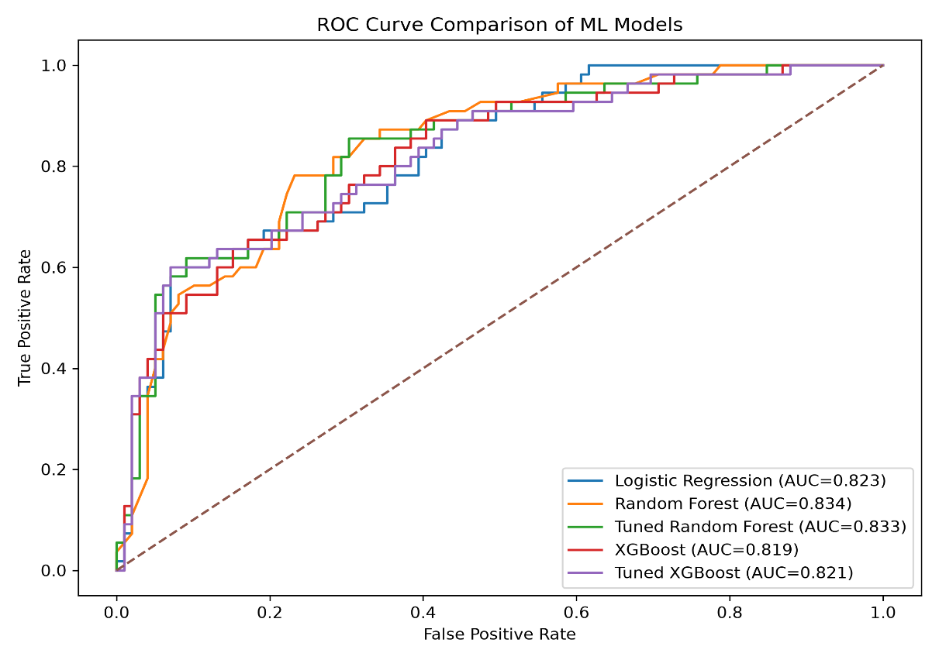
Figure 1. Receiver operating characteristic (ROC) curve comparison of different machine learning models for diabetes prediction.

3.4 Confusion Matrix Analysis
Confusion matrices were analyzed to further evaluate the classification behavior of the developed machine learning models. This analysis provides detailed information regarding correctly classified cases, false predictions, and the ability of each model to identify diabetic patients.
The Logistic Regression model correctly classified 82 non-diabetic cases and 34 diabetic cases, while 21 diabetic cases were incorrectly classified as non-diabetic. The Random Forest model correctly identified 37 diabetic cases with only 18 false negatives, demonstrating improved sensitivity for detecting diabetic patients compared with Logistic Regression.
The optimized Random Forest model achieved the highest number of correctly classified non-diabetic cases (True Negative = 84) and the lowest false-positive predictions (False Positive = 15). However, its false-negative rate remained higher compared with the standard Random Forest model, indicating a trade-off between specificity and sensitivity.
The XGBoost model correctly classified 36 diabetic cases, whereas the optimized XGBoost model identified 37 diabetic cases with 18 false negatives. These results indicate that Random Forest and optimized XGBoost models showed better capability for diabetes case detection.
Considering medical screening applications, minimizing false-negative predictions is important because missed diabetic cases may delay treatment and increase health risks. Therefore, models with higher recall values, particularly Random Forest and optimized XGBoost, demonstrated advantages for identifying individuals at higher risk of diabetes.
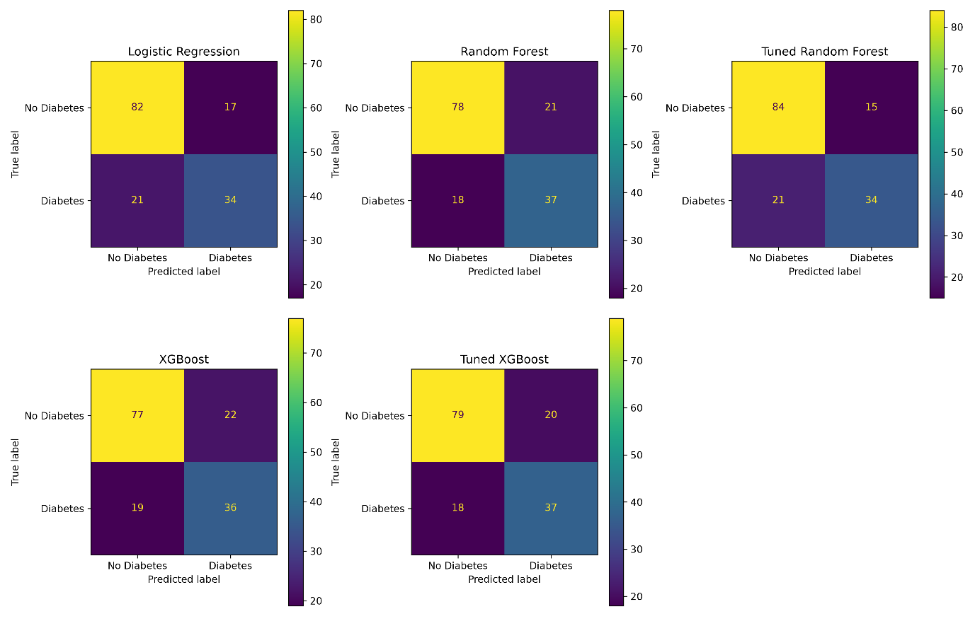
Figure 2. Confusion matrix comparison of different machine learning models for diabetes prediction.
3.5 Explainable AI-Based Feature Interpretation
To improve the interpretability of the machine learning model, SHAP (SHapley Additive exPlanations) analysis was performed to identify the contribution of individual clinical features toward diabetes prediction. The SHAP approach provides both global and local explanations by quantifying how each feature influences the model output.
The SHAP feature importance analysis revealed that Glucose was the most influential predictor contributing to diabetes classification, followed by Body Mass Index (BMI) and Age. These findings indicate that glucose concentration, obesity-related factors, and demographic characteristics played major roles in the model's decision-making process.
The SHAP summary plot demonstrated that higher glucose values generally contributed positively to diabetes prediction, increasing the probability of a positive classification. Similarly, higher BMI values showed a positive contribution toward diabetes risk estimation, suggesting the importance of obesity-related factors in model predictions. Age also showed a notable influence, with higher age values contributing to increased diabetes risk prediction.
The consistency between SHAP-based interpretation and conventional feature importance analysis from the Random Forest model supports the consistency of the identified important predictors. The explainability analysis enhances model transparency and provides clinically meaningful insights into the factors influencing diabetes prediction.
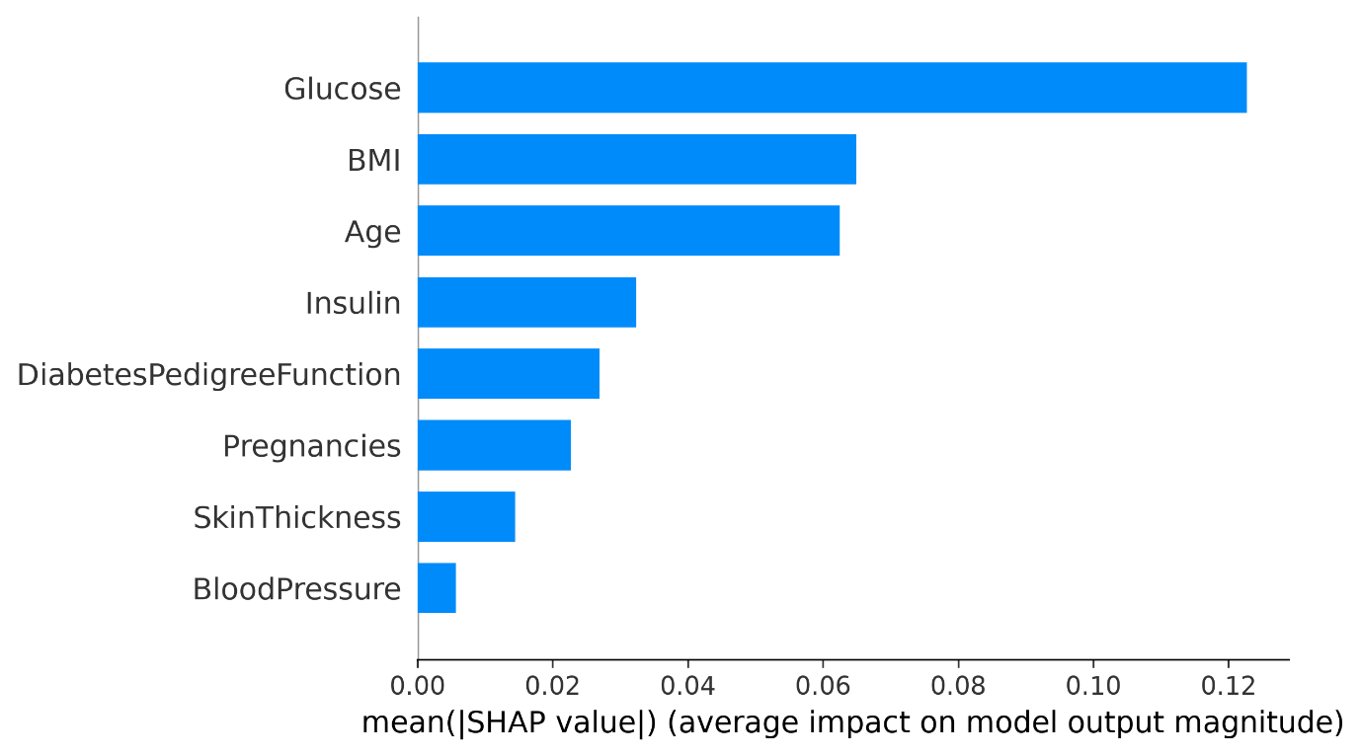
Figure 3. SHAP-based feature importance analysis showing the contribution of clinical variables to diabetes prediction.

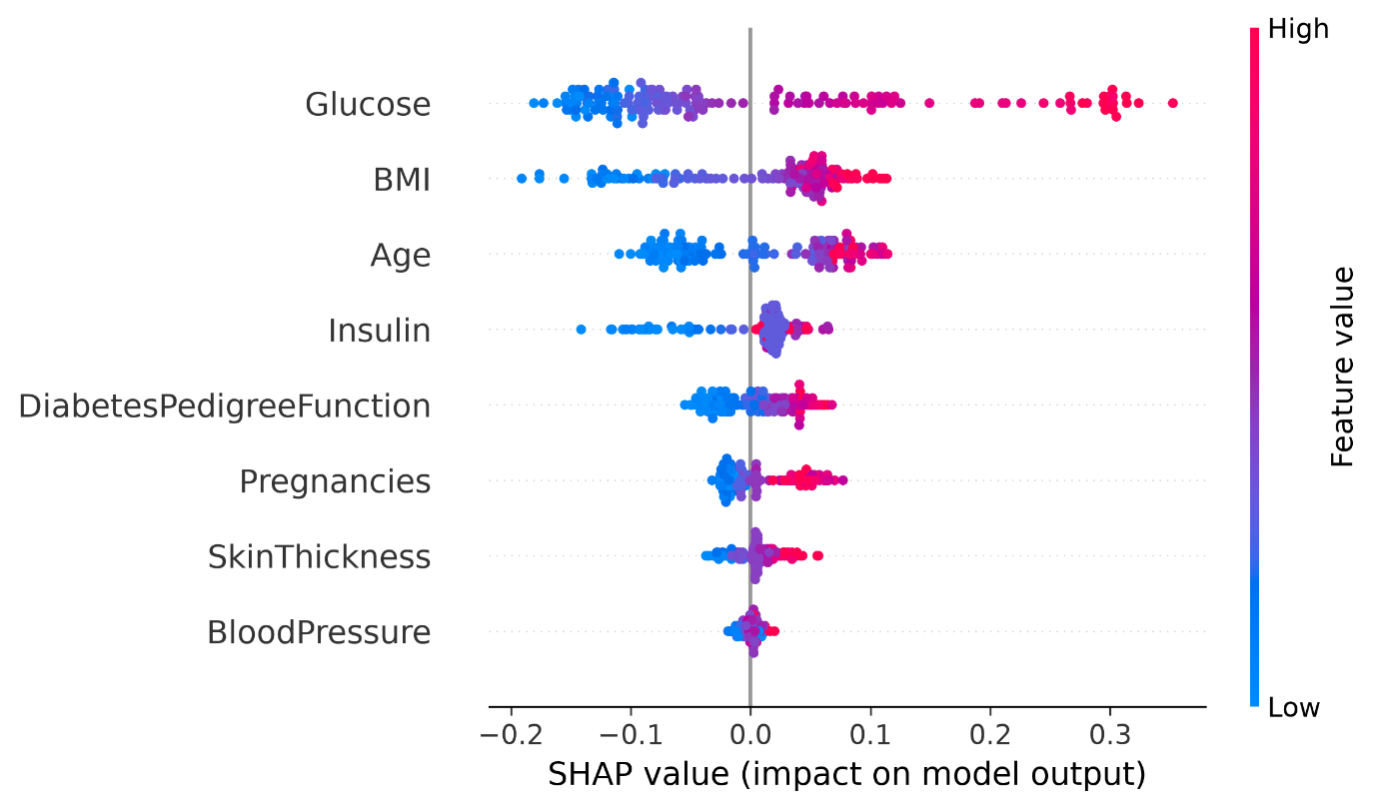
Figure 4. SHAP summary plot illustrating the direction and magnitude of feature contributions.

4. Discussion

4.1 Machine Learning Model Performance
The present study demonstrated that different machine learning algorithms showed varying predictive capabilities for diabetes classification. Among the evaluated models, the optimized Random Forest model achieved the highest test accuracy (76.62%), indicating its ability to effectively capture complex interactions among clinical variables. The improvement after hyperparameter optimization suggests that controlling model complexity can enhance generalization performance by reducing unnecessary model variance.
The superior performance of Random Forest-based approaches may be attributed to their ensemble learning mechanism, where multiple decision trees are combined to improve prediction stability and handle nonlinear relationships among predictors (Breiman, 2001). Similar observations have been reported in previous healthcare machine learning studies where tree-based ensemble methods demonstrated strong performance in disease prediction tasks.
Although optimized Random Forest achieved the highest accuracy, standard Random Forest showed slightly higher recall for diabetic cases. In medical screening applications, recall is particularly important because false-negative predictions may result in undetected diabetes cases. Therefore, selecting the most appropriate model depends on the intended clinical objective. For screening purposes, models with higher sensitivity may be preferred, whereas for general classification tasks, accuracy and AUC performance may receive greater emphasis.
The XGBoost-based models showed competitive performance but did not significantly outperform Random Forest models in this study. This may be related to the relatively small sample size and limited number of clinical variables in the Pima Indians Diabetes dataset. Gradient boosting algorithms generally achieve strong performance with large and complex datasets; however, their advantage may become limited when the available data contain fewer observations and predictors (Chen & Guestrin, 2016).

4.2 Importance of Clinical Features in Diabetes Prediction
The explainable artificial intelligence analysis identified glucose level as the most influential predictor of diabetes classification, followed by BMI and age. These findings are consistent with established diabetes risk factors, as elevated blood glucose is a primary indicator of impaired glucose metabolism and diabetes progression (American Diabetes Association, 2024).
BMI showed a substantial contribution to model predictions, supporting the well-established association between obesity and increased risk of type 2 diabetes. Excess body weight can contribute to insulin resistance and metabolic dysfunction, which are important mechanisms underlying diabetes development.
Age was also identified as an important predictor. Increasing age is associated with physiological changes that may reduce insulin sensitivity and increase susceptibility to metabolic disorders. The agreement between SHAP-based interpretation and Random Forest feature importance indicates that the identified predictors consistently influenced model decisions.

4.3 Clinical Implications and Future Applications
A major limitation of conventional machine learning models is the difficulty in interpreting their decision-making processes. This limitation becomes particularly important in healthcare applications where transparency and trust are essential.
In this study, SHAP analysis provided insight into how individual clinical variables influenced diabetes prediction. Unlike traditional feature importance methods, SHAP values explain both the magnitude and direction of feature contributions, improving understanding of model behavior (Lundberg & Lee, 2017; Lundberg et al., 2020).
The integration of predictive modeling with explainable AI strengthens the practical relevance of machine learning-based healthcare systems by providing interpretable predictions rather than only numerical outputs.

Although previous studies have demonstrated the effectiveness of machine learning approaches for diabetes prediction, many investigations primarily focus on predictive performance without sufficient interpretation of model decisions. Therefore, this study integrates comparative machine learning evaluation with explainable artificial intelligence analysis to provide both predictive performance assessment and transparent insights into important clinical predictors.

4.4 Limitations and Future Perspectives
Despite promising results, this study has several limitations. First, the analysis was performed using the Pima Indians Diabetes dataset, which contains a limited number of samples and may not fully represent diverse populations. Second, only eight clinical variables were considered, while additional factors such as lifestyle information, dietary patterns, and biochemical markers may further improve prediction performance.
Future studies should validate the developed models using larger multicenter datasets and investigate advanced explainable machine learning frameworks. External validation and real-world clinical implementation studies will be necessary before practical deployment.

5. Conclusion
This study developed and compared multiple machine learning models for diabetes prediction using clinical features. Five classification algorithms, including Logistic Regression, Random Forest, optimized Random Forest, XGBoost, and optimized XGBoost, were evaluated using various performance metrics.
The results demonstrated that the optimized Random Forest model achieved the highest overall accuracy (76.62%), while Random Forest and optimized XGBoost showed better sensitivity for identifying diabetic cases. The findings highlight that model selection depends not only on overall accuracy but also on the specific clinical objective, particularly the importance of minimizing false-negative predictions in disease screening applications.
Furthermore, SHAP-based explainable artificial intelligence analysis identified glucose level, body mass index (BMI), and age as the most influential predictors contributing to diabetes classification. The integration of predictive modeling with explainability improves model transparency and provides clinically meaningful insights into decision-making processes.
Overall, this study demonstrates the potential of machine learning and explainable AI approaches for supporting early diabetes risk prediction. Future research should focus on larger and more diverse clinical datasets, external validation, and integration of additional medical variables to improve model robustness and practical applicability.

• Explainable machine learning improved transparency and interpretation of diabetes prediction models.
• SHAP-based explainable AI analysis identified glucose, BMI, and age as the most influential predictors.
• Optimized Random Forest achieved the highest test accuracy of 76.62% among evaluated models.
• Evaluated Logistic Regression, Random Forest, optimized Random Forest, XGBoost, and optimized XGBoost models.
• Developed and compared five machine learning models for diabetes prediction using clinical features.
Highlights

References
American Diabetes Association. (2024). Standards of care in diabetes—2024. Diabetes Care, 47(Supplement 1), S1–S321. https://doi.org/10.2337/dc24-SINT
Breiman, L. (2001). Random forests. Machine Learning, 45, 5–32. https://doi.org/10.1023/A:1010933404324
Chen, T., & Guestrin, C. (2016). XGBoost: A scalable tree boosting system. In Proceedings of the 22nd ACM SIGKDD International Conference on Knowledge Discovery and Data Mining (pp. 785–794). Association for Computing Machinery. https://doi.org/10.1145/2939672.2939785
Cortes, C., & Vapnik, V. (1995). Support-vector networks. Machine Learning, 20, 273–297. https://doi.org/10.1007/BF00994018
Friedman, J. H. (2001). Greedy function approximation: A gradient boosting machine. The Annals of Statistics, 29(5), 1189–1232. https://doi.org/10.1214/aos/1013203451
Lundberg, S. M., & Lee, S. I. (2017). A unified approach to interpreting model predictions. In Advances in Neural Information Processing Systems (Vol. 30).
Lundberg, S. M., Erion, G. G., Chen, H., DeGrave, A., Prutkin, J. M., Nair, B., Katz, R., Himmelfarb, J., Bansal, N., & Lee, S. I. (2020). From local explanations to global understanding with explainable AI for trees. Nature Machine Intelligence, 2, 252–260. https://doi.org/10.1038/s42256-019-0138-9
Smith, J. W., Everhart, J. E., Dickson, W. C., Knowler, W. C., & Johannes, R. S. (1988). Using the ADAP learning algorithm to forecast the onset of diabetes mellitus. In Proceedings of the Symposium on Computer Applications and Medical Care (pp. 261–265).
American Diabetes Association. (2024). Standards of care in diabetes—2024. Diabetes Care, 47(Supplement 1), S1–S321.
https://doi.org/10.2337/dc24-SINT
International Diabetes Federation. (2021). IDF Diabetes Atlas (10th ed.). International Diabetes Federation.
Saeedi, P., Petersohn, I., Salpea, P., Malanda, B., Karuranga, S., Unwin, N., Colagiuri, S., Guariguata, L., Motala, A. A., Ogurtsova, K., Shaw, J. E., Bright, D., & Williams, R. (2019). Global and regional diabetes prevalence estimates for 2019 and projections for 2030 and 2045. Diabetes Research and Clinical Practice, 157, 107843.
https://doi.org/10.1016/j.diabres.2019.107843
Breiman, L. (2001). Random forests. Machine Learning, 45, 5–32.
https://doi.org/10.1023/A:1010933404324
Friedman, J. H. (2001). Greedy function approximation: A gradient boosting machine. The Annals of Statistics, 29(5), 1189–1232.
https://doi.org/10.1214/aos/1013203451
Chen, T., & Guestrin, C. (2016). XGBoost: A scalable tree boosting system. In Proceedings of the 22nd ACM SIGKDD International Conference on Knowledge Discovery and Data Mining (pp. 785–794). ACM.
https://doi.org/10.1145/2939672.2939785
Hosmer, D. W., Lemeshow, S., & Sturdivant, R. X. (2013). Applied logistic regression (3rd ed.). Wiley.
Lundberg, S. M., & Lee, S. I. (2017). A unified approach to interpreting model predictions. In Advances in Neural Information Processing Systems, 30.
Lundberg, S. M., Erion, G. G., Chen, H., DeGrave, A., Prutkin, J. M., Nair, B., Katz, R., Himmelfarb, J., Bansal, N., & Lee, S. I. (2020). From local explanations to global understanding with explainable AI for trees. Nature Machine Intelligence, 2, 252–260.
https://doi.org/10.1038/s42256-019-0138-9
Molnar, C. (2022). Interpretable machine learning: A guide for making black box models explainable.
Sisodia, D., & Sisodia, D. S. (2018). Prediction of diabetes using classification algorithms. Procedia Computer Science, 132, 1578–1585.
https://doi.org/10.1016/j.procs.2018.05.122
Kavakiotis, I., Tsave, O., Salifoglou, A., Maglaveras, N., Vlahavas, I., & Chouvarda, I. (2017). Machine learning and data mining methods in diabetes research. Computational and Structural Biotechnology Journal, 15, 104–116.
https://doi.org/10.1016/j.csbj.2016.12.005
Zou, Q., Qu, K., Luo, Y., Yin, D., Ju, Y., & Tang, H. (2018). Predicting diabetes mellitus with machine learning techniques. Frontiers in Genetics, 9, 515.
https://doi.org/10.3389/fgene.2018.00515
Smith, J. W., Everhart, J. E., Dickson, W. C., Knowler, W. C., & Johannes, R. S. (1988). Using the ADAP learning algorithm to forecast the onset of diabetes mellitus. In Proceedings of the Symposium on Computer Applications and Medical Care (pp. 261–265).
Rajkomar, A., Dean, J., & Kohane, I. (2019). Machine learning in medicine. New England Journal of Medicine, 380, 1347–1358.
https://doi.org/10.1056/NEJMra1814259
Esteva, A., Robicquet, A., Ramsundar, B., et al. (2019). A guide to deep learning in healthcare. Nature Medicine, 25, 24–29.
https://doi.org/10.1038/s41591-018-0316-z

