-- 5）查询“2020-01-22”途经“武汉”的所有列车；

SELECT \*

FROM TRAIN

WHERE TID IN(

SELECT TID

FROM TRAINPASS,STATION

WHERE STIME LIKE '2020-01-22%'

AND TRAINPASS.SID=STATION.SID

AND STATION.CityName='武汉'

);

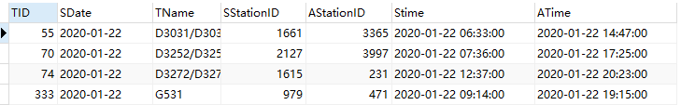

-- 9）查询2020年1月乘车途径武汉的外地人员（身份证非“420”开头）；

-- 考虑乘车区间问题

SELECT DISTINCT

passenger.\*

FROM

trainpass t,

taketrainrecord,

passenger

WHERE

t.SID IN ( SELECT SID FROM station WHERE CITYNAME = '武汉' )

AND t.TID = TakeTrainRecord.TID

AND t.SNo <= ( SELECT SNO FROM trainpass WHERE taketrainrecord.ASTATIONID = trainpass.SID AND taketrainrecord.TID = trainpass.TID )

AND t.SNo >= ( SELECT SNO FROM trainpass WHERE taketrainrecord.SSTATIONID = trainpass.SID AND taketrainrecord.TID = trainpass.TID )

AND TakeTrainRecord.SSTATUS = 1

AND t.STime LIKE '2020-01%'

AND passenger.PCardID = taketrainrecord.PCardID

AND NOT passenger.PCardID LIKE '420%';

