# TripSheet by Frode Ulriksen

Contents

TripSheet by Frode Ulriksen 1

Introduction 2

Startup UI 3

Edit Pipe and Casing Data UI 3

TripSheet UI 4

## Introduction

TripSheet was made to remove all the different types of excel sheets, and to reduce amount of excel sheets running.

Please locate the program in “D:\TripSheet” folder, with all files from the Zip file located here.

## Startup UI

UI Explained:

1. 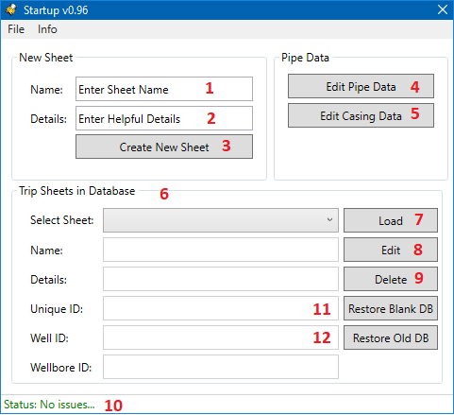Enter sheet name, pick something that is recognizable.
2. Optional, enter some more info in details.
3. Creates a new empty sheet, requirement is to have at least 1 entry in “Pipe data”.
4. Add or delete pipe details, more info here.
5. Add or delete casing details, more info here.
6. Existing trip sheets in database.
7. Load selected trip sheet.
8. Edit selected trip sheet, you can edit name and/or details.
9. Delete selected sheet, it will remove it from DB.
10. The CDA connection status, if Message Server is not running, most features will be disabled.
11. Restore blank DB, will copy the Pipe and Casing details over to a new blank DB. It will also do a backup of current DB, which can be restored. Located in TripSheet\Database folder.
12. Restore Old DB; a popup will appear and you can select a historic TripSheet DB.

## Edit Pipe and Casing Data UI

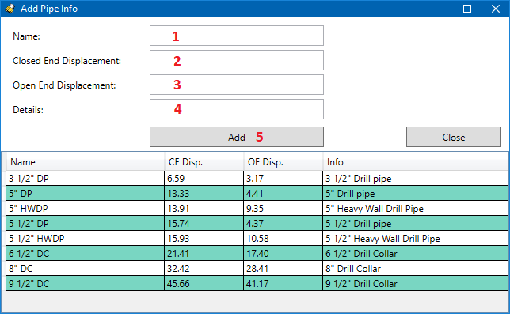

UI Explained:

1. Enter a name for pipe entry.
2. CE displacement in liter/meter.
3. OE displacement in liter/meter.
4. Add any details you think might be useful.
5. 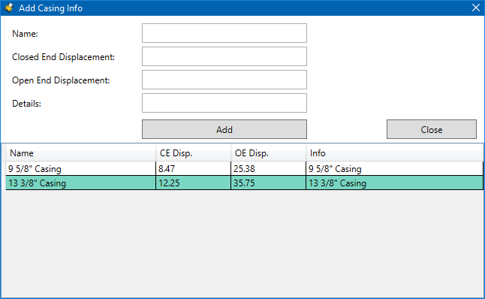Add it to table, can hit enter when at “Details” text box to add as well and return to “Name” text box.

To delete an entry or many, right click the table row or mark more than one, and right click and “Delete”. If the pipe or casing is in use in a TripSheet, it will be locked and you cannot delete it.

Add casing info works the same, split into Pipe and Casing for logistics purpose.

## TripSheet UI

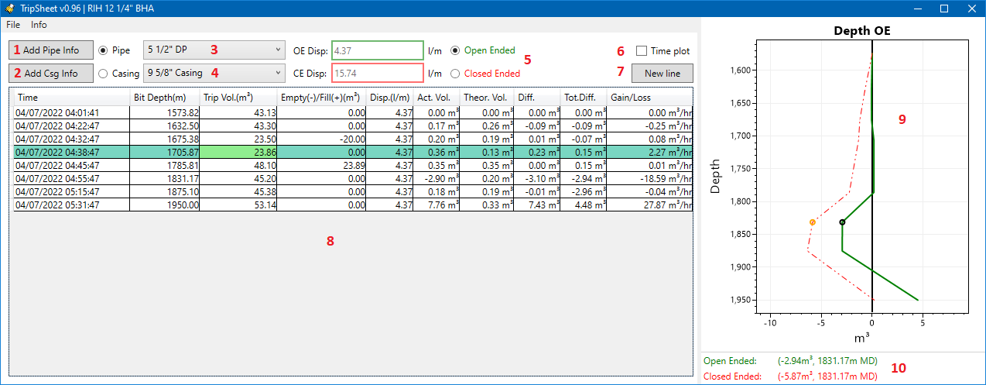UI Explained:

1. Same as in Startup add or delete pipe data.
2. Same as in Startup add or delete casing data.
3. Pipe selection for next line, this will be remembered for the sheet when you load it. The last entry in the table decides which one will be chosen.
4. Same as above, just for casing.
5. Chose open or closed ended displacement. The active one will always be green, both the displacement value boxes and plot curve colors.
6. Enable time based plot, default is depth based.
7. Add a new line to the TripSheet, it will grab depth and volume from CDA and current timestamp. Then calculate theoretical and actual volume change, total difference, gain/loss between stations.
8. You can edit Bit Depth, Trip Volume, Empty/Fill and Displacement, when finished editing cell, it will recalculate all values and update plot.
9. Plotted data, can zoom, move, open in separate window and save picture (Right click menu).
10. Mouse over details, will only work for 1 data point along main axis (depth or time).

## Insert

Right click inside TripSheet table and you get some choices, and one of them is to insert a row where you can decide the timestamp.

Clicking “Insert” will bring up the following UI:

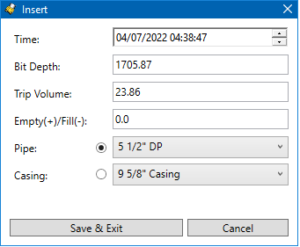

Here you can enter:

* Timestamp
* Bit Depth
* Trip Volume
* Empty/Fill
* Pipe or Casing used

Press “Save & Exit” to add it to the table, and all values will be recalculated to match the added row. Can insert line above your first row or below your last row as well.