Construction of engineered bacteria with surface-displayed deacetylase and chitosan hydrolase for whole-cell biocatalysis of shrimp chaff with in-situ recovery of proteins, minerals and production of chitooligosaccharides
ABSTRACT
The primary challenge in the biological refining of shrimp chaff is reducing the complexity of its components and the difficulty of pretreatment, while simultaneously achieving the separation of multiple products. The recombinant E. coli BL21-pET23b(+)-CDA strain, displaying a distinct chitin deacetylase, achieved a 48.2 % deacetylation efficiency on chitin. The engineered E. coli BL21-pET23b(+)-NICHI expressing chitosanase CHI-1 reached a hydrolysis efficiency of 40 %. The optimal strain combination for simultaneous deproteinization (DP) and demineralization (DM) was identified as B. subtilis and Acetobacter sp., achieving efficiencies of 78.3 % and 75.3 %, respectively. Correspondingly, the recovery efficiencies for protein and minerals reached 83.2 % and 91.4 %. Finally, a whole-cell biocatalytic system comprising the aforementioned four strains was successfully constructed. Following optimization via Response Surface Methodology, the system enabled direct chitooligosaccharide (COS) production from shrimp chaff, reaching 4.9 g/L. Additionally, 2.35 g of crude protein and 1.93 g of calcium carbonate were recovered from 10 g of shrimp chaff. Employing a synthetic biology approach, this study develops an integrated whole-cell biocatalytic system using wild-type and engineered strains. It achieves directed COS production and in-situ recovery of protein and minerals, offering a consolidated and energy-efficient strategy for high-value crustacean waste valorization.

Keywords: Shrimp chaff, Whole-cell biocatalysis, Cell surface display, In-Situ Recovery, COS production

1.Introduction
Shrimp chaff is a processed by-product of dried and milled shrimp shells, originating primarily from industrial food processing. According to an FAO report, approximately 9 million metric tons of crustacean waste, such as shrimp and crab shells, are generated globally each year (Topić Popović et al., 2023). Conventional landfill or ocean discharge leads to environmental pollution and resource wastage from underutilized components (Ali et al., 2024). Numerous high-value by-products can be recovered from shrimp chaff, such as chitin, calcium carbonate, and proteins. Shrimp chaff protein can be directly used in high-end feed and further processed into seasonings, nutritional peptides, and food additives. (Wang et al., 2022). The minerals can serve as eco-friendly calcium supplements and food fortifiers (Deng et al., 2020). High-efficiency DP and DM are critical prerequisites for obtaining high-purity chitin. Chitin and its derivatives have been widely utilized in diverse fields including functional foods, biomedicine, modern agriculture, and environmental remediation, leading to significant value addition. Chitin in shrimp chaff is a biocompatible polymer embedded within protein and minerals (Amiri et al., 2022). Owing to its highly crystalline structure and dense hydrogen-bonding network, chitin is insoluble in acids and water, posing challenges to its degradation and high-value utilization (Khan et al., 2024).
COS is the major degradation product of chitin via hydrolysis involving deacetylation and depolymerization processes, with a typical degree of polymerization of 2–20 (Lv et al., 2019). Compared to chitin, COS exhibit superior solubility, enhanced tissue penetration, and a broader spectrum of bioactivities (e.g., antimicrobial, antioxidant, and antitumor properties), endowing them with extensive application potential in food, pharmaceutical, and biomaterial sectors (Barikani et al., 2014). The process of extracting and preparing COS from shrimp chaff waste involves DM, DP, deacetylation, and chitosan hydrolysis (Zhang et al., 2012). Deacetylation is a pivotal step, which involves the selective cleavage of the stable C–N bonds between acetyl groups and glucosamine units in chitin, while overcoming the steric hindrance imposed by its dense crystalline structure and hydrogen-bonding network. The degree of deacetylation serves not only as a key indicator of reaction efficiency but also as the fundamental structural determinant governing the antimicrobial, immunomodulatory, and antioxidant activities of COS (Cai et al., 2006). Conventional industrial COS production relies on harsh thermochemical methods with concentrated acids and alkalis, generating corrosive wastewater and inducing excessive, random depolymerization (Kaczmarek et al., 2019), thereby compromising the molecular weight distribution and functional uniformity of the final product. Although enzymatic and fermentation-based biological methods offer mild, environmentally benign alternatives, traditional biological processes are often constrained by low catalytic efficiency and inadequate product controllability (Kumar et al., 2021). To address these limitations, synthetic biology offers a transformative framework for the precise engineering of microbial cell factories.
Engineering microbial systems for shrimp chaff conversion faces a dual challenge: single strains are burdened by heavy metabolic loads, while multi-strain systems suffer from coordination and stability issues, limiting overall efficiency. Whole-cell catalysis integrated with synthetic biology creates a powerful platform for sustainable biomanufacturing (Gianolio et al., 2025). Its core involves constructing engineered microorganisms that simultaneously produce key enzymes and regulate functional complementarity, ensuring stable collaboration among strains for efficient decomposition and complete valorization of shrimp chaff waste (Ruangwicha et al., 2024). As an environmentally friendly and efficient method, successive fermentation has been applied for extracting chitin from shrimp chaff (Xie et al., 2021). Specifically, a two-step co-fermentation process utilizing protease and acid-producing bacteria is typically employed, where initial DP via proteases is followed by DM catalyzed by microbially produced organic acids (Sun & Mao, 2016). The innate crystallinity and stability of chitin originate from its C2 acetamido groups; conversely, the solubility and viscosity of chitosan are governed by the degree of deacetylation, directly correlating with the free amino group content (Yang et al., 2022). Compared to traditional chemical methods requiring concentrated alkali, biological deacetylation employing chitin deacetylase (CDA) offers distinct advantages, enabling the production of chitosan with higher molecular weights, superior uniformity, and controllable acetylation patterns (Blair et al., 2005). However, CDA faces limitations in practical applications, such as low catalytic efficiency, poor accessibility to insoluble substrates, susceptibility to inactivation, and difficulties in recovery and reuse (Ding et al., 2021). While heterologous expression of recombinant CDA in E. coli has yielded purified enzymes achieving a deacetylation degree DD of up to 63.05% (Yang et al., 2022), its industrial feasibility is heavily constrained by complex purification procedures, high costs, and poor operational stability. To address these bottlenecks, cell-surface display technology offers a versatile and effective solution: by anchoring enzymes directly onto the microbial cell envelope, this strategy enhances the physical proximity between the biocatalyst and insoluble substrates, accelerates reaction kinetics, improves the structural stability of the enzymes against pH and temperature fluctuations, and facilitates effortless biocatalyst recycling (Tozakidis et al., 2015). Previous studies have utilized this technology to construct engineered strains for chitosan hydrolysis, achieving efficiencies up to 41% through fermentation (Chen et al., 2022). Despite these advancements, contemporary research has predominantly focused on optimizing isolated catalytic steps. There remains a conspicuous lack of consolidated bioprocessing strategies capable of seamlessly integrating DP, DM, deacetylation, and depolymerization into a unified, whole-cell driven platform for the holistic valorization of crustacean waste.
This study aims to develop an integrated whole-cell biocatalytic system for the high-value utilization of shrimp chaff waste and the production of COS. By applying synthetic biology principles, this study functionally partitioned the refining process into two specialized modules: a "pre-treatment module" comprising B. subtilis and Acetobacter sp. for the synchronized recovery of proteins and minerals, an "engineering biocatalysis module" utilizing surface-displayed enzymes. Specifically, the recombinant E. coli BL21-pET23b(+)-CDA, displaying chitin deacetylase, and the engineered E. coli BL21-pET23b(+)-NICHI expressing chitosanase CHI-1 were integrated into this system. Ultimately, through systematic optimization of fermentation timing and medium composition, we established an integrated, seamless green conversion system. This system combines the DP/DM functional consortia with the two aforementioned engineered strains (Fig. S1). Using shrimp chaff directly in a single bioreactor, this whole-cell catalytic process efficiently produces COS, thereby circumventing the myriad complexities and secondary pollution associated with conventional multi-step fractionations. Ultimately, this study provides a highly efficient, energy-saving, and economically viable paradigm for the complete valorization of crustacean by-products, unlocking new pathways for the directed biosynthesis of high-value COS.

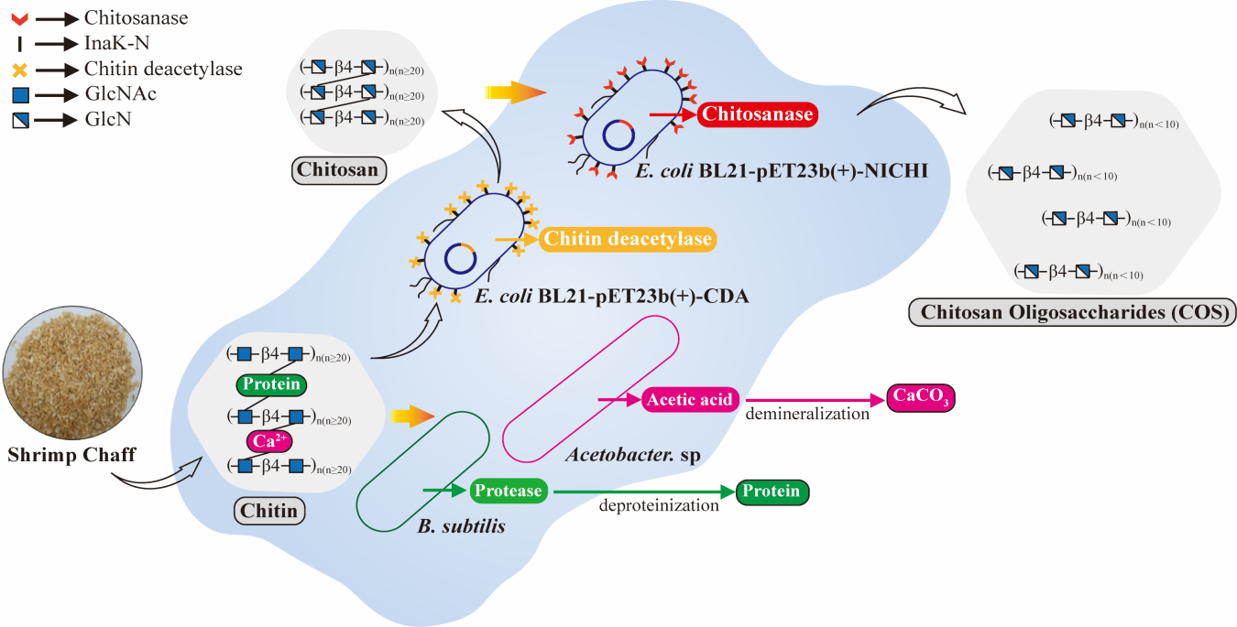
Graphic Abstract. Schematic of whole-cell biocatalysis of shrimp chaff for byproduct recovery and COS production

2. Materials and Methods
2.1 Material
Commercial chitin and chitosan were purchased from Sigma-Aldrich (China). Water-soluble chitosan (DD 95% and 70%) was purchased from Baichuan Biotechnology Co., Ltd. (Shaanxi, China). Shrimp chaff was purchased from Xiaoxu Feed Company (Qingdao, China) and stored under dried conditions until use. Folin-Ciocalteu reagent, 3,5-Dinitrosalicylic acid (DNS), and other reagents were purchased from Sinopharm Group (Beijing, China). BamHI, XhoI, Taq DNA polymerase, T4 DNA ligase, and the competent cell preparation kit were obtained from Takara Holdings Inc. COS standards with a degree of polymerization of 3–7 were purchased from Shanghai Yuanye Bio-Technology Co., Ltd.
2.2 Strains and culture conditions
B. subtilis (ATCC6633), Serratia marcescens (ATCC8100), and L. fermentum (ATCC8014) were maintained as laboratory stock cultures. Acetobacter sp. (BNCC336433) and Gluconacetobacter xylinus (ATCC23767) were provided by Beina Chuanglian Biotechnology Institute (Beijing, China). B. subtilis, L. fermentum, Acetobacter sp., and Gluconacetobacter xylinus were evaluated as potential fermentation strains for the DP and DM of shrimp chaff; Serratia marcescens was used as a protease activity control for the four engineered strains expressing chitin deacetylase. B. subtilis was cultivated in Luria-Bertani (LB) medium at 37 °C, 180 rpm. Acetobacter sp. was grown in GYC medium at 30 °C, 180 rpm. Gluconacetobacter xylinus was cultured statically in HS medium at 30 °C. L. fermentum was propagated in MRS medium at 30 °C, 180 rpm. These four strains were preserved in 50% glycerol at −80 °C for long-term storage and −20 °C for short-term use.
2.3 Determination of Shrimp Components
The shrimp chaff was cleaned and crushed into a powder with a particle size of 0.25–0.425 mm. The basic chemical composition of shrimp chaff powder was characterized by determining the contents of moisture, ash, chitin, and protein (Liu et al., 2020). Moisture content was determined by calculating the difference in weight before and after drying the powder in an oven at 105 °C for 24 h. Ash content was analyzed by heating in a muffle furnace at 600–605 °C for 6 h (Muley et al., 2018). Crude protein content was determined using the Kjeldahl method by measuring the total nitrogen content and applying a conversion factor of 6.25. Chitin content was determined by subtracting protein and ash from the dried shrimp chaff powder. DP and DM efficiencies were calculated according to previously reported methods (Iber et al., 2023).
$$\begin{aligned}\text{DP}\left(\text{\%}\right)\text{=}\frac{\left[\text{(}{\text{Y}}_{\text{0}}\text{×}{\text{M}}_{\text{0}}\text{)-(}{\text{Y}}_{\text{0}}\text{×}{\text{M}}_{\text{0}}\text{)}\right]}{\text{(}{\text{Y}}_{\text{0}}\text{×}{\text{M}}_{\text{0}}\text{)}}\#\left(1\right)\end{aligned}$$
$$\begin{aligned}\text{DM}\left(\text{\%}\right)\text{=}\frac{\left[\left({\text{P}}_{\text{0}}\text{×}{\text{M}}_{\text{0}}\right)\text{-}\left({\text{P}}_{\text{S}}\text{×}{\text{M}}_{\text{S}}\right)\right]}{\left({\text{P}}_{\text{0}}\text{×}{\text{M}}_{\text{0}}\right)}\#(2)\end{aligned}$$

Where M_{O} and M_{S} are the weight of raw and fermented samples (g), respectively. Y_{O} and Y_{S} are the protein content in raw and fermented samples (%), respectively. P_{O} and P_{S} are the ash content in raw and fermented samples (%), respectively.
2.4 Protease activity assay
Protease activity was determined by the Folin-Ciocalteu method through the enzymatic hydrolysis of casein under controlled conditions, which yields phenolic amino acids such as tyrosine. These hydrolysis products subsequently reduce the Folin-Ciocalteu reagent in alkaline solution, generating a stable blue chromophore composed of molybdenum and tungsten blues. The intensity of this blue color, measured spectrophotometrically, is directly proportional to the concentration of the products, thereby allowing for the quantitative assessment of enzymatic activity (Coelmont et al., 2023). Briefly, the reaction mixture containing enzyme solution and casein substrate (1 %, w/v) in appropriate buffer was incubated at 37 °C for 10 min. The reaction was terminated by adding trichloroacetic acid (5 %, w/v). After centrifugation, the supernatant was mixed with Na₂CO₃ (0.5M) and Folin-Ciocalteu reagent (1:1 dilution), followed by incubation at 30 °C for 30 min. The absorbance was measured at 680 nm. One enzyme activity unit was defined as the amount of enzyme that produced 1 μg of tyrosine per minute under specified conditions (Chatterjee et al., 2015).
2.5 FTIR and SEM analysis
The degree of deacetylation of chitin in this study was determined by Fourier transform infrared spectroscopy (FTIR) using the KBr pellet method (Ilankovan et al., 2006). The specific procedure involved accurately weighing the thoroughly dried sample and spectral grade potassium bromide at an approximate mass ratio of 1:100 (w/w). The mixture was then ground homogenously in an agate mortar and pressed into a uniform thin pellet suitable for transmission measurement under a pressure of approximately 10 MPa. Infrared spectra were acquired in the range of 4000–400 cm⁻¹, and the degree of deacetylation was calculated based on the characteristic absorbance ratio method (Hajji et al., 2014). Characteristic bands of chitosan – such as O–H/N–H stretching (∼3200–3400 cm⁻¹), amide I (∼1655 cm⁻¹), amide II (∼1560 cm⁻¹), and C–O stretching (∼1070 cm⁻¹) – were analyzed to confirm the chemical structure. According to the formula (Ben Seghir & Benhamza, 2017), the degree of deacetylation is calculated using the absorption bands at 1655 and 3450 cm^{–1}, as follows:
$$\text{DD=}\left(\text{1}−\frac{{{\text{A}}_{\text{1655}}}/{{\text{A}}_{\text{3450}}}}{\text{1.33}}\right)\text{×100}$$
SEM was utilized to examine the structural alterations in shrimp chaff during fermentation, to characterize the morphology of recovered minerals and crude protein, and to assess the coexistence within the whole-cell biocatalytic system. For morphological observation using SEM, bacterial cells harvested from the fermentation culture were suspended in phosphate buffer and centrifuged three times, followed by fixation with 2.5% (v/v) glutaraldehyde for 12 h. After centrifugation and washing with phosphate buffer, the cells were dehydrated through a graded ethanol series (30%, 50%, 70%, 90%, and 100% (v/v), 15 min each), followed by supercritical drying and gold sputtering prior to SEM observation (Valdez Castillo et al., 2022).
2.6 Construction of E. coli BL21-pET23b(+)-CDA
Four distinct chitin deacetylase genes previously documented in literature were selected for developing engineered strains using cell surface display technology. These genes were individually fused with the N-terminal core domain of ice nucleation protein to create chimeric expression units (Tan et al., 2019). The resulting four target gene constructs were synthesized by GenScript Biotech Co., Ltd. (Nanjing, China) and inserted into the cloning vector pUC57. The recombinant pUC57 plasmids and the empty expression vector pET-23b(+) were subjected to double digestion with BamHI and XhoI at 37 °C overnight. The digested products were separated by agarose gel electrophoresis, and the linearized vector backbone and target gene fragments were excised and purified. The purified vector and gene fragments were mixed at a molar ratio of 1:3, ligated using T4 DNA ligase at 16 °C overnight, and then transformed into E. coli DH5α competent cells for amplification (Liu et al., 2019). After plasmid extraction and preliminary identification, the constructs were finally transformed into E. coli BL21(DE3) expression competent cells. The transformed cells were spread onto LB agar plates containing ampicillin for selection. The correct recombinant engineering strains E. coli BL21- pET23b (+)-CDA1, CDA2, CDA3, and CDA4 were further confirmed by colony PCR and DNA sequencing. Primers employed in this study are listed in Fig. S2.
2.7 RSM for optimizing COS conversion
RSM is a collection of experimental techniques designed to elucidate interactions between dependent and independent variables (Kaur & Rahi, 2024). The Box-Behnken design (BBD) using Design-Expert software followed by a response surface model was employed to optimize key parameters affecting the reducing sugar yield. RSM enables robust experimental design and data collection (Jiang et al., 2019), fitting the functional relationship between factors and response values using a multivariate quadratic regression equation. The analysis assessed three factors: Carbon source (A), Nitrogen source (B) and Inoculum volume (C), each at tow levels (low, high) . Utilizing Box-Behnken Design, which minimizes the number of experiments required, experiment design can be completed with fewer runs. A total of 17 experimental runs were carried out and the outcomes recorded. Analysis of variance (ANOVA) was performed to evaluate model significance and identify which factors or interactions were statistically significant (Hai et al., 2024). Response surface plots (3D surfaces and 2D contour plots) were generated to visualize the effect of factor interactions on reducing sugar yield.
2.8 COS Product Analysis
The conversion of chitin in shrimp chaff into COS by the constructed whole-cell biocatalytic system was subjected to both quantitative and qualitative analysis. As a reducing sugar, COS was quantitatively analyzed using the 3,5-dinitrosalicylic acid (DNS) method.
Under alkaline heating conditions, the hemiacetal hydroxyl group of COS reduces 3,5-dinitrosalicylic acid in DNS reagent to brown-red 3-amino-5-nitrosalicylic acid (Kramer et al., 1962). The resulting colored product shows maximum absorbance at 540 nm, with its intensity being directly proportional to the reducing sugar concentration within a specific range, a standard curve was established to calculate the COS yield in the fermentation system. The COS obtained from enzymatic hydrolysis was analyzed using High Performance Liquid Chromatography (HPLC) coupled with Liquid Chromatography-Mass Spectrometry (LC-MS). For HPLC analysis, 20 μL of the filtered fermentation mixture was injected into the liquid chromatography system. The mobile phase consisted of 70% acetonitrile and 30 % ultrapure water (v/v), delivered under isocratic elution at a flow rate of 1.0 mL/min, with the column temperature maintained at 30 °C, absorption was monitored at 210 nm. For LC-MS analysis, the injection volume was 2 μL with a flow rate of 1.0 mL/min. The mobile phase consisted of 70 % acetonitrile (containing 0.5 % acetic acid) and 30 % ultrapure water. The absorption values in the m/z range from 300 to 1100 were monitored at 210 nm (Guo et al., 2019).
2.9 Statistical analysis
The data in each figure or table were derived from three parallel experiments, and expressed as the mean ± standard deviation (SD). The difference was evaluated by analysis of variance (ANOVA) based on Duncan’s multiple range test via the software of SPSS version 26.0. P values of <0.05 were considered statistically significant.
- Results and discussion
3.1 Construction and evaluation of chitin deacetylase recombinants
In this study, four distinct CDA genes were selected based on literature reports (Fig. S3): Gene1 (MW295944.1) from Acinetobacter schindleri, Gene2 (LT630322.1) from Arthrobacter sp., Gene3 (EU263917.1) from Colletotrichum lindemuthianum, and Gene4 (JF737986.1) from Mucor rouxii. Analysis of the amino acid sequences of these four deacetylases revealed low overall similarity (Fig. 1A). Common chitin deacetylases (CDA, EC 3.5.1.41) are predominantly classified within the carbohydrate esterase family 4 (CE4) in the CAZY database (carbohydrate-active enzyme, www.cazy.org). All four enzymes belong to this family and share a conserved catalytic domain containing the deacetylation-active triad, which constitutes their common molecular basis for chitin deacetylase activity. The phylogenetic relationships among these CDAs were elucidated via a phylogenetic tree (Fig. 1B) (Ding et al., 2021; Kang et al., 2014; Liu et al., 2016). Using cell surface display technology, the target genes were fused to the N-terminal domain of the ice nucleation protein (INP-N) from Pseudomonas syringae and expressed in E. coli BL21, resulting in the successful construction of four engineered strains: E. coli BL21-pET23b(+)-CDA1, CDA2, CDA3, and CDA4 (Fig. 1C, Fig. S3). Serratia marcescens, known for its broad spectrum of chitinolytic enzymes, was employed as a positive control for general chitin degradation activity to benchmark the performance of the engineered strains (Ali et al., 2026). Among the candidates, E. coli BL21-pET23b(+)-CDA1 demonstrated superior extracellular CDA activity during fermentation (Fig. 1D). FTIR was employed to comparatively analyze the structural properties of commercial chitin, chitin extracted via co-fermentation, and chitosan produced by the engineered strain (Fig. 1E). Crucially, variations were observed in the characteristic amide bands, located at 1655 cm⁻¹ (Amide I), 1560 cm⁻¹ (Amide II), and 1314 cm⁻¹ (Amide III). Quantification of DD was performed using the ratio of absorbance intensities at 1655 cm⁻¹ (acetamide group) and 3450 cm⁻¹ (hydroxyl group), according to the linear relationship established in previous studies (Vicente et al., 2020). The FTIR analysis demonstrated that E. coli BL21-pET23b(+)-CDA1 achieved a deacetylation degree of 48.2 %.
The deacetylation of chitin by CDA is a pivotal step in chitosan production, enhancing the valorization efficiency of chitin biomass (Grifoll-Romero et al., 2018). The deacetylase MCDA01, encoded by Gene1, has been previously reported to exhibit exceptional catalytic efficiency towards highly crystalline chitin (Yang et al., 2022). Compared to the wild-type strain Serratia marcescens and the engineered strains E. coli BL21-pET23b(+)-CDA1-3, E. coli BL21-pET23b(+)-
CDA1 constructed based on Gene1 exhibited the highest enzyme activity and the most effective deacetylation performance. FTIR analysis confirmed that the degree of deacetylation significantly influences the type and density of inter- and intra-molecular hydrogen bond networks associated with amide groups, thereby inducing specific spectral shifts (Sun et al., 2024). Meanwhile, the retention of the glycosidic bond characteristic peak confirmed that the deacetylation process did not disrupt the conformational integrity of the β-(1,4)-glycosidic linkage in chitosan. In this study, deacetylating engineered strains were constructed using cell surface display technology, eliminating the need for enzyme purification and immobilization, thereby offering a more stable, cost-effective, and sustainable route for continuous chitosan production.
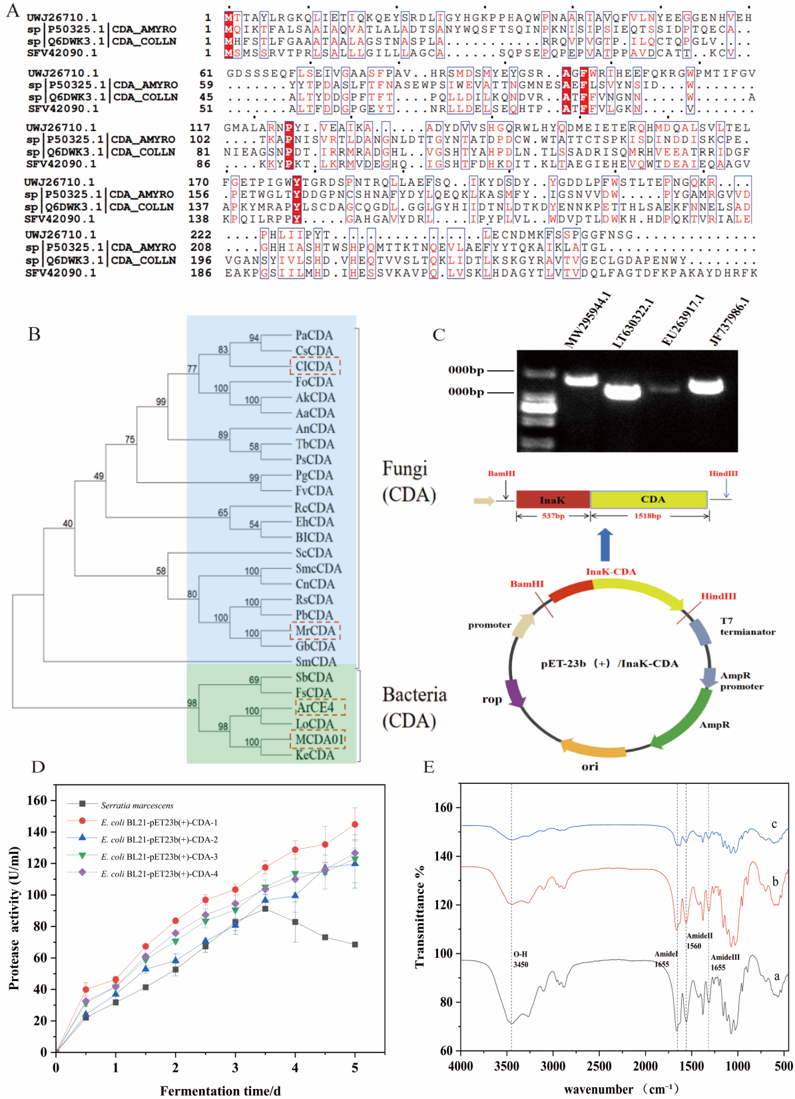

Fig. 1. Construction of deacetylating engineered bacteria E. coli BL21-pET23b(+)-CDA
- Multiple amino acid sequence alignment. (B) Phylogenetic analysis of CDAs. (C) Plasmid design using cell surface display. (D) Changes in protease activity. (E) a: commercial chitin; b: chitin prepared by the co-fermentation; c:chitosan prepared by whole-cell biocatalytic system.

3.2 Construction of chitosanase recombinant and its verification
In our previous work, the engineered strain E. coli BL21-pET23b(+)-NICHI, displaying the GH8 family chitosanase CHI-1 (derived from B. thuringiensis), was successfully constructed and preserved in the the laboratory (construction strategy shown in Fig. 2A) (Chen et al., 2022). However, upon revitalization from long-term storage, the strain exhibited a marked attenuation in catalytic performance. When inoculated into a medium containing 0.5 % chitosan, the hydrolysis efficiency plummeted to below 10 % by the fourth day (Fig. 2C), rendering it unsuitable for practical application. This functional deterioration was attributed to plasmid instability or segregational loss induced by prolonged preservation. To restore efficient hydrolytic capability, the engineered strain E. coli BL21-pET23b(+)-NICHI was re-constructed. The recombinant plasmid pET23b(+)-NICHI, carrying the fusion cassette of the INP-N anchor and the CHI-1 gene, was extracted from the preserved host and re-transformed into fresh E. coli BL21 (DE3) competent cells via the heat-shock method. Positive transformants were selected on ampicillin-containing LB plates and subsequently confirmed by colony PCR (Ling et al., 2018). Fermentation kinetics demonstrated that the re-constructed strain recovered its catalytic vigor. The chitosanase activity increased steadily during the initial cultivation phase, peaking at 143 U/mL on the fourth day (Fig. 2B). Consequently, the chitosan hydrolysis efficiency was significantly enhanced, reaching approximately 40% (Fig. 2D).
Microbial cell surface display technology serves as a robust platform for the immobilization of biocatalysts, facilitating the stable presentation of target proteins on the bacterial exterior via fusion with anchoring motifs (Zhang et al., 2025). Compared to the instability and low enzyme activity of chitosanase secreted by wild-type strains, E. coli BL21-pET23b(+)-NICHI constructed using this technology maintained continuously increasing enzyme activity during fermentation, indicating that CHI-1 achieved stable expression on the cell surface with good stability (Chen et al., 2022). In contrast to conventional thermochemical depolymerization, this engineered whole-cell biocatalytic platform offers significant advantages by driving efficient substrate conversion under mild, environmentally benign conditions, thereby establishing a sustainable paradigm for targeted COS biosynthesis.

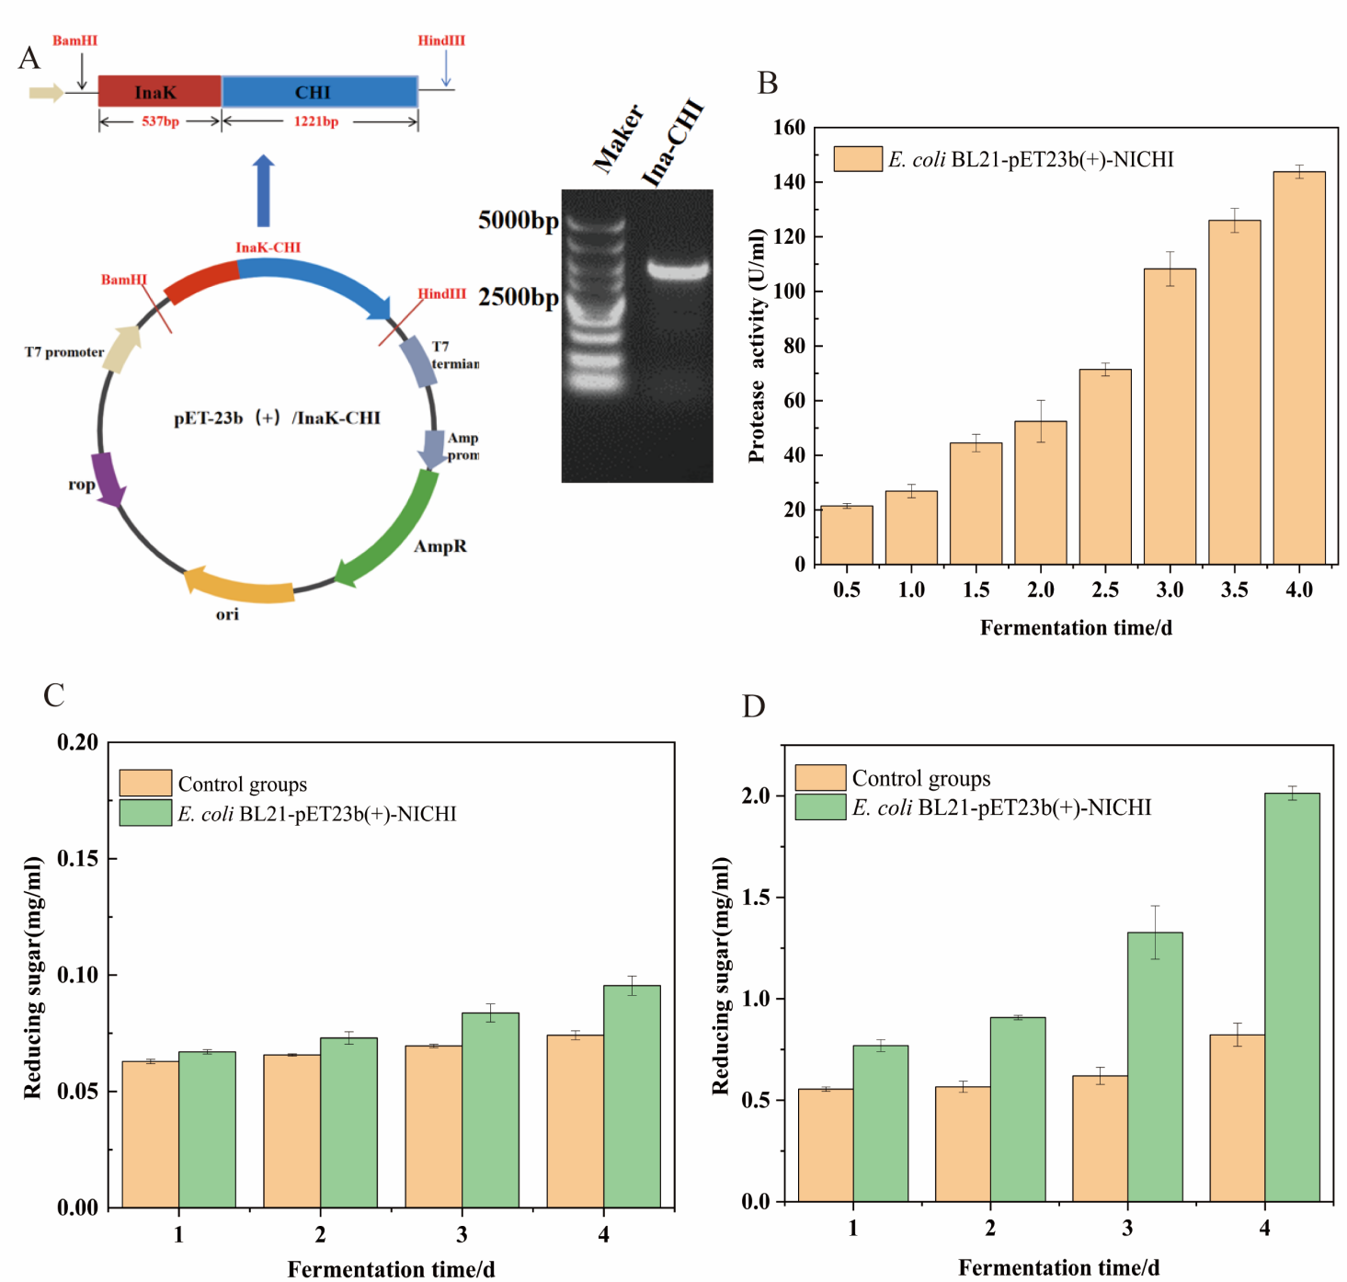

Fig. 2. Construction of hydrolytic engineered strain E. coli BL21-pET23b(+)-NICHI
- Plasmid design utilizing cell surface display technology and PCR validation by Ina-CHI. (B) Changes in protease activity. (C) Hydrolytic activity of the E. coli BL21-pET23b(+)-NICHI before construction. (D) Hydrolytic activity of the reconstructed E. coli BL21-pET23b(+)-NICHI.

3.3 Screening and validation of co-fermenting strains for DP and DM
The fundamental chemical composition of shrimp chaff was initially characterized. As shown in Table S1, the substrate contained 10% moisture, 23 % ash, 42 % protein, and 25 % chitin. Given this complex matrix, the primary determinants for obtaining high-purity chitin are the efficiencies of DP and DM (Dun et al., 2019). In this study, a co-fermentation process utilizing protease-producing and acidogenic strains was established for the simultaneous DP and DM of shrimp chaff. During screening , B. subtilis was selected as the DP strains. Its proteolytic activity was monitored over a 4-day fermentation period, exhibiting a continuous increase that peaked at 145 U/mL on day 4 (Fig. 3E). Subsequently, three acid-producing strains—Acetobacter xylinus, L. plantarum, and Acetobacter sp.—were evaluated as candidates for co-fermentation with B. subtilis to achieve DM. A sequential inoculation strategy was adopted, wherein the DP strain was introduced prior to the DM strain. Specifically, B. subtilis was cultivated as a mono-culture for 3 days, followed by the addition of each DM candidate for a 5-day extended co-fermentation. The co-fermentation of B. subtilis and Acetobacter sp. exhibited outstanding acidification capacity, with the culture medium pH significantly decreasing from an initial 5.7 to 4.2 (Fig. 3A). Correspondingly, this combination yielded the highest titratable acidity, reaching 25 g/L on the 5th day of co-fermentation (Fig. 3B). In terms of removal efficiency, significant variations were observed (Fig. 3C, Fig. 3D). The combination of L. plantarum and B. subtilis yielded DP and DM efficiencies of 70.1 % and 54.8 %, respectively, while Acetobacter xylinus with B. subtilis resulted in 60.4 % and 17.0 %. In contrast, Acetobacter sp. combined with B. subtilis outperformed the other consortia, achieving the highest efficiencies of 78.3 % for DP and 75.3 % for DM (Fig. 3C, Fig. 3D). Following biological treatment, the simultaneous recovery of valuable by-products was addressed. Calcium carbonate was precipitated by adding a saturated sodium carbonate solution to the calcium-rich filtrate obtained after DM, followed by vacuum filtration and drying. For crude protein recovery, freeze-drying was applied to the co-fermentation supernatant (Zhang et al., 2024). SEM analysis provided visual evidence of the structural transformation of shrimp chaff and the morphology of the recovered products. The native shrimp chaff surface appeared compact with no detectable crystalline microfiber morphology at 20,000× magnification (Fig. 3F1). Conversely, the treated substrate exhibited profound structural alterations, characterized by the effective disintegration of the original dense mineral-protein-chitin complex and the formation of a porous, honeycomb-like network (Fig. 3F2). The recovered calcium carbonate displayed distinct cubic and rhombohedral crystal structures with sharp edges (Fig. 3F3). Meanwhile, the crude protein product presented a fragmented, thin-walled architecture (Fig. 3F4).
Successive co-fermentation represents the optimal strategy for the biological extraction of chitin, as it integrates the DP and DM stages within a single bioreaction unit, thereby streamlining the process (Sixto-Berrocal et al., 2023). The steadily increasing enzyme activity indicates that B. subtilis effectively adapts to the fermentation environment and continuously secretes proteases, providing the essential enzymatic basis for efficient protein removal. The rationale for adopting the sequential inoculation strategy (DP strain followed by DM strain) lies in the fact that protease action effectively disrupts the native calcium-protein-chitin complex inherent in shrimp chaff, thereby exposing mineral sites for subsequent acid attack (Rao et al., 2000). SEM observations revealed that the co-fermented shrimp chaff exhibited a porous structure, confirming the effective removal of mineral and protein components (Xu et al., 2008). The recovered calcium carbonate displayed distinct cubic and rhombohedral crystal structures with well-defined edges, indicating high purity and crystallinity. Meanwhile, the crude protein product presented a fragmented, thin-walled morphology, a typical structure induced by lyophilization that facilitates the preservation of protein bioactivity (Lu et al., 2023). The results demonstrate that co-fermentation of shrimp chaff using Acetobacter sp. and B. subtilis enables efficient chitin extraction while achieving value-added recovery of minerals and proteins, thereby successfully realizing the integrated valorization of shrimp chaff.

Table S1. Composition of shrimp waste powder
Component |  | This study |  | Range content
Moisture |  | 10.1% |  | 8% - 15%
Ash |  | 28.3% |  | 30% - 45%
Protein |  | 36.5% |  | 25%-40%
Chitin |  | 25.1% |  | 15% - 30%

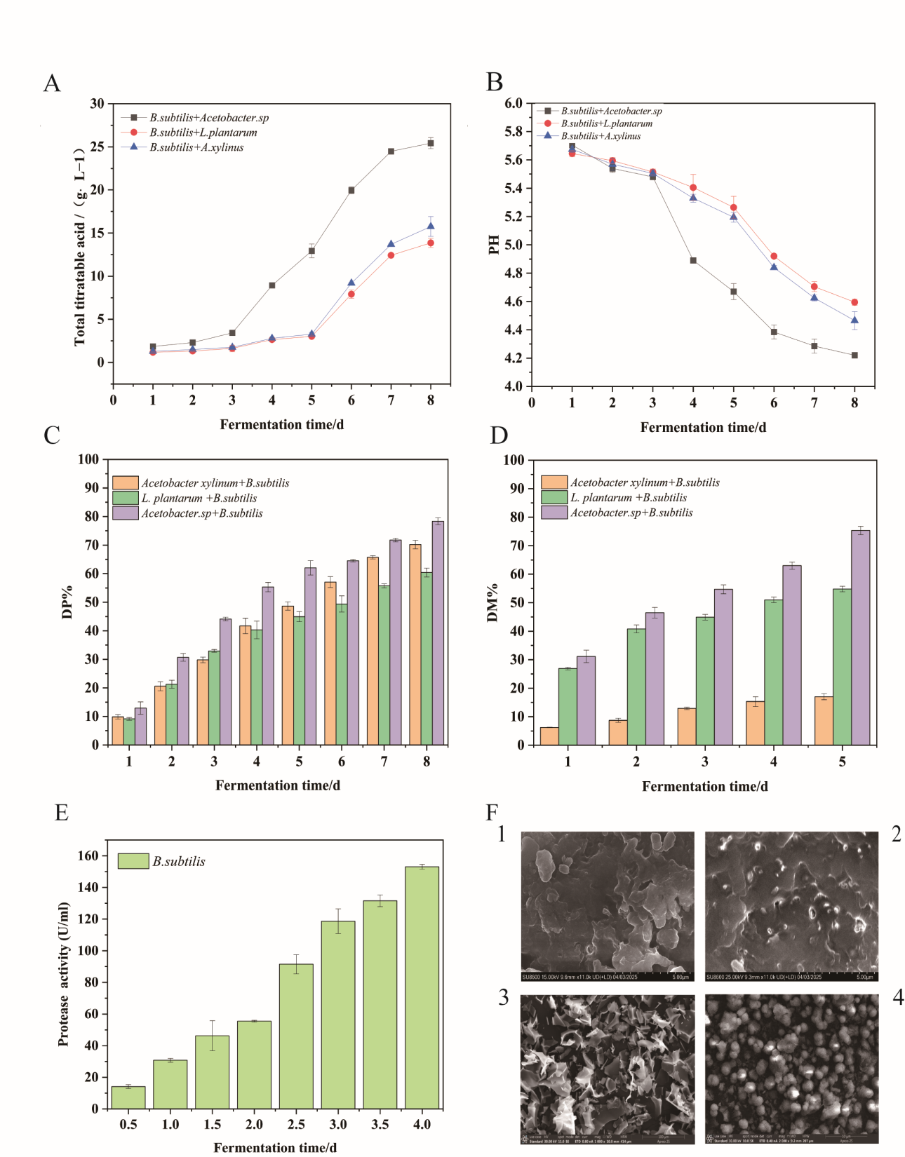
Fig. 3. Screening of microbial strains for co-fermentation to DP and DM
(A, B) Trends in pH and total titratable acid during the successive co-fermentation. (C, D) DP and DM efficiency in continuous co-fermentation process. (E) Protease assay for B. subtilis. (F) 1. Unfermented shrimp chaff ; 2. DP and DM fermented shrimp chaff; 3. SEM image of recovered CaCO₃ sample; 4. SEM image of recovered crude protein sample.

3.4 Verification of coexistence in multi-strain whole-cell biocatalytic systems
In this study, a whole-cell biocatalysis system comprising B. subtilis, Acetobacter sp., and the two engineered E. coli strains (displaying CDA and CHI-1, respectively) was established. The constructed multi-strain whole-cell biocatalytic system was analyzed using plate spreading and SEM. The results indicated that Acetobacter sp., B. subtilis, and the engineered E. coli strains all formed characteristic colonies on selective agar plates, confirming their viability in the whole-cell biocatalytic system. SEM analysis provided direct microscopic evidence of their spatial coexistence. As shown in Fig. 4A, diverse cellular morphologies—including short rods (B. subtilis), ellipsoidal cells (Acetobacter sp.), and typical rod-shaped cells (E. coli)—were discernible within the same field of view. All cells exhibited intact structures without obvious lysis or damage, indicating that the whole-cell biocatalytic system maintained good cellular viability and structural stability during fermentation (Rodríguez et al., 2022). Furthermore, quantitative population analysis revealed dynamic microbial succession patterns. The relative abundance of the constituent strains shifted distinctively across fermentation stages. During the initial phase, the population was dominated by B. subtilis and Acetobacter sp., aligning with their roles in driving DP and DM. Conversely, the proportion of engineered E. coli strains increased significantly in the later stages (Fig. 4B). This temporal succession confirms that the system successfully achieved an orchestrated balance, allowing B. subtilis and Acetobacter sp. to prepare the substrate before the engineered strains dominated to execute the final conversion.
The pivotal challenge in orchestrating this system lay in regulating microbial interactions to ensure system stability. This was addressed through optimized fermentation strategies, including temporal inoculation control and medium modulation, to foster synergistic relationships. During shrimp chaff fermentation, the four strains formed complementary functional relationships: B. subtilis initiated the process by secreting proteases to hydrolyze proteins, releasing peptides and amino acids that served as essential nitrogen sources for Acetobacter sp. and the engineered E. coli strains. Simultaneously, its oxygen consumption created a favorable microaerobic environment for Acetobacter sp., while protein removal exposed the embedded chitin, enhancing substrate accessibility for subsequent reactions. Subsequently, Acetobacter sp. produced organic acids (e.g., acetic acid) to solubilize calcium carbonate. This DM step not only synergized with proteolysis but also effectively exposed the recalcitrant chitin matrix (Xu et al., 2025), thereby significantly enhancing substrate accessibility for the downstream enzymatic reactions. While the engineered E. coli strains do not provide direct nutritional feedback to the upstream starters, their catalytic efficiency is intrinsically dependent on the high-purity chitin substrate liberated during the initial co-fermentation phase. E. coli BL21-pET23b(+)-CDA1 deacetylates this pretreated chitin to yield chitosan, which is subsequently hydrolyzed into the final COS product by the surface-displayed chitosanase on E. coli BL21-pET23b(+)-NICHI. Compared to monocultures, whole-cell biocatalysis based on multi-strain interactions demonstrates multiple advantages in biosynthesis, notably metabolic division of labor, efficient conversion of complex substrates, and enhanced engineering flexibility (Meng et al., 2025).

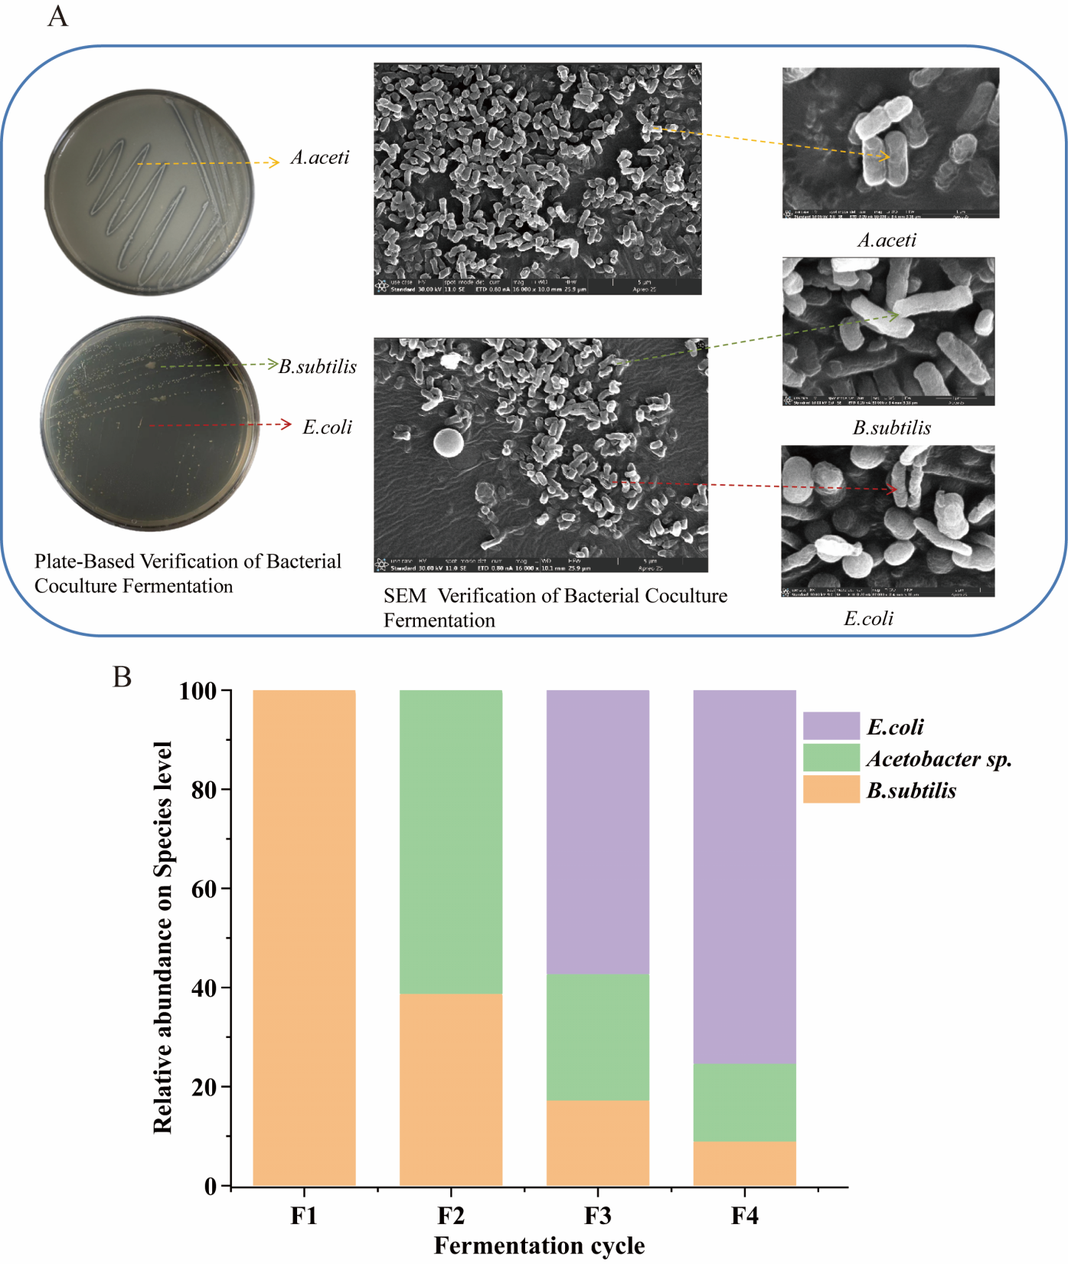
Fig. 4. Verification of strain coexistence in whole-cell biocatalytic systems
- Schematic of coexistence of late-stage strains in whole-cell biocatalysis systems.
- Strain abundance variation plot. (F1: DP via sole fermentation of shrimp chaff with B. subtilis; F2: DM and DP via co-fermentation with Acetobacter sp. and B. subtilis; F3: Deacetylation via inoculation with recombinant E. coli BL21-pET23b(+)-CDA1; F4: Hydrolysis via inoculation with recombinant E. coli BL21-pET23b(+)-NICHI).

3.5 Optimization of the integrated whole-cell biocatalytic system for COS production and by-product recovery
To evaluate the constructed multi-strain whole-cell biocatalytic system for COS production from shrimp chaff chitin, a sequential process involving DP, DM, deacetylation, and chitosan hydrolysis was conducted. Initially, a co-culture of B. subtilis and Acetobacter sp. selected for their high efficiency in DM and DP was fermented for 8 days to obtain purified chitin. The medium was subsequently supplemented and inoculated with the recombinant E. coli BL21-pET23b(+)-CDA-1, which had been iverified for its high deacetylation efficiency. After 5 days of reaction, E. coli BL21-pET23b(+)-NICHI was introduced to catalyze the final hydrolysis step (Fig. 5A). Given that the final hydrolysis efficiency is critical for COS yield, a Box–Behnken Design (BBD) using Design-Expert® software was employed to optimize the key parameters of this phase (Khayet et al., 2011). Three independent variables, carbon source, nitrogen source, and inoculum size, were evaluated at levels specified in Table S2, with COS yield designated as the response. Statistical analysis demonstrated that the chitosan hydrolysis model was significant, with an F-value of 13.93 and a P-value < 0.01, indicating its suitability for analyzing COS production. The Coefficient of Variation (CV) was 4.18 %, well below the 10 % threshold, which indicates high experimental precision and minimal interference from extraneous variables (He et al., 2023). To further validate the model adequacy, diagnostic analyses were performed using normal probability plot and residuals versus predicted plot (Fig. S4-5). In the chitosan hydrolysis model, factors A (carbon source) and B (nitrogen source) showed significant effects (p < 0.05), while other terms had no significant impact on reducing sugar content (p > 0.05). Based on the F-values and P-values, the factors influencing chitooligosaccharide content followed this order: carbon source > nitrogen source > inoculum size. The 3D response surface plots visually elucidated the interactive effects of these variables on COS yield (Fig. 5B). The highest COS yield of 4.9 g/L was achieved with a carbon source concentration of 30 g/L, nitrogen source concentration of 17.5 g/L, and 6 % (v/v) inoculum of the hydrolytic engineered strain E. coli BL21-pET23b(+)-NICHI (Fig. 5C). Simultaneously, the fermentation system yielded recoveries of 2.35 g crude protein and 1.93 g calcium carbonate per 10 g of shrimp chaff (Fig. 5D Fig. 5E).
These results demonstrate that the constructed multi-strain whole-cell biocatalytic system enables the production of COS from shrimp chaff chitin via a one-step fermentation process, while simultaneously achieving in situ recovery of protein and minerals. During the critical chitosan hydrolysis phase, fermentation conditions were optimized using RSM. The optimization results indicated that carbon and nitrogen source concentrations significantly influenced COS yield, whereas inoculum size exhibited a relatively minor effect. This is likely attributable to the metabolic activity of the hydrolytic engineered strain E. coli BL21-pET23b(+)-NICHI being highly dependent on the supply of carbon and nitrogen sources. The entire conversion process constitutes a precise, stepwise microbial relay that mimics the chemical steps of DP, DM, deacetylation, and hydrolysis, but replaces harsh acid-alkali treatments with sequential microbial metabolism, thereby embodying the concept of green biomanufacturing.

Table S2. Levels of Factors in Response Surface Experiments
Factor | Units | Levels
 |  | Low | High
(A) Carbon source | g/L | 10 | 30
(B) Nitrogen source | g/L | 10 | 30
(C) Inoculum volume | % | 3 | 6

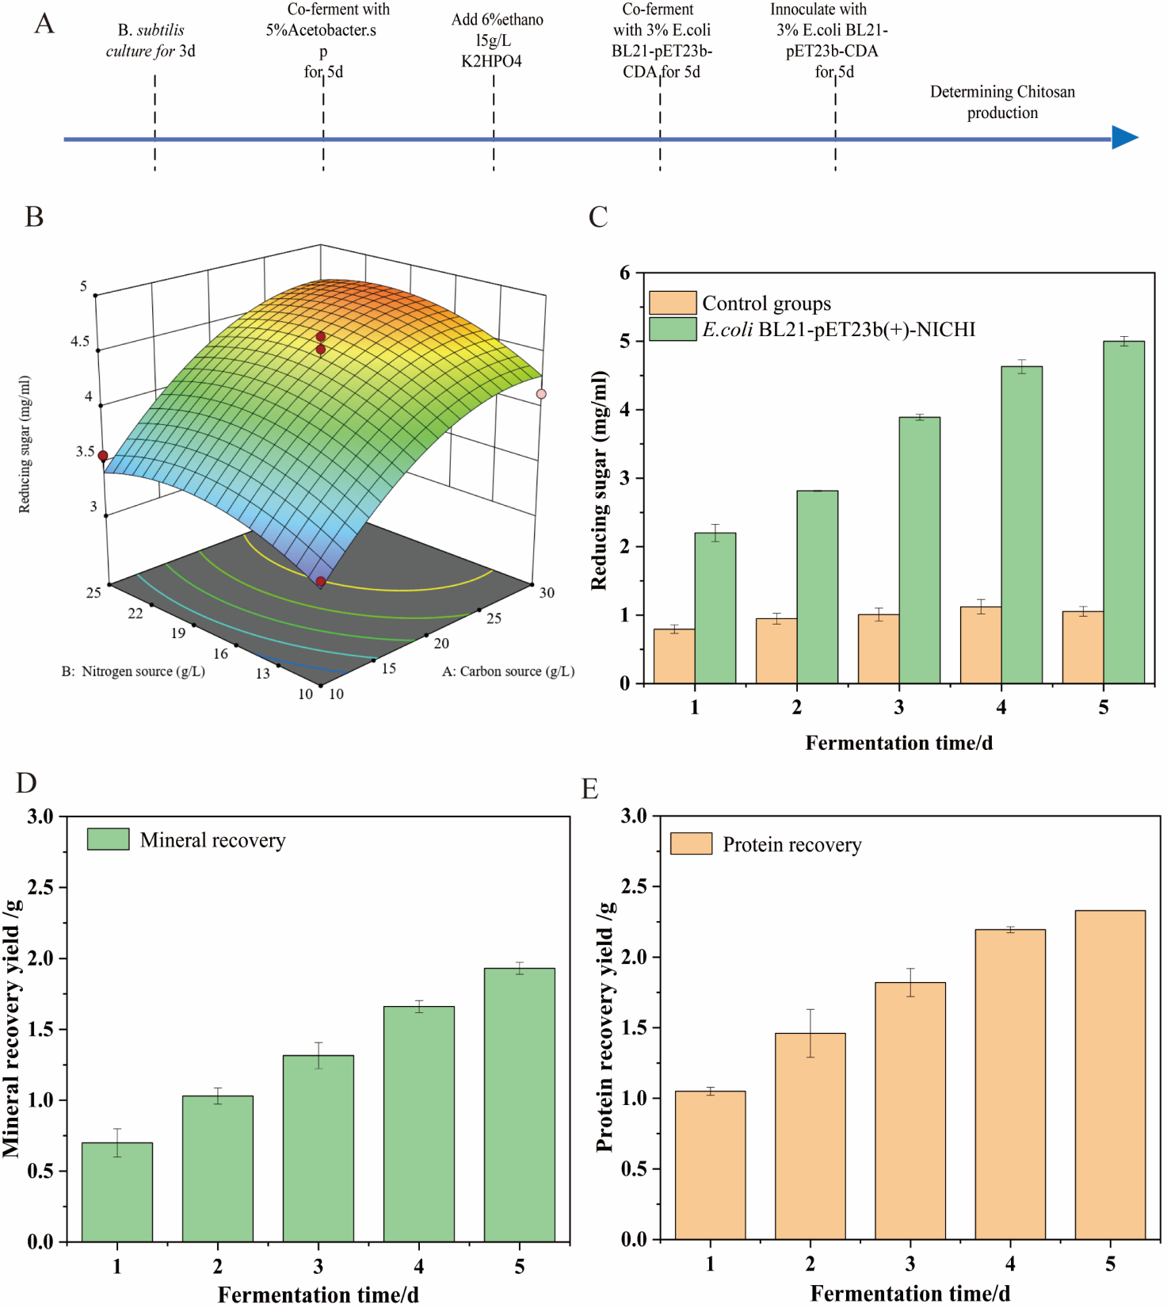
Fig. 5. RSM Optimization of COS Production and Validation of COS Products
(A) Schematic of the shrimp chaff whole-cell biocatalysis process.
(B) 3D Surface Plot of the interaction between carbon and nitrogen sources on reducing sugar content.
(C) Reducing sugar yield from shrimp chaff fermented by multi-strain whole-cell biocatalytic system.
(D) Recovery of minerals in multi-strain whole-cell biocatalytic system
(E) Recovery of protein in multi-strain whole-cell biocatalytic system
3.6 HPLC and LC-MS analysis of COS products
To comprehensively characterize the distribution of degrees of polymerization (DP) and the chemical structures of the products obtained from the multi-strain whole-cell biocatalytic system, a combinatorial analytical approach utilizing HPLC coupled with LC-MS was employed. The HPLC profile of the hydrolysate exhibited five distinct peaks, which showed concordant retention times (RT) with standard oligomers (Ding et al., 2020). As illustrated in Fig. 6A and 6B, the detected components were identified as chitotriose (GlcN3, RT = 1.734 min), chitotetraose (GlcN4, RT = 2.239 min), chitopentaose (GlcN5, RT = 2.431 min), chitohexaose (GlcN6, RT = 2.855 min), and chitoheptaose (GlcN7, RT = 5.093 min). Subsequent LC-MS analysis provided molecular mass confirmation for these fractions. Discrete ion peaks were observed at m/z 588, 701, 853, 1005, and 1093, unambiguously corresponding to COS oligomers with DPs ranging from 3 to 7 (Zhang et al., 2015). Notably, among the oligomeric mixture, GlcN3 exhibited the highest relative abundance. This distribution pattern suggests that the surface-displayed chitosanase CHI-1 possesses a preferential endolytic cleavage mode favoring the generation of trimers (Fig. 6C, Fig. 6D).
The high consistency between the chromatographic retention behaviors and the mass spectrometric data corroborates the efficiency of the developed system in converting shrimp chaff chitin into specific, low-molecular-weight COS. Existing literature has established a robust correlation between the biological efficacy of COSs and their chain length, a property largely governed by the accessibility of free amino functionalities (Mengíbar et al., 2013). The product spectrum generated in this study (GlcN3–GlcN7) bridges the functional advantages of both low- and medium-molecular-weight oligomers (Li et al., 2012). Specifically, the predominant product, GlcN3, owing to its superior membrane permeability and bioavailability, holds substantial potential for applications in nutraceuticals and cosmeceuticals (Jia et al., 2024). Concurrently, the oligomers ranging from GlcN4 to GlcN7 display distinct pharmacological properties suitable for biomedical applications. For instance, GlcN4 has been reported to significantly mitigate colitis-associated intestinal damage and reduce neutrophil infiltration (Wang et al., 2023). Furthermore, higher DP oligomers (≥5) /are known to exhibit potent antibacterial activity against pathogens such as S. aureus, while GlcN6 and GlcN7 have been documented to enhance macrophage phagocytosis and inhibit tumor cell proliferation (Liu et al., 2023).
Fig. 6. HPLC and LC-MS analysis of COS products
(A, C) COS Standard (DP: 3-7)
(B, D) COS product from shrimp chaff through whole-cell biocatalysis

Conclusions
In this study, an integrated and sustainable biorefinery strategy was developed for the comprehensive valorization of shrimp chaff waste. Using cell surface display technology, we constructed engineered strains with high deacetylation and chitosanase activities. An optimal microbial combination of B. subtilis and Acetobacter sp. was selected for efficient DP and DM, achieving protein and mineral recovery rates of 83.2% and 91.4%, respectively. A stable multi strain whole cell catalytic system comprising these four strains was successfully established. Through systematic optimization via Response Surface Methodology, the system enabled an efficient "chitin → chitosan → COS" cascade conversion, yielding a maximum COS titer of 4.9 g/L. HPLC and LC MS analyses confirmed that the main products were bioactive oligomers ranging from chitotriose to chitoheptaose. From a synthetic biology perspective, the success of this system is attributed to the effective coordination of metabolic activities and enzyme accessibility among the distinct microbial strains. Whole cell catalysis of shrimp chaff using synthetic microbes represents a transformative technology. Despite significant challenges in microbial design, process integration, and economic viability, its immense potential for environmental protection, resource recycling, and economic value creation makes it an exceptionally attractive research direction in synthetic biology and green biomanufacturing. Future breakthroughs will depend on more powerful synthetic biology tools, deeper understanding of microbial physiology, and innovative bioprocess design. In summary, this study constructed a whole cell biocatalytic system capable of the simultaneous recovery of proteins and minerals alongside COS production from shrimp chaff. By replacing traditional multi step chemical treatments reliant on harsh acids and alkalis with an efficient and environmentally benign biological route, this approach overcomes the limitations of sequential recovery strategies. It offers a promising and scalable pathway for the industrial valorization of chitinous waste, significantly contributing to the circular economy by transforming marine by products into high value functional materials.

References
Ali, G., Alkorbi, A. S., Jalalah, M., Harraz, F. A., Ling, Z. M., Saif, I., Alqahtani, A. R., Salama, E.-S., & Li, X. (2026). Anaerobic co-digestion of shrimp chaff and lignocellulosic biomass via hydrolytic bacteria: Enhanced biogas production and microbial community. Journal of Material Cycles and Waste Management, 28(1), 710-725. https://doi.org/10.1007/s10163-025-02451-w
Ali, M. S., Roy, V. C., Park, J.-S., Haque, A. R., Mok, J. H., Zhang, W., & Chun, B.-S. (2024). Protein and Polysaccharide Recovery from Shrimp Wastes by Natural Deep Eutectic Solvent Mediated Subcritical Water Hydrolysis for Biodegradable Film. Marine Biotechnology, 26(5), 876-890. https://doi.org/10.1007/s10126-024-10321-z
Amiri, H., Aghbashlo, M., Sharma, M., Gaffey, J., Manning, L., Moosavi Basri, S. M., Kennedy, J. F., Gupta, V. K., & Tabatabaei, M. (2022). Chitin and chitosan derived from crustacean waste valorization streams can support food systems and the UN Sustainable Development Goals. Nature Food, 3(10), 822-828. https://doi.org/10.1038/s43016-022-00591-y
Barikani, M., Oliaei, E., Seddiqi, H., & Honarkar, H. (2014). Preparation and application of chitin and its derivatives: a review. Iranian Polymer Journal, 23(4), 307-326. https://doi.org/10.1007/s13726-014-0225-z
Ben Seghir, B., & Benhamza, M. E. (2017). Preparation, optimization and characterization of chitosan polymer from shrimp shells. Journal of Food Measurement and Characterization, 11. https://doi.org/10.1007/s11694-017-9490-9
Blair, D. E., Schüttelkopf, A. W., MacRae, J. I., & van Aalten, D. M. (2005). Structure and metal-dependent mechanism of peptidoglycan deacetylase, a streptococcal virulence factor. Proc Natl Acad Sci U S A, 102(43), 15429-15434. https://doi.org/10.1073/pnas.0504339102
Cai, J., Yang, J., Du, Y., Fan, L., Qiu, Y., Li, J., & Kennedy, J. F. (2006). Purification and characterization of chitin deacetylase from Scopulariopsis brevicaulis. Carbohydrate Polymers, 65(2), 211-217. https://doi.org/https://doi.org/10.1016/j.carbpol.2006.01.003
Chatterjee, J., Giri, S., Maity, S., Sinha, A., Ranjan, A., Rajshekhar, & Gupta, S. (2015). Production and characterization of thermostable alkaline protease of Bacillus subtilis (ATCC 6633) from optimized solid-state fermentation. Biotechnol Appl Biochem, 62(5), 709-718. https://doi.org/10.1002/bab.1309
Chen, Y., Ling, Z., Mamtimin, T., Khan, A., Peng, L., Yang, J., Ali, G., Zhou, T., Zhang, Q., Zhang, J., & Li, X. (2022). Chitooligosaccharides production from shrimp chaff in chitosanase cell surface display system. Carbohydrate Polymers, 277, 118894. https://doi.org/https://doi.org/10.1016/j.carbpol.2021.118894
Coelmont, T., Van Gaelen, P., & Smets, I. (2023). Quantification of hydrolysis activity in a biological wastewater treatment context. Appl Microbiol Biotechnol, 107(7-8), 2143-2153. https://doi.org/10.1007/s00253-023-12465-9
Deng, J.-J., Mao, H.-H., Fang, W., Li, Z.-Q., Shi, D., Li, Z.-W., Zhou, T., & Luo, X.-C. (2020). Enzymatic conversion and recovery of protein, chitin, and astaxanthin from shrimp shell waste. Journal of Cleaner Production, 271, 122655. https://doi.org/https://doi.org/10.1016/j.jclepro.2020.122655
Ding, M., Zhang, T., Sun, C., Zhang, H., & Zhang, Y. (2020). A Chitosanase mutant from Streptomyces sp. N174 prefers to produce functional chitopentasaccharide. International Journal of Biological Macromolecules, 151, 1091-1098. https://doi.org/https://doi.org/10.1016/j.ijbiomac.2019.10.151
Ding, Z., Ahmed, S., Hang, J., Mi, H., Hou, X., Yang, G., Huang, Z., Lu, X., Zhang, W., Liu, S., & Fang, Y. (2021). Rationally engineered chitin deacetylase from Arthrobacter sp. AW19M34-1 with improved catalytic activity toward crystalline chitin. Carbohydrate Polymers, 274, 118637. https://doi.org/https://doi.org/10.1016/j.carbpol.2021.118637
Dun, Y., Li, Y., Xu, J., Hu, Y., Zhang, C., Liang, Y., & Zhao, S. (2019). Simultaneous fermentation and hydrolysis to extract chitin from crayfish shell waste. International Journal of Biological Macromolecules, 123, 420-426. https://doi.org/https://doi.org/10.1016/j.ijbiomac.2018.11.088
Gianolio, S., Mrigwani, A., & Paradisi, F. (2025). Advances in integrating microbial metabolism with catalytic systems. Nature Chemical Biology, 21(11), 1654-1666. https://doi.org/10.1038/s41589-025-02048-2
Grifoll-Romero, L., Pascual, S., Aragunde, H., Biarnés, X., & Planas, A. (2018). Chitin Deacetylases: Structures, Specificities, and Biotech Applications. Polymers (Basel), 10(4). https://doi.org/10.3390/polym10040352
Guo, N., Sun, J., Wang, W., Gao, L., Liu, J., Liu, Z., Xue, C., & Mao, X. (2019). Cloning, expression and characterization of a novel chitosanase from Streptomyces albolongus ATCC 27414. Food Chemistry, 286, 696-702. https://doi.org/https://doi.org/10.1016/j.foodchem.2019.02.056
Hai, T. C., Van Man, P., & Hong Anh, L. T. (2024). Optimization of ultrasound-assisted extraction of astaxanthin from black tiger shrimp (Penaeus monodon) shells using deep eutectic solvent and ethanol as a co-solvent. LWT, 212, 116965. https://doi.org/https://doi.org/10.1016/j.lwt.2024.116965
Hajji, S., Younes, I., Ghorbel-Bellaaj, O., Hajji, R., Rinaudo, M., Nasri, M., & Jellouli, K. (2014). Structural differences between chitin and chitosan extracted from three different marine sources. Int J Biol Macromol, 65, 298-306. https://doi.org/10.1016/j.ijbiomac.2014.01.045
He, M., Yasin, K., Yu, S., Li, J., & Xia, L. (2023). Total Flavonoids in Artemisia absinthium L. and Evaluation of Its Anticancer Activity. Int J Mol Sci, 24(22). https://doi.org/10.3390/ijms242216348
Iber, B. T., Torsabo, D., Chik, C. E. N. C. E., Wahab, F., Sheikh Abdullah, S. R., Abu Hassan, H., & Kasan, N. A. (2023). Response Surface Methodology (RSM) Approach to Optimization of Coagulation-Flocculation of Aquaculture Wastewater Treatment Using Chitosan from Carapace of Giant Freshwater Prawn Macrobrachium rosenbergii. Polymers, 15(4), 1058. https://www.mdpi.com/2073-4360/15/4/1058
Ilankovan, P., Hein, S., Ng, C.-H., Trung, T. S., & Stevens, W. F. (2006). Production of N-acetyl chitobiose from various chitin substrates using commercial enzymes. Carbohydrate Polymers, 63(2), 245-250. https://doi.org/https://doi.org/10.1016/j.carbpol.2005.08.060
Jia, Z., Su, H., Zhao, Q., Wang, S., Sun, J., & Mao, X. (2024). Structure-Assisted Design of Chitosanase Product Specificity for the Production of High-Degree Polymerization Chitooligosaccharides. Journal of Agricultural and Food Chemistry, 72(34), 19081-19092. https://doi.org/10.1021/acs.jafc.4c03048
Jiang, C., Sun, G., Zhou, Z., Bao, Z., Lang, X., Pang, J., Sun, Q., Li, Y., Zhang, X., Feng, C., & Chen, X. (2019). Optimization of the preparation conditions of thermo-sensitive chitosan hydrogel in heterogeneous reaction using response surface methodology. Int J Biol Macromol, 121, 293-300. https://doi.org/10.1016/j.ijbiomac.2018.09.210
Kaczmarek, M. B., Struszczyk-Swita, K., Li, X., Szczęsna-Antczak, M., & Daroch, M. (2019). Enzymatic Modifications of Chitin, Chitosan, and Chitooligosaccharides. Front Bioeng Biotechnol, 7, 243. https://doi.org/10.3389/fbioe.2019.00243
Kang, L.-X., Liang, Y.-X., & Ma, L.-X. (2014). Novel characteristics of chitin deacetylase from Colletotrichum lindemuthianum: Production of fully acetylated chitooligomers, and hydrolysis of deacetylated chitooligomers. Process Biochemistry, 49(11), 1936-1940. https://doi.org/https://doi.org/10.1016/j.procbio.2014.07.011
Kaur, H., & Rahi, D. K. (2024). Response surface methodology-based optimisation of chitin production and its antioxidant activity from Aspergillusniger. Heliyon, 10(4), e25646. https://doi.org/10.1016/j.heliyon.2024.e25646
Khan, I., Ali, N., Jing, Z., Khan, A., Ali, F., Hhan, F., Kareem, A., Sun, Y., Al Balushi, R. A., Al-Hinaai, M. M., Al-Harthy, T., & Nawaz, A. (2024). Biopolymer‑carbonaceous composites, progress, and adsorptive mitigation of water pollutants. International Journal of Biological Macromolecules, 274, 133379. https://doi.org/https://doi.org/10.1016/j.ijbiomac.2024.133379
Khayet, M., Zahrim, A. Y., & Hilal, N. (2011). Modelling and optimization of coagulation of highly concentrated industrial grade leather dye by response surface methodology. Chemical Engineering Journal, 167(1), 77-83. https://doi.org/https://doi.org/10.1016/j.cej.2010.11.108
Kramer, D. N., Gamson, R. M., & Miller, F. M. (1962). A Study of the Physical and Chemical Properties of the Esters of Indophenols. III. Characterization of Isomeric Esters and Their Reduction Products. The Journal of Organic Chemistry, 27(5), 1848-1851. https://doi.org/10.1021/jo01052a090
Kumar, M., Madhuprakash, J., Balan, V., Kumar Singh, A., Vivekanand, V., & Pareek, N. (2021). Chemoenzymatic production of chitooligosaccharides employing ionic liquids and Thermomyces lanuginosus chitinase. Bioresource Technology, 337, 125399. https://doi.org/https://doi.org/10.1016/j.biortech.2021.125399
Li, K., Xing, R., Liu, S., Li, R., Qin, Y., Meng, X., & Li, P. (2012). Separation of chito-oligomers with several degrees of polymerization and study of their antioxidant activity. Carbohydrate Polymers, 88(3), 896-903. https://doi.org/https://doi.org/10.1016/j.carbpol.2012.01.033
Ling, M., Li, J., Du, G., & Liu, L. (2018). Metabolic engineering for the production of chitooligosaccharides: advances and perspectives. Emerg Top Life Sci, 2(3), 377-388. https://doi.org/10.1042/etls20180009
Liu, J., Jia, Z., Li, S., Li, Y., You, Q., Zhang, C., Zheng, X., Xiong, G., Zhao, J., Qi, C., & Yang, J. (2016). Identification and characterization of a chitin deacetylase from a metagenomic library of deep-sea sediments of the Arctic Ocean. Gene, 590(1), 79-84. https://doi.org/10.1016/j.gene.2016.06.007
Liu, M., Lu, X., Khan, A., Ling, Z., Wang, P., Tang, Y., Liu, P., & Li, X. (2019). Reducing methylmercury accumulation in fish using Escherichia coli with surface-displayed methylmercury-binding peptides. Journal of Hazardous Materials, 367, 35-42. https://doi.org/https://doi.org/10.1016/j.jhazmat.2018.12.058
Liu, X., Li, X., Bai, Y., Zhou, X., Chen, L., Qiu, C., Lu, C., Jin, Z., Long, J., & Xie, Z. (2023). Natural antimicrobial oligosaccharides in the food industry. International Journal of Food Microbiology, 386, 110021. https://doi.org/https://doi.org/10.1016/j.ijfoodmicro.2022.110021
Liu, Y., Xing, R., Yang, H., Liu, S., Qin, Y., Li, K., Yu, H., & Li, P. (2020). Chitin extraction from shrimp (Litopenaeus vannamei) shells by successive two-step fermentation with Lactobacillus rhamnoides and Bacillus amyloliquefaciens. International Journal of Biological Macromolecules, 148, 424-433. https://doi.org/https://doi.org/10.1016/j.ijbiomac.2020.01.124
Lu, D.-L., Zhang, M.-S., Deng, J.-J., Lu, W.-J., Yang, Z.-D., Li, Z.-W., Chen, Y.-C., & Luo, X.-C. (2023). Highly efficient shrimp shell recovery by solid-state fermentation with Streptomyces sp. SCUT-3. Chemical Engineering Journal, 458, 141256. https://doi.org/https://doi.org/10.1016/j.cej.2022.141256
Lv, X., Liu, Y., Song, S., Tong, C., Shi, X., Zhao, Y., Zhang, J., & Hou, M. (2019). Influence of chitosan oligosaccharide on the gelling and wound healing properties of injectable hydrogels based on carboxymethyl chitosan/alginate polyelectrolyte complexes. Carbohydr Polym, 205, 312-321. https://doi.org/10.1016/j.carbpol.2018.10.067
Meng, Z., Ma, D., He, N., Lu, Y., & Cao, M. (2025). Expanding the frontiers of microbial biosynthesis with synthetic microbial communities. Current Opinion in Biotechnology, 96, 103351. https://doi.org/https://doi.org/10.1016/j.copbio.2025.103351
Mengíbar, M., Mateos-Aparicio, I., Miralles, B., & Heras, A. (2013). Influence of the physico-chemical characteristics of chito-oligosaccharides (COS) on antioxidant activity. Carbohydr Polym, 97(2), 776-782. https://doi.org/10.1016/j.carbpol.2013.05.035
Muley, A. B., Chaudhari, S. A., Mulchandani, K. H., & Singhal, R. S. (2018). Extraction and characterization of chitosan from prawn shell waste and its conjugation with cutinase for enhanced thermo-stability. International Journal of Biological Macromolecules, 111, 1047-1058. https://doi.org/https://doi.org/10.1016/j.ijbiomac.2018.01.115
Rao, M. S., Muñoz, J., & Stevens, W. F. (2000). Critical factors in chitin production by fermentation of shrimp biowaste. Appl Microbiol Biotechnol, 54(6), 808-813. https://doi.org/10.1007/s002530000449
Rodríguez, J., Vázquez, L., Flórez, A. B., & Mayo, B. (2022). Phenotype testing, genome analysis, and metabolic interactions of three lactic acid bacteria strains existing as a consortium in a naturally fermented milk. Front Microbiol, 13, 1000683. https://doi.org/10.3389/fmicb.2022.1000683
Ruangwicha, J., Cheirsilp, B., & Suyotha, W. (2024). Green biorefinery of shrimp shell waste for α-chitin and high-value co-products through successive fermentation by co-lactic acid bacteria and proteolytic fungus. Bioresource Technology, 393, 130106. https://doi.org/https://doi.org/10.1016/j.biortech.2023.130106
Sixto-Berrocal, A. M., Vázquez-Aldana, M., Miranda-Castro, S. P., Martínez-Trujillo, M. A., & Cruz-Díaz, M. R. (2023). Chitin/chitosan extraction from shrimp shell waste by a completely biotechnological process. International Journal of Biological Macromolecules, 230, 123204. https://doi.org/https://doi.org/10.1016/j.ijbiomac.2023.123204
Sun, J., & Mao, X. (2016). An environmental friendly process for Antarctic krill (Euphausia superba) utilization using fermentation technology. Journal of Cleaner Production, 127, 618-623. https://doi.org/https://doi.org/10.1016/j.jclepro.2016.04.020
Sun, X., Wang, Y., Yu, J., Wei, Q., & Ren, X. (2024). Study on the deacetylation and mechanism of chitin in natural deep eutectic solvent. International Journal of Biological Macromolecules, 255, 127698. https://doi.org/https://doi.org/10.1016/j.ijbiomac.2023.127698
Tan, L., Cui, H., Xiao, Y., Xu, H., Xu, M., Wu, H., Dong, H., Qiu, G., Liu, X., & Xie, J. (2019). Enhancement of platinum biosorption by surface-displaying EC20 on Escherichia coli. Ecotoxicology and Environmental Safety, 169, 103-111. https://doi.org/https://doi.org/10.1016/j.ecoenv.2018.10.116
Topić Popović, N., Lorencin, V., Strunjak-Perović, I., & Čož-Rakovac, R. (2023). Shell Waste Management and Utilization: Mitigating Organic Pollution and Enhancing Sustainability. Applied Sciences, 13(1), 623. https://www.mdpi.com/2076-3417/13/1/623
Tozakidis, I. E. P., Sichwart, S., & Jose, J. (2015). Going beyond E. coli: autotransporter based surface display on alternative host organisms. New Biotechnology, 32(6), 644-650. https://doi.org/https://doi.org/10.1016/j.nbt.2014.12.008
Valdez Castillo, M., Brar, S. K., Arriaga, S., Blais, J.-F., & Avalos Ramirez, A. (2022). Effect of passive cell immobilization of co-cultured yeasts on the whey fermentation and alcohols production. Journal of Cleaner Production, 375, 133988. https://doi.org/https://doi.org/10.1016/j.jclepro.2022.133988
Vicente, F. A., Bradić, B., Novak, U., & Likozar, B. (2020). α-Chitin dissolution, N-deacetylation and valorization in deep eutectic solvents. Biopolymers, 111(5), e23351. https://doi.org/10.1002/bip.23351
Wang, W., Cui, Z., Ning, M., Zhou, T., & Liu, Y. (2022). In-silico investigation of umami peptides with receptor T1R1/T1R3 for the discovering potential targets: A combined modeling approach. Biomaterials, 281, 121338. https://doi.org/10.1016/j.biomaterials.2021.121338
Wang, Y., Ji, X., Zhao, M., Li, J., Yin, H., Jin, J., & Zhao, L. (2023). Modulation of tryptophan metabolism via AHR-IL22 pathway mediates the alleviation of DSS-induced colitis by chitooligosaccharides with different degrees of polymerization. Carbohydr Polym, 319, 121180. https://doi.org/10.1016/j.carbpol.2023.121180
Xie, J., Xie, W., Yu, J., Xin, R., Shi, Z., Song, L., & Yang, X. (2021). Extraction of Chitin From Shrimp Shell by Successive Two-Step Fermentation of Exiguobacterium profundum and Lactobacillus acidophilus. Front Microbiol, 12, 677126. https://doi.org/10.3389/fmicb.2021.677126
Xu, J., Liu, X., Wu, W., Liu, T., & Wang, C. (2025). Synergistic Fermentation Effect of Cellulose-Degrading Complex Microflora and Enzymes on Oat Grass Straw. Appl Biochem Biotechnol. https://doi.org/10.1007/s12010-025-05461-4
Xu, Y., Gallert, C., & Winter, J. (2008). Chitin purification from shrimp wastes by microbial deproteination and decalcification. Appl Microbiol Biotechnol, 79(4), 687-697. https://doi.org/10.1007/s00253-008-1471-9
Yang, G., Wang, Y., Fang, Y., An, J., Hou, X., Lu, J., Zhu, R., & Liu, S. (2022). A Novel Potent Crystalline Chitin Decomposer: Chitin Deacetylase from Acinetobacter schindleri MCDA01. Molecules (Basel, Switzerland), 27(16), 5345. Retrieved 2022/08//, from http://europepmc.org/abstract/MED/36014581
https://doi.org/10.3390/molecules27165345
https://europepmc.org/articles/PMC9416191
https://europepmc.org/articles/PMC9416191?pdf=render
Zhang, B., Gao, X., Zhou, Y., You, S., Qi, W., & Wang, M. (2025). Surface Display Technologies for Whole-Cell Biocatalysts: Advances in Optimization Strategies, Food Applications, and Future Perspectives. Foods, 14(10), 1803.
Zhang, H., Jin, Y., Deng, Y., Wang, D., & Zhao, Y. (2012). Production of chitin from shrimp shell powders using Serratia marcescens B742 and Lactobacillus plantarum ATCC 8014 successive two-step fermentation. Carbohydr Res, 362, 13-20. https://doi.org/10.1016/j.carres.2012.09.011
Zhang, J., Cao, H., Li, S., Zhao, Y., Wang, W., Xu, Q., Du, Y., & Yin, H. (2015). Characterization of a new family 75 chitosanase from Aspergillus sp. W-2. International Journal of Biological Macromolecules, 81, 362-369. https://doi.org/https://doi.org/10.1016/j.ijbiomac.2015.08.026
Zhang, Z., Ma, Z., Song, L., & Farag, M. A. (2024). Maximizing crustaceans (shrimp, crab, and lobster) by-products value for optimum valorization practices: A comparative review of their active ingredients, extraction, bioprocesses and applications. J Adv Res, 57, 59-76. https://doi.org/10.1016/j.jare.2023.11.002

